Scoil Mhuire ANNUAL ADMISSION NOTICE in respect of admissions to the 2023/2024 school year

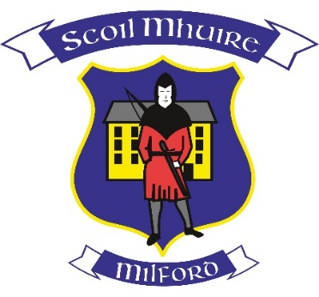

Admission Policy and Application Form
A copy of the school’s Admission Policy and the Application Form for Admission for Scoil Mhuire is available as follows:
To download at: www.scoilmhuiremilford.com
On request: By emailing milfordns2016@gmail.com or writing to: Scoil Mhuire, Milford, Co. Donegal, F92 D744 or by calling the school office on 074 91 53494/0861894920

PART 1
Admissions to the 2024/2025 school year
Application and Decision Dates for Admission to 2024/2025

The following are the dates applicable for admission to Junior Infants in
Scoil Mhuire, Milford

The school will commence accepting applications for admission on | 8th January 2024
The school shall cease accepting applications for admission on | 29th January 2024
The date by which applicants will be notified of the decision on their application is | 19th February 2024
The period within which applicants must confirm acceptance of an offer of admission is | 1st March 2024

*Failure to accept an offer within the prescribed period above may result in the offer being withdrawn
Note: the school will consider and issue decisions on late applications in accordance with the school’s admission policy.
Special Class Application and Decision Dates for Admission to Scoil Mhuire, Milford

The following are the dates applicable for admission to the school’s Special Class which caters for Children with Autism/Autistic Spectrum Disorder:

The school will commence accepting applications for admission on | 1st December 2023
The school shall cease accepting applications for admission on | 29th January 2024
The date by which applicants will be notified of the decision on their application is | 19th February 2024
The period within which applicants must confirm acceptance of an offer of admission is | 1st March 2024

Failure to accept an offer within the prescribed period above may result in the offer being withdrawn

Number of places being made available in 2023/2024

The number of places being made available in junior infants is | 35
The number of places being made available in the Autism/Autistic Spectrum Disorder Class is | 4

