Scoil Mhuire ANNUAL ADMISSION NOTICE in respect of admissions to the 2026/2027 school year

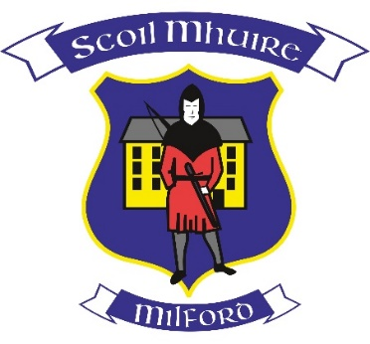

Admission Policy and Application Form
A copy of the school’s Admission Policy and the Application Form for Admission (Enrolment Form) for the 2026/2027 school year is available as follows:
To download at: www.scoilmhuiremilford.com
On request: By emailing milfordns2016@gmail.com or writing to: Scoil Mhuire, Milford, Co. Donegal, F92 D744 or by calling the school office on 074 91 53494/0861894920

PART 1
Admissions to the 2026/2027 school year
Application and Decision Dates for Admission to 2026/2027

The following are the dates applicable for admission to Junior Infants in
Scoil Mhuire, Milford

The school will commence accepting applications for admission on | 20th October 2025
The school shall cease accepting applications for admission on | 10th November 2025
The date by which applicants will be notified of the decision on their application is | 1st December 2025
The period within which applicants must confirm acceptance of an offer of admission is | 15th December 2025
The number of places being made available in Junior Infants is | 35

*Failure to accept an offer within the prescribed period above may result in the offer being withdrawn

The following are the dates applicable for admission to the school’s Special Class which caters for Children with Autism/Autistic Spectrum Disorder:

The school will commence accepting applications for admission on | 20th October 2025
The school shall cease accepting applications for admission on | 10th November 2025
The date by which applicants will be notified of the decision on their application is | 1st December 2025
The period within which applicants must confirm acceptance of an offer of admission is | 15th December 2025
The number of places being made available in the Autism/Autistic Spectrum Disorder Class is | 0

*Failure to accept an offer within the prescribed period above may result in the offer being withdrawn
Note: the school will consider and issue decisions on late applications in accordance with the school’s admission policy.

