CV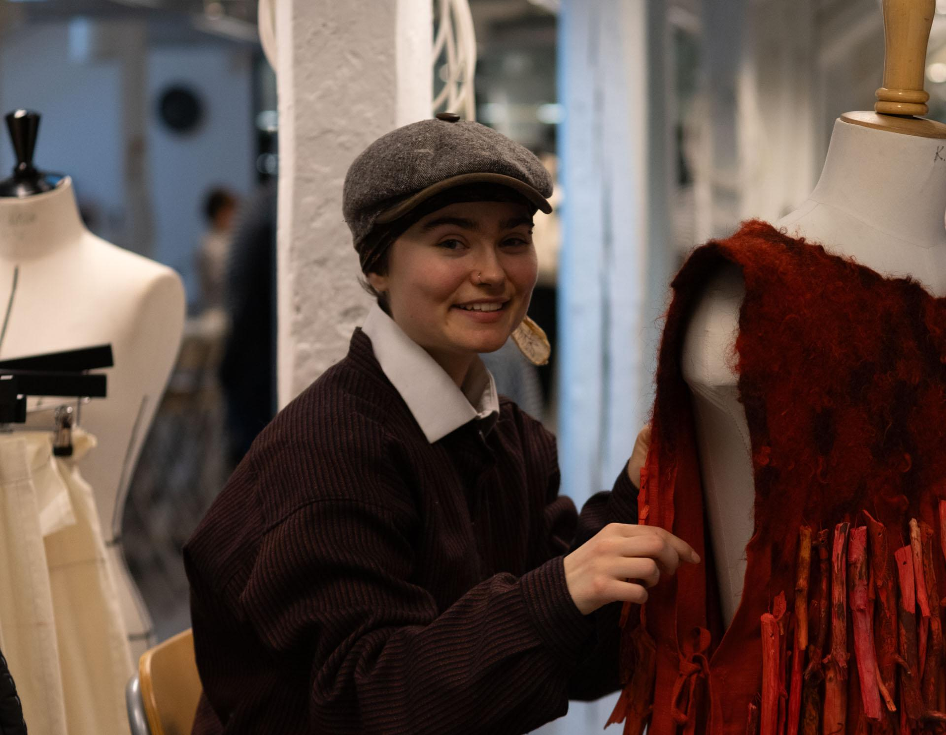

Vårhild Bakke Berntzen

Designer, artist from Nittedal, Norway

+47 94974840

[vaarhild@gmail.com](mailto:vaarhild@gmail.com)

### Work experience

* Artist assistant/intern for Sandra Mujinga for the exhibition *Time as a Shield*, Kunsthalle Basel 2024 (Residency at ISCP, New York)
* Founder and board member of *Unge Skogfinner i Norge/Norjan Metsäsuomalaisnuoret (Young Forest Finns in Norway)*

### Education

2022-2025 BA Fashion and Costume Design, Oslo Academy of Fine Arts

2020-2022 Einar Granum Kunstfagskole (threedimentional artforms)

### Courses and workshops

* *Tanning fish skin, ULU Vågå, july 2023*
* *Forging, Hjerleid Dovre, july 2024*
* *Birch bark braiding, Unge Skogfinner/Trygve Løvseth, august/october 2024*
* *“The In-between”, workshop with Carte Blanche, october 2024*

### Utstillinger/visninger

2024 - Ingen er fri før alle er fri, Omnibus, Oslo. Group

2024 - Open Academy (performance and exhibition), KHiO. Group

2024 - One Man Show - A group exhibition, Resepsjonsgalleriet KHiO. Group

2024 - Elvelangs, performance med Ingeborg Wangen Kallhovd. Group

2024 - Tråd og never (performance and exhibition), Omnibus, Oslo. Group

2023 - NATURE/FIBERS/FINGERS/TIME/THREAD, Resepsjonen, KHiO. Group

2023 - SIGNAL (performance), White Box, KHiO. Solo

2022 - Monokrom (runway show), Katedralen, KHiO. Group

2022 - Brynje, Galleri VEKTA, Oslo. Solo

2021 - STORM, Galleri VEKTA, Oslo. Group

2021 - Sjåkutstillinga, Bøstugu, Sjåk. Group