Blueprint General Election Contrast Messaging
The best bullets Biden has to drive a contrast with Trump with the voting blocs that matter most

Overall

Voters’ top concerns about Trump are:

- Trump would abuse the presidency to take revenge on his political rivals (57%)
- Trump would break the law (57%)
- Trump would pardon himself for crimes he was convicted of (56%)
- Trump will let rich tax cheats off of the hook (56%)
- Trump would ignore military leaders and act in dangerous ways that threaten national security (56%)
- Trump would cut taxes for the rich but not working- and middle-class families (56%)
- Trump would abuse the presidency to enrich himself and his family (55%)
- Trump would cut funding for Social Security and Medicare (55%)
- Trump would erode democracy and try to overturn future elections (54%)
- Trump would put the interests of conservative activists over the public (52%)
- Trump would institute cruel policies that separate immigrant families (52%)
- Trump would repeal environmental protections, making the air and water dirtier (52%)

Consistently, voters’ leading concerns about a Trump presidency are his personal fitness for office and him favoring the wealthy at the expense of the working and middle class. The lowest ranked concerns are:

- Trump would attack gay and trans rights (47%)
- Trump would be too old to do the job well (47%)
- Trump would weaken the American economy (47%)
- Trump would favor Christians and discriminate against other religious groups (46%)
- Trump would be too conservative (44%)
- Trump would be too favorable to Israel in the conflict between Israel and Palestine (39%)
- Trump would be too moderate (22%)

Voters are not as concerned about Trump’s ideological placement, his position on Israel, his age, or any damage he would do to the economy. Notably, few are worried that he would privilege favor Christians or limit LGBTQ rights.

The top concerns among voters about Biden are:

- Biden would be too old to do the job well (69%)
- Biden would increase the national debt (63%)
- Biden would allow the prices to increase on goods and services (63%)
- Biden would allow immigrants to illegally cross the U.S. border with Mexico (60%)
- Biden would weaken the American economy (58%)
- Biden would get America involved in new wars (57%)
- Biden would allow all immigrants living illegally in the United States to stay forever (57%)
- Biden would ban new oil and gas drilling, driving up gas prices (56%)
- Biden would raise taxes on middle-class families (55%)
- Biden would be bad for American businesses (53%)
- Biden would put the interests of liberal and progressive activists over the general public (52%)
- Biden would be too liberal or progressive (52%)

Here, we see that Biden faces a number of traditional voter concerns about Democrats, such as the national debt, weakness on inflation, and middle-class tax hikes. Voters are also concerned about immigration and limits on oil and gas drilling. Notably, a majority of voters express concern that Biden would be too liberal.

The concerns about Biden that test lowest are:

- Biden would break the law (45%)
- Biden would abuse the presidency to take revenge on his political rivals (44%)
- Biden would persecute religious organizations and individuals (43%)
- Biiden would undermine democracy and try to steal future elections (43%)
- Biden would legalize abortion on demand (41%)
- Biden would be too favorable to Israel in the conflict between Israel and Palestine (38%)
- Biden would be too moderate (32%)

Attempts by Republicans to convince voters that Biden is dishonest or corrupt have largely fallen flat. In addition, claims from the left that Biden needs to be more progressive have little support: we find that being too moderate is the thing voters are least worried about when it comes to Biden. While concerns about Biden’s position on Israel and Palestine dominate on social media, they are not top of mind for voters (with one exception: new voters are worried that Biden would favor Israel too much). We find that Biden can feel comfortable leaning in on abortion; the concern that Biden supports abortion on demand ranked third from the last.

Based on our testing, the following contrast messages between Trump and Biden are most compelling, focusing on abortion (a key base motivator for Democrats that’s persuasive to independents), lowering drug prices and inflation (pocketbook economic issues that meet the current moment), and Trump’s disregard for democracy (a framing that pressurizes Republican divisions and highlights Biden’s character):

- [ABORTION] Donald Trump's hand-picked Supreme Court rolled back abortion rights, and if he's elected, he will ban abortion and roll back access to birth control. Republicans want to tell women what to do with their bodies and to tell families how to make personal decisions with lifelong consequences. President Biden wants to protect our fundamental rights and freedoms, including a woman's right to control her own body and families' right to control their own destiny.

- [PHARMA] While Donald Trump talked about taking on pharmaceutical companies, President Biden actually delivered the policy that would combat them jacking up prices to make more profit, making their medicine too expensive for ordinary Americans. The Biden administration forced big pharmaceutical companies to the table to lower the prices of the drugs most commonly used by Americans. President Biden is committed to bringing down prices for working- and middle-class Americans and has the wins to prove it.

- [INFLATION] Since taking office, President Biden has brought inflation down from 8 percent to 3 percent, reduced the deficit by $1.8 trillion, created millions of jobs, and lowered gas prices from $4 a gallon to $3 a gallon by increasing US oil and gas production to record highs. When Donald Trump was president, he increased the deficit with big tax cuts for the wealthy and tried to strip health insurance away from millions of Americans.

- [INSURRECTION] Donald Trump denied the results of the 2020 election and actively incited a deadly insurrection at the Capitol where police officers were killed. Donald Trump is not a normal Republican; he attacks our fundamental rights and freedoms at every turn, and Americans of all parties should reject him. President Biden is a uniter who has worked with both Democrats and Republicans to protect democracy at home and abroad.
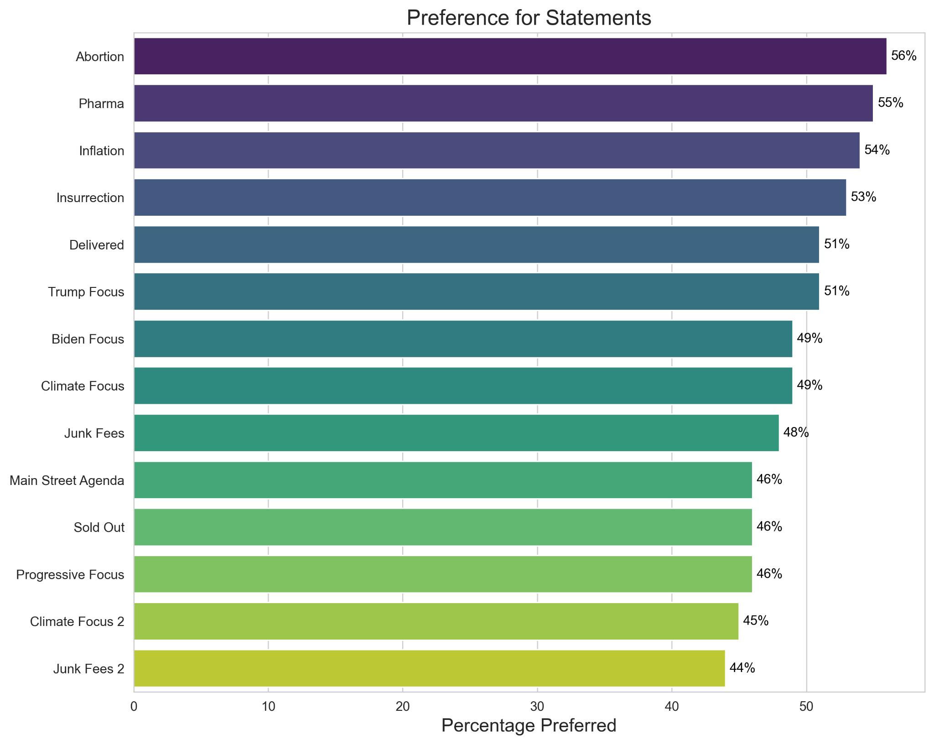

The best-testing Biden quotes are focused on capping the prices of insulin, the Bipartisan Infrastructure Law, and Medicare negotiating with pharmaceutical companies. Those messages are:

- [INSULIN] Insulin costs less than $10 to make, but Americans are sometimes forced to pay over $300 for it. It’s flat wrong. I signed a law to cap insulin at $35 for seniors and I called on pharma companies to bring prices down for everyone on their own.
- [INFRASTRUCTURE] Two years ago, I signed into law a once-in-a-generation investment in our nation’s infrastructure and to fix our roads, railroads, bridges, ports, airports; remove every single lead pipe in the country; and extend high-speed Internet, advance clean energy, and modernize the energy grid.
- [DRUG PRICES] Negotiating drug prices will not only save consumers money, it’s going to save the federal government money. Negotiating drug prices alongside other parts of my prescription drug plan is going to save the taxpayers so far one hundred and sixty billion dollars.
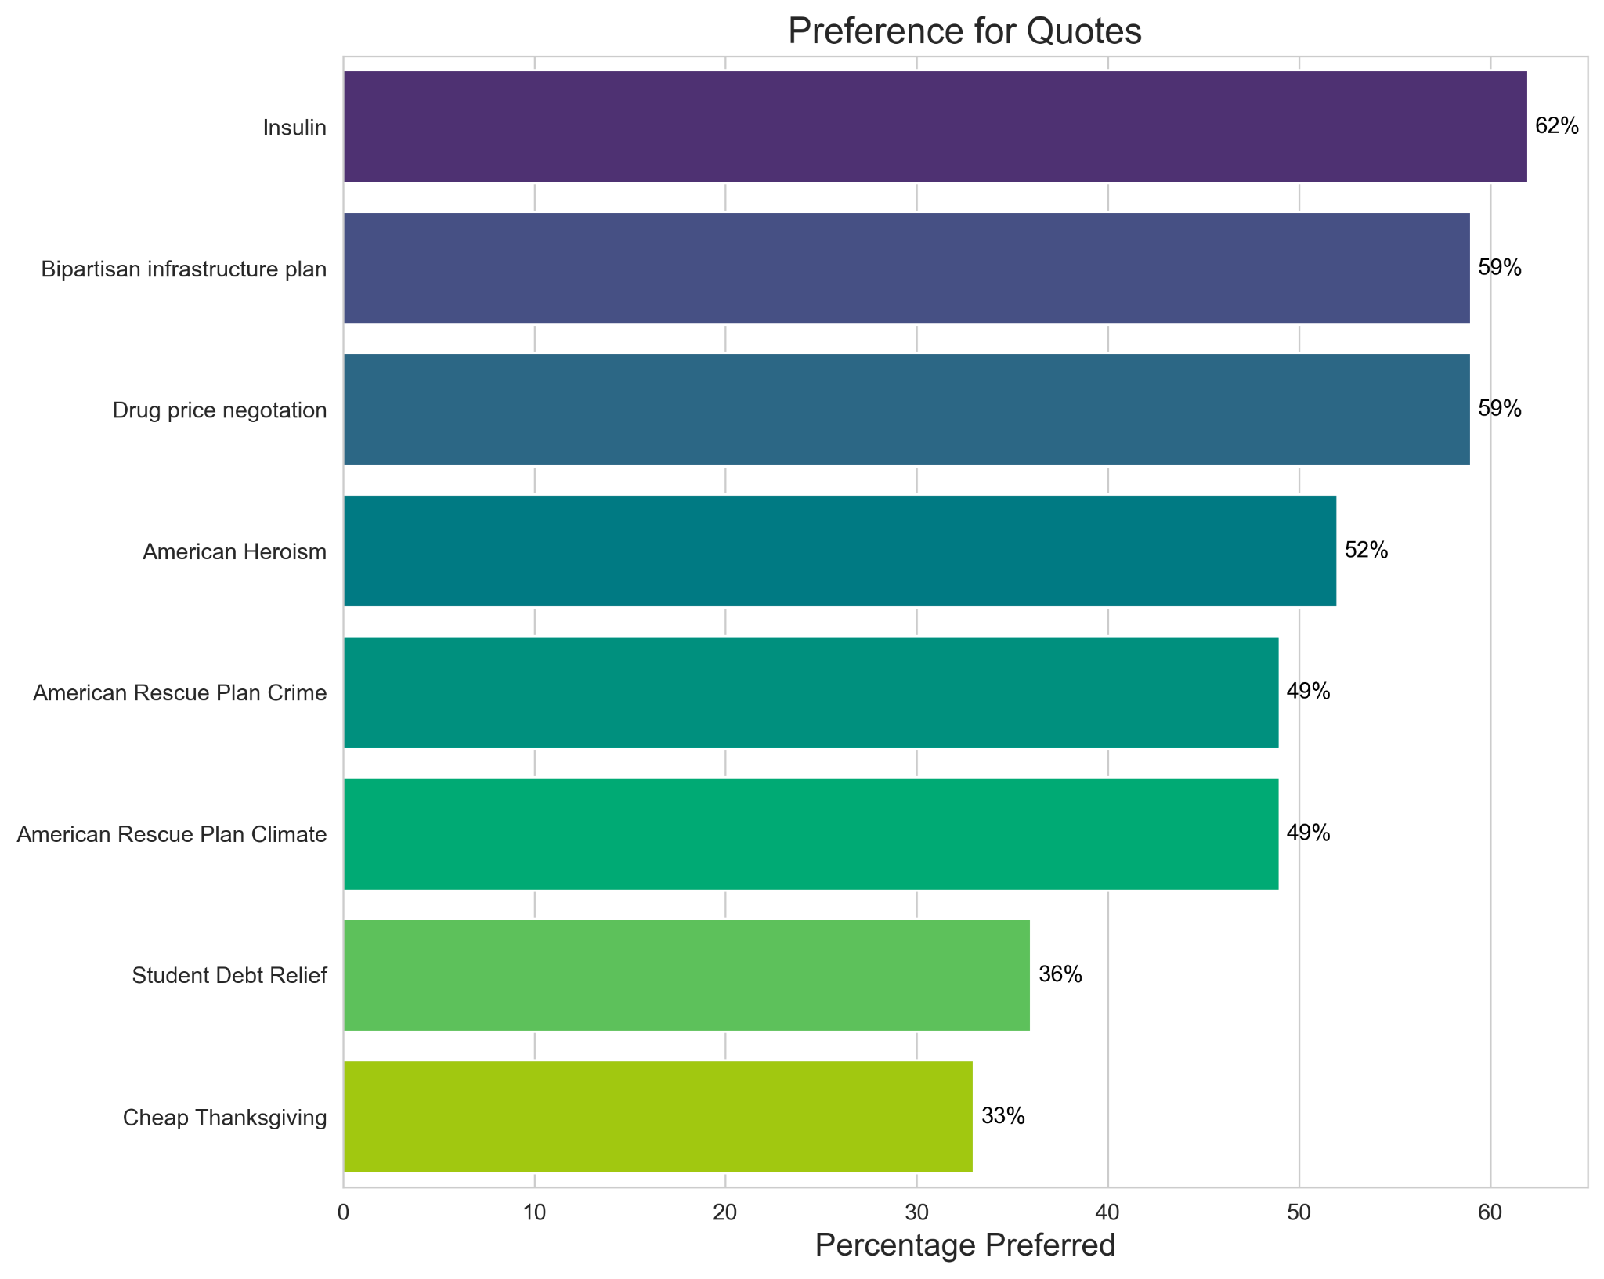

Non-College Voters (33% Biden, 57%, Trump)
The top concerns about Trump among non-college voters are:

- Trump would cut taxes for the rich, but not working- and middle-class families (54%, 48% among non-college whites)
- Trump will let rich tax cheats off of the hook (53%, 48% among non-college whites)
- Trump would cut funding for Social Security and Medicare (53%, 46% among non-college whites)

The top concerns about Biden among non-college voters are:

- Biden would be too old to do the job well (72%, 77% among non-college whites)
- Biden would allow prices to increase on goods and services (68%, 73% among non-college whites)
- Biden would increase the national debt (66%, 72% among non-college whites)

These concerns share a theme: non-college voters are deeply concerned that Trump would cut taxes for the rich, leave them out of tax cuts, and cut their Social Security and Medicare. Two of our top-testing contrast messages can help defuse these concerns:

- While Donald Trump talked about taking on pharmaceutical companies, President Biden actually delivered the policy that would combat them jacking up prices to make more profit, making their medicine too expensive for ordinary Americans. The Biden administration forced big pharmaceutical companies to the table to lower the prices of the drugs most commonly used by Americans. President Biden is committed to bringing down prices for working- and middle-class Americans and has the wins to prove it.
- Since taking office, President Biden has brought inflation down from 8 percent to 3 percent, reduced the deficit by $1.8 trillion, created millions of jobs, and lowered gas prices from $4 a gallon to $3 a gallon by increasing US oil and gas production to record highs. When Donald Trump was president, he increased the deficit with big tax cuts for the wealthy and tried to strip health insurance away from millions of Americans.

Working-Class Voters (Under $60,000), (43% Biden, 46% Trump)

The top concerns about Trump among working-class voters are:

- Trump will let rich tax cheats off the hook (58%)
- Trump would cut funding for Social Security and Medicare (57%)
- Trump would cut taxes for the rich but not working- and middle-class families (57%)

The top concerns about Biden among working-class voters are:

- Biden would be too old to do the job well (70%)
- Biden would allow prices to increase on goods and services (67%)
- Biden would increase the national debt (65%)

For working-class voters the most common concerns are about tax cuts for the wealthy at the expense of middle- and working-class families, cutting funding for Social Security and Medicare, and letting tax cheats off the hook. For these voters ,a class-centric contrast message is most convincing. For example:

- While Donald Trump talked about taking on pharmaceutical companies, President Biden actually delivered the policy that would combat them jacking up prices to make more profit, making their medicine too expensive for ordinary Americans. The Biden administration forced big pharmaceutical companies to the table to lower the prices of the drugs most commonly used by Americans. President Biden is committed to bringing down prices for working- and middle-class Americans and has the wins to prove it.
- Since taking office, President Biden has brought inflation down from 8 percent to 3 percent, reduced the deficit by $1.8 trillion, created millions of jobs, and lowered gas prices from $4 a gallon to $3 a gallon by increasing US oil and gas production to record highs. When Donald Trump was president, he increased the deficit with big tax cuts for the wealthy and tried to strip health insurance away from millions of Americans.

Independent Voters (40% Biden, 37% Trump)

Among independents, the top concerns about Trump are that:

- Trump would pardon himself for crimes he was convicted of (57%)
- Trump will let rich tax cheats off of the hook (56%)
- Trump would ignore military leaders and act in a dangerous ways that threaten national security (56%)

The top concerns about Biden among independents are that:

- Biden would allow prices to increase on goods and services (77%)
- Biden would be too old to do the job well (76%)
- Biden would increase the national debt (75%)

Independents have both democracy concerns and populist concerns about Trump. Contrast messages that highlight Trump’s anti-democracy behaviors as well as his plutocratic tendencies are the most popular among independents, as well as strong abortion messaging.

- Donald Trump denied the results of the 2020 election and actively incited a deadly insurrection at the Capitol where police officers were killed. Donald Trump is not a normal Republican; he attacks our fundamental rights and freedoms at every turn, and Americans of all parties should reject him. President Biden is a uniter who has worked with both Democrats and Republicans to protect democracy at home and abroad.
- While Donald Trump talked about taking on pharmaceutical companies, President Biden actually delivered the policy that would combat them jacking up prices to make more profit, making their medicine too expensive for ordinary Americans. The Biden administration forced big pharmaceutical companies to the table to lower the prices of the drugs most commonly used by Americans. President Biden is committed to bringing down prices for working- and middle-class Americans and has the wins to prove it.
- Donald Trump's hand-picked Supreme Court rolled back abortion rights, and if he's elected, he will ban abortion and roll back access to birth control. Republicans want to tell women what to do with their bodies and to tell families how to make personal decisions with lifelong consequences. President Biden wants to protect our fundamental rights and freedoms, including a woman's right to control her own body and families' right to control their own destiny.

Young Voters (Age 18 to 29), (54% Biden, 24% Trump)

Among young voters (18-29), the top concerns about Trump are that:

- Trump would ignore military leaders and act in dangerous ways that threaten national security (77%)
- Trump would pardon himself for crimes he was convicted of (72%)
- Trump would abuse the presidency to take revenge on his political rivals (72%)

Among young voters (18-29), the top concerns amount Biden are that:

- Biden would be too old to do the job well (60%)
- Biden would increase the national debt (55%)
- Biden would allow prices to increase on goods and services (55%)

Young voters express the strongest concern about Trump exploiting his office, pardoning himself for crimes he committed, and, broadly, his anti-democratic tendencies. Concerns about Biden are quite similar to the concerns expressed by other age groups, with a focus on inflation and the national debt. For young voters, the top-testing messages are:

- Donald Trump denied the results of the 2020 election and actively incited a deadly insurrection at the Capitol where police officers were killed. Donald Trump is not a normal Republican; he attacks our fundamental rights and freedoms at every turn, and Americans of all parties should reject him. President Biden is a uniter who has worked with both Democrats and Republicans to protect democracy at home and abroad.
- Since taking office, President Biden has brought inflation down from 8 percent to 3 percent, reduced the deficit by $1.8 trillion, created millions of jobs, and lowered gas prices from $4 a gallon to $3 a gallon by increasing US oil and gas production to record highs. When Donald Trump was president, he increased the deficit with big tax cuts for the wealthy and tried to strip health insurance away from millions of Americans.
- Donald Trump's hand-picked Supreme Court rolled back abortion rights, and if he's elected, he will ban abortion and roll back access to birth control. Republicans want to tell women what to do with their bodies and to tell families how to make personal decisions with lifelong consequences. President Biden wants to protect our fundamental rights and freedoms, including a woman's right to control her own body and families' right to control their own destiny.

Senior Voters (Age 65+), (Biden 41%, Trump 56%)

Among senior voters (age 65+), the top concerns about Biden are that:

- Biden would be too old to do the job well (71%)
- Biden would allow immigrants to illegal cross the US border with Mexico (68%)
- Biden would increase the national debt (65%)

Among senior voters (age 65+), the top concerns about Trump are that:

- Trump would cut taxes for the rich but not working- and middle-class families (50%)
- Trump will let tax cheats off the hook (50%)
- Trump would abuse the presidency to take revenge on his political rivals (50%)

Older voters are concerned about Trump’s anti-democracy tendencies and the possibility he will let the wealthy off the hook. For Biden, older voters are more concerned than other groups about immigration. For older voters, the following messages are most persuasive:

- While Donald Trump talked about taking on pharmaceutical companies, President Biden actually delivered the policy that would combat them jacking up prices to make more profit, making their medicine too expensive for ordinary Americans. The Biden administration forced big pharmaceutical companies to the table to lower the prices of the drugs most commonly used by Americans. President Biden is committed to bringing down prices for working- and middle-class Americans and has the wins to prove it.
- Donald Trump denied the results of the 2020 election and actively incited a deadly insurrection at the Capitol where police officers were killed. Donald Trump is not a normal Republican; he attacks our fundamental rights and freedoms at every turn, and Americans of all parties should reject him. President Biden is a uniter who has worked with both Democrats and Republicans to protect democracy at home and abroad.

Non-college women (49% Biden, 40% Trump)

Among non-college women, the top concerns about Biden are that:

- Biden would be too old to do the job well (71%)
- Biden would allow prices to increase on goods and service (65%)
- Biden would increase the national debt (62%)

Among non-college women, the top concerns about Trump are that:

- Trump would let tax cheats off the hook (63%)
- Trump would cut taxes for the rich but not working- and middle-class families (63%)
- Trump would ignore military leaders and act in dangerous ways that would threaten national security (61%)

Non-college women are particularly concerned about Trump’s anti-democratic behaviors and the idea that he would favor the wealthy at the expense of the middle and working class. For Biden, they are concerned about prices and the national debt. he messages below are most persuasive for non-college women:

- Donald Trump denied the results of the 2020 election and actively incited a deadly insurrection at the Capitol where police officers were killed. Donald Trump is not a normal Republican; he attacks our fundamental rights and freedoms at every turn, and Americans of all parties should reject him. President Biden is a uniter who has worked with both Democrats and Republicans to protect democracy at home and abroad.
- Donald Trump's hand-picked Supreme Court rolled back abortion rights, and if he's elected, he will ban abortion and roll back access to birth control. Republicans want to tell women what to do with their bodies and to tell families how to make personal decisions with lifelong consequences. President Biden wants to protect our fundamental rights and freedoms, including a woman's right to control her own body and families' right to control their own destiny.
- Since taking office, President Biden has brought inflation down from 8 percent to 3 percent, reduced the deficit by $1.8 trillion, created millions of jobs, and lowered gas prices from $4 a gallon to $3 a gallon by increasing US oil and gas production to record highs. When Donald Trump was president, he increased the deficit with big tax cuts for the wealthy and tried to strip health insurance away from millions of Americans.

Mend under 45 (43% Biden, 40% Trump)

Among men under 45 men, the top concerns about Trump are that:

- Trump would break the law (60%)
- Trump would pardon himself for crimes he was convicted of (54%)
- Trump would abuse the presidency to enrich himself and his family (54%)

Among men under 45, the top concerns about Biden are that:

- Biden would allow prices to increase on goods and services (64%)
- Biden would be too old to do the job well (63%)
- Biden would increase the national debt (62%)

Young men were particularly concerned about Trump’s anti-democratic behavior and the idea that he would favor himself and his family. No other group ranked these democracy-centric concerns as the top three worries. Young men are worried about a second Biden term leading to rising prices and the national debt. Below are the most popular messages among this group of voters:

- Donald Trump denied the results of the 2020 election and actively incited a deadly insurrection at the Capitol where police officers were killed. Donald Trump is not a normal Republican; he attacks our fundamental rights and freedoms at every turn, and Americans of all parties should reject him. President Biden is a uniter who has worked with both Democrats and Republicans to protect democracy at home and abroad.
- President Biden has delivered where Donald Trump failed the American people. On day one, President Biden got to work fixing the economic crisis Donald Trump left behind by helping to create over 14 million jobs, including bringing back hundreds of thousands of manufacturing jobs, and lowering costs for families. The bottom line: President Biden wakes up every day working and rooting for the American people. Donald Trump spends every day worried about himself
- Since taking office, President Biden has brought inflation down from 8 percent to 3 percent, reduced the deficit by $1.8 trillion, created millions of jobs, and lowered gas prices from $4 a gallon to $3 a gallon by increasing US oil and gas production to record highs. When Donald Trump was president, he increased the deficit with big tax cuts for the wealthy and tried to strip health insurance away from millions of Americans.

Appendix

Message | Short Code
Donald Trump's hand-picked Supreme Court rolled back abortion rights, and if he's elected, he will ban abortion and roll back access to birth control. Republicans want to tell women what to do with their bodies and to tell families how to make personal decisions with lifelong consequences. President Biden wants to protect our fundamental rights and freedoms, including a woman's right to control her own body and families' right to control their own destiny. | Abortion
While Donald Trump talked about taking on pharmaceutical companies, President Biden actually delivered the policy that would combat them jacking up prices to make more profit, making their medicine too expensive for ordinary Americans. The Biden administration forced big pharmaceutical companies to the table to lower the prices of the drugs most commonly used by Americans. President Biden is committed to bringing down prices for working- and middle-class Americans and has the wins to prove it. | Pharma
Since taking office, President Biden has brought inflation down from 8 percent to 3 percent, reduced the deficit by $1.8 trillion, created millions of jobs, and lowered gas prices from $4 a gallon to $3 a gallon by increasing US oil and gas production to record highs. When Donald Trump was president, he increased the deficit with big tax cuts for the wealthy and tried to strip health insurance away from millions of Americans. | Inflation
Donald Trump denied the results of the 2020 election and actively incited a deadly insurrection at the Capitol where police officers were killed. Donald Trump is not a normal Republican; he attacks our fundamental rights and freedoms at every turn, and Americans of all parties should reject him. President Biden is a uniter who has worked with both Democrats and Republicans to protect democracy at home and abroad. | Insurrection
Donald Trump spent his presidency working to strip healthcare from working Americans and cutting taxes for the wealthy. President Biden has been delivering for American families, passing the Child Tax Credit that puts money directly in working people's pockets, allowing Medicare to negotiate prices with big pharma, and providing tax credits for buying an electric vehicle or retrofitting your house to make it more energy efficient and environmentally friendly. | Delivered
Trump was a disaster as president. He spent his time in office insulting anyone who disagreed with him, including fellow Republicans, the military, and vulnerable people. He tried to strip health insurance from millions of people to fund a tax cut for his multimillionaire and billionaire friends. He openly brags about appointing Supreme Court justices who overturned Roe and has a plan to ban abortion. We can't afford to give Donald Trump a second term. | Trump Focus
President Biden has delivered where Donald Trump failed the American people. On day one, President Biden got to work fixing the economic crisis Donald Trump left behind by helping to create over 14 million jobs, including bringing back hundreds of thousands of manufacturing jobs, and lowering costs for families. The bottom line: President Biden wakes up every day working and rooting for the American people. Donald Trump spends every day worried about himself | Biden Focus
Donald Trump pulled the United States out of the Paris Climate Accords and gave large government handouts to fossil fuel companies and big corporate polluters. President Biden passed historic legislation to invest in a clean energy future that will create good-paying American jobs and provide direct cash benefits to Americans buying next-generation electric vehicles. | Climate Focus
Donald Trump was on the side of big businesses, gutting consumer protections and allowing junk fess to get out of control. President Biden has cracked down on exploitative practices. He’s taking on companies like Ticketmaster for jacking up ticket prices with bogus fees. He’s taking on Frontier and Spirit airlines for their absurd baggage fees. And he’s taking on banks like J.P. Morgan Chase and Wells Fargo for exorbitant overdraft fees and for shutting down customer accounts without explanation. | Junk Fees
Donald Trump is an extremist who has undermined democracy, stripped women of the right to choose, and passed extreme tax cuts that ballooned the deficit. President Biden has pursued a main street agenda: he's reduced the federal deficit by more than a trillion dollars, expanded oil and gas exploration in the United States, and worked with Republicans to pass historic investments in American infrastructure. | Main Street Agenda
When Donald Trump was president, he sold out working people. He tried to take away health insurance for people with pre-existing conditions to pay for a massive tax break for his rich pals. President Biden has been a fighter for middle-class families. He passed a law to have Medicare negotiate with big pharma companies to lower prescription drug prices and capped the price of insulin. | Sold Out
Donald Trump is an extremist who has undermined democracy, stripped women of the right to choose, and passed extreme tax cuts that ballooned the deficit. President Biden is taking on big corporations to fight for working families. He's canceled student debt for some Americans, passed tax credits for working families with children, and lowered the cost of electric vehicles. | Progressive Focus
Donald Trump pulled the United States out of the Paris Climate Accords and gave large government handouts to fossil fuel companies and big corporate polluters. President Biden passed historic legislation to invest in a clean energy future that will create good-paying American jobs, reduce air pollution, and ensure that the energy grid is secure and reliable. | Climate Focus 2
Donald Trump was on the side of big businesses, gutting consumer protections and allowing junk fess to get out of control. President Biden has cracked down on exploitative practices. He’s taking on ticket companies for jacking up ticket prices with bogus fees. He‚Äôs taking on airlines for their absurd baggage fees. And he’s taking on banks for exorbitant overdraft fees and for shutting down customer accounts without explanation. | Junk Fees 2

Quote | Short Code
Insulin costs less than $10 to make, but Americans are sometimes forced to pay over $300 for it. It’s flat wrong. I signed a law to cap insulin at $35 for seniors and I called on pharma companies to bring prices down for everyone on their own. | Insulin
Two years ago, I signed into law a once-in-a-generation investment in our nation’s infrastructure and to fix our roads, railroads, bridges, ports, airports; remove every single lead pipe in the country; and extend high-speed Internet, advance clean energy, and modernize the energy grid. | Bipartisan Infrastructure Plan
Negotiating drug prices will not only save consumers money, it’s going to save the federal government money. Negotiating drug prices alongside other parts of my prescription drug plan is going to save the taxpayers so far one hundred and sixty billion dollars. | Drug Price Negotiation
But for all we’ve done, the real heroes of the story are the American people. In thousands of towns all across America, we see the stories of revival and renewal; hope and optimism; and pride. Pride in your work, pride in your family, pride in your town, pride in this nation. | American Heroism
The American Rescue Plan enabled cities and states to invest $15 billion to improve public safety. There’s more work to do, but we’re making real progress: there was a significant drop in crime in 2023 including one of the largest-ever yearly declines in homicides in history. | American Rescue Plan Crime
We’re using the American Rescue Plan to help states and cities become more resilient to climate change, promoting energy efficiency by weatherizing homes, reducing flooding by building infrastructure to handle storm surges, and opening cooling centers where there’s a particularly great heat impact and people need a shelter. | American Rescue Plan Climate
Despite the actions of the Supreme Court and MAGA Republicans, we’ve relieved student debt for 3.6 million Americans, who now have a chance to buy their first home and get out of debt. | Student Debt Relief
From turkey, to air travel, to a tank of gas, costs went down. They went down. Now, to people making a lot of money, that doesn’t matter a whole lot, because the costs are relatively small compared to wealthy incomes. In fact, as a share of earnings, this Thanksgiving dinner was the fourth-cheapest ever on record. And I want you all to know that. | Cheap Thanksgiving

