December 9, 2024

RE: Supporting Rep. Jared Huffman for House Natural Resources Committee Ranking Member

Dear Democratic Colleagues,

We have each been frontliners or faced highly competitive races during our congressional careers, some very recently, so we know what it’s like to face brutal, endless partisan attacks and win re-election in the country’s most expensive and hard-fought campaign battles. Some of us know the pain of losing those battles, as well. These experiences give us a special appreciation for colleagues who understand that we are in this together – that the ability of House Democrats to gain and hold the majority depends on the success of members in districts like ours. Committee leaders (Ranking Members and Chairs) are an important part of this equation. By doing strong committee work and helping members in difficult seats with committee actions and with their campaigns, Ranking Members/Chairs play an important role in the overall success of our Democratic Caucus.

That is why we are writing to urge your support of Jared Huffman to serve as Ranking Member of the House Natural Resources Committee. Although some of us are leaving at the end of the 118th Congress, each of us cares greatly about all of you and the future success of our caucus. Congressional Democrats will soon be our country’s most important bulwark against President-elect Trump and his extreme Project 2025 agenda. We want you to succeed, and the country needs you to succeed. That requires being ready to put your best work forward on Day 1, including the work of your committees which will be critical to protecting our core values, advancing good policy, and drawing a contrast that enables Democrats to reclaim the House majority.

We have worked closely with Jared over the years, including many of us as members of the Natural Resources Committee. We have seen the qualities that make him uniquely equipped to lead this committee: deep substantive knowledge of environmental and climate issues, an environmental record second to none (98% career LCV score), strong work ethic, passionate advocacy for tribes and environmental justice, and results-oriented pragmatism focused on getting things done. Another important aspect of Jared’s leadership style: he understands that this is a team sport. In addition to always paying his DCCC dues early and in full, he actively works with colleagues in tough districts – helping them with legislation, campaigning with them, and supporting them financially. Each of us has been through some thorny political challenges over the years, and Jared was there when we needed him. That’s the kind of Ranking Member/Chair he will be.

The Natural Resources Committee touches all of our districts and it will be a key battleground as we brace for an onslaught of attacks on the fundamental rights of our communities and our precious environment. House Democrats will be in great hands with Jared leading this important committee as Ranking Member. We endorse him enthusiastically and urge you to support him in the upcoming caucus election.

Sincerely,

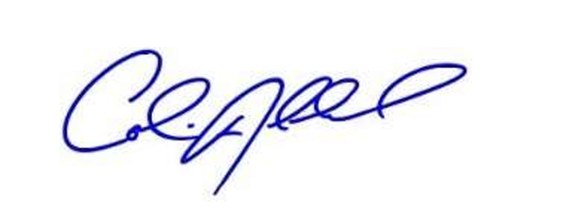  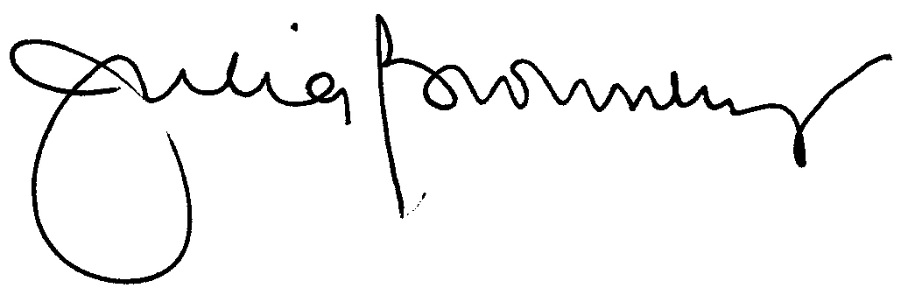  ___________________________  Colin Allred | ___________________________  Julia Brownley
  ___________________________  Salud Carbajal | 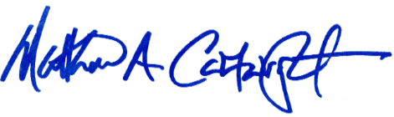  ___________________________  Matt Cartwright
 | 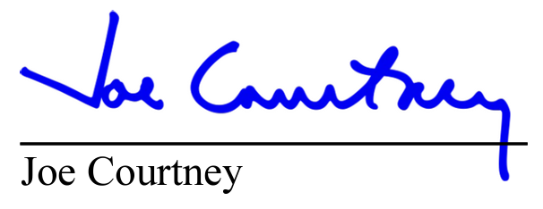
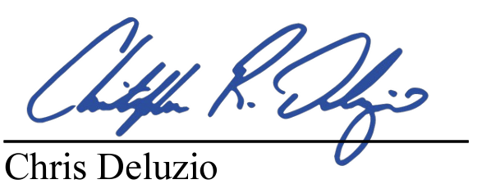 | 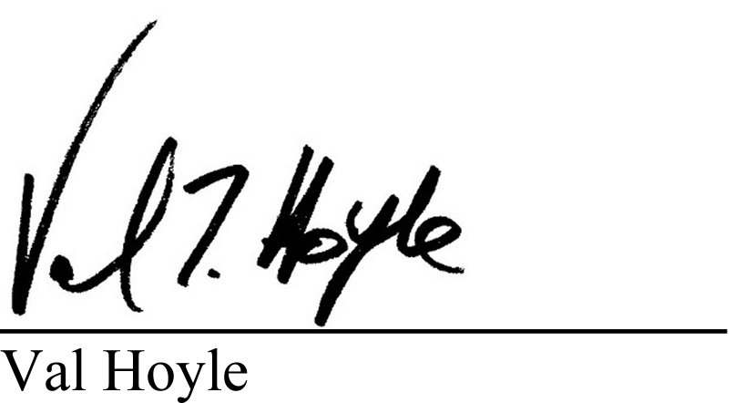
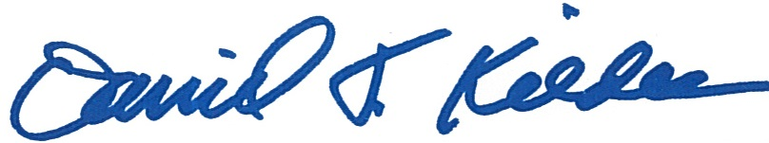  ___________________________  Dan Kildee | 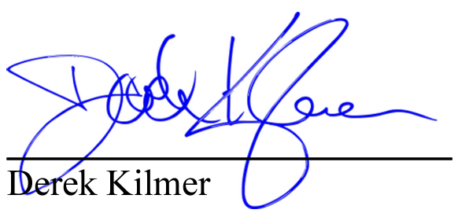
   | ___________________________  Susie Lee

___________________________
Mike Levin

___________________________
Chris Pappas
___________________________  Adam Schiff | ___________________________  Elissa Slotkin
___________________________
Greg Stanton

___________________________
Dina Titus

