Operating Instructions

Operating Instructions

**MAIL-IN SERVICE**

When shipping the unit carefully pack and send it prepaid, adequately insured and preferably   
in the original carton. Include a letter detailing the complaint and provide a day time phone  
and/or email address where you can be reached.

**1X8 HDMI Splitter Over Single Cat5e/6 Cable,   
Up to 50M/164ft. with IR**

**JTD-3198 | JTECH-HDEX1X8P**

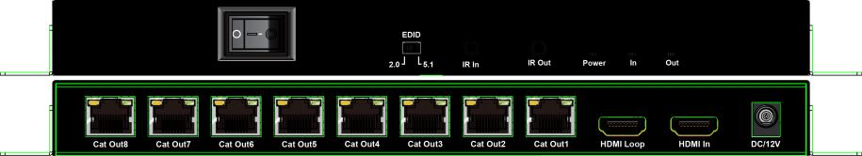**LIMITED WARRANTY LIMITS AND EXCLUSIONS**1) This Limited Warranty ONLY COVERS failures due to defects in materials   
or workmanship, and DOES NOT COVER normal wear and tear or cosmetic damage.  
The Limited Warranty ALSO DOES NOT COVER damages which occurred in shipment, or  
failures which are caused by products not supplied by warrantor, or failures which result from   
accidents, misuse, abuse, neglect, mishandling, misapplication, alteration, faulty installation,  
set-up adjustments, misadjustment of consumer controls, improper maintenance, power line



surge, lightning damage, modification, or service by anyone other than a Factory Service  
center or other Authorized Servicer, or damage that is attributable to acts of God.  
2) THERE ARE NO EXPRESS WARRANTIES EXCEPT AS LISTED UNDER "LIMITED  
WARRANTY COVERAGE". THE WARRANTOR IS NOT LIABLE FOR INCIDENTAL  
OR CONSEOUENTIAL DAMAGES RESULTING FROM THE USE OF THIS PRODUCT,  
OR ARISING OUT OF ANY BREACH OF THIS WARRNTY. (As examples, this excludes  
damages for lost time, cost of having someone remove or re-install an installed unit if  
applicable, travel to and from the service, loss of or damage to media or images, data or other  
recorded content. The items listed are not exclusive, but are for illustration only.)  
3) PARTS AND SERVICE, WHICH ARE NOT COVERED BY THIS LIMITED  
WARRANTY ARE YOUR RESPONSIBILITY.

-Operating Instructions

Operating Instructions

**Notice**

**MAINTENANCE**

Clean this unit with a soft, dry cloth. Never use alcohol, paint thinner of benzine to clean this unit.

**PRODUCT SERVICE**

**1) Damage requiring service:**The unit should be serviced by qualified service personnel if:  
(a)The DC power supply cord or AC adaptor has been damaged;  
(b) Objects or liquids have gotten into the unit;

(c) The unit has been exposed to rain;

(d) The unit does not operate normally or exhibits a marked change in performance;  
(e) The unit has been dropped or the cabinet damaged.  
**2) Servicing Personnel:** Do not attempt to service the unit beyond that described in  
these operating instructions. Refer all other servicing to authorized servicing personnel.  
**3) Replacement parts:** When parts need replacing ensure the servicer uses parts  
specified by the manufacturer or parts that have the same characteristics as the  
original parts. Unauthorized substitutes may result in fire, electric shock, or other hazards.  
**4) Safety check:** After repairs or service, ask the servicer to perform safety checks to confirm that the unit is in proper working condition.

**WARRANTY**

If' your product does not work properly because of a defect in materials or workmanship, our  
Company (referred to as "the warrantor" ) will, for the length of the period indicated as below,  
**(Parts(1)Year)** which starts with the date of original purchase ("Limited  
Warranty period"), at its option cither(a) repair your product with new or refurbished parts, or  
(b) replace it with a new of a refurbished product. The decision to repair or replace will be  
made by the warrantor.

During the "Labor" Limited Warranty period there will be no charge for labor.  
During the "Parts" warranty period, there will be no charge for parts. You must mail-in your  
product during the warranty period. This Limited Warranty is extended only to the original  
purchaser and only covers product purchased as new. A purchase receipt or other proof of  
original purchase date is required for Limited Warranty service.

The information in this document is subject to change without notice. Every effort has been  
made in the preparation of this document to ensure accuracy of the contents, but all statements,  
information, and recommendations in this document do not constitute the warranty of any  
kind, express or implied.

**Features**

>HDM12.0 splitter extender, deep color up to 1080P@60Hz 8bit  
>Distributes I HDMI source to 8 RJ45 output with HDM loop out  
>8 network line will be extended by 50 meters>HDCP1.4 Compliant

>Support LPCM2.0 and Dolby 5.1

>Support Bi-Directional wide band IR control

>Support EDID management

>Support POC (RX powered by TX)

**Package Contents**

>1x JTD-3198-TX & 8x JTD-3198-RX

>1x 12V/3A DC Power Adapter

>1x User Manual

>9 x IR TX cables

>9xIR RX cables

>18 x Mounting ears (2pcs for TX; 16pcs for RX)

Operating Instructions

Operating Instructions

**SPECIFICATIONS**

**The Splitter has to work with Receivers**

|  |  |
| --- | --- |
| Operating Temperature Range | -5 to 40℃（+23 to 104°F） |
| Operating Humidity Range | 5 to 90%RH (No Condensation) |
| Data transfer speed rate | 10.2Gbps |
| Input port | 1xHDMI |
| Output ports | 8xRJ45 output port,1xHDMI loop out |
| Output Video Format Supported | DTV/HDTV:720P/1080i/1080P |
| Transmission Distance | 50m at 1080P@60Hz |
| Power consumption | 25W(Maximum) |
| Dimensions (LxWxH) | TX:114.15mmx252.73mmx25.13 RX:83.92mm x 75.2mm x 23.1mm |
| Net Weight | TX:1000g RX:2400g（8pcs） |

**Connection Diagram**

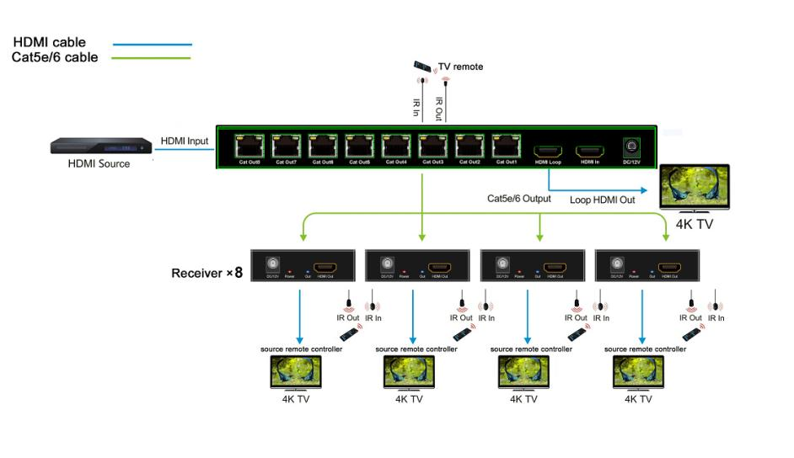

**Connecting and operating**

1) Connect the HDMI input sources to the HDMI Splitter.

2) Connect HDMI receiver over Cat5e/6 cables to the RJ45 port of both HDMI Splitter and Receiver. The RJ45 connections must follow EIA-TIA 568b standards.

3) Connect the HDMI output from the Receiver (RX) into the display HDM1 input.

4) Plug the IR TX and IR RX cables into the matching IR ports of the splitter.

5) Plug the IR TX and IR RX cables into the matching IR ports of the receiver.

6) Power on the source and display.

Operating Instructions

Operating Instructions

**Receiver Panel Description**

**Transmitter Panel Description**

**Front Panel**

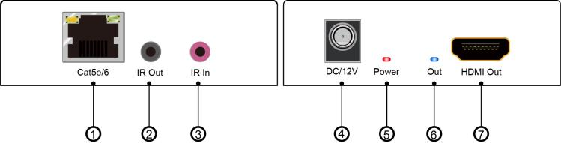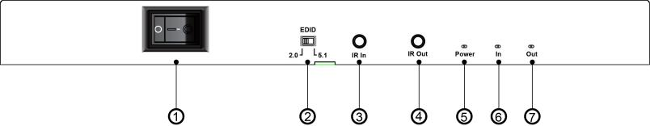

① Power on/off: press the up/down to open/close the device.  
② EDID dip switch

① Cat5e/6 input port

② IR out port

③ IR in port

④ DC 12V power input port

⑤ Power input indicator

⑥ HDMI out indicator

7.HDMI output port

③ IR in port

④ IR out port

⑤ Power input indicator  
⑥ indicator of HDMI input  
⑦ indicator of HDMI output

**Rear Panel**

**EDID Switch Settings：**

This splitter support EDID management through a 2-pin dip switch:

|  |  |
| --- | --- |
| Turn left: | Default（1080P60-2.0 2ch） |
| Turn right: | Default（1080P60-5.1 6ch） |

1. 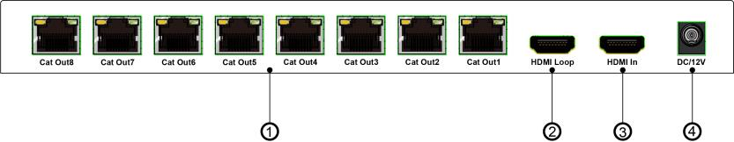Cat5e/6 output 1~8 ports
2. HDMI loop out port  
   ③ HDMI input port  
   ④ DC 12V power input port