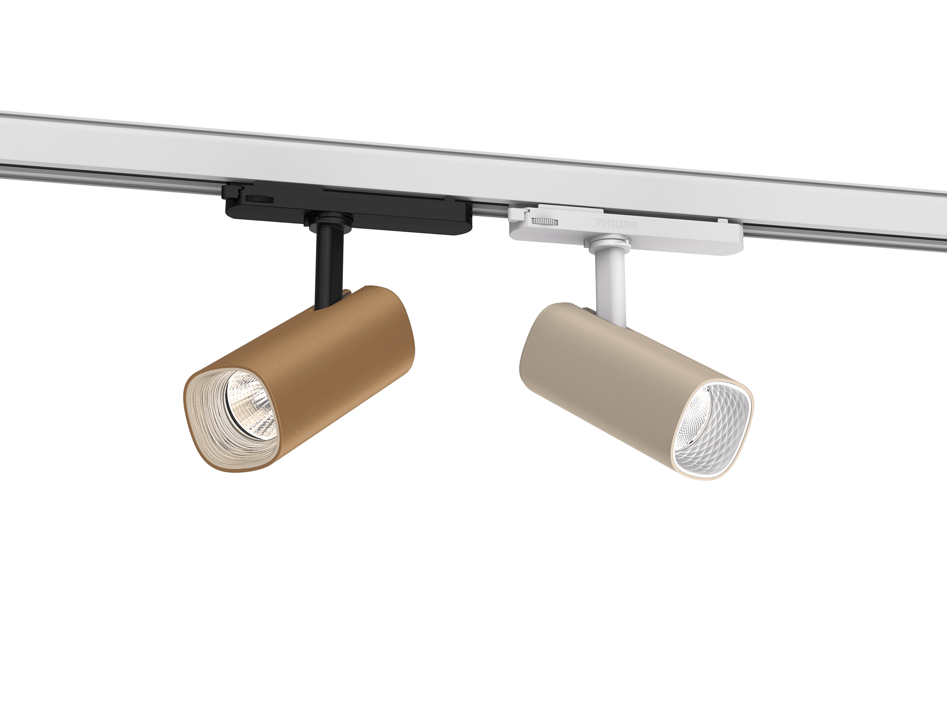


Smooth Track

Description
The myCreation Smooth Track is a modular LED spotlight designed for track-mounted accent lighting applications in retail, hospitality, and residential environments. It combines high lighting performance, design flexibility, and circular sustainability principles.
The 3D printed housing is crafted from at least 65% recycled or bio-circular materials, while the heatsink is made from 85% recycled aluminum. Because of its circular design, the luminaire is upgradable, reusable, serviceable, and recyclable, making it a true game-changer in the world of lighting design.
USP
- Various light recipes to choose from - 3000K, 4000K, Premium White, Premium Color
- Wide range of beam angles to choose from
- Option for Collimator Optics for precise beam control
- Rich pallet of housing colors and Textures - Standard & On demand
- Textured front rings for the luxurious effect
- Different Driver options – Non Dimming / DIA (Dali interact Dimming / WIA (Wireless interact dimming)
- Housing made from at least 65% recycled or bio-circular materials
- Heatsink made from 85% recycled aluminum
- Interact ready
- Bio-circular materials are ISCC Plus certified
- EPD document available (Environmental Product Declaration)
- SDCM Light Source < 3 2
The Projector complies with the following standards:
- CE marked
- RoHS

Specifications:
- Efficacy up to 132 140 lm/W
- Option for CRI80 or CRI90
- Lumen 1000 - 2200 lm
- Lifetime: 100,000hrs to L80 @ 25°C Ta
- IP20 / IK02
- Electrical Class II
- Ambient range: +10°C to +35°C
- Glow wire test 650°C
- 5-year warranty
- Driver Failure Rate <1% @ 5,000 hrs
- Color temperature: 3000K / 4000K
- Binning: CRI80 SDCM<3 2 and CRI90 SDCM<3 2

Schematic light drawing
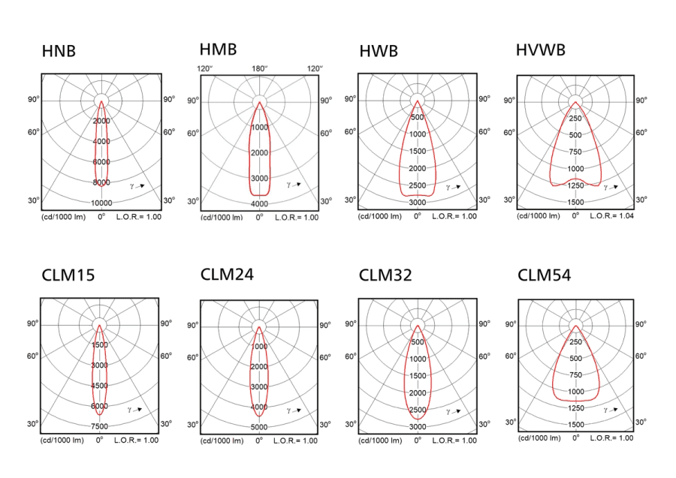
Dimensional drawing
