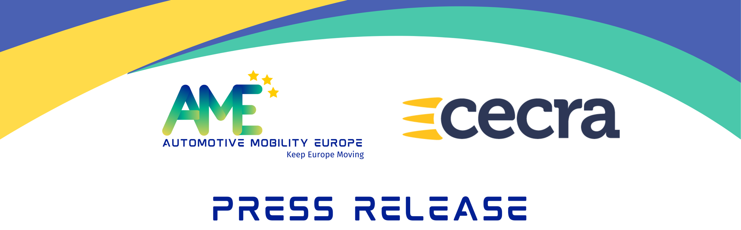

25th September, 2025

CECRA and Automotive Mobility Europe (AME) decided to join forces to represent the automotive and mobility services in Brussels

The members of CECRA unanimously approved, during their General Assembly on 24th September in Budapest, the launch of a merger process with Automotive Mobility Europe (AME), a European association founded in 2025 by eight national associations representing the automotive services sector in Europe. AME is co-chaired by Xavier Horent, from Mobilians (France), and Jürgen Hasler, from the German Federation of Motor Traders and Repairers (ZDK) (Germany). CECRA, originally founded by France and Germany and chaired by Peter Daeninck, is an integral part of the heritage of automotive services. In parallel, the General Assembly of AME also decided to prepare for this merger, marking a joint and strategic commitment to building a unified European voice for the sector.
Following this General Assembly, Automotive Mobility Europe (AME), will become the representative body of the sector in Brussels and the key interlocutor for public decision-makers and stakeholders in the automotive industry. AME is accredited by the European Commission's transparency register.
As the automotive sector undergoes unprecedented transformations, and with an increasingly complex automotive market, companies in the automotive and mobility services sector need a united and strong representation more than ever, along with collective mobilization from professionals.

The goal of the new association, now supported by all European countries following the confirmation of CECRA’s integration, is to engage in high-level dialogue with European decision-makers and other stakeholders in the sector, including manufacturers, suppliers, consumer associations, and environmental organizations.
With this integration and wide representation, Automotive Mobility Europe will have greater influence to represent the sector’s interests and ensure its legitimacy and the effectiveness of its actions.
AME is based on two essential pillars: on one hand, representation by national associations, and on the other, European associations in the automotive aftermarket sector.
Keep Europe moving!

Eight founding members of « Automotive Mobility Europe » : AKL (Finland), ARAN (Portugal), AutoBranchen (Denmark), BOVAG (Netherlands), GANVAM (Spain), Mobilians (France), Traxio (Belgium), ZDK (Germany).

About Automotive Mobility Europe
Founded in 2025, the European association Automotive Mobility Europe (AME) represents authorized vehicle dealers, independent repairers, service stations, the recharging network of electric vehicles, vehicles recyclers and all services related to the automotive aftermarket. The sales and maintenance sector accounts for 4.5 million jobs in the EU. With great care for customer service and expertise, we are the direct link to the consumers and are the key factor to push sustainable mobility.

About CECRA
CECRA - the European Council for Motor Trades and Repairs – is a European association of the motor trade and repair sector, representing the interests of franchised dealers/agents of passenger cars and trucks, authorised repairers and independent repairers. In 2025, CECRA initiated the merger process with Automotive Mobility Europe, in support of a unified representation in Brussels.

