HEADLINE POSTS

- Start a little chat with a huge impact.

- Find the best way to get people you’re worried about, talking.

Social Copy:

<MGH SUPPORTER TO INSERT>

CARD NO. 11 and 22

Social Post Copy:

No matter where you sit in the whānau, your love and support are important. If someone you care about is stressed about their gambling, be the one who reaches out to help. Use these free Kōrero cards to guide you. Download your free set here.

https://www.safergambling.org.nz/safer-gambling/sharing-and-talking

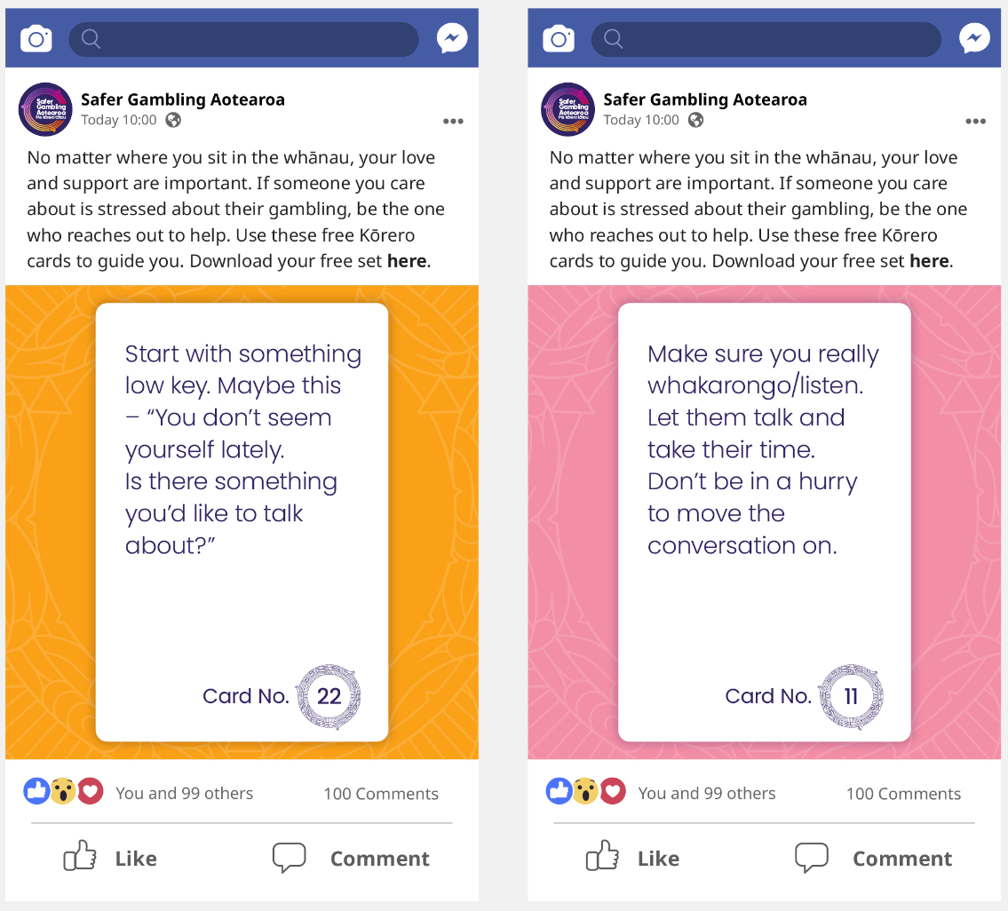

CARD NO. 4 and 31

Social Post Copy:

Remember, it doesn’t have to be a serious sit-down to be helpful. Keeping things
relaxed and low key will make it easier for them and you. Our Kōrero cards show you how.
Download your free set here.

https://www.safergambling.org.nz/safer-gambling/sharing-and-talking

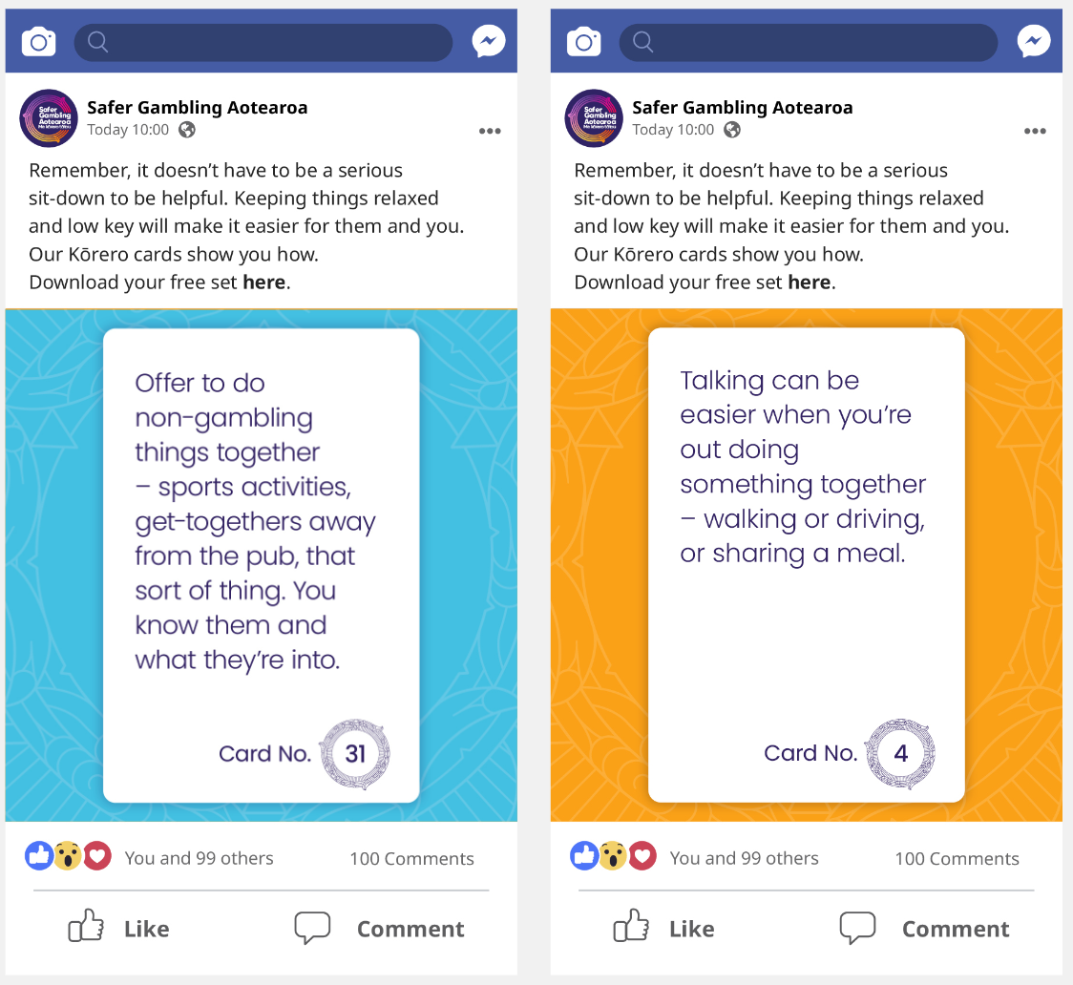

CARD NO. 17 and 26

Social Post Copy:

Let’s come together, all of us, to listen to and support those we know are having issues with their gambling. Our Kōrero cards will help get them to open up and start talking about it.
Download your free set here.

https://www.safergambling.org.nz/safer-gambling/sharing-and-talking

