What does Vayikra Rabbah 37:2 compare giving tzedakah to? Lending to Hashem
Tzedakah is only about giving money. FALSE
According to Vayikra Rabbah 37:2, what is the MAIN reason we give tzedakah? Because it’s like lending to Hashem
Why does the Midrash say giving tzedakah is like "lending to Hashem"? Because helping others is like doing a favor for Hashem
Judaism teaches that tzedakah is optional, not a commandment. FALSE
What is the main message of Vayikra Rabbah 37:2 about tzedakah? Giving to the poor is like helping Hashem
Which of these is NOT a form of tzedakah? Ignoring someone in need
The Midrash teaches that Hashem will repay those who give tzedakah. TRUE
What is the Hebrew word for charity/commandment to give? Tzedakah
If you see a classmate who forgot their lunch, what’s a way to practice tzedakah? Share your food
Why do the Torah and Midrash emphasize giving tzedakah? To fulfill Hashem's commandment and create a just society
Based on Vayikra Rabbah 37:2, which scenario BEST demonstrates the concept that tzedakah is "like lending to Hashem"? David anonymously donates his allowance to a food pantry.

Instructions for Uploading to Quizlet
- Log in to your account and click on your class
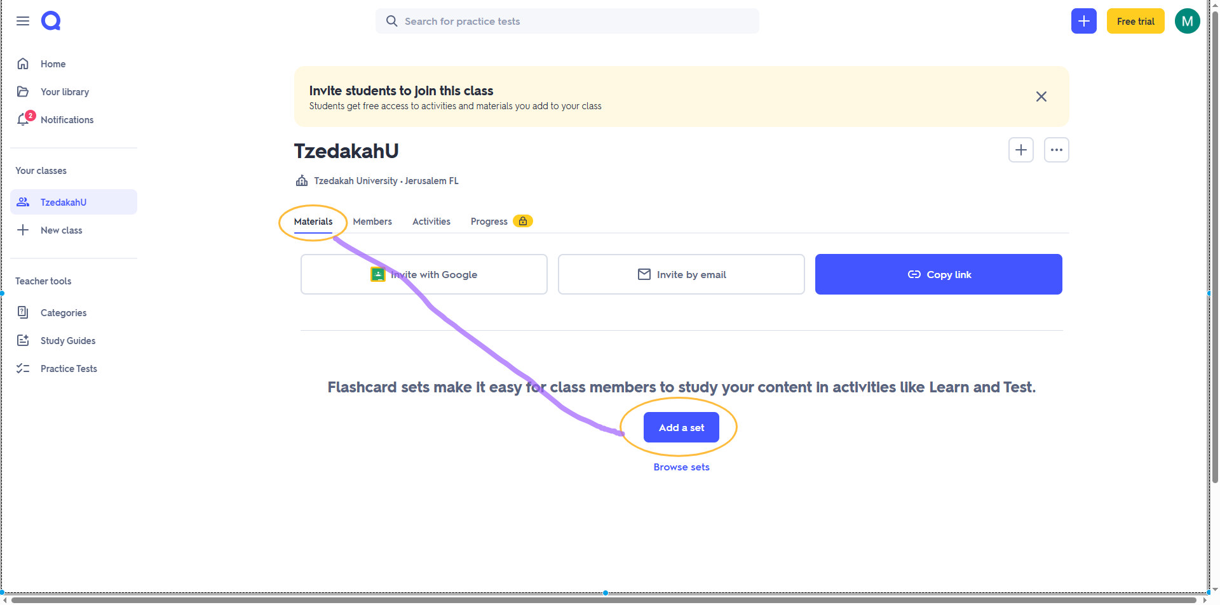
- Click Materials and then Add a set


- Create new

- Give your set a name and description, then click +Import

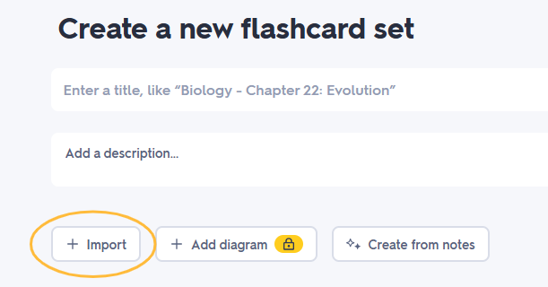

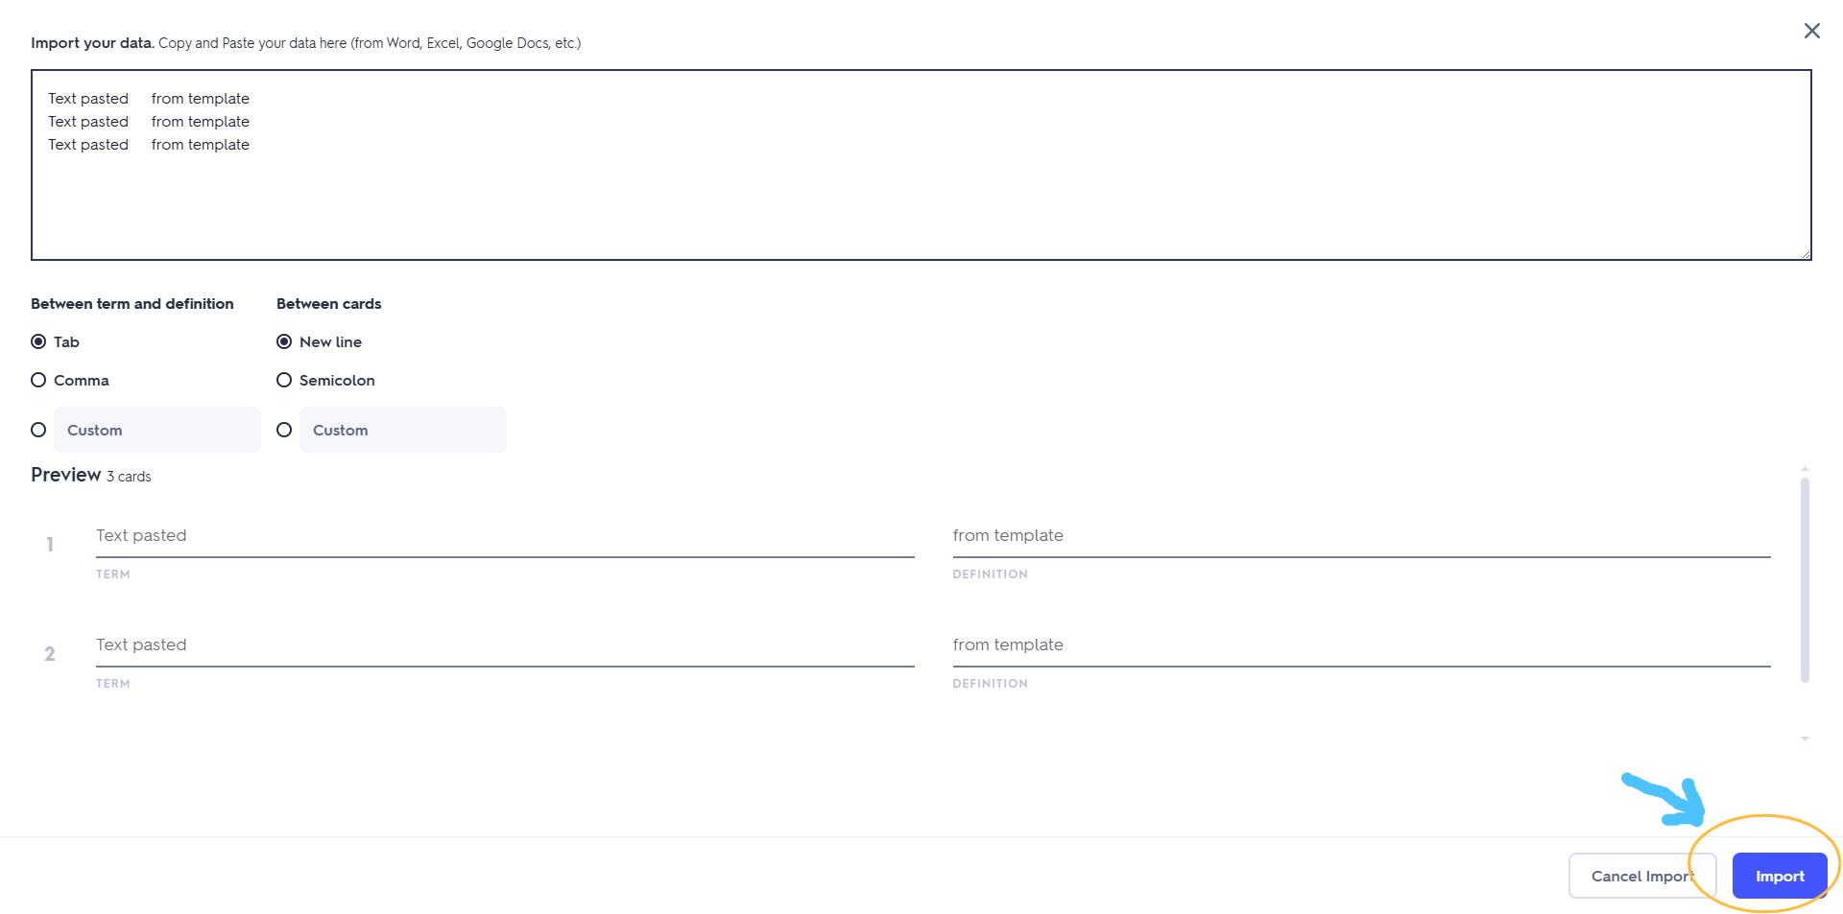
- Cut and paste the text above into the box provided (leave all the default settings as is), check that the preview looks correct and click import

- If all looks good, click Create in the lower left corner

