Instructions for Uploading to Kahoot

- Download the file for your class than ends in KAHOOT.xlsx
- Log in to your account
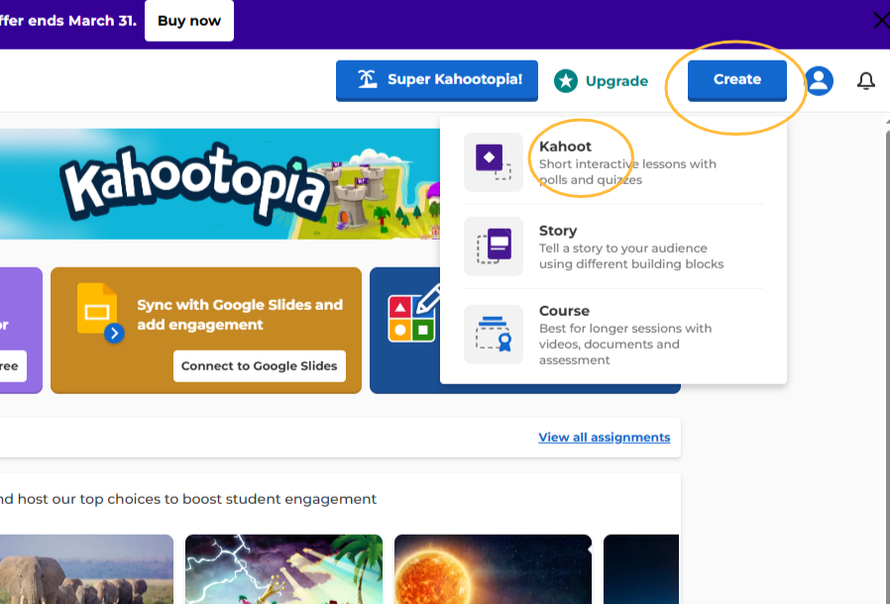
- Click Create and then Kahoot

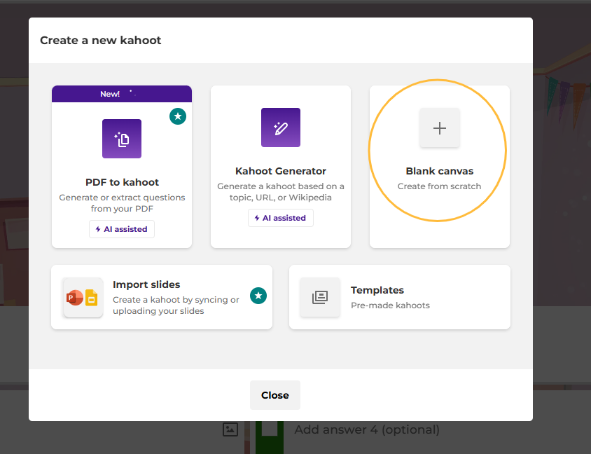
- Choose Blank Canvas

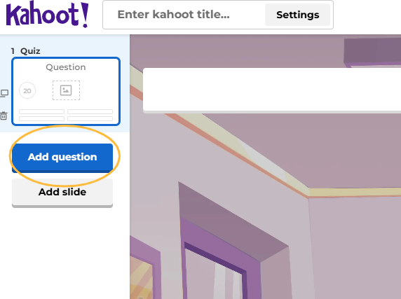
- Click Add question

- Click Import spreadsheet

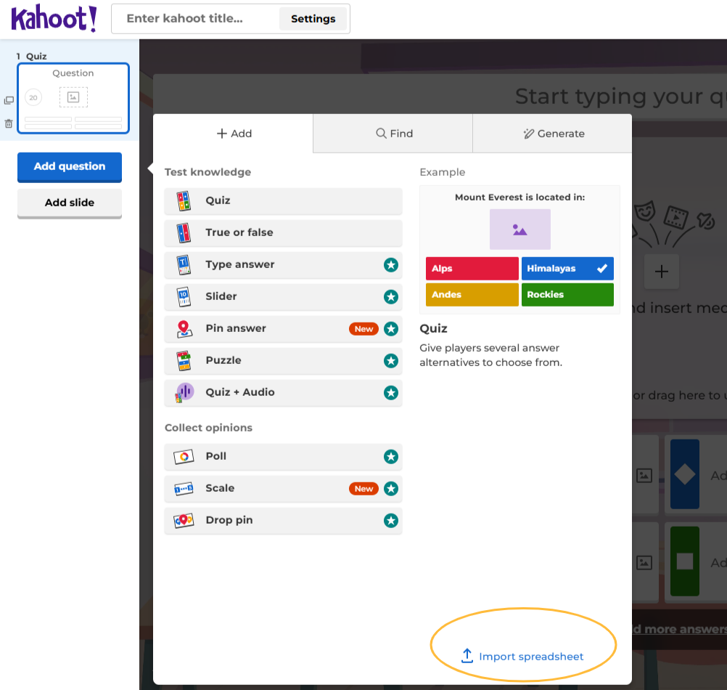

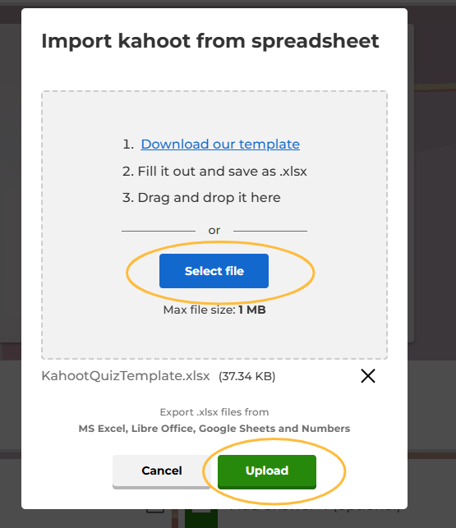
- Select the file you downloaded earlier and Upload

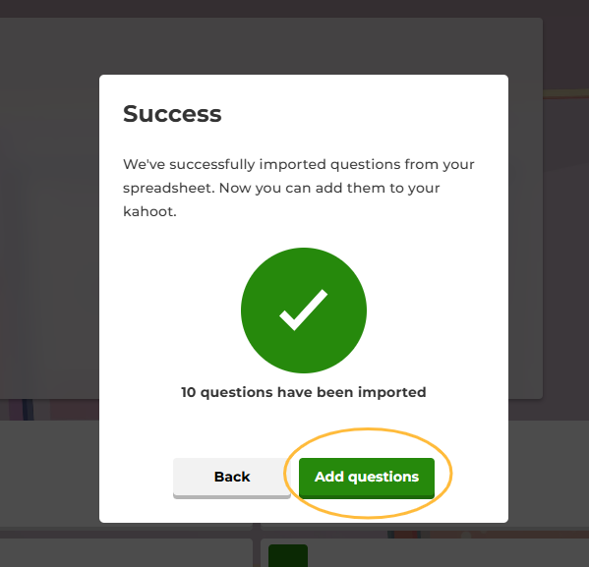
- Click Add questions

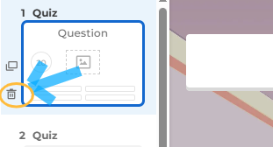
- Delete the first question. It is usually blank and just a placeholder.

- Save and give it a title. You are now ready to play

