Who gave tzedakah before doing justice? Abraham
Who listened to both sides before giving tzedakah? David
What does 'tzedakah' mean? Charity or righteousness
What was special about Abraham’s way of helping people? He gave before judging
What was special about David’s way of helping people? He judged before giving
Which person used their own money to help people in both stories? Both Abraham and David
What did Abraham do if no one owed money? He said: Split what you have and go in peace
What did David do after hearing both sides of a case? He gave his own money to the person who won the case
Why is Abraham's way considered generous? Because he gave without waiting to judge
Why is David's way considered fair? Because he made sure to listen first
How can we be like Abraham or David today? By helping others with kindness and fairness
What is one thing both Abraham and David cared about? Helping people

Instructions for Uploading to Quizlet
- Log in to your account and click on your class
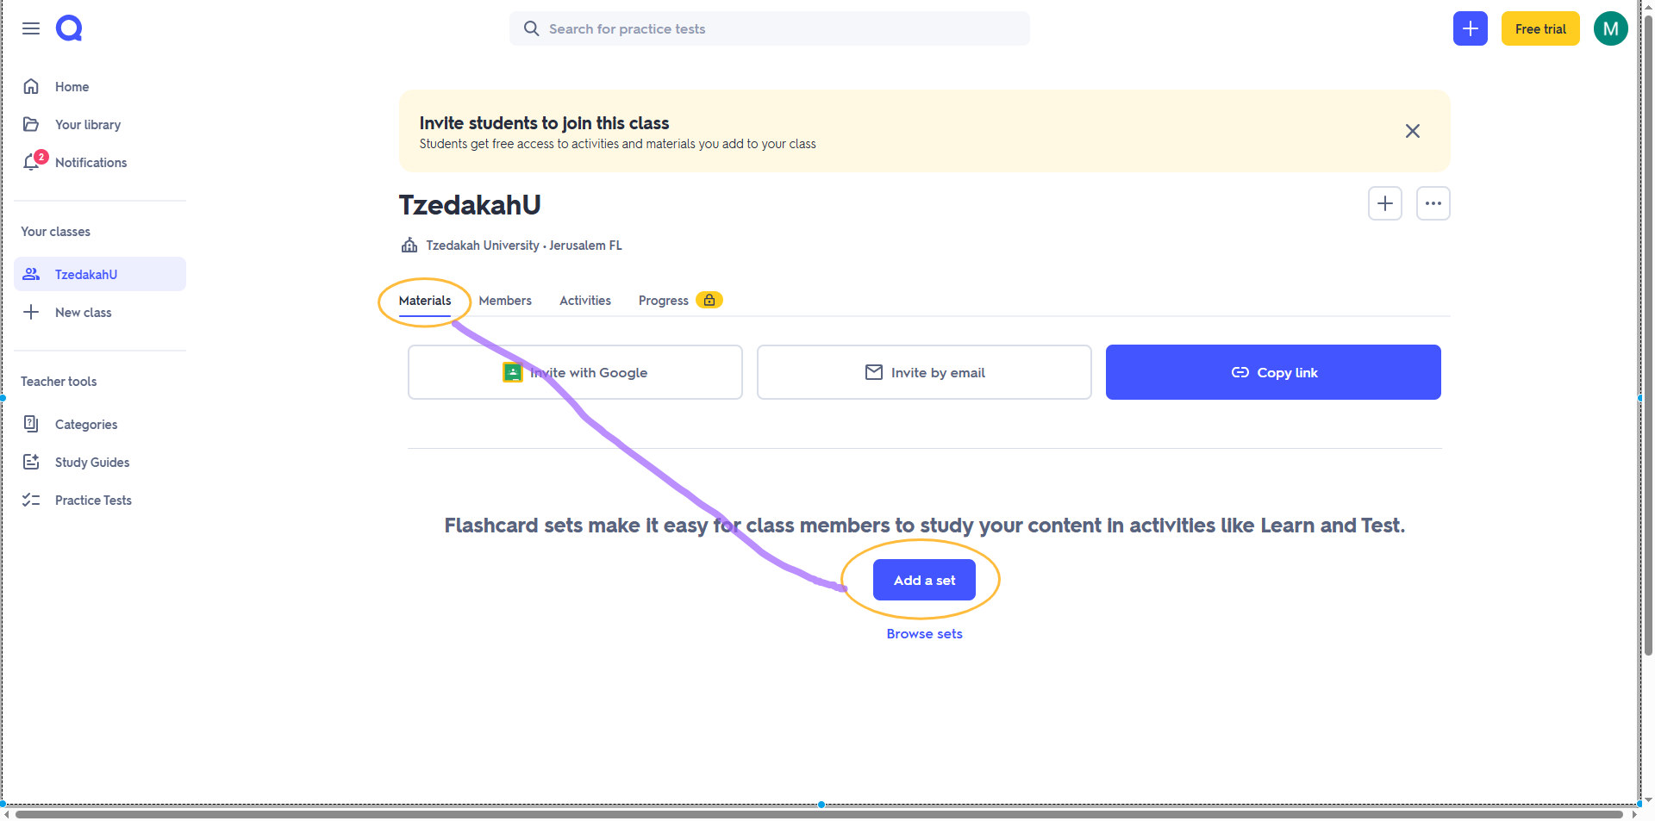
- Click Materials and then Add a set


- Create new

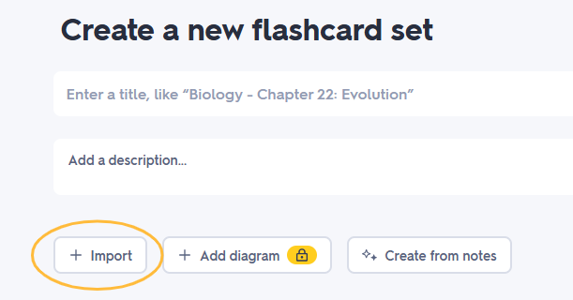
- Give your set a name and description, then click +Import

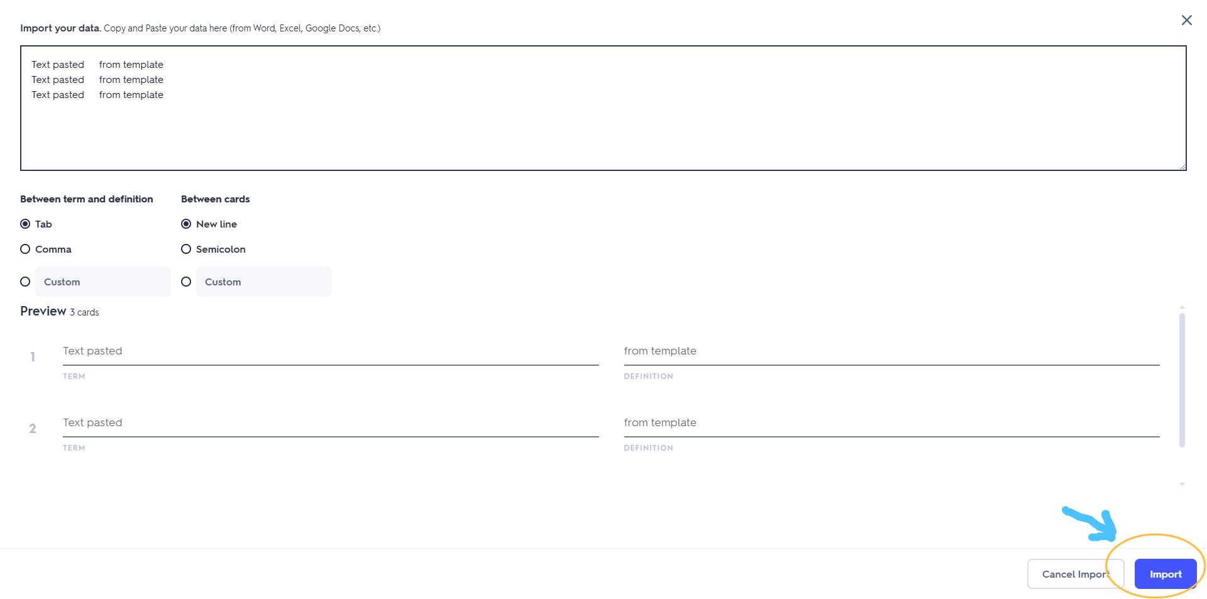
- Cut and paste the text above into the box provided (leave all the default settings as is), check that the preview looks correct and click import

- If all looks good, click Create

