Instructions for uploading to Blooket:

- Download the file for your class than ends in BLOOKET.xlxs as a CVS File
- Log in to your account
- Click Create
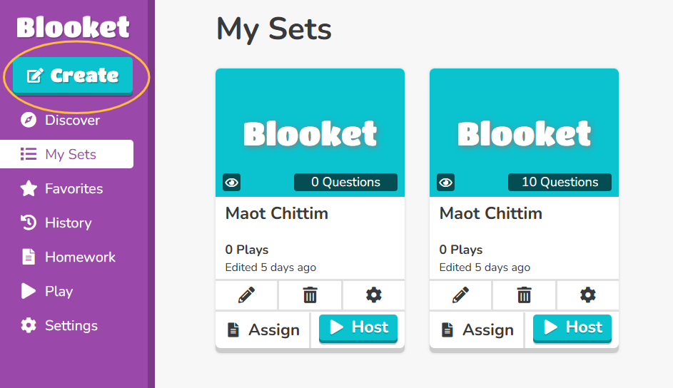

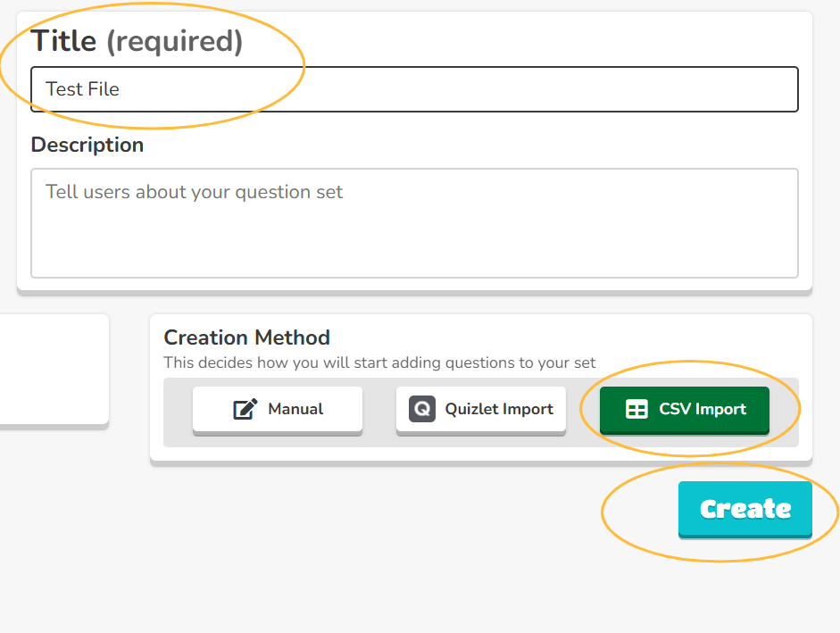
- Add a Title (you can also add an image and description at this point), Click CSV and then Create

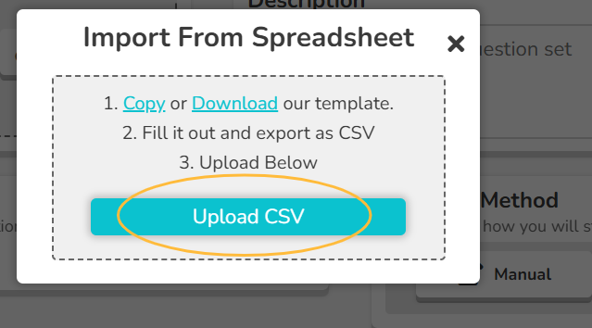
- Upload the file you downloaded earlier.

- If all looks good, click Save.

