What do the letters gimmel and dalet stand for in the Talmudic interpretation? Give to the poor
Why is the leg of the gimmel extended toward the dalet? To show the giver should pursue the poor
Why does the dalet face slightly away from the gimmel? To protect the dignity of the recipient
What value were we learning about today? צדקה
How should charity be given, according to the Talmud? Discreetly and respectfully
What does the word 'דלים' mean? The poor
What is the purpose of giving charity discreetly? To avoid embarrassing the recipient
According to the Talmud, how should the giver act? They should actively pursue opportunities to give
Which of the following best reflects 'גמול דלים'? Helping those in need
Why should a poor person reach toward the giver? To make themselves available to receive
What kind of giving is most respected in Jewish tradition? Giving that maintains the dignity of the recipient
What does the Talmud teach about young students’ interpretations? That they can uncover deep Torah insights

Instructions for Uploading to Quizlet
- Log in to your account and click on your class

- Click Materials and then Add a set


- Create new


- Give your set a name and description, then click +Import

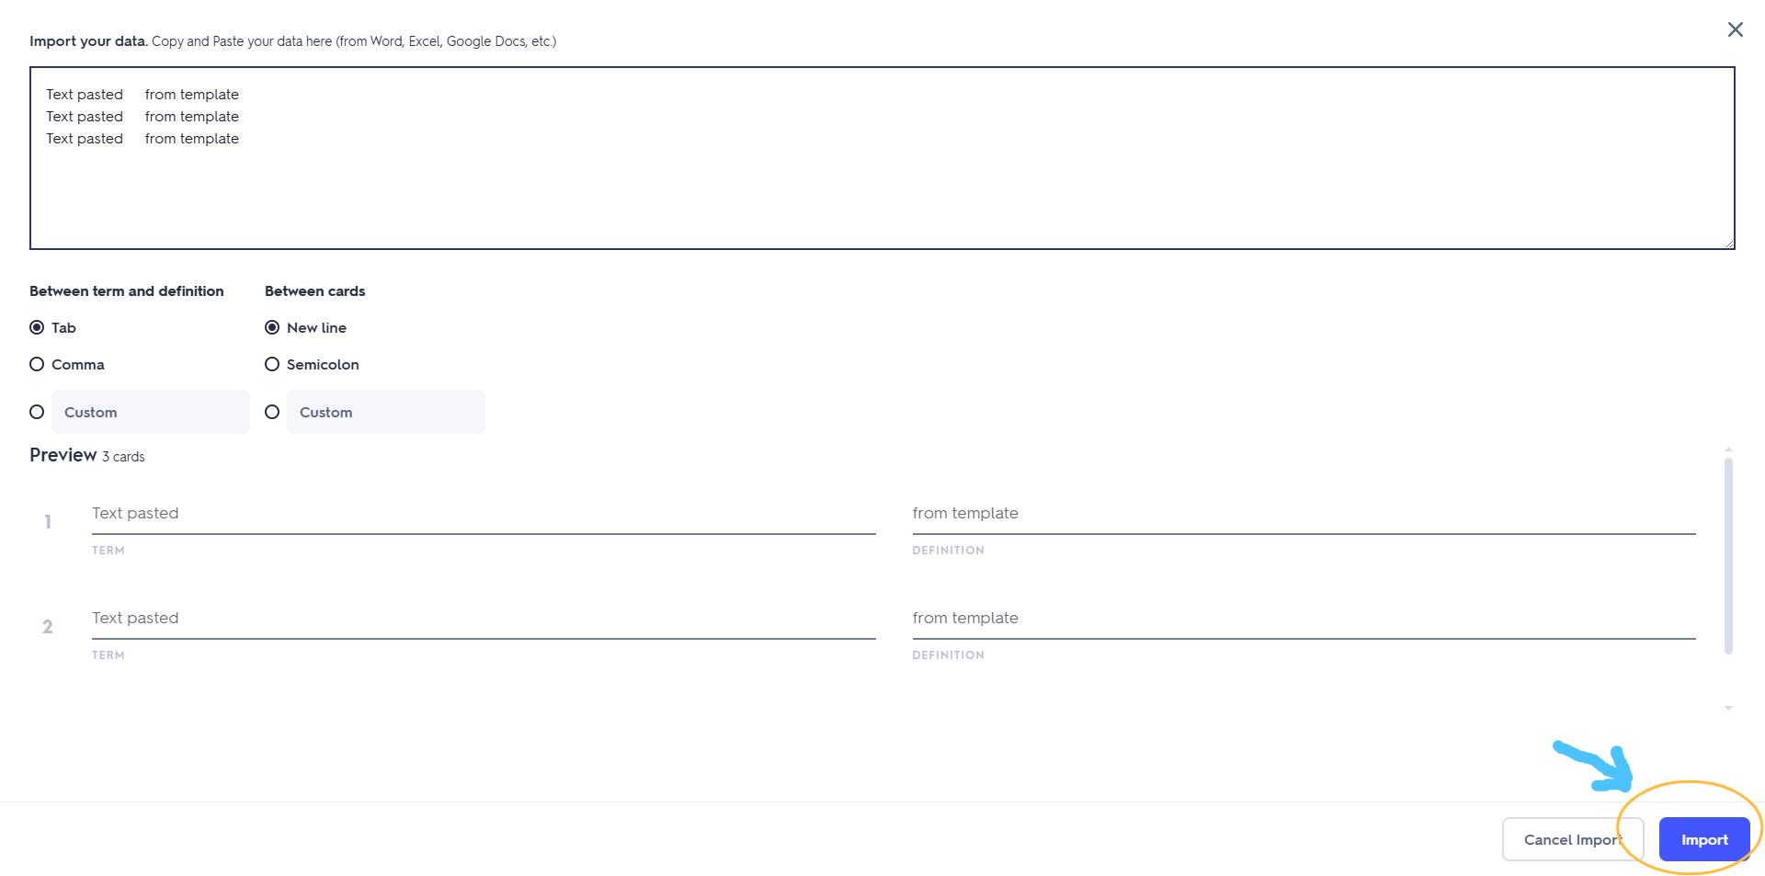
- Cut and paste the text above into the box provided (leave all the default settings as is), check that the preview looks correct and click import

- If all looks good, click Create

