Maot Chitim is given out before which Yom Tov (Holiday)? Pesach
If you lived in a city for this many months, you must give Maot Chittim 12
Maot Chittim means: Money for wheat
The best way to give Tzedakah is: Secretly
Can food be given for Maot Chittim? Always
What Mitzvah are you doing when you give Maot Chittim? Tzedakah
Why do we give Maot Chittim? To enable everyone to celebrate Yom Tov
What does Tzedakah mean? Justice
Where do we find the Mitzvah of Tzedakah in the Torah? Devarim
What can people buy with Maot Chittim? Whatever they need. There are no restrictions

Instructions for Uploading to Quizlet
- Log in to your account and click on your class
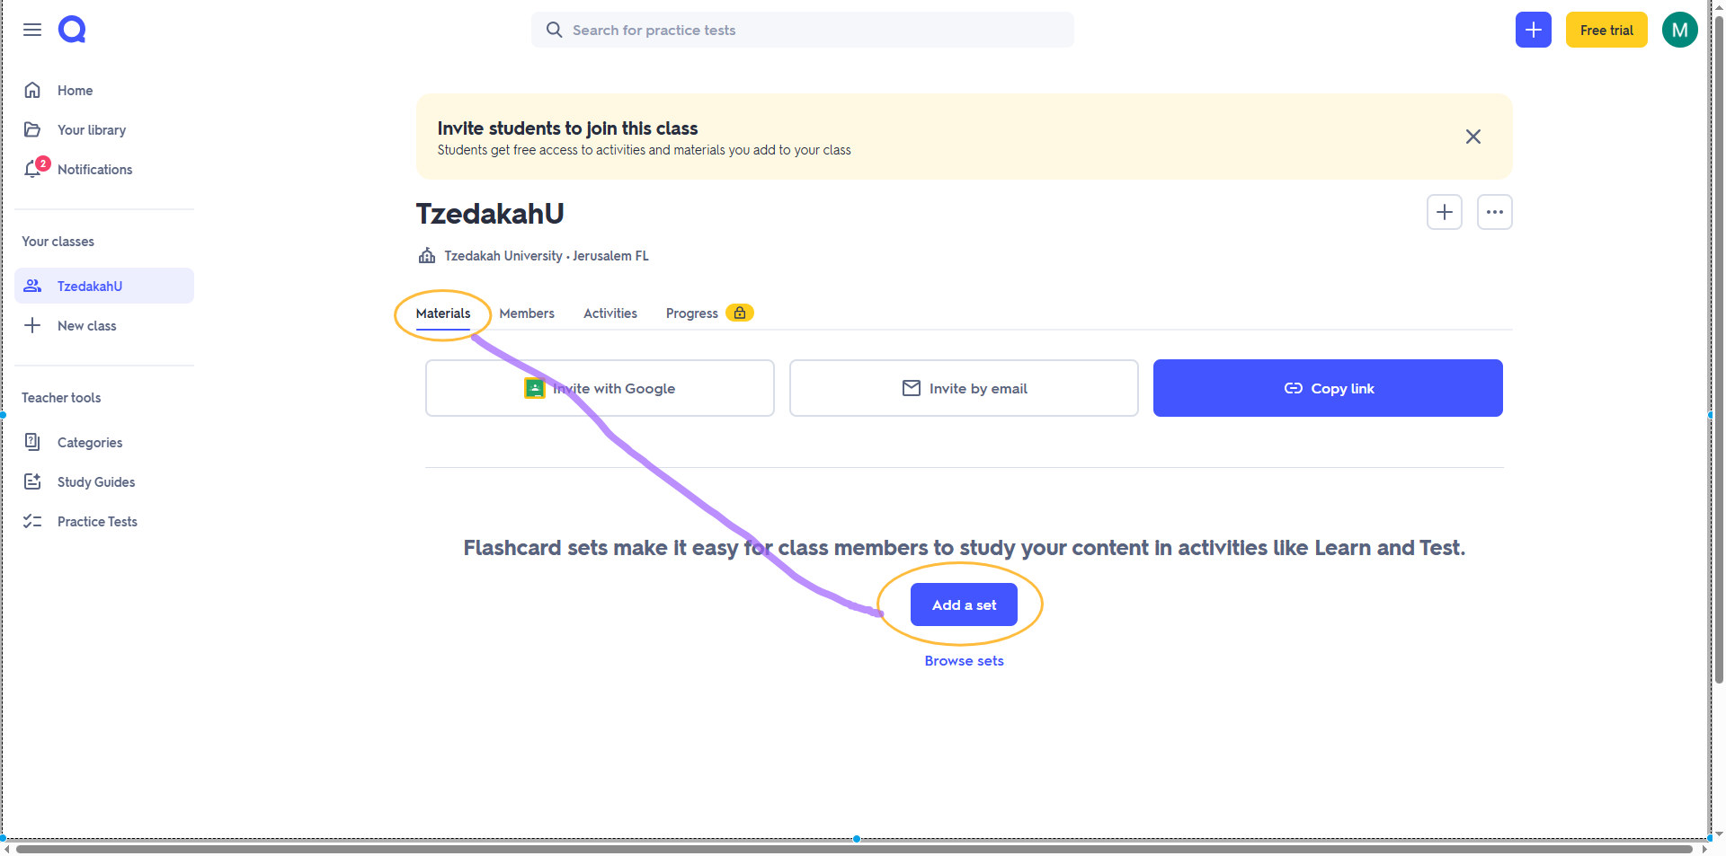
- Click Materials and then Add a set

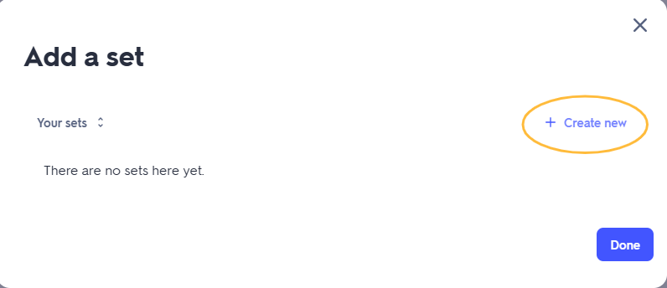
- Create new

- Give your set a name and description, then click +Import
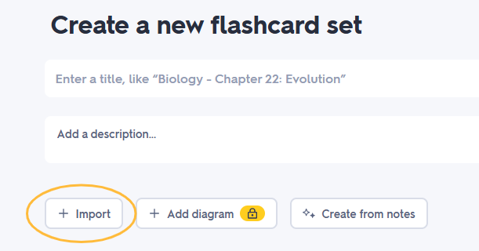

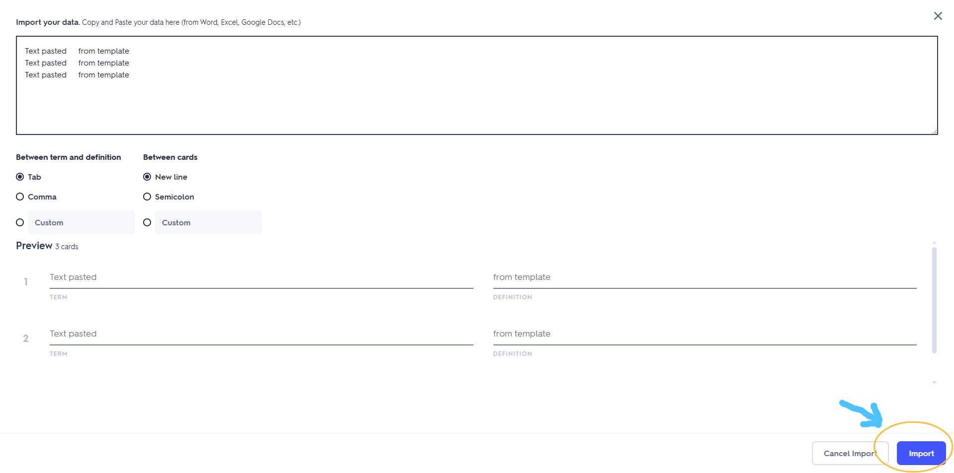
- Cut and paste the text above (as is) into the box provided (leave all the default settings), check that the preview looks correct and click import

- If all looks good, click Create

