What was the name of the chamber in the Beit Hamikdash where people gave charity anonymously? Lishkat Chashaim
Why did people give anonymously in the Beit Hamikdash? To protect the dignity of both giver and receiver
What is one benefit of giving tzedakah anonymously? It shows true kindness without seeking praise
Which Jewish value is shown when we protect someone’s dignity? Kavod HaBriyot
What does 'tzedakah' mean? Justice or righteousness
How were the poor helped in the Chamber of Secrets? They took what they needed without knowing who gave
What kind of giving does the Mishnah in Shekalim 5:6 describe? Anonymous giving
Why is it good not to know who gave or received tzedakah? It keeps everyone’s dignity safe
Which mitzvah are we learning about in this lesson? Giving tzedakah
Which of these is a modern way to give anonymously? Donating online without your name
What do we learn from the Beit Hamikdash’s example? We should give in a way that respects others
How can YOU give tzedakah in a respectful way? Give secretly or without making someone feel bad

Instructions for Uploading to Quizlet
- Log in to your account and click on your class
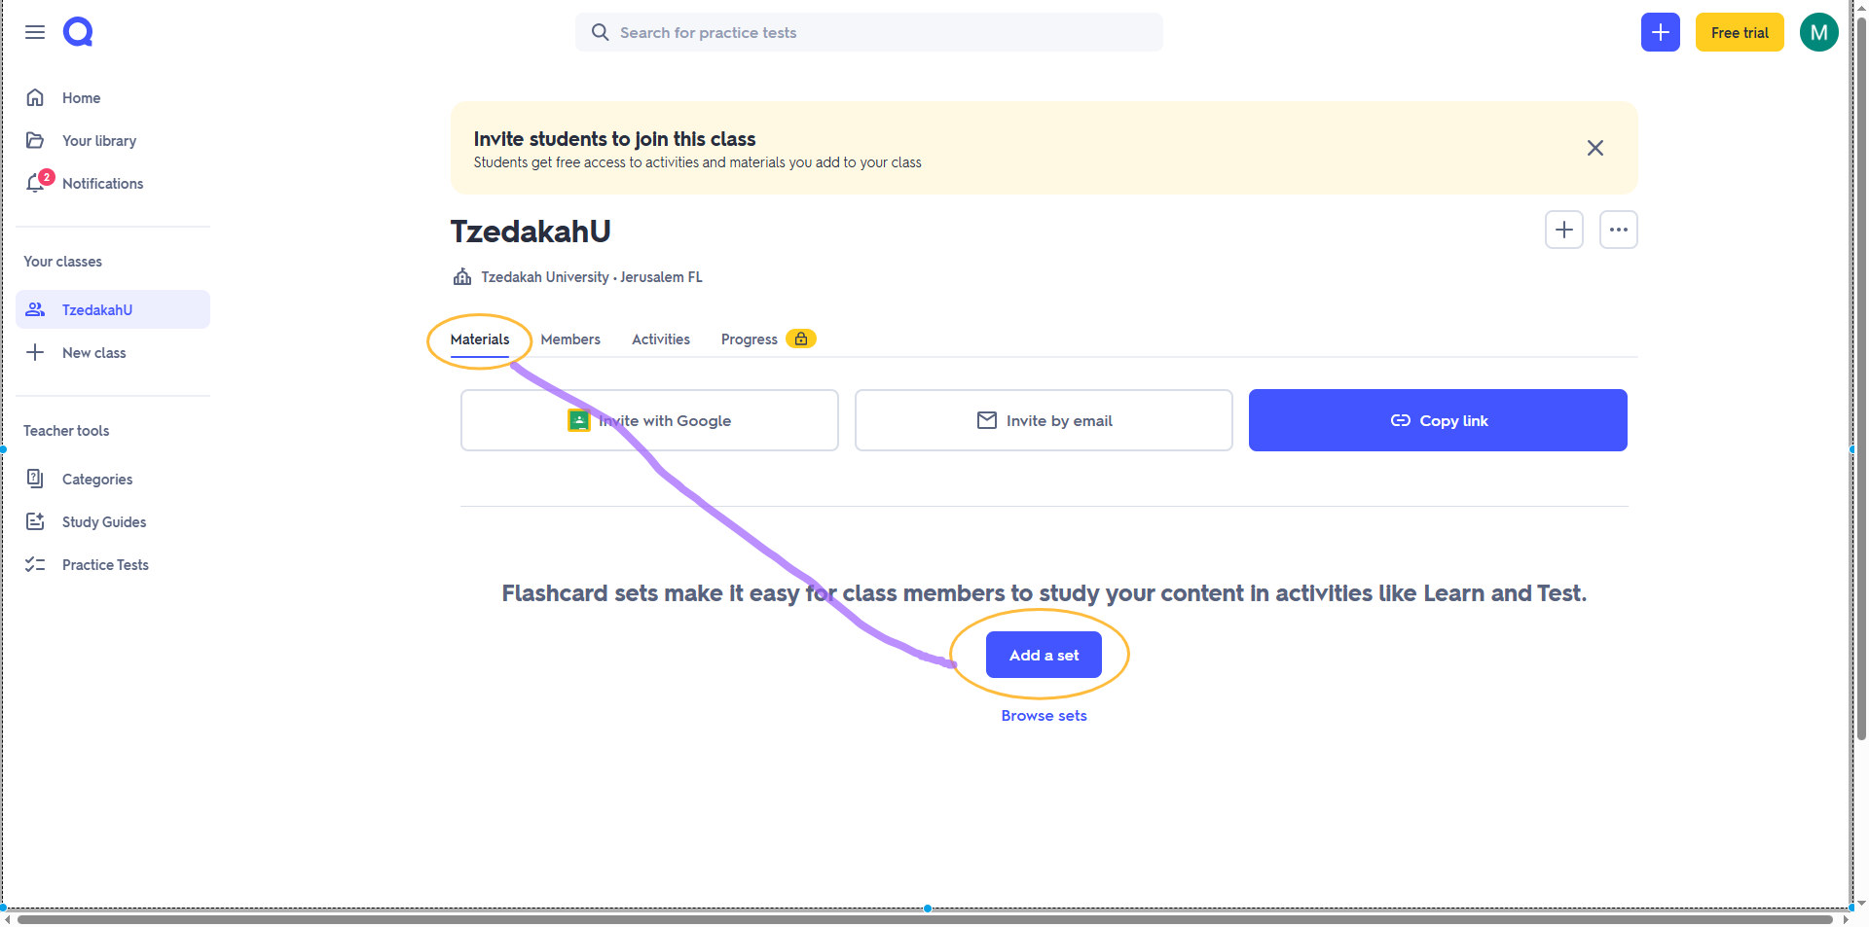
- Click Materials and then Add a set

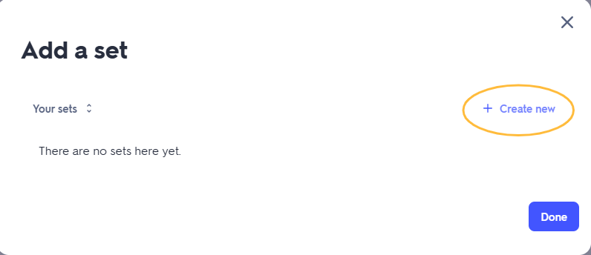
- Create new

- Give your set a name and description, then click +Import
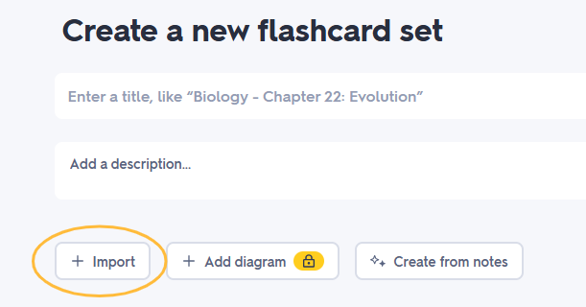

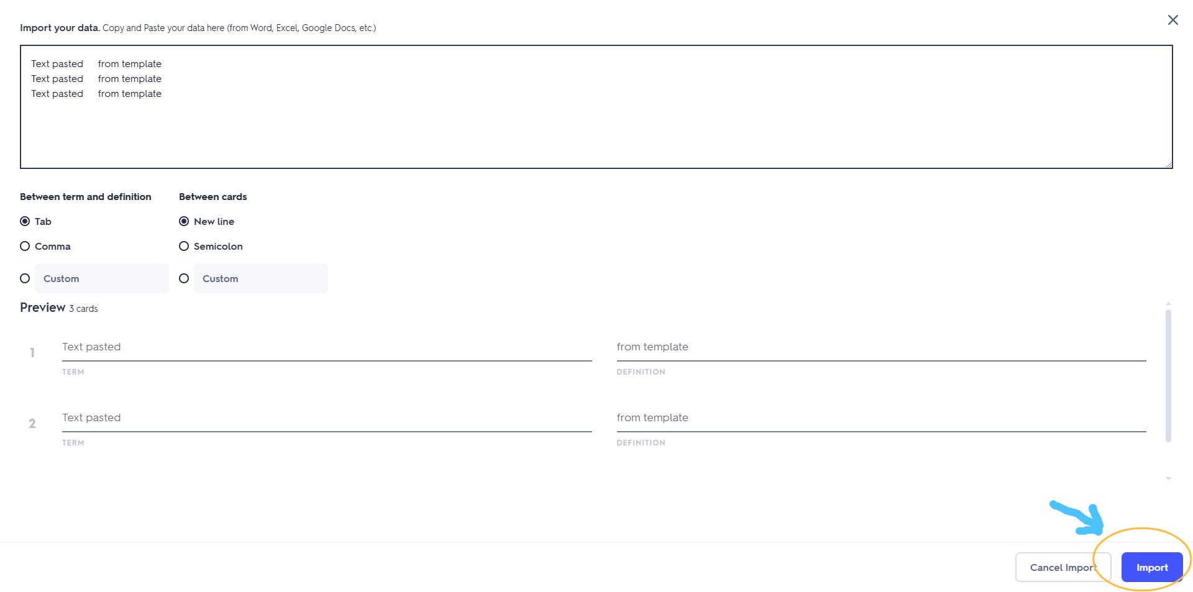
- Cut and paste the text above into the box provided (leave all the default settings as is), check that the preview looks correct and click import

- If all looks good, click Create

