What is the main topic of Ketubot 48a? Obligations to support one's wife or dependents
When can a court step in to provide support from someone’s assets? When the husband is absent or mentally incapable
What is a central halachic value learned from this sugya? Preserving dignity and avoiding disgrace
What case does the Gemara bring about someone who lost mental capacity? We use his property to support his wife and children
How does the Gemara support acting on behalf of someone who became insane? By citing Rav Amram/Mar Ukva’s statement
What is one condition that allows the court to distribute funds from someone's estate? That it's for the purpose of essential needs
According to halacha, what is considered a basic need that justifies taking money from someone’s estate? Food and dignity-preserving support
Why is jewelry sometimes allowed to be bought for a woman from her husband’s assets? Because it's part of her dignity
Why does Rashi say we act even if the husband didn’t command support? We assume he would not want her to be degraded
What debate is reflected in the reversed version of the sugya Whether jewelry or charity is more essential
What modern value can students learn from this sugya? Preserving human dignity is a core Jewish principle

Instructions for Uploading to Quizlet
- Log in to your account and click on your class
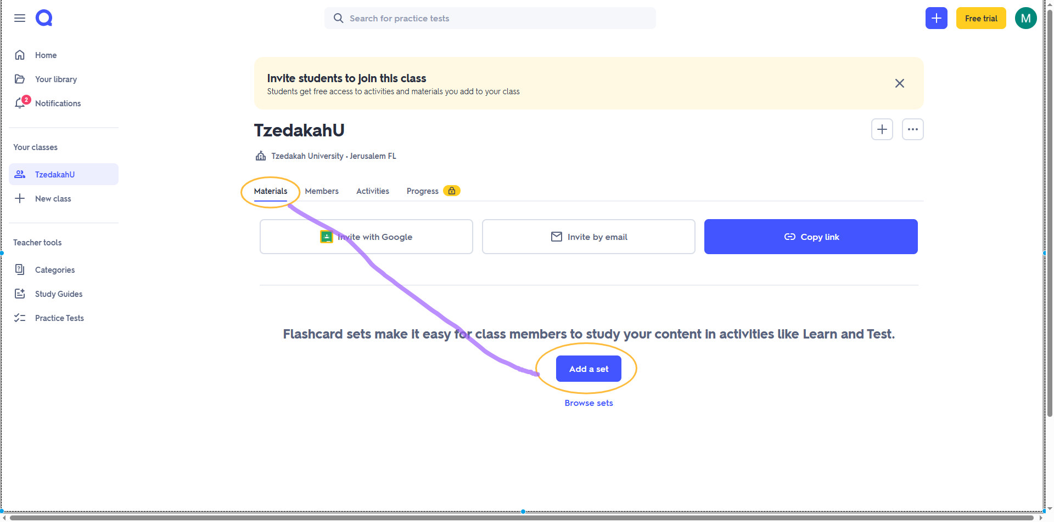
- Click Materials and then Add a set


- Create new

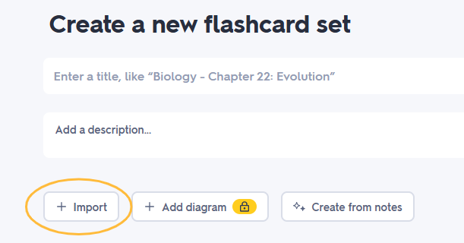
- Give your set a name and description, then click +Import

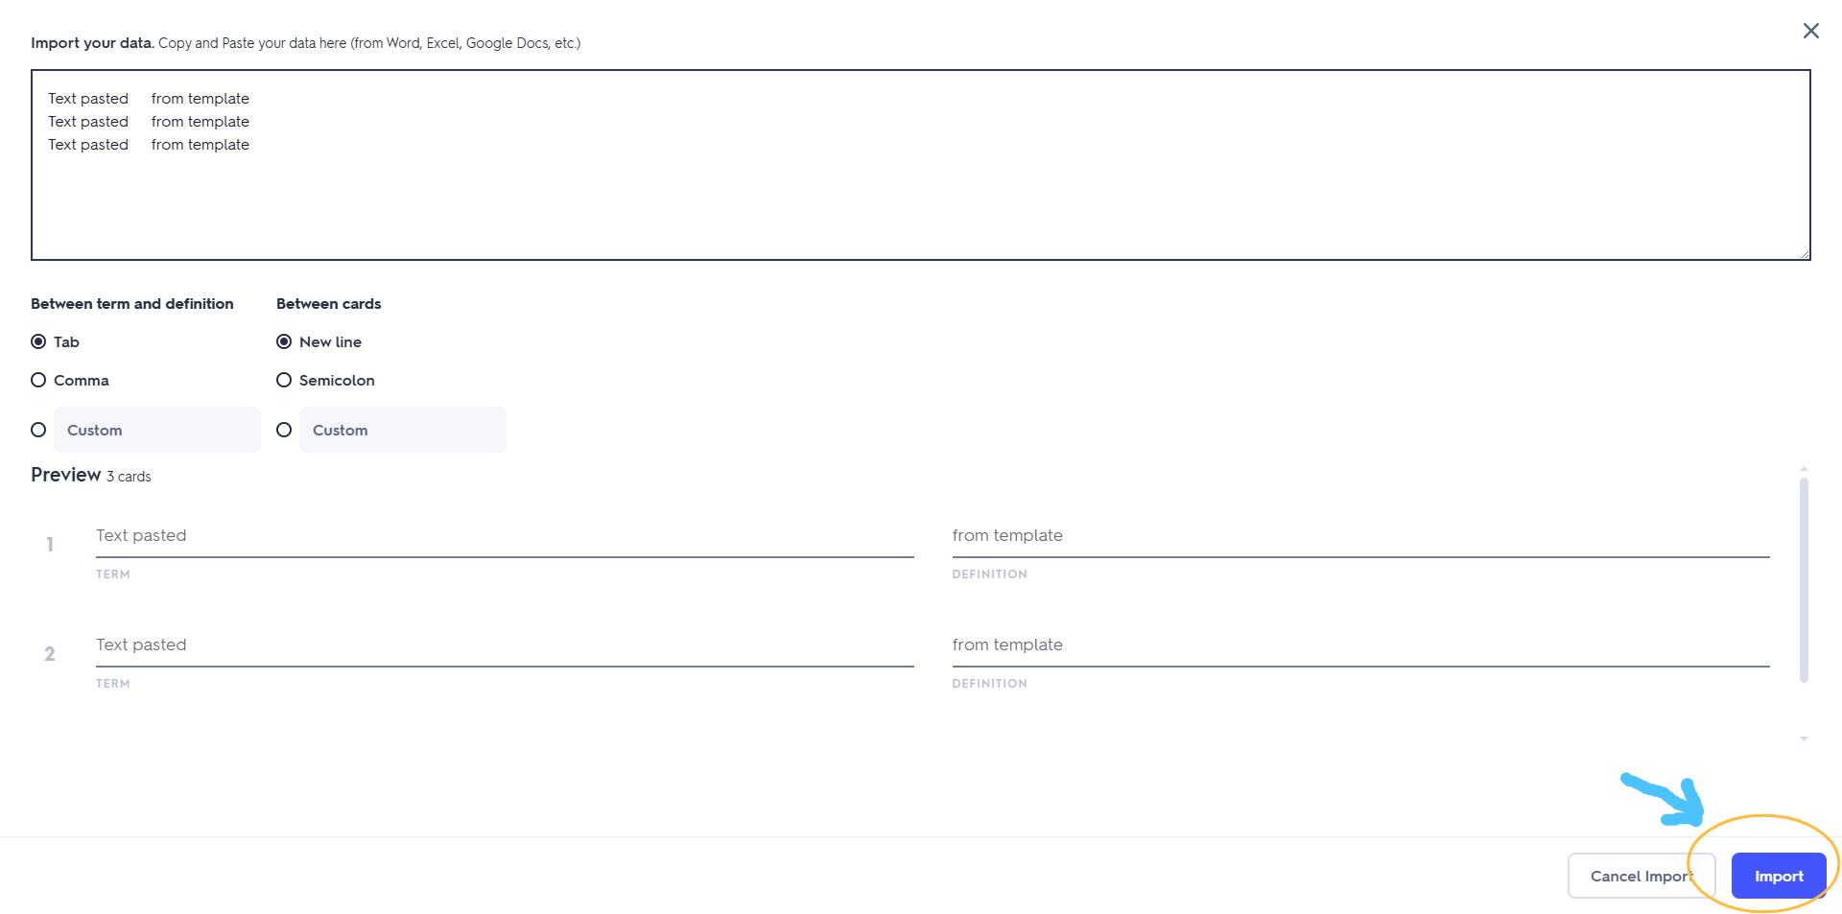
- Cut and paste the text above into the box provided (leave all the default settings as is), check that the preview looks correct and click import

- If all looks good, click Create

