Brown’s School
Acceptable Use Policy for Internet Use for Pupils

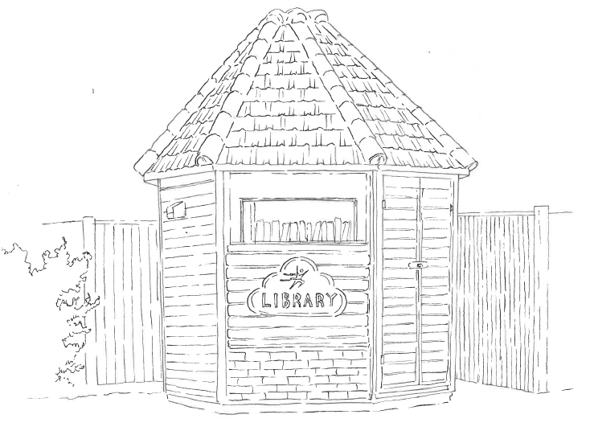

Full Name of Policy | Acceptable Use Policy for Internet Use for Pupils
Date of Approval | September 2024
Date of Next Formal Review | September 2025

Brown’s School Pupil Acceptable Use Agreement

These rules will keep everyone safe and help us to be fair to others. I understand that the school monitors my use of the internet at school.

- I will only use the school’s computers for schoolwork, homework and as directed.
- I will not bring files into school (on removable media or online) without permission or upload inappropriate material to my workspace.
I will only edit or delete my own files and not view, or change, other people’s files without their permission.
- I will keep my logins and passwords secret.
- I will use the Internet responsibly and will not visit web sites I know to be banned by the school. I am also aware that during lessons I should only visit web sites that are appropriate for my studies.
- I will only e-mail people I know, or those approved by my teachers.
- The messages I send, or information I upload, will always be polite and sensible.
- I will not open attachments, or download a file, unless I have permission from an adult or I know and trust the person that has sent them.
- I will not give my home address, phone number, send photographs or videos, or give any other personal information that could be used to identify me, my family, my friends or peers, unless a trusted adult has given permission.
- I will never arrange to meet someone I have only ever previously met on the Internet or by email or in a chat room, unless I take a trusted adult with me.
- If I see anything I am unhappy with or I receive a message I do not like, I will not respond to it but I will save it and talk to a teacher / trusted adult.
- I am aware that some websites and social networks have age restrictions and I should respect this.
- I am aware that my online activity at all times should not upset or hurt other people and that I should not put myself at risk.

I have read and understand these rules and agree to them.

Name:

Signed:

Date:

