Brown’s School
Risk Assessment Policy

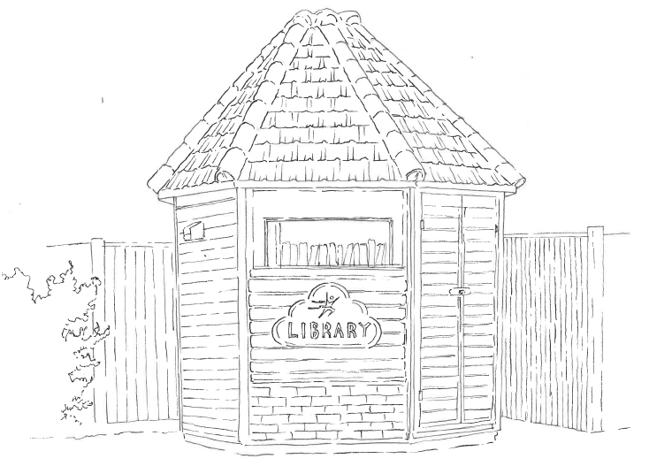

Full Name of Policy | Risk Assessment Policy
Date of Approval | September 2024
Date of Next Formal Review | September 2025

Introduction

Brown’s School clearly recognises that a failure to take reasonable safety precautions in relation to identified hazards would represent a serious risk to staff, visitors, general public and contractors and, in particular, pupils, and expose the School to the possibility of prosecution.

The aim of this Policy is to set out the systematic approach for suitable and sufficient risk management throughout Brown’s School. This policy has particular regard for ensuring the welfare of pupils at the school is safeguarded and promoted at all times and appropriate action is taken to reduce risks and potential risks that are identified.

The purpose of risk assessment is to identify hazards and evaluate any associated risks. This includes such areas as:
- Safeguarding
- Health and Safety
- Security
- Fire Safety
- Educational Visits and Off-Site Activities

Risk assessments do not have to be complicated. The level of detail contained in them should be relevant to the level of the risks involved with the activity. In many cases a risk assessment will lead to clarification and documenting of protocols and procedures that are often already in place, following best practice and relevant industry standards where applicable.

Risk assessments can also assist in the identification of requirements for levels of instruction, information, training and supervision that may be required for the activity.

In addition, some topic specific risk assessments are required by legislation for example those concerning fire safety, pupil supervision, school trips, manual handling, display screen assessments, substances hazardous to health, provision and use of work equipment, asbestos, and security assessments. This list is in no way exhaustive.

Where relevant these risk assessments will be completed using industry standard assessment templates or guidelines. All other Brown’s risk assessments should be completed using the standard risk assessment template.

(See separate Brown’s General Health & Safety Policy and relevant topic specific policies for further information and guidance on specific risk assessments).

Responsibilities

Employees are responsible for:

  - Assisting with and participating in the process of risk assessment.

The Senior Management Team are responsible for:

- Ensuring risk assessments are carried out by the appropriate staff members, identifying and implementing control measures, ensuring the outcomes are effectively communicated to others as appropriate.

- Allocating resources in response to risk assessments completed within departments and determining a course of action should it be identified that a risk cannot be suitably controlled so far as is reasonably practicable.

- Setting up frameworks for decision making and strategies which incorporate risk assessment principles. This will ensure that decisions made take into account relevant risk factors.

- Ensuring that those who are tasked with completing risk assessments are suitably trained to do so.

- Ensuring that a suitable mechanism exists to communicate the safe systems of work identified as part of the risk assessment procedures. Daily staff meetings update staff on updated safety information and, if necessary, appropriate documents are circulated to staff (these have to been signed for by individual staff members). Brown’s guidelines, such as those set out in Brown’s policies, procedures, handbooks and codes of conduct also give safety guidance.

- Ensuring the Health & Safety Officer or relevant staff member is informed if risk assessments identify an outstanding need which needs to be resourced.

- The Senior Management Team are responsible for undertaking risk assessments of individual pupils where there is a safeguarding risk.

- SMT are also responsible for risk assessing staff when they return to work after an illness or injury that may affect their ability to carry out their duties at work.

Scope

For the purpose of this policy the following definitions apply:

- Hazard: Something with the potential to cause harm

- Hazardous Outcome: A description of how someone could be hurt or damage could occur as a result of interacting with the hazard

- Risk Rating: The overall judgement of the level of risk which may arise from the hazard, based upon the likelihood of the event occurring and the potential severity of the consequence

- Control Measures: Method used to reduce or control risks arising from identified hazards

- Residual Risk: The level of risk remaining once control measures have been applied to reduce risks so far as is reasonably practicable.

Legal aspects of Risk Assessment

There are clear duties for risk assessment under acts such as the Health & Safety at Work Act 1974 and The Management of Health & Safety at Work Regulations. The following requirements are laid down in those regulations and can be applied to other areas of risk assessment;

- The risk assessment shall be ‘suitable and sufficient’ and cover both employees and non-employees affected by the employers undertaking (e.g. contractors, members of the public, pupils, etc)

The term ‘suitable and sufficient’ is important as it defines the limits to the risk assessment process. A suitable and sufficient risk assessment should:

- Identify the significant risks and ignore the trivial ones;
- Identify and prioritise the measures required to comply with any relevant statutory provisions;
- Remain appropriate to the nature of the work and valid over a reasonable period of time;
- Identify the risk arising from or in connection with the work. The detail should be proportionate to the risk.

The significant findings that should be recorded include a detailed statement of the hazards and risks; the preventative, protective or control measures in place; and any further measures to reduce the risks present.

Risk Assessment

Brown’s has a responsibility to ensure that the risk posed to staff, pupils, property, contractors and the public are reduced, so far as reasonably practicable.

Risk assessment is a subjective but logical process which can be broken down into 5 steps:

- Step 1 Identify the hazard
- Step 2 Decide who or what might be harmed and how
- Step 3 Evaluate the risks and decide on precautions
- Step 4 Record significant findings and implement them
- Step 5 Review the assessment and update if necessary. When conducting a risk assessment, staff should adopt a team approach to risk assessment and consult with the Risk Assessment Coordinator and other staff members who have practical experience (as they often have the best awareness and understanding of the hazards involved with the activity and how the activity is actually carried out.)

Types of Risk Assessment

All significant risks shall be assessed. Although the principals of assessment remain the same their application can differ. There are 3 recognised methods of assessment;

- Formal – A written method of evaluating the risk of harm (as described above).

- Generic – An evaluation of risk that can be applied to common tasks.

In unusual circumstances, when an unforeseen risk presents itself (a previous Formal or Generic risk assessment not having been compiled and / or in use) an employee may be required to use a dynamic risk assessment.

- Dynamic – A mental assessment of risk for use when any delay would increase the risk from harm.

Training

Brown’s, as a responsible employer, will provide appropriate risk assessment training for staff as necessary, as identified by their line manager.

Those who have a responsibility for the completion of risk assessments will initially be provided with basic (online or internally coached) risk assessment training. Risk assessments are regularly discussed in staff meetings.

This foundation training covers the processes and key stages of risk assessment including the rationale behind the risk assessment; application of suitable and sufficient control measures to mitigate risk; communication of the risk assessment; record keeping and incident management.

Relevant staff members (Health & Safety, Fire Safety, First Aiders) will assist staff as necessary to enable them to complete their assessment.

Specialised risk assessment training will be provided to staff as required ensuring appropriate expertise, monitoring and supervision.

Communication
Relevant information identified in the risk assessment regarding the hazards, their associated risks to the School and the appropriate control measures must be effectively communicated, and be readily accessible to, employees and others as appropriate. Copies of Risk Assessments should be uploaded onto the School’s Intranet and hard copies kept in the main office.

Monitoring
Managers or appropriate persons shall monitor the effectiveness of control measures and ensure that physical control measures are used, installed correctly and suitably maintained where applicable. Likewise checks should be made to ensure that agreed control measures and safe systems of work are being followed correctly.

Record Keeping
Risk Assessments and associated documents must be kept for a minimum period of three years from the date which they are superseded as they may be required in the event of a litigation claim for compensation (note that claims for compensation can generally be made up to 3 years from the date of the incident occurring). It should be noted that risk assessments which relate to the use of substances may need to be kept for 40 years, in order to trace exposure to substances which are known to have ill health effects e.g. asbestos.

Key Staff
Health & Safety Representative: Ryan Lovett
On Site Health & Safety Coordinator: George Mitchell
Risk Assessment Coordinator: George Mitchell

Review of Policy

This policy will be reviewed annually or at an earlier date if changes are required due to risk assessment review or changes in legislation and/or guidance.

Reviewed in Staff Meeting.

Person responsible for editing: George Mitchell in September 2024

Signature

Date

Headteacher……………………………………… Date………………………….

Review date: September 2025

