Brown’s School
Accessibility Plan

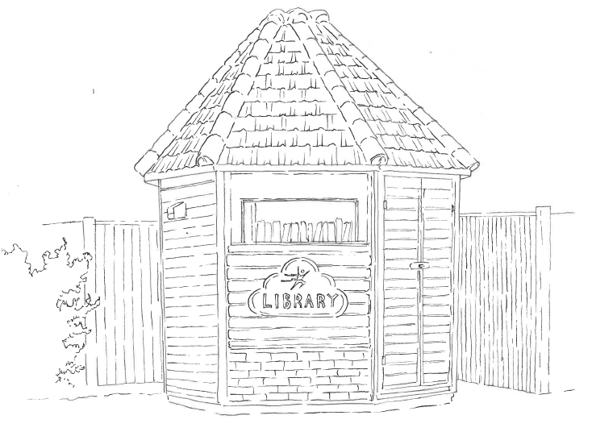

Full Name of Policy | Accessibility Plan
Date of Approval | September 2024
Date of Next Formal Review | September 2025

This Accessibility Plan is drawn up in compliance with current legislation and requirements as specified in Schedule 10, relating to Disability, of the Equality Act 2010. School Governors and Senior Leaders are accountable for ensuring the implementation, review and reporting of progress of the Accessibility Plan over a prescribed period.

The Equality Act 2010 replaced all existing equality legislation, including the Disability Discrimination Act. The effect of the law is the same as in the past, meaning that “schools cannot unlawfully discriminate against pupils because of sex, race, disability, religion or belief and sexual orientation”.

We define equality in line with the Equality Act 2010 and recognise the following protected characteristics:
- age
- disability
- gender reassignment
- marriage and civil partnership
- pregnancy and maternity
- race
- religion or belief
- sex
- sexual orientation.

According to the Equality Act 2010 a person has a disability if:
(a) He or she has a physical or mental impairment, and
(b) The impairment has a substantial and long-term adverse effect on his or her ability to carry out normal day-to-day activities.

Objectives
Brown’s School is committed to providing an environment that enables full curriculum access that values and includes all pupils, staff, parents and visitors regardless of their education, physical, sensory, social, spiritual, emotional and cultural needs. We are committed to taking positive action in the spirit of the Equality Act 2010 with regard to disability and to developing a culture of inclusion, support and awareness within the school.

The school recognises and values parent’s knowledge of a child’s disability and its effect on their ability to carry out everyday activities. The parent’s and child’s right to confidentiality is respected.

The Accessibility Plan shows how access to the school is provided for disabled pupils, staff and visitors and anticipates the need to make reasonable adjustments to accommodate their needs where practicable. It also acknowledges that a full assessment of the school’s accessibility arrangements would be necessary as and when new pupils or families with particular disabilities join the school.

The Accessibility Plan contains relevant and timely actions to:
- Maintain and develop access to the curriculum for pupils with a physical disability and/or sensory impairments, expanding the curriculum as necessary to ensure that pupils with a disability are as equally prepared for life as the able-bodied pupils; (If a school fails to do this they are in breach of their duties under the Equalities Act 2010); this covers teaching and learning and the wider curriculum of the school - it also covers the provision of specialist or auxiliary aids and equipment, which may assist these pupils in accessing the curriculum within a reasonable timeframe.
- Improve and maintain access to the physical environment of the school, adding specialist facilities as necessary – this covers improvements to the physical environment of the school and physical aids to access education within a reasonable timeframe.
- Improve the delivery of written information to pupils, staff, parents and visitors with disabilities; examples might include hand-outs, timetables, textbooks and information about the school and school events; the information should be made available in various preferred formats within a reasonable timeframe.

The Accessibility Plan relates to the key aspects of physical environment, curriculum and written information. Whole school training will recognise the need to continue raising awareness for staff and governors on equality issues with reference to the Equality Act 2010.

The accessibility plan for physical accessibility relates to an access audit undertaken during annual health and safety workplace inspections, which remain the responsibility of the governing body. It may not be feasible to undertake all of the works during the life of this accessibility plan and therefore some items will carry forward into subsequent plans. An accessibility audit will be completed by the school prior to the end of each period covering this plan in order to inform the development of a new accessibility plan for the ongoing period.

The terms of reference for all governors’ committees will include the need to consider Equality and Diversity issues as required by the Equality Act 2010. The Accessibility Plan will be published on the school website.

Accessibility Plan
The following areas were identified as in need of development.

Physical Environment

Item/Area | Recommendations | Timescale | Cost
Previous issues surrounding safety of ramp to Baker Suite during slippery conditions has been addressed but a monitoring period will be implemented to ensure long-term sustainability. | Monitoring period of success of actions taken. | December 2024 | TBC

Curriculum Access
Item/Area | Recommendations | Timescale | Cost
Necessary arrangements to provide information on audiotape or in braille for prospective pupils who have difficulty with standard forms of printed information. | Research to be carried out as to how to provide this service if required. | As soon as possible. | TBC

Written Information/Communications
Item/Area | Recommendations | Timescale | Cost
School information to be  available in alternative  languages or formats. | Research to be carried out on providing such a service if needed. | As soon as possible. | TBC

