Brown’s School
Curriculum Policy

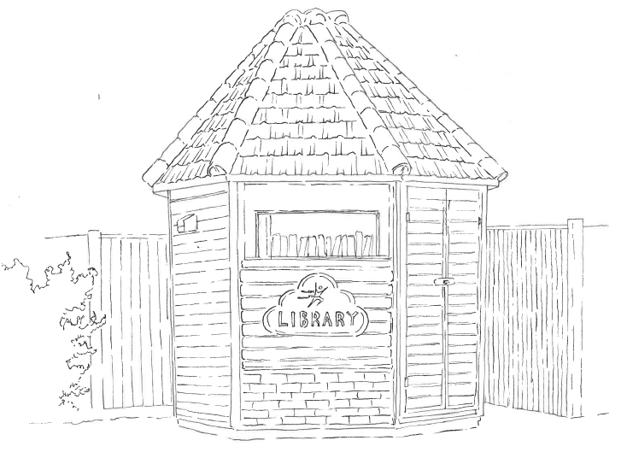

Full Name of Policy | Curriculum Policy
Date of Approval | September 2024
Date of Next Formal Review | September 2025

Context
Brown’s School is a specialist independent day school. We specialise in educating children with specific learning difficulties and associated diagnoses, namely, dyslexia, dyspraxia, dyscalculia, autism spectrum disorder (ASD), attention deficit hyperactivity disorder (ADHD), and speech and language difficulties.

Brown's School believes that all students have the right to be taught in a safe environment to enable them to optimise their learning and achievement. We expect all students to develop self-discipline and respect for others and to feel valued and supported. The school promotes the values of honesty, tolerance, and fairness within a caring and nurturing environment.

At Brown’s we aim to guide and support students on their academic journey and empower them to reach their potential. With small classes and a strong staff: pupil ratio, lessons are tailored to meet the individual needs of every student. We are fortunate to have passionate, committed staff that work closely with our students to support their needs but also to help develop well-rounded, virtuous young people. Students are supported by a variety of specialist staff including teachers, learning support assistants, literacy and maths intervention specialists, speech & language and occupational therapists, clinical psychologists, and our pastoral team. The school works tirelessly to install and cultivate a culture of achievement and positive self-esteem. Brown’s strives to create a positive, safe learning environment for staff and students alike, allowing them to feel valued and giving them the opportunities to develop, succeed, and reach their fullest potential.

Aims of the Curriculum
- For the curriculum to be differentiated and accessible to all learners.
- To provide opportunities for students to take accredited examination courses, at varying levels of ability.
- To promote student's social, spiritual, moral, and cultural development through all subject areas and through activities within the school day.
- To encourage an independent attitude towards work and personal development.
- To establish a positive, safe learning environment in all subjects, in order to promote a ‘love of learning’ ethos.
- To support and improve students’ development of their literacy and numeracy across the whole curriculum.
- To personalise the curriculum to suit individual needs.
- To encourage students to celebrate their achievements and those of others.
- To raise the aspirations of all our students and encourage them to reach their full potential.
- To provide access to the curriculum irrespective of race, gender, sexuality, or disability.
- To prepare students for their next step towards either further education, employment, or independent living and to encourage them to make positive life choices.
- To allow our pupils to belong and contribute to our school community, as well as make a positive impact on the local community.

Schemes of Work and Lesson Plans
At Brown's School, schemes of work are established by the subject department teachers and are tailored to meet the individual student needs. Lesson plans within the subject area are differentiated and are appropriately challenging. These are delivered with a multi-sensory approach to teaching, with support and training on strategies delivered by Senior Leaders and the Therapy Team.

Brown’s School Curriculum
Brown’s School aims to provide a broad and balanced curriculum and as such we offer the following timetabled lessons:

- English
- Maths
- Science
- Physical Education
- ICT
- Art
- Photography
- Humanities
- DT
- Food Technology
- PSHE
- Life & Social Skills
- Cognitive Skills
- Healthy Living Enrichment Programme
- Mindfulness
- AQA Awards
- Introduction to Languages (German & Italian)

In addition to these subjects the school gained approval to run the Duke of Edinburgh Award from September 2021. Students have access to off-site activities such as swimming, Forest School, wall climbing, and athletics at various points in the year.

There are subject reviews annually to identify any areas of development and to implement any strategies for improvement. We seek to establish a fitting curriculum to take into consideration the wide needs of our students, whilst at the same time paying due regard to the national and borough proposals at any particular time.

Formal Qualifications at Brown’s School
Brown’s School is registered to deliver qualifications with AQA, Pearson Edexcel, OCR, Eduqas, and Cambridge International Examinations. Brown’s are also registered to deliver the Duke of Edinburgh and ASDAN awards.

At Brown’s School we believe that it is our duty to offer bespoke education programmes to suit the needs of our pupils. It is our aim that at the end of KS4 pupils will have achieved a formal qualification in English, Mathematics, and Science. Details of formal qualifications offered at Brown’s School are offered below.

Art
GCSE Art and Design (AQA)
GCSE Photography (AQA)

English
IGCSE First Language English (Cambridge International Examinations)
Functional Skills English (AQA)
Entry Level English (Pearson Edexcel)

History
Entry Level Certificate History (OCR)

ICT
Functional Skills ICT (Pearson Edexcel)
Entry Level ICT (Pearson Edexcel)

Maths
GCSE Mathematics (AQA)
Functional Skills Mathematics (AQA)
Entry Level Certificate Mathematics (AQA)

Physical Education
GCSE Physical Education Short Course (Edquas)

Science
GCSE Biology (AQA) – Sixth Form Only
Entry Level Certificate Science (AQA)

Delivering the Curriculum at Brown’s School
At Brown’s School we encourage our students to work in classes, small groups, and independently. We aim to develop independent learning skills to prepare students for examinations as well as life after Brown’s.

Literacy and Numeracy are highly regarded at Brown's and cross curricular links are encouraged wherever possible. Individual 1:1 and small group interventions are a feature for various students where the need has been identified for extra support.

Individual and group sessions are run by our qualified Speech and Language Therapy and Occupational Therapy teams. Interventions are determined by documented needs as well as observed needs. Stimulating and varied programmes are followed by the pupils to ensure that the sessions are engaging, enjoyable and rewarding.

We endeavour to continually increase the number of colleges and other educational providers that we work with to ensure that our pupils are offered as many different opportunities to learn as possible.

Education Health Care Plans (EHCP)
The majority of students at Brown’s School have an Education, Health, and Care Plan. The school aims to meet the needs and objectives outlined on all plans to ensure students have access to a substantial and balanced curriculum. Greater information on adjustments for students can be gained through consultation with the school.

English as an Additional Language (EAL)
Reasonable adjustments would be made for all students with English as an additional language. Consultation with the school as part of the entry process would be required to discuss plans for adjustment.

Person Responsible for Editing: George Mitchell in September 2024

_____________________________________________Signature

_____________________________________________Date

_____________________________________________Headteacher

_____________________________________________Date

This policy will be reviewed in September 2025.

