Brown’s School
Admissions Policy

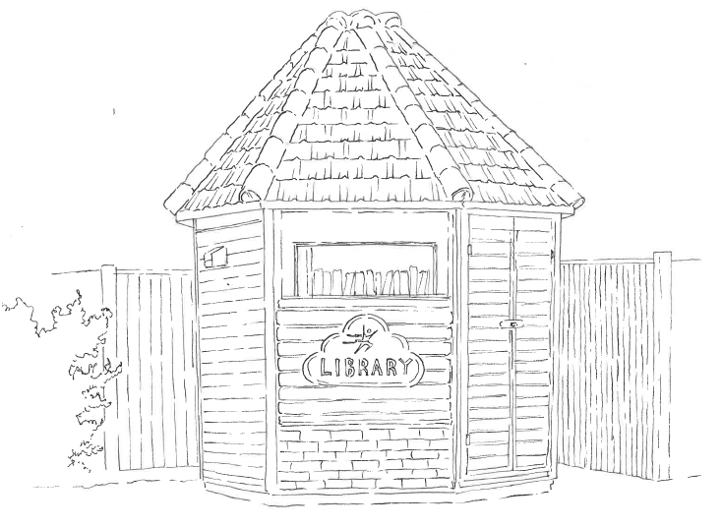

Full Name of Policy | Admissions Policy
Date of Approval | September 2024
Date of Next Formal Review | September 2025

Brown’s is a DfE and CReSTeD approved independent, co-educational day school. It provides specialist teaching, therapy and pastoral support to pupils with Dyslexia, Dyspraxia, Dyscalculia, ADD/ADHD, ASD (Asperger’s) and pupils with Social Communication difficulties.
We welcome admissions from all kinds of families regardless of disability, religion, race and ethnicity.
Our admissions procedures aim to be honest, transparent and respectful of individual rights.
The admission procedure is as follows:
- On receiving an enquiry about the school a record is made of the enquirer’s name and contact details and the child’s information including the nature of the child’s difficulties. A visit to the school is then arranged or a prospectus sent out.
- On visiting the school prospective parents/guardians are shown around and informed of the schools provision. A more in-depth discussion takes place regarding the prospective pupils’ needs and relevant reports are requested, if not already provided.
- All relevant reports (educational psychologist report, speech and language, occupational therapy, EHCPs, CAMHS) must be provided prior to an assessment visit. These are discussed with the professionals in school regarding suitability.
- Assessment visits are arranged if the enquirer wishes to proceed and, on inspection of paperwork, it is possible that Brown’s can meet the therapeutic and educational needs of the child. Assessment visits can range from one to several days depending on the child.
- If appropriate an offer of a placement is made when assessment information has been gathered and relevant reports considered. An offer is made if the school believes it can meet the child’s assessed needs.
- All places are offered on a half termly review basis.
- During this period Brown’s reserves the right to withdraw the place if the placement proves unsuccessful/inappropriate.
- Brown’s School reserves the right to refuse placements and to take the decision that a placement is no longer appropriate. All decisions regarding the suitability of a placement are at the discretion of the Headteacher
- All placements are costed on an individual basis

When a placement at Brown’s has been agreed a joining/information pack is issued. It contains the enrolment form, home/school contract, school rules and behaviour expectations, joining information about the school day at Brown’s, term dates, uniform details, Safeguarding Policy, Strengths and Difficulties Questionnaire and fee account (private fee payers) if necessary.

The Home/School contract informs parents of the basic standards of expected behaviour and the attitude towards teaching and learning that the school expects. Parents/carers are expected to take all reasonable steps to support their child and the school on issues of behaviour management.

The Enrolment Form provides the schools teaching and therapeutic staff with the following vital information:
- Name, home address and date of birth of child.
- Contact details of parents/guardians.
- Start date of Brown’s placement and details of previous educational placements.
- Emergency contact details.
- Medical information including GP details and consent for emergency procedures
- Allergy and special dietary information.
- Special needs information
- Information on therapy or additional external provision/agency involvement
- Sensory profile and developmental information
- Permission for therapy staff to work with a pupil
- Permission for photographs
- Any further information relevant to the care of the child

All students placed at the school are continuously monitored to ensure they are following the correct educational and therapeutic path. Any move to a more mainstream setting is facilitated, if agreed to be appropriate, and is viewed as an indicator of success.

Reviewed in Staff Meeting.

Person responsible for editing: Mrs Denise Mitchell

_________________________Signature

_________________________Date

Signed by:

Headteacher: Date: ..............................

Governors: Date: ………………………

