**Brown’s School**

**Anti-Bullying Policy**

|  |  |
| --- | --- |
| **Full Name of Policy** | Anti-Bullying Policy |
| **Date of Approval** | September 2024 |
| **Date of Next Formal Review** | September 2025 |

**Philosophy of the school**

Brown's School believes that all students have the right to be taught in a safe environment to enable them to optimise their learning and achievement. We expect all students to develop self-discipline and respect for others and to feel valued and supported. The school promotes the values of honesty, tolerance and fairness within a caring and nurturing environment.

Students at the school have a variety of complex needs and the school provides a high level of pastoral care for all students in order to encourage appropriate and cooperative behaviour. As a result of this ongoing support, students are expected to take responsibility for their own behaviour but as a staff group we understand that we need to utilise numerous strategies to achieve this.

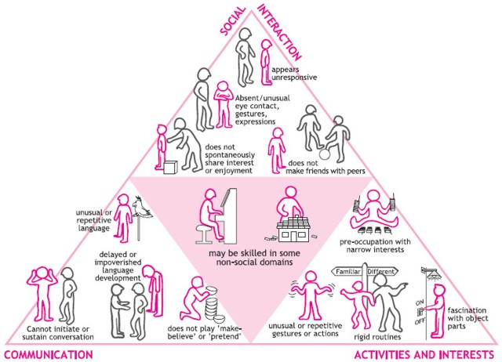

The triad of impairment (Figure 1, above, originally devised in 1979 by Lorna Wing and Judy Gould) is a useful tool to refer to when educating pupils with complex needs (especially those with an ASD diagnosis). It is important to identify behaviours that may be perceived as “rude” but are actually a symptom of a pupils diagnosed difficulties. Brown’s School aims to work with pupils to modify undesirable behaviour through therapeutic intervention and staff recognise that behaviour associated with ASD/ADHD/ODD take time to change.

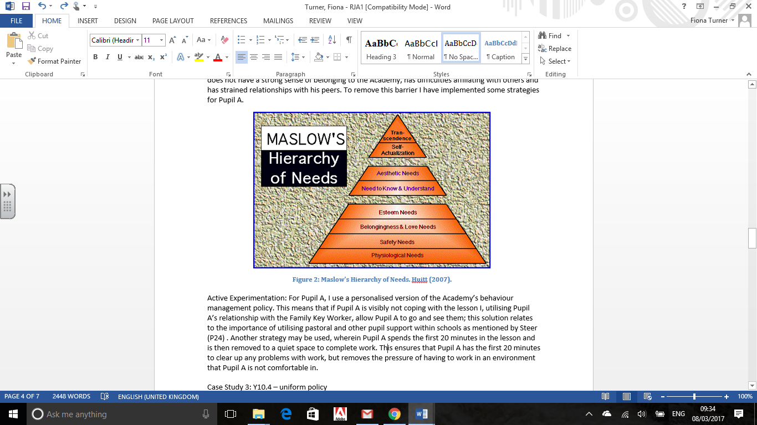

**Figure 1: Maslow's Hierarchy of Needs - Huitt (2007)**

Maslow’s Hierarchy of Needs is another useful tool for educators. Many of the pupils at Brown’s have a diagnosis of complex, co-occurring difficulties. Often behaviours displayed by our pupils are consistent with their individual diagnosis and make achieving learning difficult. For example, one of the common behaviours displayed by a pupil with ADHD is impulsivity. This behaviour could lead to a pupil not feeling safe in a classroom and therefore mean he is not able to access the learning of the lesson. In addition to this, pupils with difficulties in the classroom are well documented to struggle with “fitting in” and identifying with others, these are important factors to remember when a pupil exhibits undesired behaviour.

**Statement of Intent**

Brown’s School expects every member of the school community to behave in a considerate way towards others and any form of bullying is unacceptable and will not be tolerated. The seriousness of bullying cannot be emphasised enough. Bullying is among the top concerns that parents have about their children's safety and well-being.

The staff at Brown’s School understand that bullying can negatively affect a child or young person's self-confidence and has a real impact on their self image. It can also make them feel unsafe and insecure. Bullying may have an effect on their school attendance, their work ethic, their learning, and day to day school life. For some students bullying can have a real long--term impact on their daily lives which may be reflected later on in life. The school recognises that all forms of bullying, especially if left unaddressed, can have a devastating effect on individuals; create a barrier to learning and have serious consequences for mental wellbeing.

This policy has been developed in accordance with the principles established by The Children's Act 1989, the Equality Act 2010 and Part 3 of the Children and Families Act. It follows the Government guidance 'Preventing and tackling bullying', July 2017 and The Education (Independent School Standards) Regulations 2014 which provide that the proprietor of an Academy or other independent school ensures that bullying at the school is prevented in so far as reasonably practicable, by the drawing up and implementation of an effective anti-bullying strategy.’

**Objectives of the Policy**

The who school community, including pupils, staff and parents should have an understanding of what bullying is and how to report it. Therefore:

* All staff will have read and have constant access to the Anti-bullying Policy
* Pupils and parents are aware of the school’s policy and procedures when dealing with bullying incidents and know how to report an incident within school.
* The policy will be printed on the school’s website.

**Definition of Bullying**

Bullying is behaviour by an individual or group, repeated over time, that intentionally hurts another individual or group either physically or emotionally and usually involves an imbalance of power between the perpetrator and the victim. Bullying can take many forms (for instance, cyber-bullying via text messages, social media or gaming, which can include the use of images and video) and is often motivated by prejudice against particular groups, for example on grounds of race, religion, gender, sexual orientation, special educational needs or disabilities, or because a child is adopted, in care or has caring responsibilities. It might be motivated by actual differences between children, or perceived differences (Preventing and tackling bullying, DfE 2017).

Examples of bullying include:

* Physical (including sexual) assault, including pushing, kicking hitting, punching, taking or hiding belongings
* Verbal abuse, by name calling, teasing, insults, threats or humiliation or making offensive remarks.
* Emotional tormenting by excluding from social groups or spreading malicious rumours.
* Cyberbullying, which is defined as the use of information technology by an individual or group in a way that is intended to upset others. Examples include using social websites, mobile phones, text messaging, photographs. video and e-mail to pass on hurtful/damaging comments.

This may include prejudicial bullying such as:

* Bullying related to Special Educational Needs or Disability (SEND)
* Bulling related to race, religion, faith and belief and for those without faith
* Bullying related to ethnicity, nationality or culture.
* Bullying related to sexual orientation (homophobic/biphobic bullying)
* Gender based bullying, including transphobic bullying
* Bullying related to appearance
* Bullying related to home or other personal situations
* Bullying against teenage parents (pregnancy and maternity under the Equality Act)

Bullies often have reasons for their behaviour, and at Brown’s School we hope to establish what these traits are and deal with them effectively and sensitively. We do not allow a student to feel that they can get away with their actions but seek to find a quick and reasonable solution to the problem and decide on the direct course of action.

The following are signs and symptoms of a child or young person who may be being bullied. Staff and parents should look out for the following if a child or young person:

* is frightened/worried about travelling to or from school
* changes their usual routine
* reports a reluctance to go to school
* begins truanting
* becomes withdrawn, anxious or lacking in confidence
* starts stammering or fails to communicate
* attempts or threatens suicide, or runs away
* cries themselves to sleep at night, or has nightmares
* feels ill
* fails to thrive and achieve within the classroom
* comes home with clothes torn or damaged
* has possessions go missing
* asks for money or starts stealing money (to pay a bully)
* has unexplained cuts or bruises
* becomes aggressive, disruptive or unreasonable,
* is bullying other children or siblings
* stops eating
* is frightened to say what is wrong
* gives improbable excuses for any of the above
* is afraid to use the internet or mobile phone

These signs and behaviours could indicate other problems but bullying will be considered a possibility and will be investigated.

**Preventative Strategies**

* The school encourages a climate of openness where pupils feel safe and conducts regular pupil surveys to ensure that this is the case.
* All pupils have an identified listening/trusted adult ear in order to discuss concerns and worries.
* The school has a dedicated Pastoral care team, including a manager who is also the School's Designated Safeguarding Lead (DSL).
* The school's Therapy Team and Clinical Psychologist are in-house and support pupils on a regular basis.
* Pupils are educated through school assemblies, PHSE lessons and Social Skills lessons regarding bullying.
* These lessons offer students open forums for discussions about individual differences and preferences and the need to be objective and avoid prejudice of any kind. Pupils are also made aware that there are laws and statutes that apply to assault, harassment and threatening behaviour, which ensure that all individuals have a right to a safe and secure environment, free from any bullying.
* Pupils are given the opportunity to be a helper and to understand what acceptable behaviour is. The school has designated Peer Mentors who are trained to speak to individuals who may be involved in bullying, whether as the victim or the bully itself. The Peer Mentors act as “Students of Help” and support students who are in need of advice and reassurance. The Headteacher meets with the Peer Mentors weekly to discuss any issues and follow them up.
* There is a clear behaviour management system in the school to support pupils, which includes rewards and sanctions.
* There is a worry box for pupils who wish to report concerns without speaking to staff.
* The school consults pupils as to what they feel constitutes bullying through the School Council. Discussions about what is and what is not bullying can help form the basis for the schools anti-bullying procedures.
* The school takes part in Anti-Bullying Day each year. The whole day is spent considering what bullying is and the effect it has on others.

**Staff**

Staff create and support an inclusive environment which promotes a culture of trust and respect for all. By praising, rewarding and celebrating the success of all children we aim to prevent incidents of bullying. Staff routinely attend training which enables them to become equipped to deal with incidents of bullying and behaviour management**.**

* Staff recognise that bullying can be perpetrated or experienced by any member of the school community including adults and children, despite the robust policies and procedures put in place by the school.
* Staff openly discuss differences between people that could motivate bullying, such as: children with different family situations, e.g. looked after children or those with caring responsibilities, religion, ethnicity, disability, gender, sexuality or appearance related difference.
* Staff challenge practice and language (including ‘banter’ and particularly sexualised banter) which does not uphold the school values of tolerance, non-discrimination and respect towards others.
* Staff are trained to be vigilant to ensure that any situations where pupils are being unkind to each other are carefully observed and then dealt with immediately, using thoroughness but also sensitively.
* Staff understand the importance of listening to pupils and taking allegations of bullying seriously.
* Staff understand that it is important to protect the child or young person who is being bullied and ensure their safety.
* Staff understand that an allegation of bullying is a safeguarding concern and know to report it as such, following guidance in the school’s Safeguarding and Child Protection policy.
* Staff acknowledge and reward students who help prevent bullying through the Brown's Bonus scheme.
* Staff understand that there are a range of pupil-based strategies to help those who are struggling with friendship issues including “Buddying”, peer mediation, or peer listening. These can create a happier, friendlier environment and offer much needed support.
* Having friends is one of the best defences against bullying and the school's Therapy Team supervises friendship groups and play sessions.
* The Therapy Team teaches assertiveness skills and lessons to increase self-esteem to build pupil's resilience.

**The Role of the Senior Leadership Team (SLT)**

The Senior Leadership Team supports staff in dealing with bullying. This includes:

* Setting the school climate of mutual support and praise for success, so making bullying less likely. When pupils feel they are important and belong to a friendly and welcoming school, bullying is far less likely to be part of their behaviour.
* Ensuring that all members of the school community, including pupils, are involved in policy writing and decision making, to ensure that they understand the school’s approach and are clear about the part they play in preventing bullying.
* Recording and monitoring any incidents that occur and reviewing the effectiveness of the school policy regularly. The DSL keeps accurate records of all incidents of bullying which are monitored.
* Recognising the potential impact of bullying on the wider family of those affected and therefore ensuring that parents/carers are kept informed of all reported bullying concerns and asking parents to come into school for a meeting for serious cases of bullying.
* Ensuring that children are interviewed, facts are gathered and appropriate consequences are put into place, following the school's Behaviour Policy.
* Making a referral to an outside agency including Children’s Social Care, the police or CAMHS if the DSL considers that bullying has resulted in significant harm or risk of significant harm.
* Ensuring that all staff receive sufficient training, including in-house and online training, to equip them to deal with all incidents of bullying.
* Understanding that if an allegation of bullying occurring **outside** of school is reported to them, this should be investigated **in** school and that appropriate action needs to be taken.

**Support for the child or young person who has been bullied**

This may include:

* A support plan in the form of an anxiety management plan put in place for the child or young person, naming someone who they can talk to and listing support strategies for managing issues.
* Speaking to his/her trusted adult in school.
* Support from the school's in-house therapy team, to improve peer relationships.
* Counselling from the school's Clinical Psychologist.
* Support from the school's Pastoral Care Team.
* Conflict resolution between pupils.
* A referral to outside agencies including CAMHS, the Bromley Wellbeing Service, or the local authority's mentoring service.
* Support from a child’s peer mentor.
* Access to the school's Clinical Psychologist by parents

**Support for the child or young person who has bullied**

It is important to find out why the child or young person has behaved in such a way. It may be that they may have been bullied themselves in a similar way or may be experiencing their own difficulties. The school acknowledges its responsibility to offer support and will consider the following:

* A risk assessment and support plan will be put into place.
* The child or young person can speak to his/her trusted adult. The member of staff concerned will ensure that he/she recognises their behaviour and its effect on others.
* The school will identify whether the young person needs support from the school's Therapy Team, including the Clinical Psychologist to guide, support and advise on strategies to help change their behaviour
* The school will ensure that there is an appropriate consequence for this behaviour, including restorative justice, if appropriate.

**Supporting adults who have been bullied**

Our school understands and recognises that the bullying of adults, including staff and parents, whether by pupils, parents or other staff members, is unacceptable. Adults who have been bullied or affected will be supported by:

* Offering an immediate opportunity to discuss the concern with the school’s Headteacher or DSL.
* Advising the person concerned to keep a record of the bullying as evidence and discuss how to respond to concerns and build resilience, as appropriate.
* Where the bullying takes place off school site or outside of normal school hours (including online) the school will still investigate the concern and ensure that appropriate action is taken in accordance with the school’s Behaviour policy and/or Staff Handbook.
* Reporting offensive or upsetting content and/or accounts to the service provider where the bullying has occurred online. The school may take advice from other agencies, e.g. The UK Safer Internet Centre.
* Reassuring and offering appropriate support.
* Working with the wider community and local/national organisations to provide further or specialist advice and guidance.

Adults who have perpetrated the bullying will be helped by:

* Discussing what happened with a senior member of staff and/or the Headteacher to establish the concern.
* Establishing whether a legitimate grievance or concern has been raised and signposting to the school’s official complaints procedures.
* If online, requesting that content be removed.
* Instigating disciplinary, civil or legal action as appropriate or required.

**Cyberbullying**

Widespread access to technology has provided a new medium for ‘virtual’ bullying. Pupils are not allowed electronic devices during the school day, however the school recognises that cyberbullying can occur inside or outside of school and can involve members of the whole school community; including pupils, staff and parents.

When responding to cyberbullying concerns the school will:

* Act as soon as an incident has been reported or identified.
* Provide appropriate support for the person who has been cyberbullied and work with the person who has carried out the bullying to ensure that it does not happen again.
* Encourage the person being bullied to keep any evidence (screenshots) of the bullying activity to assist any investigation.
* Take all available steps where possible to identify the person responsible.
* Work with the individuals and online service provider to remove content if those involved are unable to be identified or if those involved refuse or are unable to delete content.
* Confiscate and search pupils’ electronic devices, such as mobile phones, in accordance with the law.
* Ensure that sanctions are applied to the person responsible for the cyberbullying; the school will take steps to change the attitude and behaviour of the bully, as well as ensuring access to any additional help they may need.
* Consider informing the police if comments are threatening, abusive, of a sexual nature or constitute a hate crime. Online harassment is a crime.
* Offer support to parents on how to help their children engage safely and responsibly with social media through regular e-safety bulletins.
* Provide information to staff and pupils regarding steps they can take to protect themselves online. This may include:
  + advising those targeted not to retaliate or reply
  + providing advice on blocking or removing people from contact lists
  + helping those involved to think carefully about what private information they may have in the public domain.

**Monitoring and review**

* The school will ensure that they regularly monitor and evaluate mechanisms to ensure that the policy is being consistently applied.
* Any issues identified will be incorporated into the school’s action planning.

**Useful links and supporting organisations**

**General**

Anti-Bullying alliance: [www.anti-bullyingalliance.org.uk](http://www.anti-bullyingalliance.org.uk)

Childline: [www.childline.org.uk](http://www.childline.org.uk)

Family Lives: [www.familylives.org.uk](http://www.familylives.org.uk)

Kidscape: [www.kidscape.org.uk](http://www.kidscape.org.uk)

MindEd: [www.minded.org.uk](http://www.minded.org.uk)

NSPCC: [www.nspcc.org.uk](http://www.nspcc.org.uk)

PSHE Association: [www.pshe-association.org.uk](http://www.pshe-association.org.uk)

Young Minds: [www.youngminds.org.uk](http://www.youngminds.org.uk)

**Cyberbullying**

Childnet: [www.childnet.com](http://www.childnet.com)

Internet Watch Foundation: [www.iwf.org.uk](http://www.iwf.org.uk)

Think U Know: [www.thinkuknow.co.uk](http://www.thinkuknow.co.uk)

UK Safer Internet Centre: [www.saferinternet.org.uk](http://www.saferinternet.org.uk)

The UK Council for Child Internet Safety (UKCCIS) [www.gov.uk/government/groups/uk-council-for-child-internet-safety-ukccis](http://www.gov.uk/government/groups/uk-council-for-child-internet-safety-ukccis)

This policy should be read in conjunction with other school policies including: Safeguarding and Child Protection, Behaviour and Child-on-Child Abuse.

Reviewed in Staff Meeting

Person responsible for editing: George Mitchell in September 2024

__________________________________________Signature

__________________________________________Date

__________________________________________Headteacher

__________________________________________Date

This policy with be reviewed: September 2025.