Brown’s School
Educational Visits, Off-Site Activities, and Visitors Policy

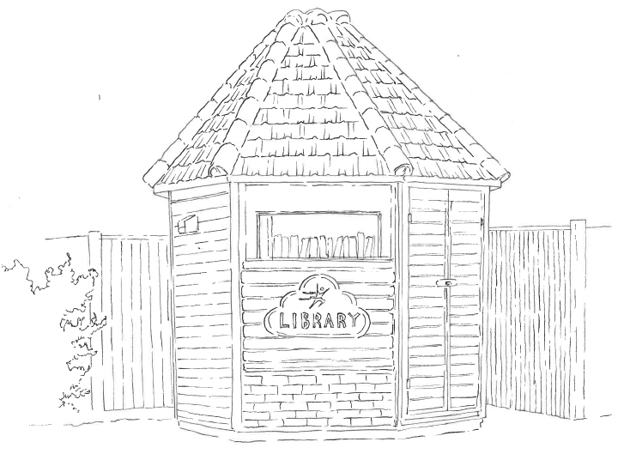

Full Name of Policy | Educational Visits, Off-Site Activities, and Visitors Policy
Date of Approval | September 2024
Date of Next Formal Review | September 2025

Brown’s School ensures that it follows both DfE and Health and Safety at Work Guidance and Regulations (including those issued by Bromley Local Authority) concerning all activities that take place off school premises, along with the Health and Safety Direct Schools Off- Site Activities Visits Manual.
All schools are required to offer their students a broad and balanced curriculum that promotes their spiritual, moral, social and cultural development, and also prepares them for the opportunities and experiences of adult life. Our school’s educational visits reflect the school ethos of Equal Opportunities and are designed to be accessible to all, irrespective of race, colour, ethnic origin, religion, or special needs. All are entitled to the development of knowledge, understanding, skills, and attitudes. To enrich the education of our students we also offer a range of visits and other activities that add to what their learning at school.

Aim
This Policy summarises the arrangements for ensuring the safety and security of our students when taken on organised trips and outings. Outings and trips will be arranged by management and staff. This policy statement and guidelines are designed to be a practical guide, and an aid to any colleague who is planning an educational visit out of school. Its principal purpose is to ensure that every member of staff is working within both legal and school-based guidelines to ensure that any visit fits within the philosophy of Brown’s School and also adheres to any health and safety legislation.

The following details of each educational visit will include:

- Where the students are going
- Date and time of departure
- Expected time of return
- Type of transport to be used
- Route taken
- Number and names of accompanying adults
- Important and emergency phone numbers
- Any medication for students required on the trip

Visits should have clear, relevant and achievable aims and objectives which support the practices and policies of the school. They will allow students and staff to interact in a somewhat less formal manner than normal – this can improve student/staff relationship in the school.
Examples of Local Visits Which Do Not Involve Transport:
- Field work in the local village
- Looking at local buildings
- Community work in Chelsfield village
- Artwork in local neighbourhood
Examples of Visits Which Involve Transport:
- Museums/Art Galleries
- Theatres
- Cinema
- Sporting Events
- Residentials
- Wall Climbing
- Forest School
- Norman Park Running Track

Visit leaders are in loco parentis and have a common law duty to act as a reasonable parent/carer whilst looking after the students in their care. They also have a responsibility, within their conditions of service, to maintain order and discipline and for safeguarding the health and safety of the children in their care.
Visit leaders always:
- Obtain permission for the visit to take place from the Headteacher before the visit is booked
- Gain written parental/carer consent for the child to go on the visit
- Ensure that the aims of the visit are matched to the needs of the children. Clear objectives have a major bearing on choice of venue, time of year for the visit to take place, and the work and experiences planned for the children
Organisation
Each visit should have a designated leader, who is considered by the Headteacher to be sufficiently competent and experienced to fulfil this role.

The parent/carer is asked to give their consent to their child participating in the visit by completing the following information and signing and returning any consent forms:

- Details of any special dietary needs (medical / religious / cultural)
- Details of any allergies
- Details of any phobias
- Details of any special care needs (e.g. difficulties with toileting, etc)
- Medication that the child requires (instructions / dosage / times / consent to medicate)
- Emergency contact telephone numbers

A risk assessment will be completed for the planned activity and the Headteacher will assess if the trip is safe for the children to attend. The following actions/considerations will need to be made when organising a trip:

- Parents will be advised on items needed for the visit (lunch, money, sun cream etc.) and suitable dress for the children
- Specific register for the visit
- First aid kit present along with a first aider on the outing
- Essentials such as a spare change of clothes (if necessary), tissues, wet wipes, carrier bag, spare food and drink
- Mobile phone and emergency contacts for children
- Head counts are taken regularly
- Student’s individual medical needs are evaluated (epi pens, medication, inhalers, dietary requirements etc.)
- If any incidents or accidents occur on the outing, they must be recorded in the usual manner
- Spare money in case of emergency
- Having a meeting point should an adult/student get lost

Visits and activities usually take place within the school day. Written permission from parents must be obtained prior to taking any students off-site. If we do not receive this written permission the student will be unable to participate.

Medical Arrangements/First Aid
Appropriate First Aid equipment should be carried on all school visits and a trained first aider should be part of the staff group responsible for the trip. Staff should be aware of any specific medical needs of the children. Students should not carry their own medication (except inhalers). If in doubt, staff should seek medical advice. For residential visits, parents/carers need to complete a Confidential Information Form.

Safety

Safety must be the first consideration in relation to educational visits. Staff must make every effort to reduce the possibility of risk through:
- A sound knowledge and understanding of the purpose of the visit
- Good preparation (e.g. preliminary visits and/or thorough risk assessment)
- Effective behaviour management and supervision
- Avoiding unplanned, spontaneous activities
- Having effective contingency plans if original plans become inappropriate e.g., weather conditions or travel plans.

Formal risk assessments are undertaken prior to any visit.

Emergency Procedures

Accidents may happen despite effective planning and control. Most injuries are likely to be minor and are easily dealt with by the organising staff as they would on a day-to-day basis in school. However, if something more serious occurs the following procedure is followed:
- All group members are accounted for, and their well-being is ensured
- The names of the people involved in the incident are established and, if necessary, the nature and extent of any injuries
- Medical assistance is sought by a member of staff
- The consequent course of action is decided upon and shared with all staff

Risk Assessment
Risk assessments are made for all Educational Visits. This necessitates that the Group Leader, where possible, has made a pre-visit in order to be able to plan for the visit and to conduct a risk assessment appropriately. Risk Assessments must be simple, manageable, and sufficient. The system must:
- Identify significant hazards
- Assess the risk of harm
- Put control measures in place
- Check if anything else is needed
Risk Assessment considers the site and its environment, the group, the activity and the leaders.
The level of adult supervision must realistically reflect the purpose and nature of the trip, the age and maturity of the pupils, and the experience of the accompanying adults. In all matters, the school expects members of staff to carry out their responsibilities in a manner which is fair and reasonable.

Fire procedures at residential sites should be checked, as far as is possible, prior to the visit being undertaken. In any event, a fire evacuation procedure involving all pupils should be carried out as soon as practically possible after arrival.

At all times the Headteacher reserves the right to exclude any student from participating in a trip or expedition. This authority is delegated to the Group Leader who is authorised to forbid the student from participating at any time during the trip if it becomes clear that the student is either incapable of or insufficiently responsible to undertake all or any part of the trip or activities.

Person Responsible for Editing: George Mitchell in September 2024

_____________________________________________Signature

_____________________________________________Date

_____________________________________________Headteacher

_____________________________________________Date

This policy will be reviewed in September 2025.

