Risk & Governance Officer

Your purpose:
This role supports the College in strengthening how it manages risk, governance and business improvement. Working closely with Senior Postholders, the postholder will help embed the College’s corporate risk framework across all business units, supporting budget holders and Heads of Department to identify, manage and report risks effectively. The role will also provide high-quality governance and project support, helping to ensure that key decisions, assurance processes and improvement activities are well coordinated, professionally managed and delivered to a high standard.
This unique role is key to enabling the College’s continuous improvement in creating opportunities and changing lives. It will support and enable:
- Development and embedding of a risk management and board assurance framework to best manage risks and evidence key controls;
- A highly effective governance function;
- Continuous improvement through project management disciplines.
The post holder will work closely with the Deputy Principal, Finance & Resources, the Director of Governance and relevant senior executive colleagues to support and co-ordinate key business activities and projects within required timeframes.
The successful candidate will demonstrate previous experience in similar areas of responsibility and the commitment, aptitude and enthusiasm to develop further to fulfil their potential in the role, with an eye for detail and the ability to work under their own initiative and to deadlines. They will also possess excellent communication, organisation and digital skills, with an ability to engage with stakeholders at all levels.
With a high degree of autonomy and initiative, you’ll consistently deliver to the highest professional standards, exercising sound judgment while collaborating with governors, senior leadership and external stakeholders.

SUMMARY OF DUTIES AND RESPONSIBILITIES:
- Risk - Maintaining and developing a robust risk management framework for the college, including developing support and training for risk owners and producing risk reports and analysis for executive and governors
- Governance - Providing a high-quality governance administration service, including supporting arrangements and papers for all governor meetings, events, training and diary management
- Project Management - Supporting effective project management and the College’s continuous improvement of its systems and services
- Providing high-quality administrative support to the Deputy Principals, including tasks like scheduling, managing correspondence, and organising events/meetings
- Engaging with college stakeholders at all levels

DUTIES:
Risk
- Embed a proactive, dynamic risk culture across the College, with high levels of engagement in risk management best practice
- Maintain and develop the risk management system, ensuring all risk registers are properly reviewed and recorded by risk owners
- Ensure risk reporting is timely, complete and presented to a high standard
- Develop and support a Board Assurance Framework to evidence and assure executive leaders and Governors that key controls operate effectively
- Develop and deliver risk management and board assurance training and support for risk owners, the Senior Executive Leadership Team and Governors
Governance
- Provide governance administration, organising, supporting and attending Corporation/committee meetings and events
- Support the production and distribution of governor meeting agendas, reports and minutes, as well as tracking actions and maintaining calendars
- Coordinate Governor engagement activities (including recruitment, induction and training) and actively maintain and develop internal and external governance communication channels
- Assist with the production of formal governance and college documents, as well as support in completing regulatory assessments, questionnaires and preparing documentation for audits and inspections
- Coordinate arrangements for governor starters and leavers, and maintain and review filing systems, archives and public access information according to policies and retention schedules
- Administer college processes, including invoices, governor expenses, statutory DBS requirements, solvency checks, the Corporation Seal, Register of Interests and other key records, while providing flexible support to the Leadership Team
Project Management
- Support business improvement activity to ensure successful adoption of new processes and technologies
- Provide excellent project management support in helping to plan, coordinate, deliver and review key projects and activities
- Research, analyse, collate and present external and internal data to support management
- Ensure all documentation is professionally created, properly organised and managed

There are things that we are all accountable for, whatever your role, these are:
- Embedding safeguarding into your/ your teams working practices and escalating any safeguarding concerns immediately in line with the College’s safeguarding policy.
- Embedding Health and Safety best practices and ensuring a safe working environment for everyone within your area of responsibility, according to the Health and Safety at Work Act.
- Being a champion and advocate for Equality and Diversity throughout College.
- Behaving in a manner that displays British values.
- Being committed to reviews of your performance and your own Continuous Professional Development.
- Any other duties commensurate with your role that may be required from time to time.

To be successful in this role you will have the following: |  |  |  |  |  |  | Essential/  Desirable?
Qualifications/ Training | Educated to degree level or equivalent |  |  |  |  |  | Desirable
 | Relevant governance / project management / business administration qualification |  |  |  |  |  | Desirable
Skills, Knowledge & Experience | Extensive administrative experience in a fast-paced and complex environment, with a proven track record in servicing meetings and coordinating paperwork for leaders and managers. |  |  |  |  |  | Essential
Skills, Knowledge & Experience | Experience in risk, governance, compliance, or professional environments, particularly within further or higher education settings, along with familiarity with policy frameworks, Board portals, and information management systems. |  |  |  |  |  | Desirable
Skills, Knowledge & Experience | Extensive experience of project planning, implementation and management support of business-critical projects |  |  |  |  |  | Desirable
Skills, Knowledge & Experience | Excellent organisational and administrative skills |  |  |  |  |  | Essential
Skills, Knowledge & Experience | A high level of analytical and numeracy skills |  |  |  |  |  | Essential
Skills, Knowledge & Experience | Excellent oral and written communication skills |  |  |  |  |  | Essential
Skills, Knowledge & Experience | Able to maintain professional standards, confidentiality and discretion in all College and Corporation matters |  |  |  |  |  | Essential
Skills, Knowledge & Experience | Excellent IT skills, including Microsoft Office packages: Word, PowerPoint, Excel, Outlook and databases |  |  |  |  |  | Essential
Skills, Knowledge & Experience | A high level of accuracy in all work with excellent attention to detail |  |  |  |  |  | Essential
Skills, Knowledge & Experience | Excellent interpersonal skills and customer service skills |  |  |  |  |  | Essential
Personal Qualities | Highly motivated, proactive, innovative and outcome focused |  |  |  |  |  | Essential
Personal Qualities | Proven ability to work effectively and accurately without direct supervision |  |  |  |  |  | Essential
Personal Qualities | Able to work at pace, with agility, and to tight deadlines |  |  |  |  |  | Essential
Personal Qualities | Calm under pressure, resilient, flexible, friendly and helpful |  |  |  |  |  | Essential
Personal Qualities | Collaborative working skills – able to develop relationships and bring people together to achieve strategic and operational aims |  |  |  |  |  | Essential
Personal Qualities | Analytical and problem-solving skills – able to unpick complex data and/or a difficult or sensitive problem and identify the best solution |  |  |  |  |  | Essential
College Values & Behaviours | Evidence of being able to demonstrate our College values in action:  - Kindness  - Unity  - Excellence  (Further information about our Values is below) |  |  |  |  |  | Essential
What are the key role dimensions?

Reporting to: |  | Deputy Principal, Finance & Resources |  |  | JD Updated | July 2026
Your job grade: |  | BS8 |  |  | Salary points: | BSSCP23
Financial/budget responsibility: |  | N/A | Job Location: | Kirklees College Sites
Your people responsibility: |  | N/A | Your key stakeholders | Governors, Executive Leadership Team, staff, students, funding bodies, Kirklees Council, Association of Colleges
Special features of the post |  |  | Travel between sites required. The postholder must also work at times which are convenient to the Governing Body, including attendance at  evening meetings.

A bit about how our values and behaviours have shaped our job roles in College

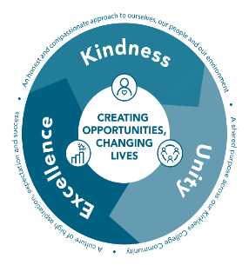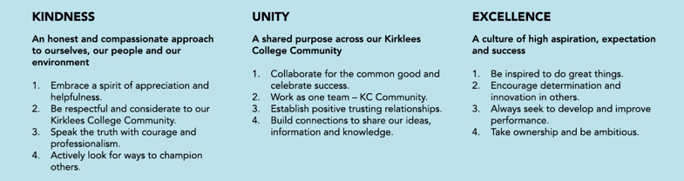

Our College values inspire us all our everyday work – when we created them we all had a voice in shaping our values and we’re proud of what we came up with together; Kindness, Unity and Excellence. Our values are important to us all and drive everything that we do and believe.

