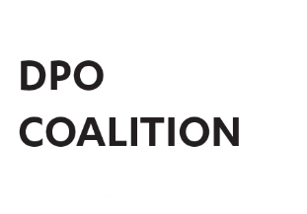
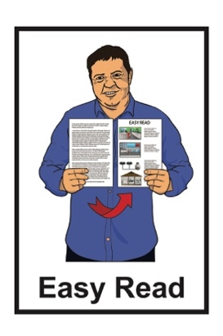

Disabled People’s

Organisations Coalition:

Key Messages March 2025
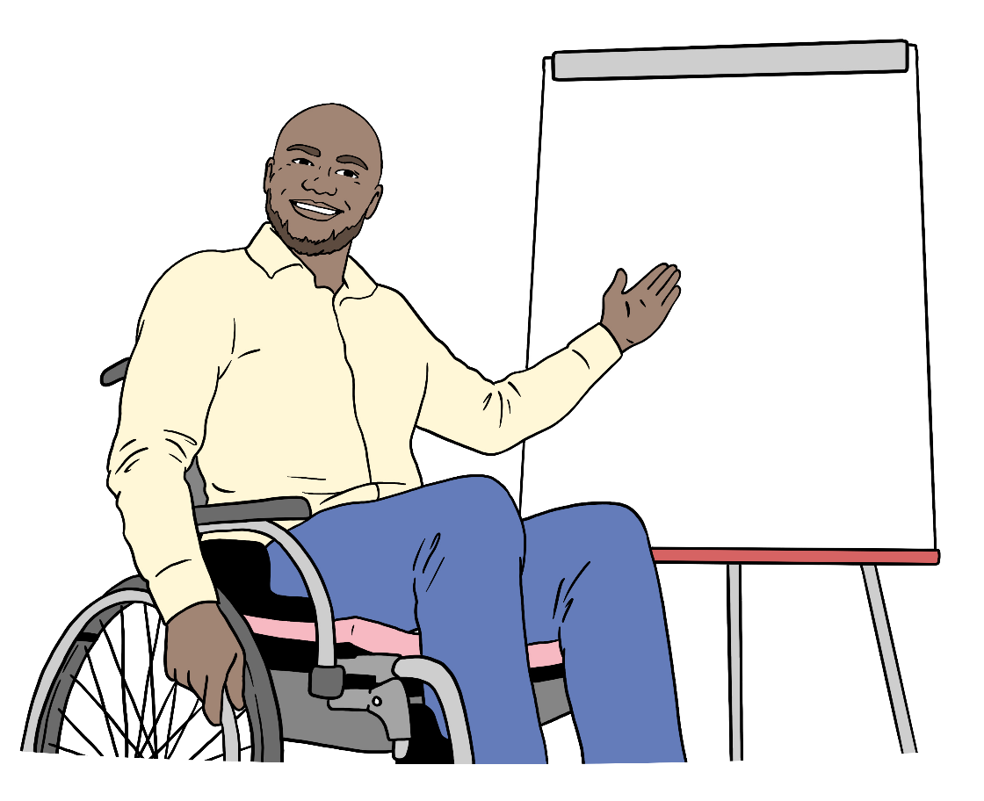

Published: May 2025

What is in this document

Page number:

The Disabled People’s
Organisations Coalition 3

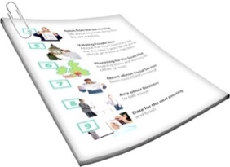
What this document is about 6

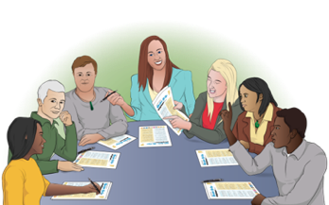
Payments NZ 9

Stats NZ 10
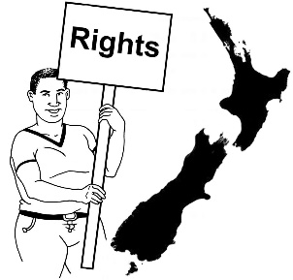

Human Rights Commissioners 11
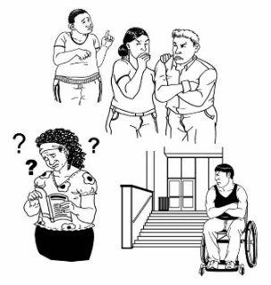

Hon Louise Upston – Minister for Disability Issues 13
Page number:

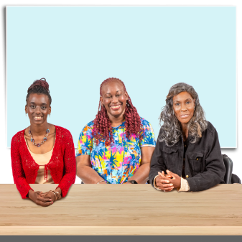
Ministry for Women 16

Donald Beasley Institute 18

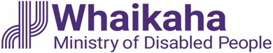
Whaikaha – Ministry of
Disabled People 22
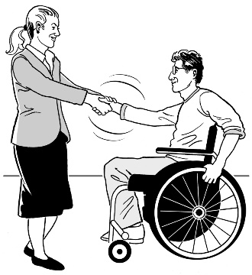

Voice of disabled people 23

The Disabled People’s
Organisations Coalition

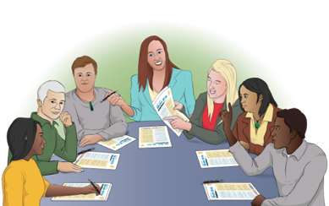
The Disabled People’s Organisations Coalition is a group of people who come from different disability organisations.

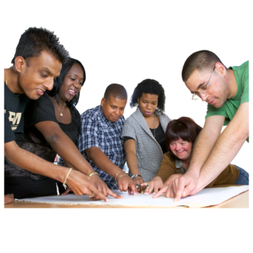
A coalition is a group of organisations that work towards shared goals.

The Disabled People’s Organisations Coalition is also called the
DPO Coalition.

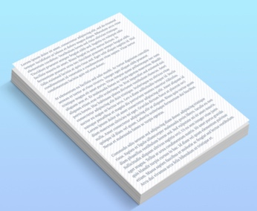
When you see the words we / us in this document it means the
DPO Coalition.

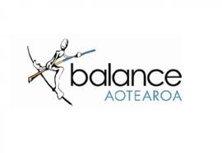
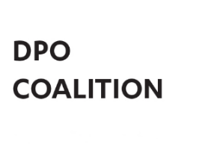
The DPO Coalition is made up of members from these 7 disability organisations:
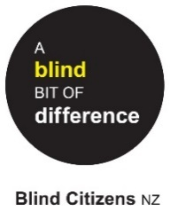
Balance Aotearoa
Blind Citizens New Zealand
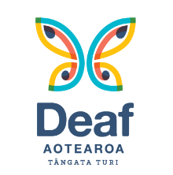
Deaf Aotearoa
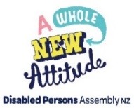
Disabled Persons Assembly NZ
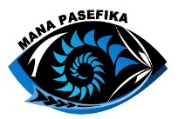
Mana Pasefika
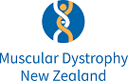
Muscular Dystrophy Association of New Zealand
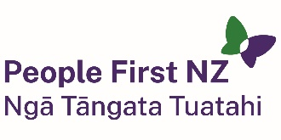
People First New Zealand – Ngā Tāngata Tuatahi.

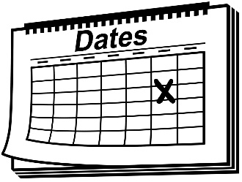
We meet about every 6 weeks to talk about important things.

We speak up about disabled people getting their human rights.

Human rights are things that the law says every person should:
have
be able to do.

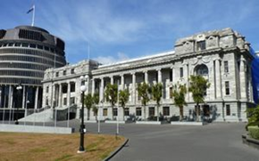
We also talk with the Government about things to do with disability.

What this document is about
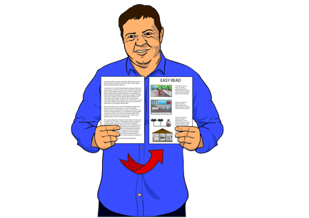

This is an Easy Read document.

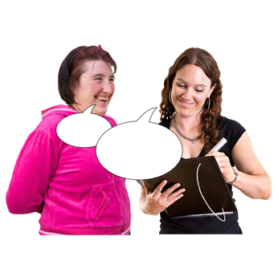
It tells you about some of the key messages from the DPO Coalition meetings we had in March 2025.

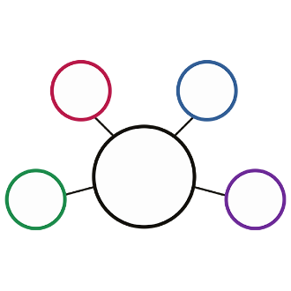
During these meetings we met with lots of:
government agencies
other community organisations.

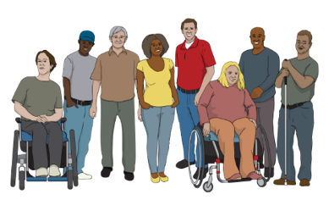
These meetings are to make sure the lives of disabled people in
New Zealand are getting better.

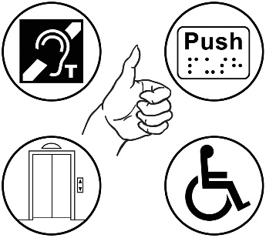
2 important things talked about often are:
accessibility
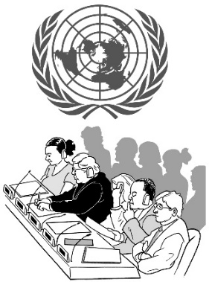
the rights of disabled people in New Zealand under the United Nations Convention on the Rights of Persons with Disabilities.
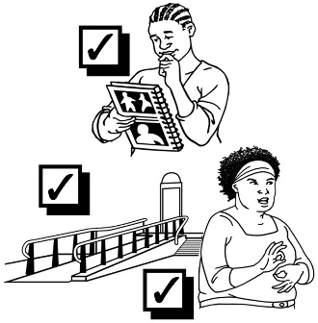

Accessibility means making things easy / safe for everyone to use.

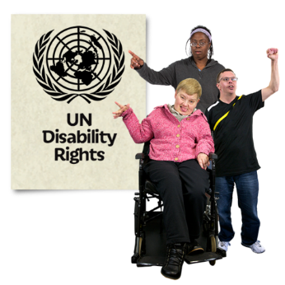
The United Nations Convention on the Rights of Persons with Disabilities:
says what governments must do to make sure disabled people get the same rights as everybody
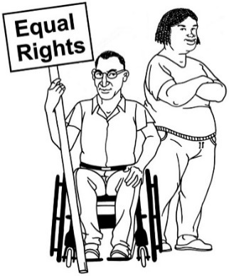
is an agreement lots of countries follow
is also called the UNCRPD.

Payments NZ

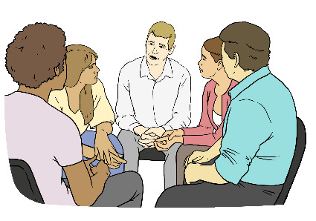
We met with 12 people from Payments NZ.

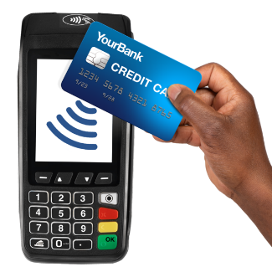
Payments NZ is a government organisation that looks at how payments are made in New Zealand.

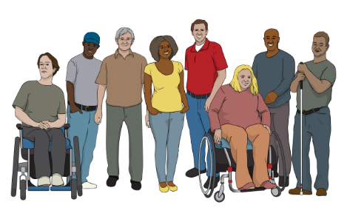
All the things we talked about were around making the way disabled people do financial transactions better.

Financial transactions means:
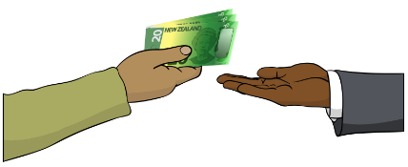
buying things
selling things.

Stats NZ

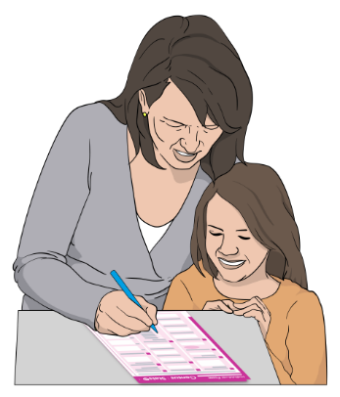
Stats NZ is a government agency that runs the census in
New Zealand.

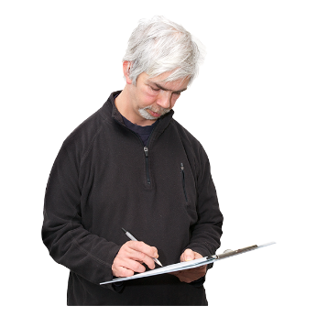
The census is a way to find out things about people in New Zealand.

We met with 6 people from Stats NZ.
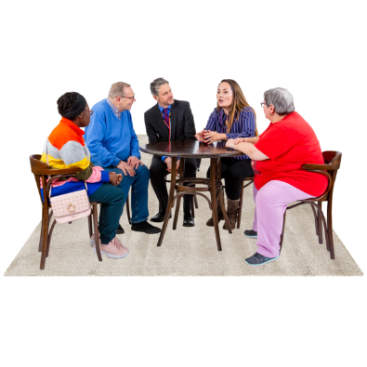

At our meeting we talked about the main things in the 2024 public consultation.

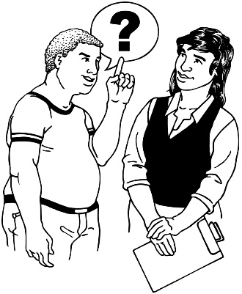
A public consultation is when people are asked questions to see what they think about something.

Human Rights Commissioner

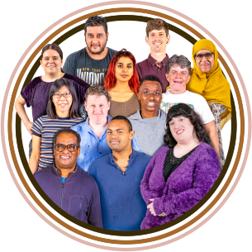
We met with:
Dr Melissa Derby – the new Race Relations Commissioner
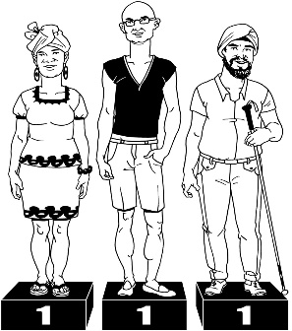
Dr Gail Pacheco – the Equal Employment Oppurtunities Commissioner
Prudence Walker – Disability Rights Commissioner
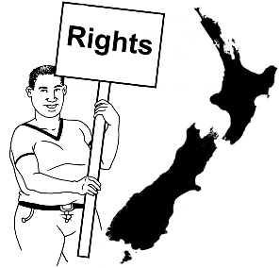
Frances Anderson – Senior Human Rights Advisor to the Disability Rights Commissioner.

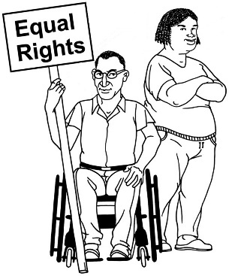
We talked about
disability rights
how disability rights is important to each of their jobs.

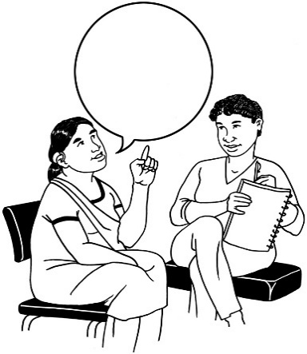
We also talked about how it is important for them to talk to disabled people about things to do with their jobs.

Hon Louise Upston –

Minister for Disability Issues

We had a meeting with:
Hon Louise Upston – Minister for Disability Issues
Chris Bunny – Deputy Chief Executive Disability Support Services Ministry of Social Development
Ben O’Meara – Deputy Chief Executive Policy and Strategy Whaikaha.

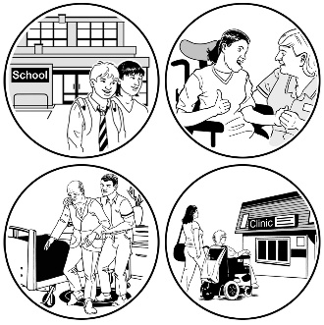
We talked about:
disability support services
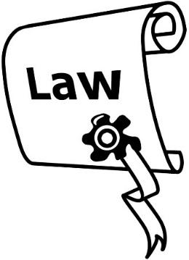
accessibility legislation – laws around accessibility
updating the Disability Strategy.

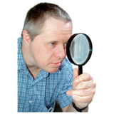
Updating means to look at something to see what needs to be done to make it better like:

changing it
adding something.

Minister Louise Upston told us:
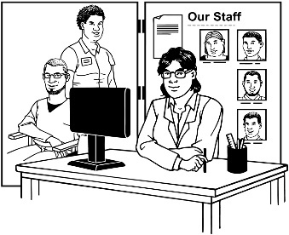
to keep working with:
- disability support services
- Whaikaha – Ministry of Disabled People.
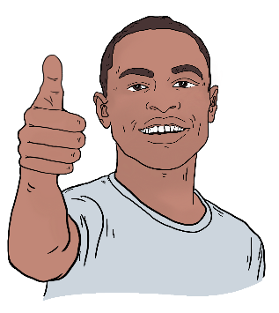
what we can add to the things we talked about in our meeting is important.

Ministry for Women

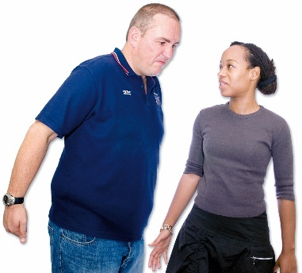
We met with the Ministry for Women to talk about their work on:
online harassment
experiences of online abuse.

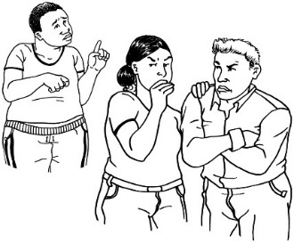
Online harassment / abuse is when someone is treated badly online like:
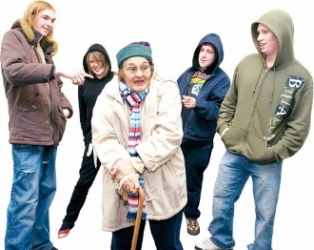
people saying nasty things:
- to them
- about them
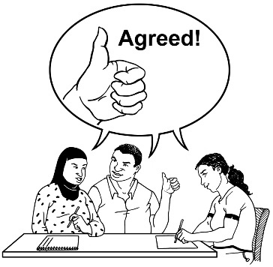
not leaving them alone.

We agreed this was important to talk about.
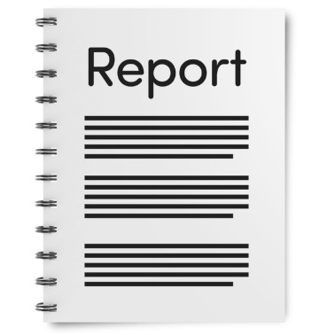
We gave some examples for the Ministry of Women to add to their Online Harm Report.

Donald Beasley Institute

The Donald Beasley Institute:
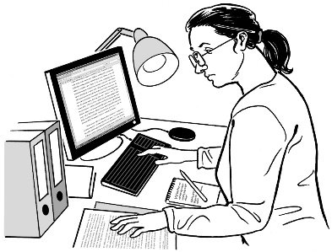
does research on things to do with disability
is also called DBI.

We met with:
Brigit Mirfin-Veitch - Director
and Associate Professor
Umi Asaka - Research and Education
Dr Robbie Francis
Watene - Senior Researcher.

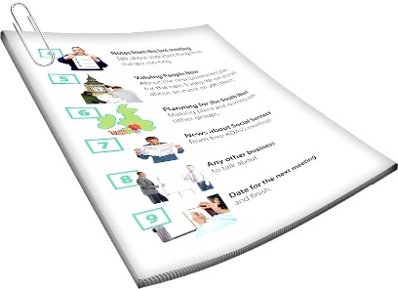
We asked the DBI on how the disabled person led monitoring reports were going.

Here monitoring is when something is being looked at closely to find out:
how well it is working
if things need to be changed to make it work better.

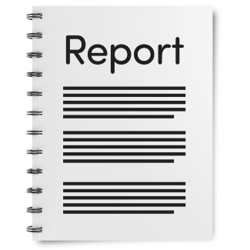
DBI had 1 report to show us.

The report was called
The Whaikaha Report.

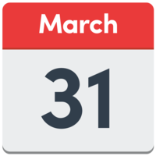
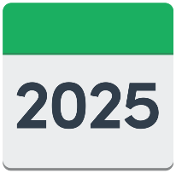
This report was made available on
31 March 2025.

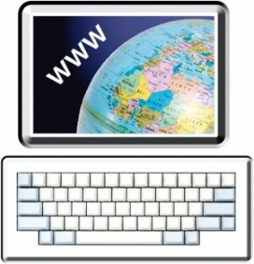
This report is available in Easy Read on the DBI website here:

tinyurl.com/yvd6rxsy
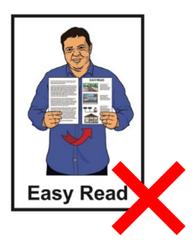

The DBI website is not in Easy Read.

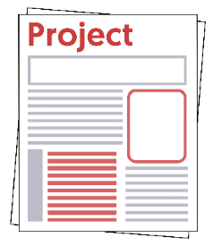
DBI is going to start a new project for us.


They will work on this project for the next 3 years.

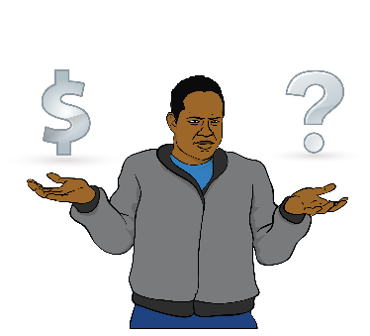
This project will be called What does an adequate standard of living look like?

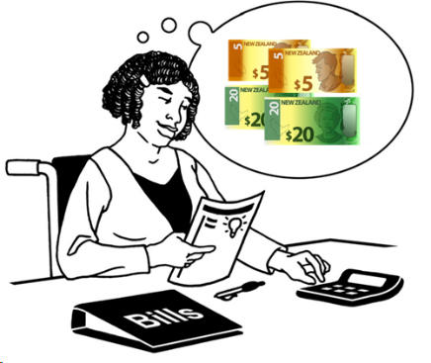
An adequate standard of living means the amount of money people need to live well in New Zealand.
This project:
will look at the cost of living for disabled people
links to Article 28 of the UNCRPD Disability Convention.

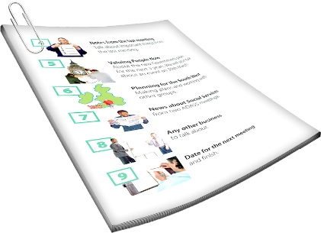
Article 28 is part of the UNCRPD to do with adequate standard of living.

Whaikaha – Ministry of
Disabled People

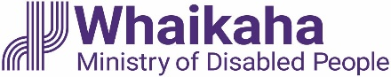
We worked with the team from Whaikaha on information that the 5 working groups will use for the next Disability Strategy.

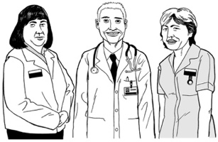
These working groups are about:
health
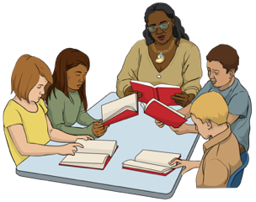
justice
education
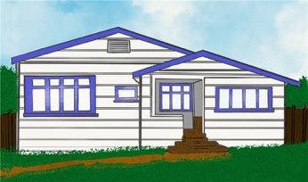
employment
housing.

Voice of disabled people

The Government meets with the DPO Coalition so disabled people can have a say in the decisions being made about them.

The DPO Coalition is always looking for new organisations to join us.

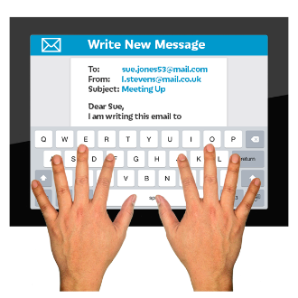
You can contact us by emailing us:

us-dpo@groups.io

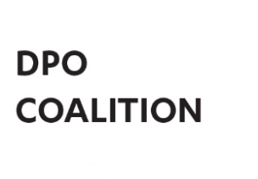
This information has been written the
DPO Coalition.

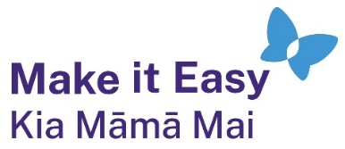
It has been translated into Easy Read by the Make it Easy Kia Māmā Mai service of People First New Zealand Ngā Tāngata Tuatahi.
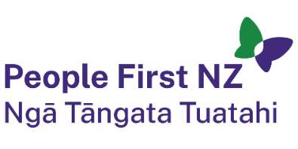
The ideas in this document are not the ideas of People First New Zealand Ngā Tāngata Tuatahi.

All images used in this Easy Read document are subject to copyright rules and cannot be used without permission.


Make it Easy uses images from:

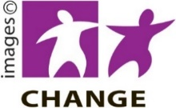
- Photosymbols

- Change Images

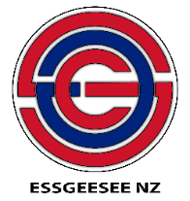
- Huriana Kopeke-Te Aho
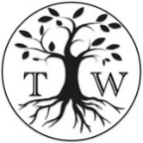
- SGC Image Works

- T Wood

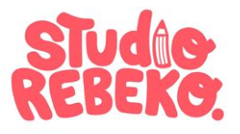
- Studio Rebeko

- Inga Kramer.

