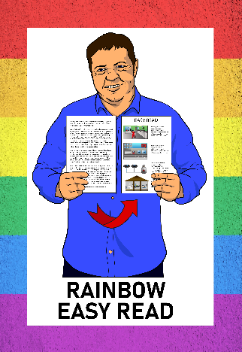
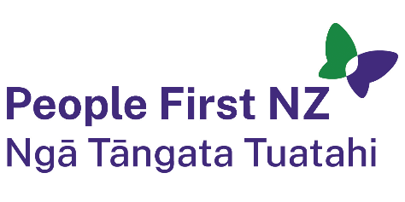
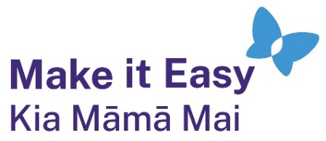

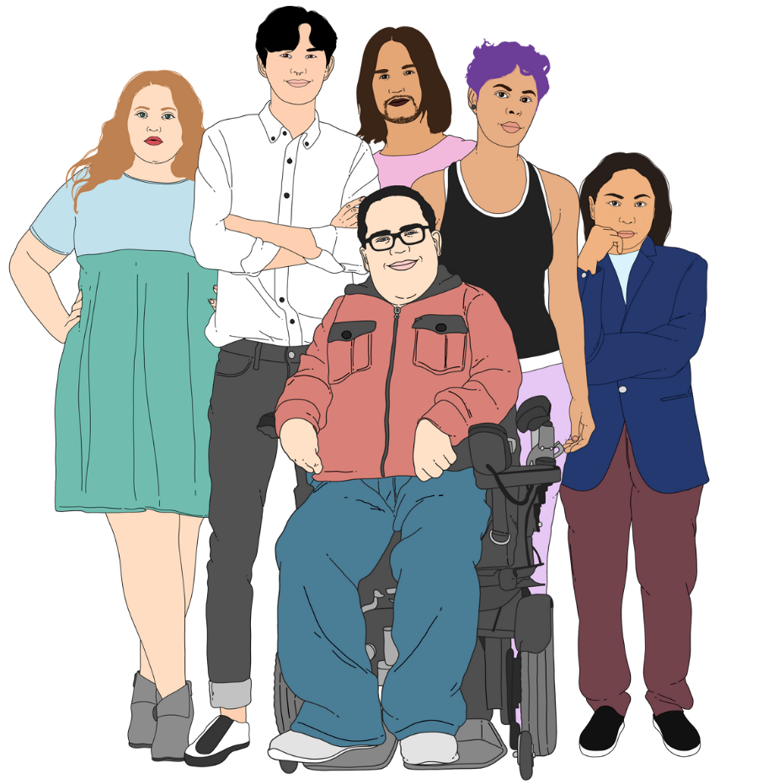
Rainbow Easy Read:
All about pronouns
he / him
she / her
they / them

Published: February 2025

About this Easy Read
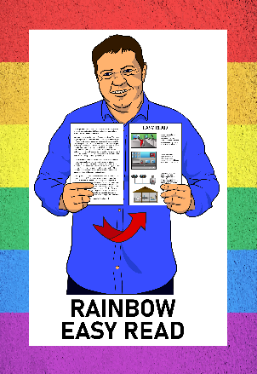

This guide is part of the Rainbow Easy Read Project.

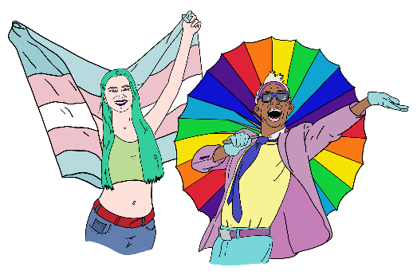
The Rainbow Easy Read Project is a group of Easy Reads for:
- people in the rainbow community
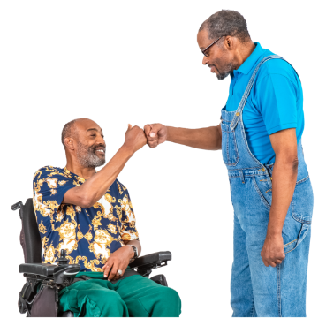
- their friends
- their whānau / families
- people who support them.


You can find all the Rainbow Easy Reads at:

https://linktr.ee/rainboweasyread

What are pronouns?

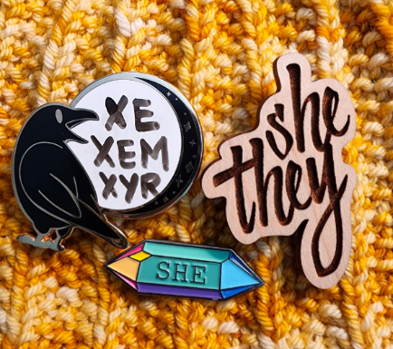
Pronouns are a kind of word.

The kind of pronouns we are talking about in this document are words we use instead of the name of another person.

For example instead of saying:

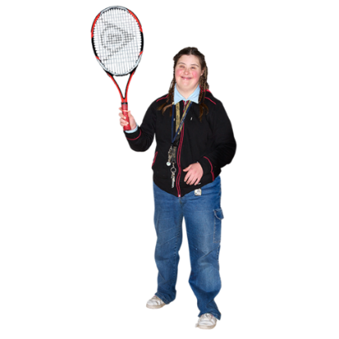
Bob goes to the park with Mary and plays tennis with Mary.

You can say:

Bob goes to the park with Mary and plays tennis with her.

In this sentence the pronoun is her.
Bob has different pronouns to Mary.

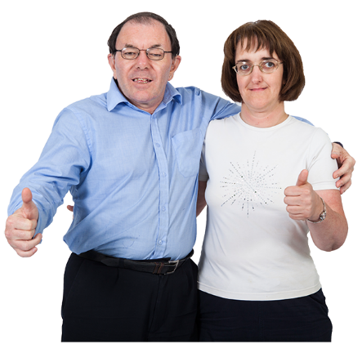
We would say:

Mary goes to the park with Bob and plays tennis with him.

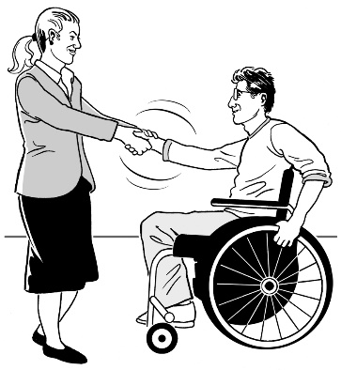
In this sentence the pronoun is him.

Using the right pronouns for people shows you respect them.

Gender and pronouns

In the English language pronouns often relate to your gender.

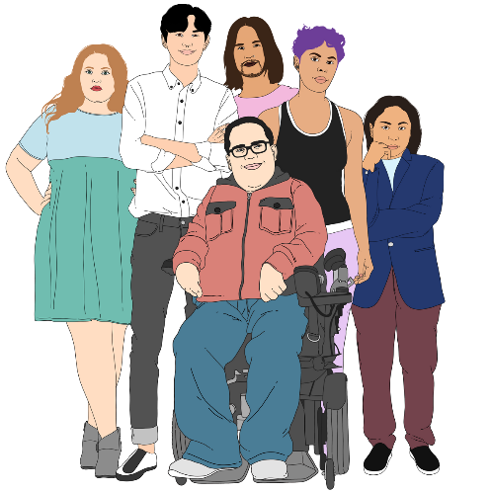
Gender is if you are:
- a man
- a woman
- another gender like non-binary.
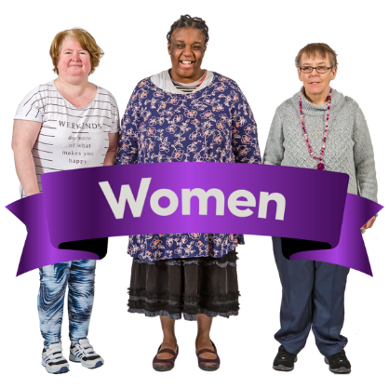

This means that:
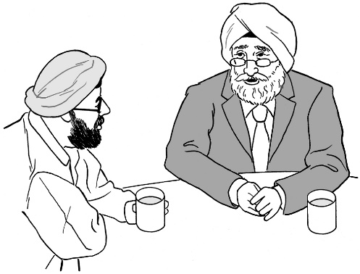
- most women use she / her pronouns
- most men use he / him pronouns.

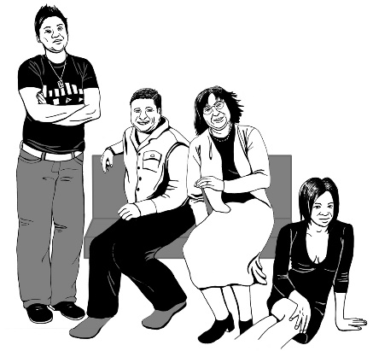
Some people change their pronouns.

1 reason people may change their pronouns is as part of transitioning because they are transgender.

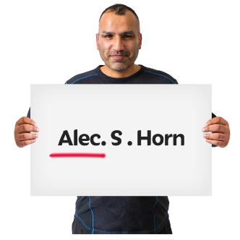
Transitioning is when a transgender person changes things to better match their gender like their:

- name
- body
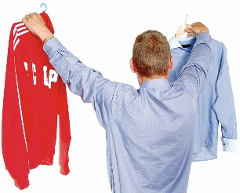
- clothes
- pronouns.

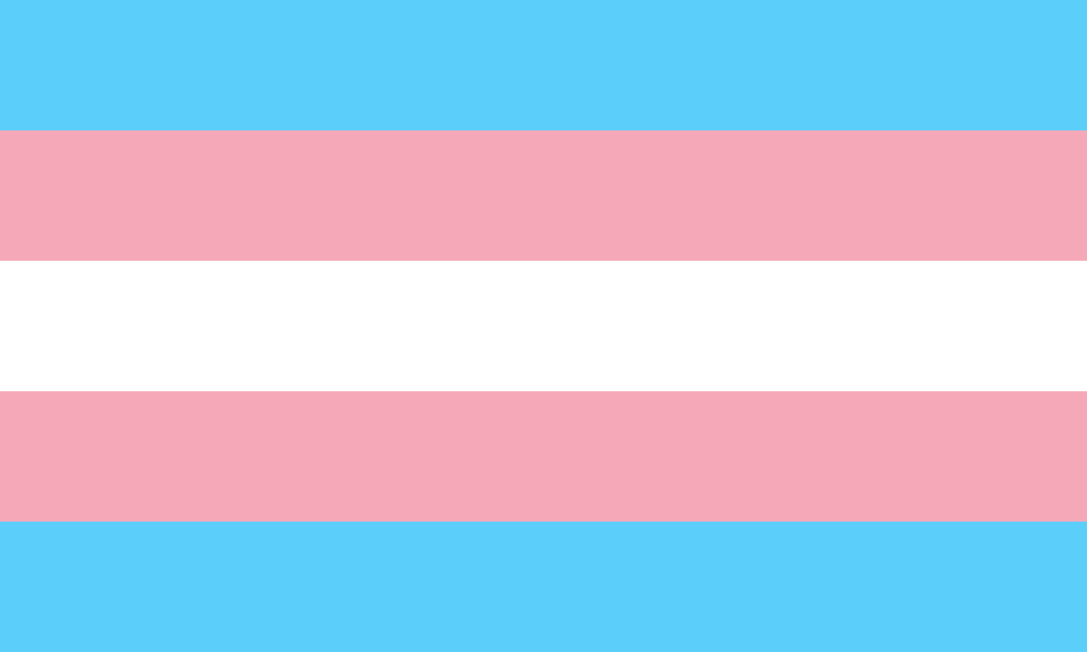
Transgender people are people whose gender is different to what people thought it was when they were born.
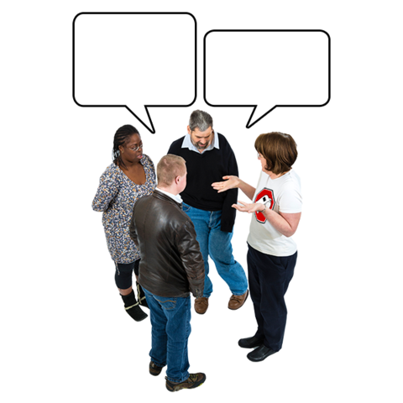
Using the wrong pronouns for someone can be misgendering.

Misgendering is when you treat someone as being a different gender to what they are.

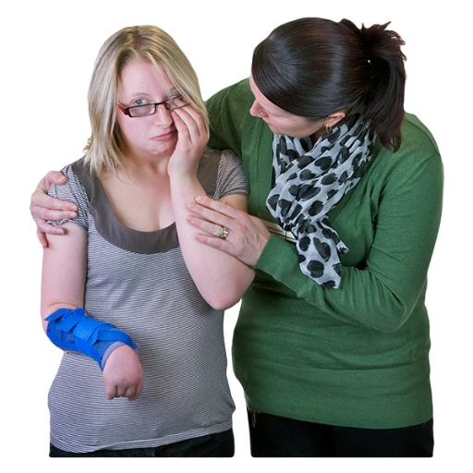
Misgendering can hurt people especially when it:
- happens a lot
- is done on purpose.

Different pronouns

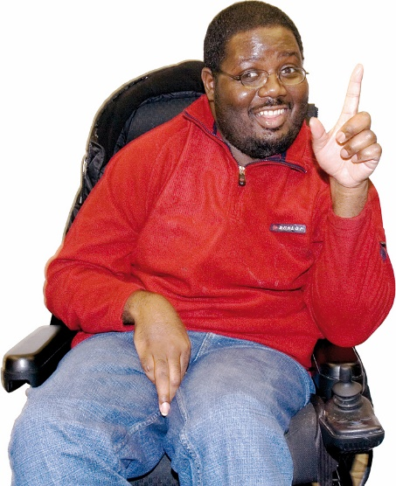
The pronouns people know best are:
- he / him / his
- she / her / hers.

They / them / their

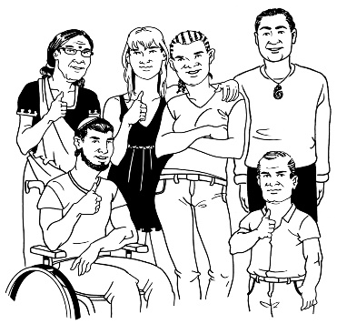
Another group of pronouns is:
they / them / their.

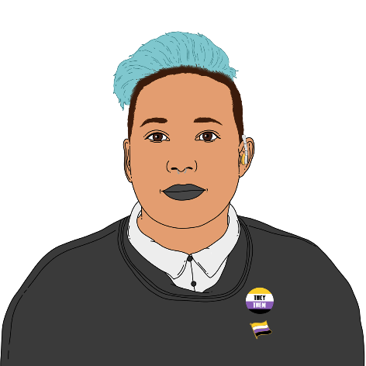
You may be used to using
they / them / their pronouns for more than 1 person.

You can also use them for one person.
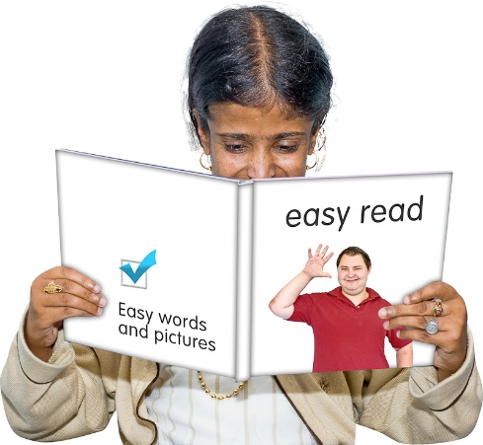
For example:

Morgan says they like reading
Easy Read because it is more accessible for them.

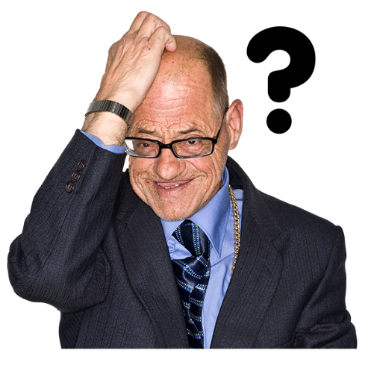
There are other ways you can use they / them / their.

You can also use they / them / their if you do not know who the person is.

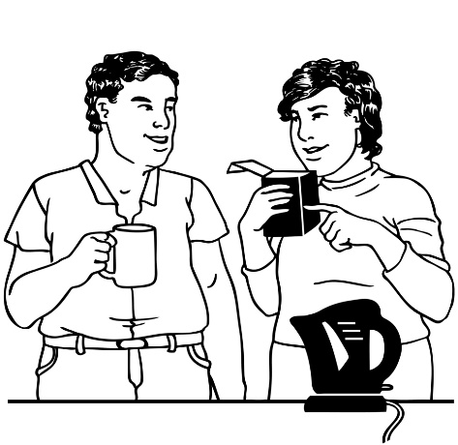
For example:

When someone comes to the event ask if they would like a coffee.

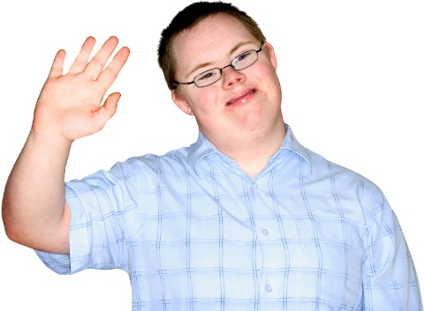
You can use they / them / their if you know a person but do not know their pronouns.


It is better to find out their pronouns if you can.

Ia

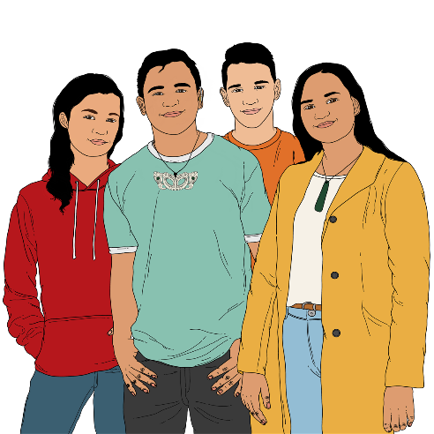
The pronoun used for talking about another person in te reo Māori is ia.

Ia is:
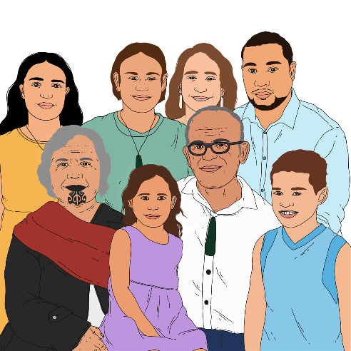
- used for everyone
- not linked to gender.

Some people have ia as their pronoun in English as well.

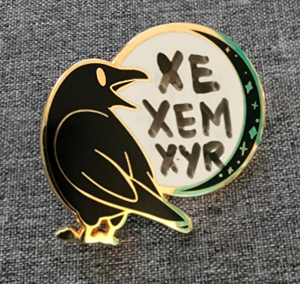
Neopronouns

There are also pronouns called neopronouns.

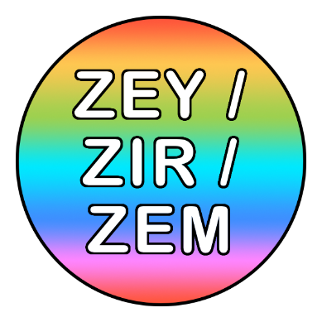
Neo means new but not all of them are very new.

There are lots of neopronouns.

Some of the most common neopronouns are:
- hir / sie
- xe / xim / xir
- zey / zem / zir
- ey / em / eir.

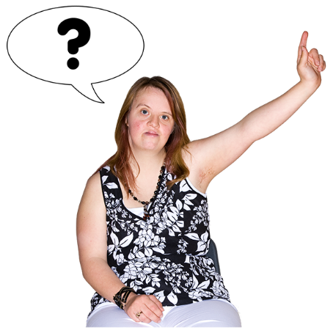
If you know someone who uses neopronouns you can ask them about how to use them.


A good website to learn more about neopronouns is:
https://en.pronouns.page/pronouns

This website shows you how different pronouns are used.
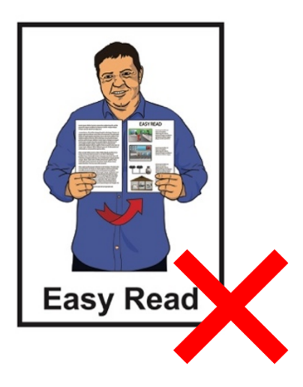

The information on this website is not in Easy Read.

Using the right pronouns

Some people guess what pronouns other people use.

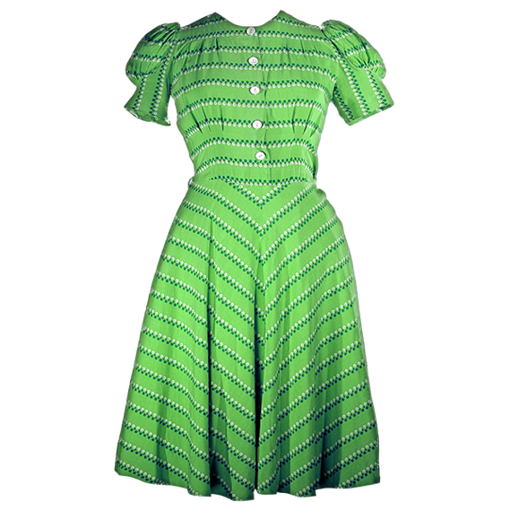
For example if they see someone wearing a dress they think:
- that person is a woman
- that person uses she / her pronouns.

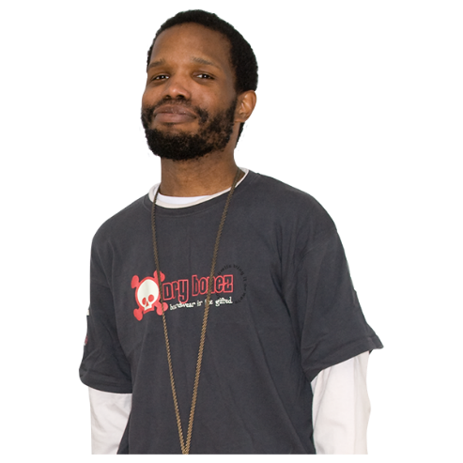
If they see someone with a beard they think:
- that person is a man
- that person uses he / him / his pronouns.

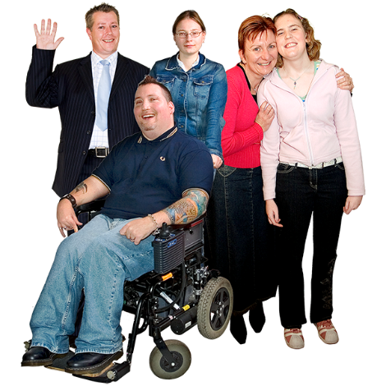
Thinking like this is not always right because:
- anyone can wear any kind of clothes
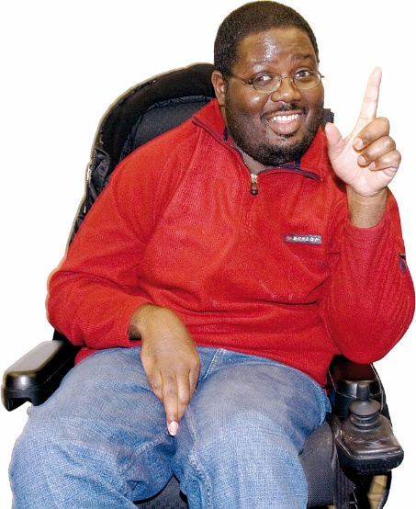
- anyone can have any type of body.

It is better to know what pronouns people use.


You can let people know your pronouns by:
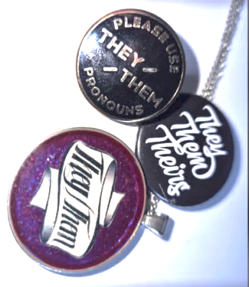
- telling them when you meet them
- wearing a badge that shows your pronouns
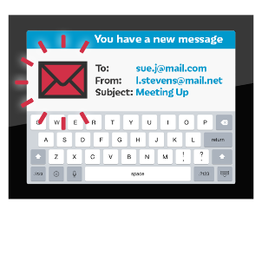
- putting your pronouns in your email signature.


An email signature is words after your email that usually include things like:
- your name
- who you work for.
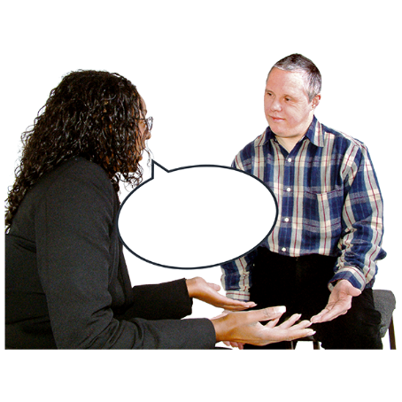

If you want to ask someone their pronouns it is best to tell them yours first.

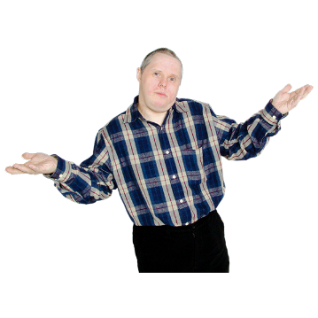
It is okay to:
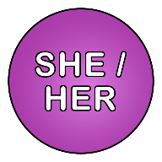
- not be sure what pronouns you want people to use when talking about you
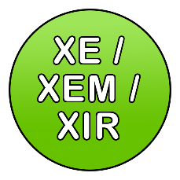
- change your pronouns
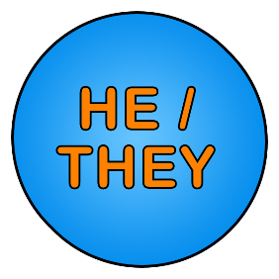
- have more than one group of pronouns.

If you get pronouns wrong

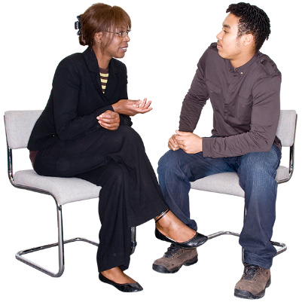
If you use the wrong pronouns for someone by mistake it is best to:
- say sorry
- keep talking using the right pronouns
- try to do better in future.

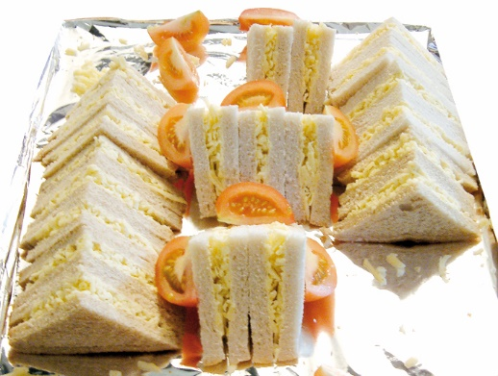
For example someone might say:

Sam said she – sorry I mean he –would bring the sandwiches.

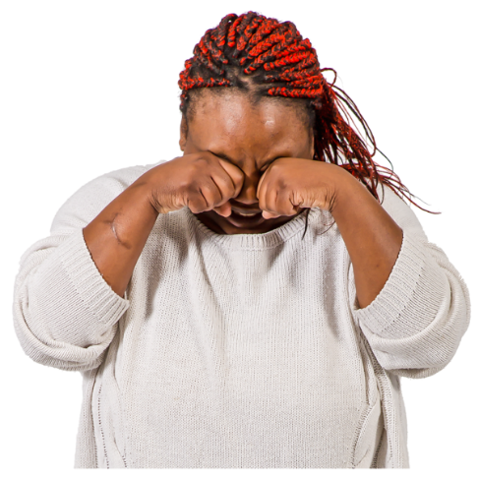
Do not spend a lot of time talking about how sorry you are.

That often makes people feel worse.
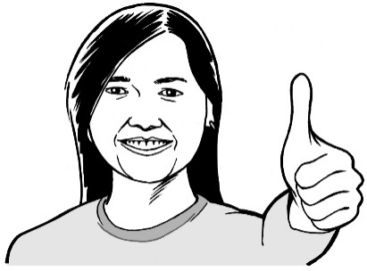

Just try to do better next time.


If someone else uses the wrong pronouns for someone who is not there you can tell them the right ones.

For example:
Sam uses he pronouns.

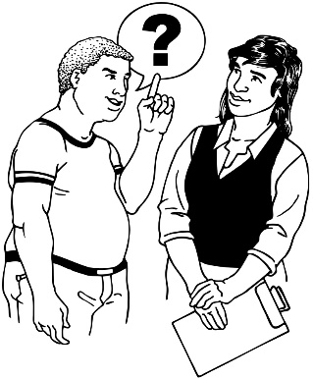
If people often use the wrong pronouns for someone who is your good friend you can ask the friend what they want you to do when that happens.

If you are having trouble remembering the right pronouns for someone the best thing to do is practise.

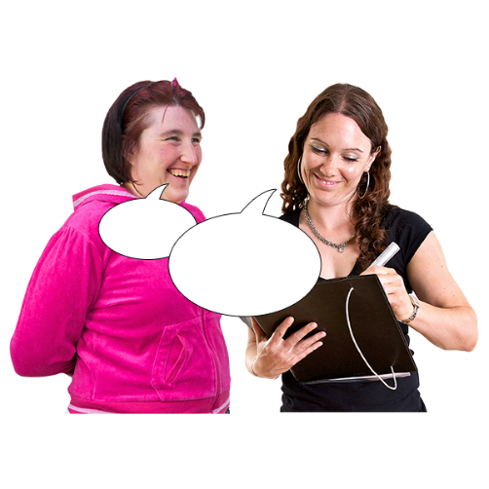
You can practise by asking a friend or family member to assist you.

Tell your friend or family member about the person using the right pronouns.

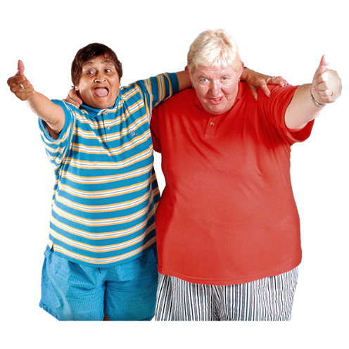
You could talk about:
- how you spend time together
- what you like about that person.

Practice is also useful if someone you know changes their pronouns.

More information

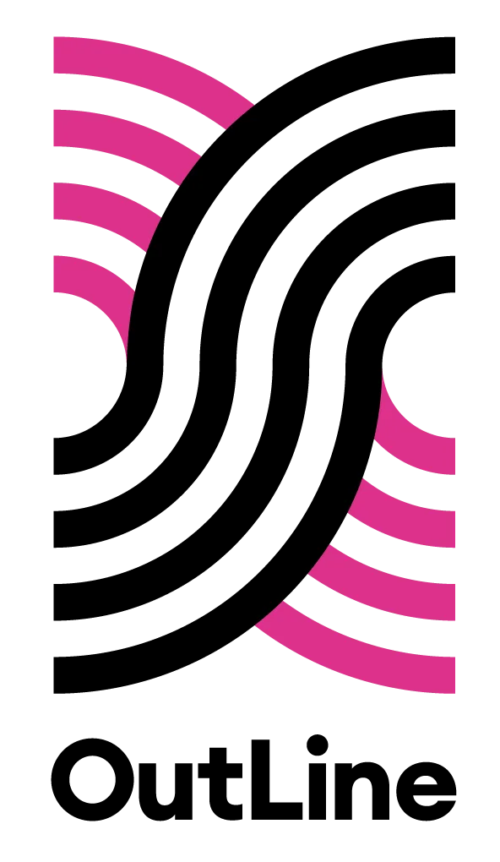
You can contact OutLine for support if you:
- are part of the rainbow community
- think you might be part of the rainbow community.

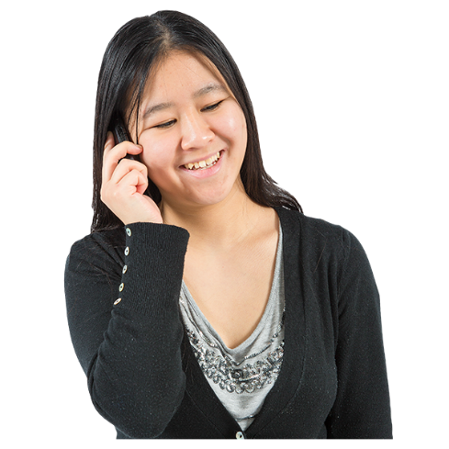
You can contact OutLine every day between 6 pm to 9 pm in the evening:
- by phone on:
0800 688 5463
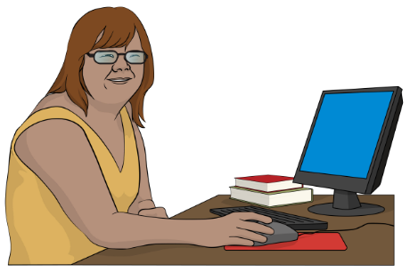
- using the text chat on their website at:
outline.org.nz/chat
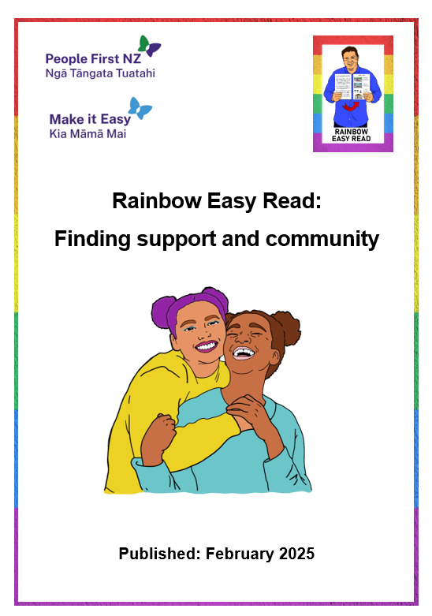
There is a Rainbow Easy Read called:

Rainbow Easy Read: Finding support and community

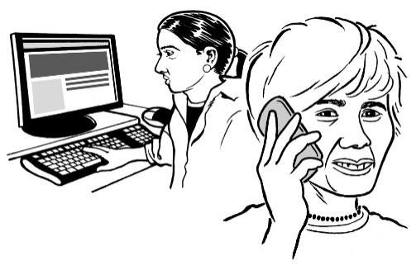
It has information about more places you can contact for:
- information
- support.

You can find this Easy Read at:

https://tinyurl.com/RERcommunity

Thank you

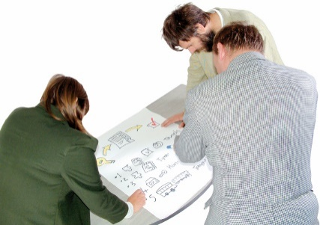
Lots of people worked together on the Rainbow Easy Reads.


Thank you to the Rule Foundation for giving us the money to make the Rainbow Easy Reads.

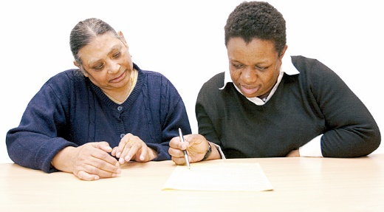
Thank you also to:
- the People First NZ members who worked as advisors
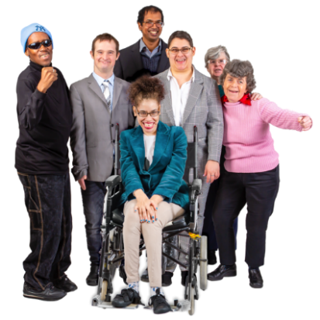
- the People First NZ staff who supported them
- everyone who has supported this mahi / work.

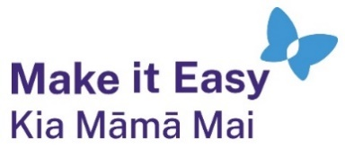
This information has been written by Make it Easy Kia Māmā Mai.

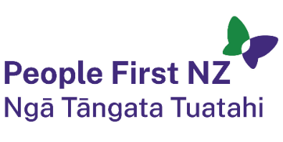
Make it Easy is a service of People First New Zealand Ngā Tāngata Tuatahi.


All images used in this Easy Read document are subject to copyright rules and cannot be used without permission.


Make it Easy uses images from:

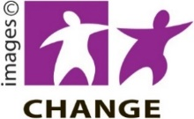
- Photosymbols


- Change Images

- SGC Image Works


- Huriana Kopeke-Te Aho

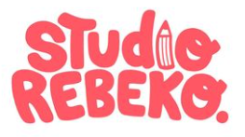
- T Wood

- Studio Rebeko

- Inga Kramer.

