# **How to watch the livestream funeral of Sir Robert Martin**

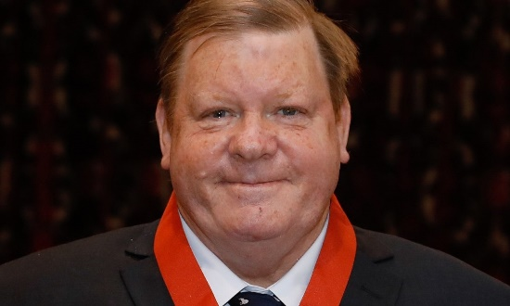

Sir Robert Martin sadly passed away on 30 April 2024.

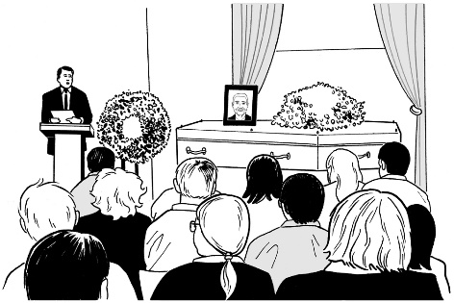

Dempsey and Forrest is the funeral service looking after the funeral for Sir Robert Martin.



The funeral for Sir Robert Martin is being held:

* **Monday 6 May 2024**

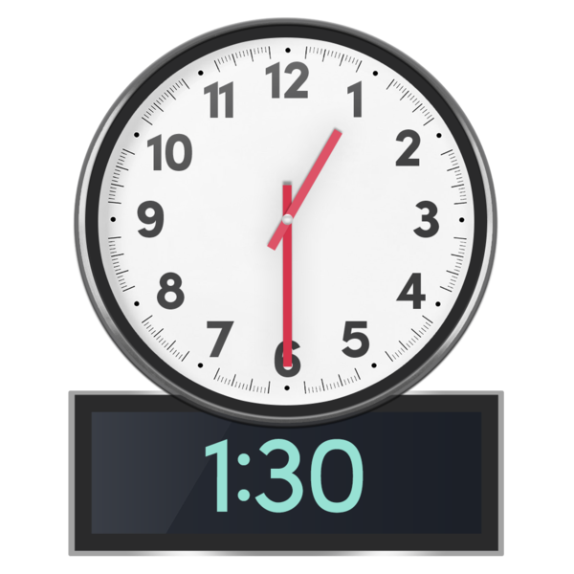

* **1.30 pm New Zealand time.**

The funeral is being **livestreamed** at this website link:

[**https://vimeo.com/event/974546/23528814a0**](https://vimeo.com/event/974546/23528814a0)

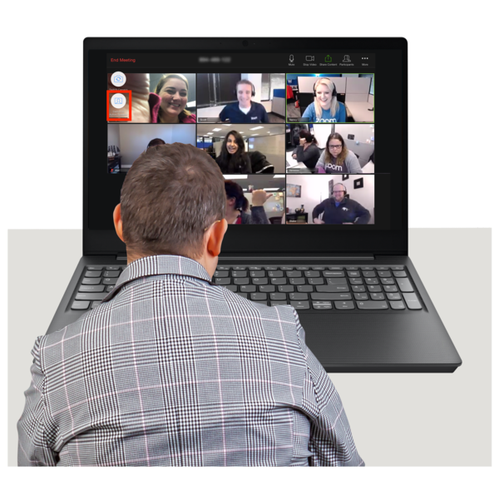

**Livestreamed** means you can watch the funeral online on devices like a:

* + laptop / computer



* + iPad
  + mobile phone.



Livestream is like watching a video of the funeral as it is happening.

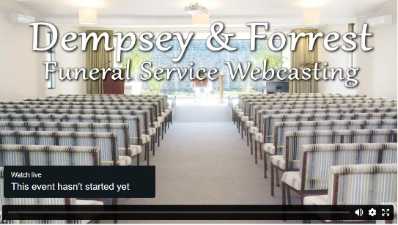You will be able to see / hear what people say at the funeral.

The people at the funeral will not be able to see / hear you.

You can also watch the livestream by going to this **website**:

[**www.dempseyandforrest.co.nz**](http://www.dempseyandforrest.co.nz/)

Then click on the box that says

**Watch Services Online**

Then click on the link that says:

**MARTIN, Sir Robert George (KNZM) (MNZM)**

* **Monday 6 May, 1.30 pm**

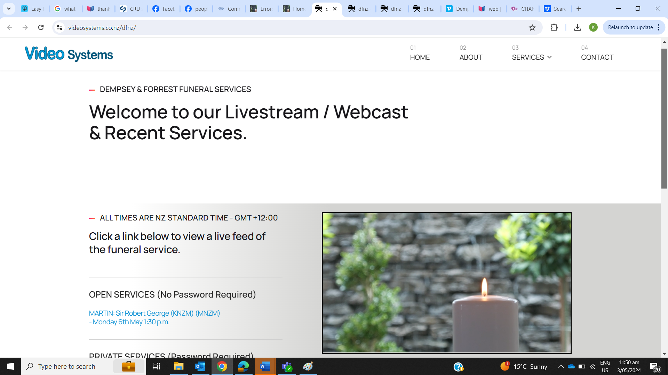

Then click Play

Sir Robert George (KNZM) (MNZM)

# **Important things to know**

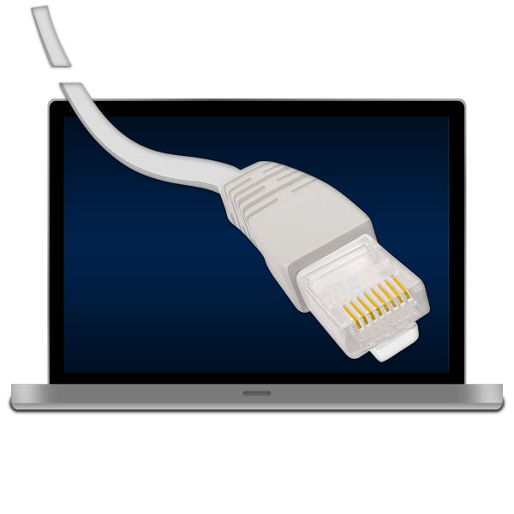You do need to make sure you have a good internet connection.

If you have a bad internet connection the livestream may not work as well.

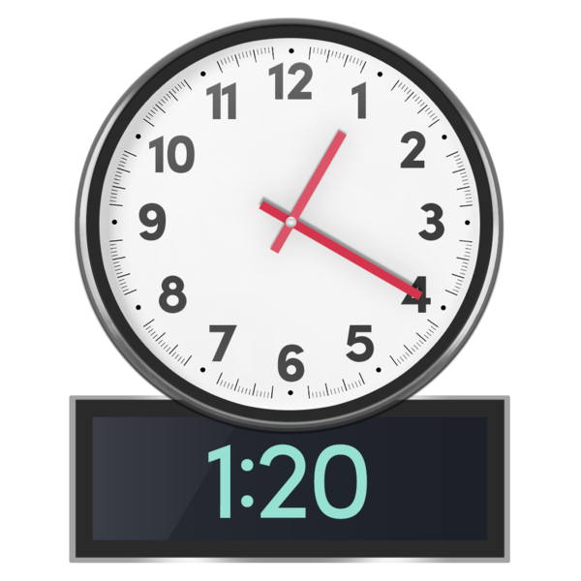

The livestream will start working from 1.20 pm on Monday 6 May 2024.

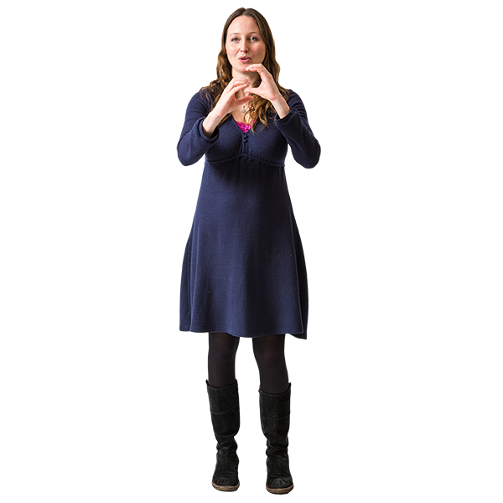

There will be New Zealand Sign Language Interpreters at the funeral / on the livestream.



You do **not** need to:

* put in a password



* pay any money to watch the livestream.

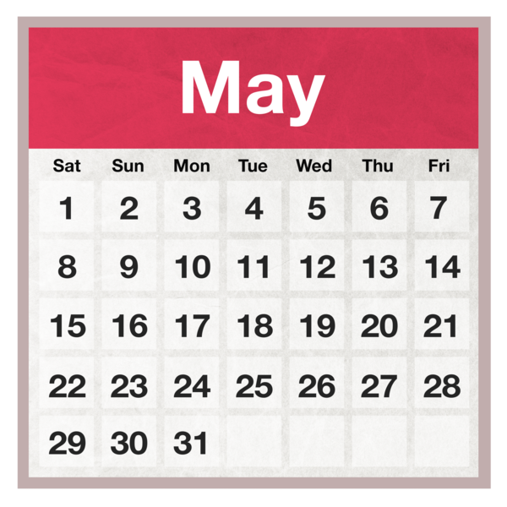The livestream video will stay on the Dempsey and Forrest website for

1 month.



This means you can watch the funeral at another time that works for you.

It can take a day or so for the video to be on the funeral website.

You can find more information

about the funeral at this **website**:

[**www.dempseyandforrest.co.nz**](http://www.dempseyandforrest.co.nz/)

Funerals can make us feel very sad.

It is okay to feel sad.

It can be good to have people around you while watching the funeral for support.

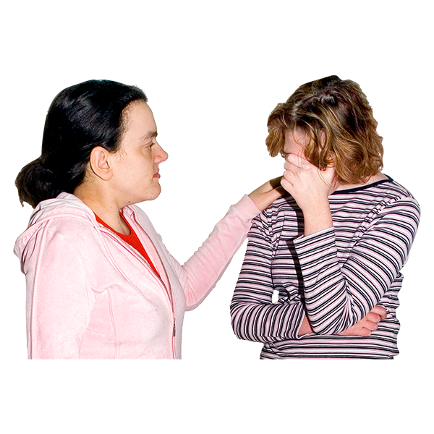

After the funeral talk to your family and friends about how you are feeling.

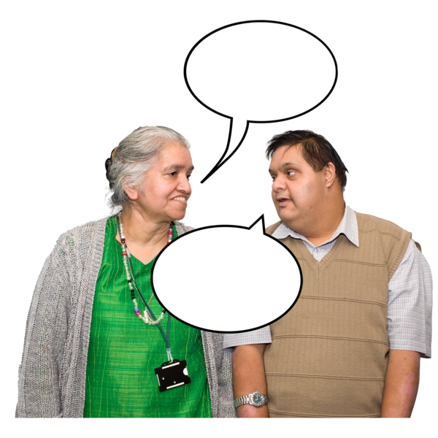

If you are a People First NZ member you can talk to your Regional Coordinator or Local Assistant.

This information has been written by People First New Zealand Ngā Tāngata Tuatahi.

It has been translated into Easy Read by the Make it Easy Kia Māmā Mai service of People First New Zealand Ngā Tāngata Tuatahi.

Photo SymbolsThis Easy Read information uses images from:



* Changepeople.org

Photosymbols.com.

  
All images used in this Easy Read document are subject to copyright rules and cannot be used without permission.