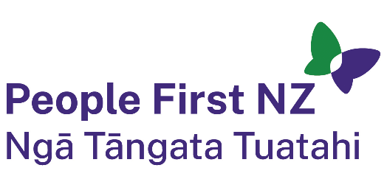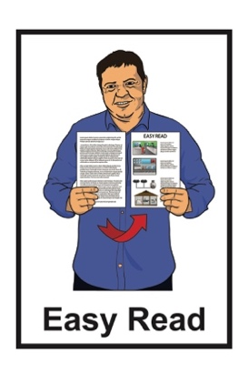

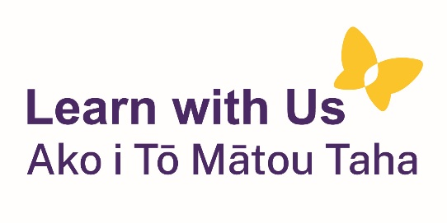

What does an

Enabling Good Lives

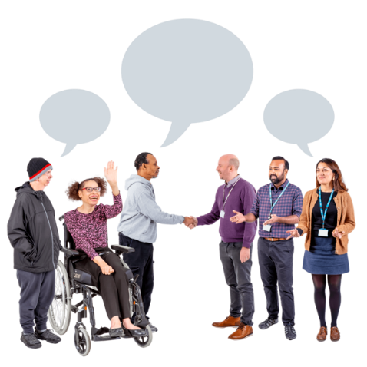Kaitūhono / Connector do?

Published: August 2024

# About this document

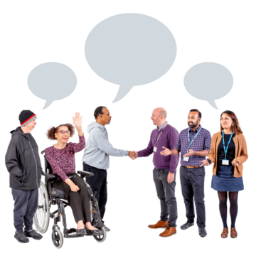

This Easy Read document is about the **role** of an **Enabling Good Lives** Kaitūhono / Connector.

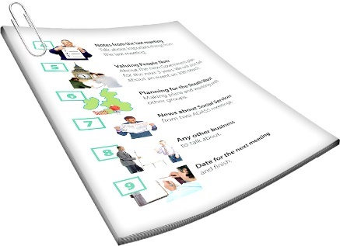

We will talk more about what the Kaitūhono / Connector does on **pages 3 to 4** of this document.

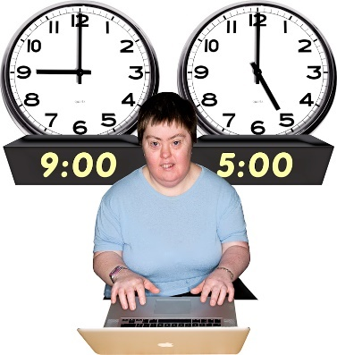A **role**:

is another word for a job

says what kind of things someone does in a job.

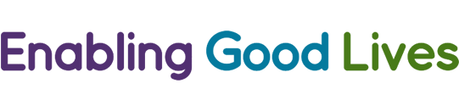**Enabling Good Lives** is a different way of thinking about disability support.

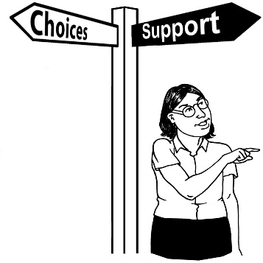

Enabling Good Lives is about having:

choice and control in your life

the support you need and want.

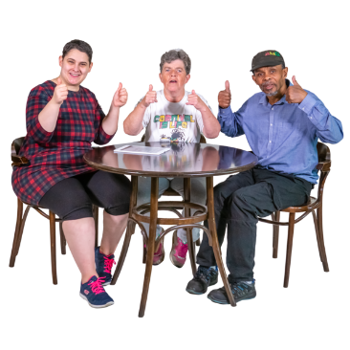

Enabling Good Lives is sometimes called **EGL** for short.

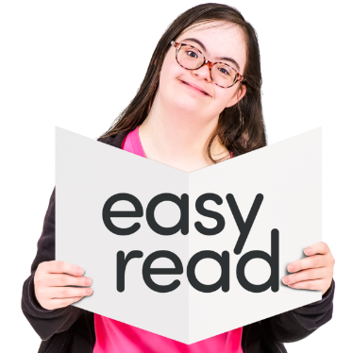

You can find out more about EGL in this Easy Read document:

**https://tinyurl.com/2p8x3fz8**

# What does the Kaitūhono / Connector do?

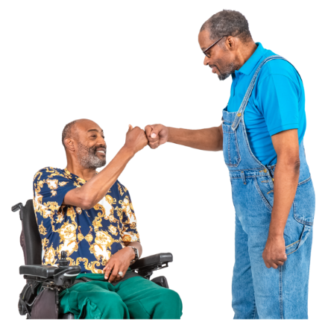

The Kaitūhono / Connector is someone who works with EGL to support the needs of disabled

people and their whānau.

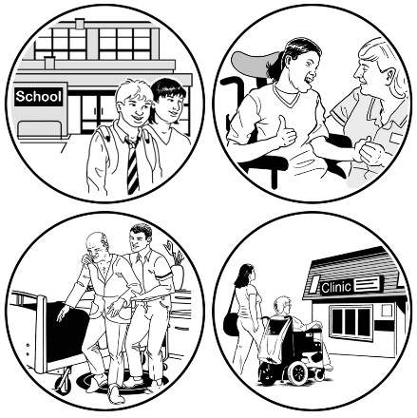They do this by connecting people with:

support services

their community.

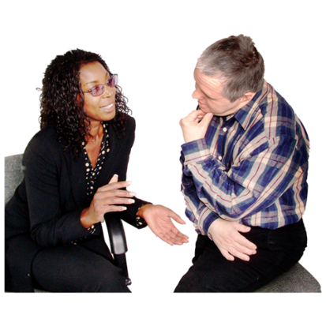The Kaitūhono / Connector listens to disabled peopl and their whānau to find out what they:

want

need.

The Kaitūhono / Connector does not tell disabled people and their whānau what to do.

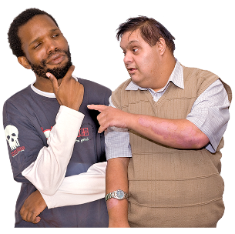

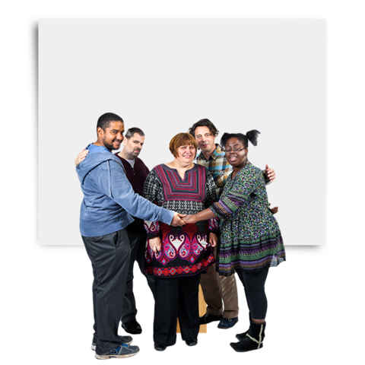The Kaitūhono / Connector knows it is important that disabled people are part of a community that:

supports them

they feel supported by.

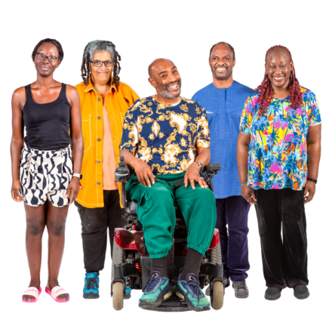

The Kaitūhono / Connector is well connected which means they know lots of different people / support services in the community.

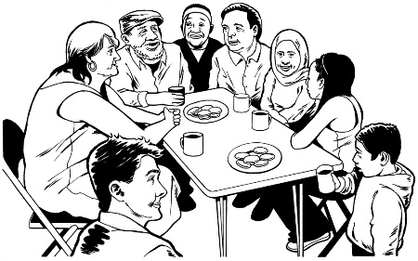

They use this knowledge to better support disabled people and their whānau.

# What makes a good

# Kaitūhono / Connector?



The Kaitūhono / Connector has a **good relationship** with the people they are supporting.

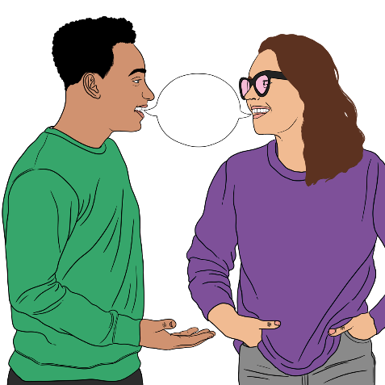A **good relationship** is when people:

work well together

like / get on with each other

have the same kinds of ideas.

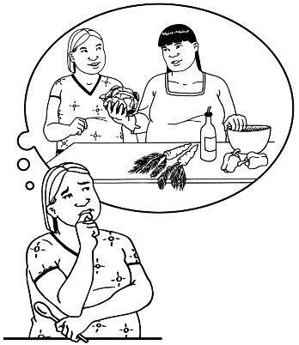

The Kaitūhono / Connector will not try to change your mind about the things you want / think.

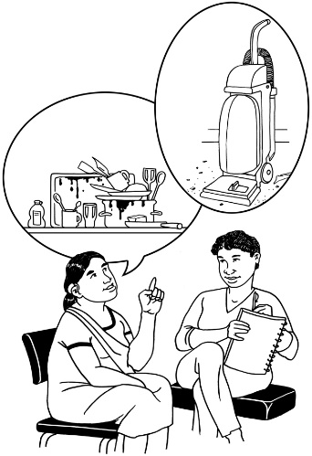The Kaitūhono / Connector can support you to think about how you want to live a good life.

The Kaitūhono / Connector is an **ally** to the people they are supporting.

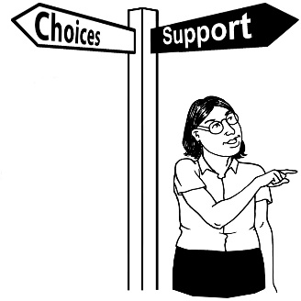

An **ally** is someone who gives other people:

support

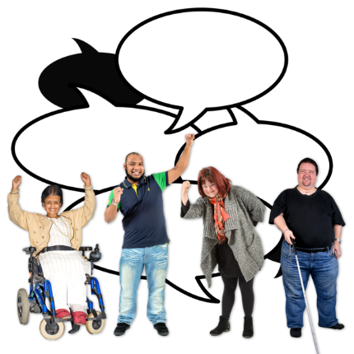advice.

An ally is also a person who speaks up for others.

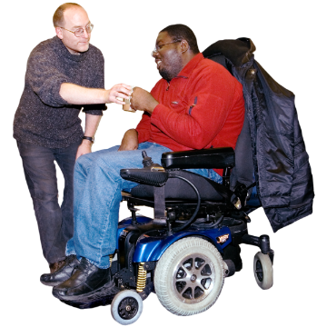

The Kaitūhono / connector always acts in a way that puts disabled people and their whānau first.

The Kaitūhono / Connector is someone you can **trust**.

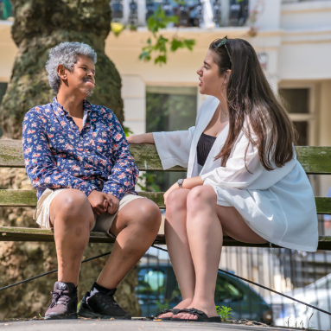**Trust** means that someone is:

good / safe to talk to

will always act / do things in a way that supports you.

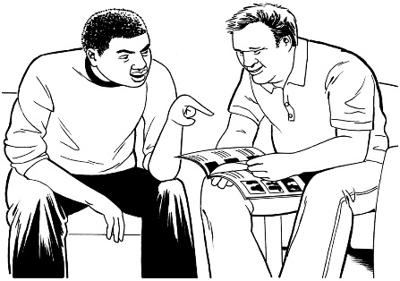The Kaitūhono / Connector will also:

explain things in a way that makes sense to you

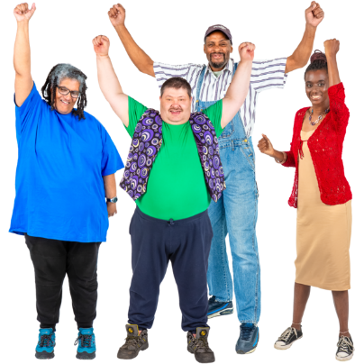support you to think about all the choices you have

encourage you to make big plans for the **future**.



The **future** is a time that has not yet happened.

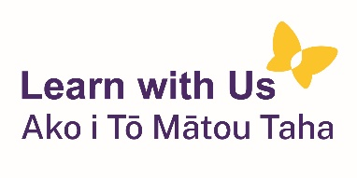This information has been written by Learn with Us Ako i Tō Mātou Taha

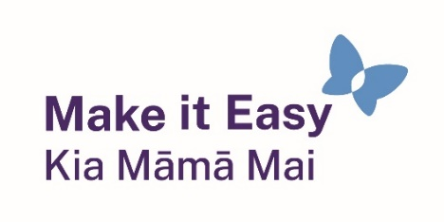

It has been translated into Easy Read by the Make it Easy Kia Māmā Mai service of People First New Zealand Ngā Tāngata Tuatahi.

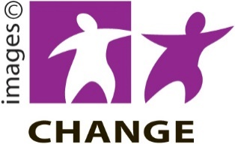

Make it Easy uses images from:

* Changepeople.org

Photosymbols.com

* SGC Image Works
* Huriana Kopeke-Te Aho

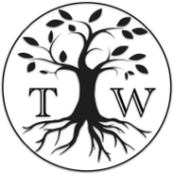

* T.Wood.

  
All images used in this Easy Read document are subject to copyright rules and cannot be used without permission.