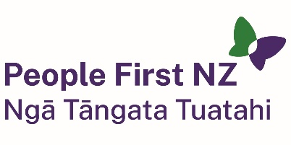
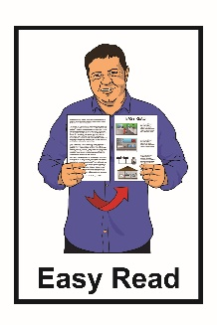

Job advert: Local Group Assistant

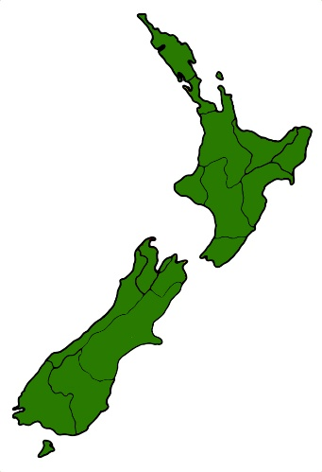

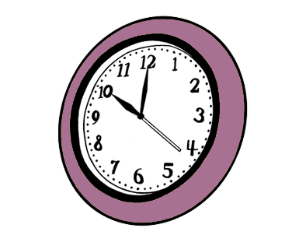
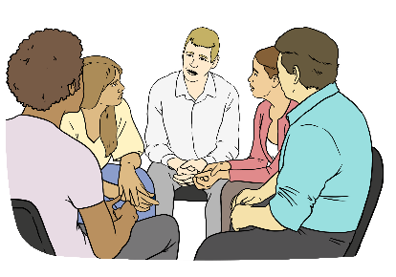
This is an Easy Read job advert for a Local Group Assistant at People First New Zealand.

We are looking for a new Local Group Assistant in the Hamilton area of New Zealand.

A Local Group Assistant supports a People First NZ group of members / people with learning disability who meet every month.

This job is part-time which means it will only be 8 each month.
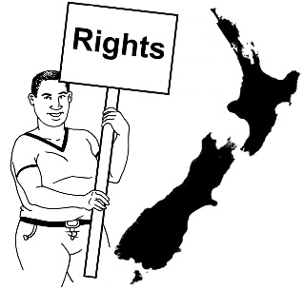
This could be a good job for you if you are interested in:

human rights / the things the law says everyone should have
social justice / people being treated fairly.


Some of the things the Local Group Assistant will do are:

- support members to plan / have a monthly meeting
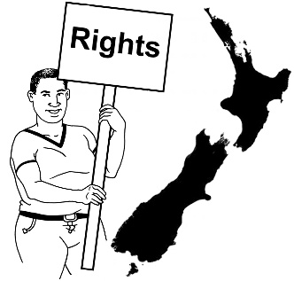
- make sure members get the information they need to make their own choices
- support members to:

- learn about their rights
- speak up for themselves / their rights.
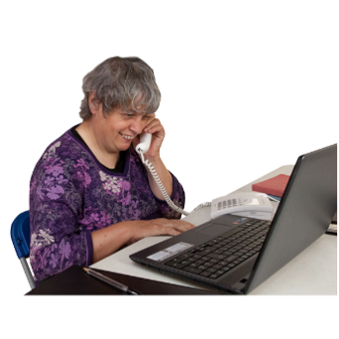
Some of the other things the Local Group Assistant will do are:
take minutes / write down what happens in meetings
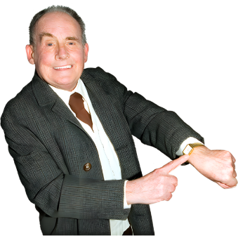
make sure the meeting runs well / on time
make bookings
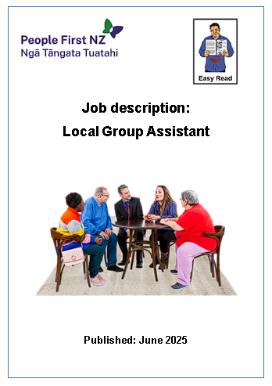
pass on information from People First NZ.

Email People First NZ for the job description / full list of things the Local Group Assistant would do.


Our email is:
ask@peoplefirst.org.nz

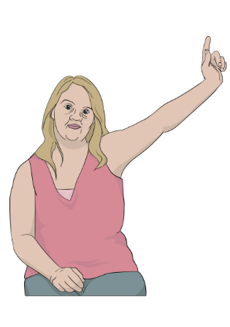
We want to hear from both:
disabled people
non-disabled people.


We want to make applying for jobs with People First NZ as easy for everyone as we can.

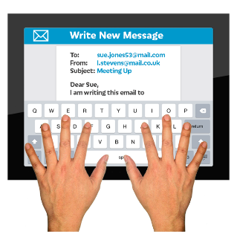
You can also contact People First NZ by email if you:
are interested in the job
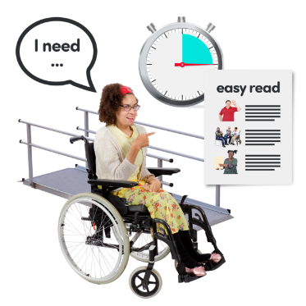
want to know more about the job
need a different way to apply instead of by email.

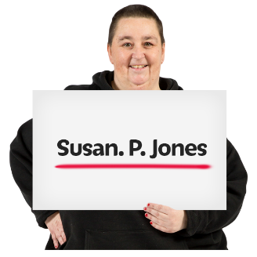
To apply please email us:
a letter telling us about you / why you would be good at the job
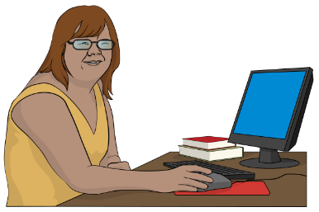
a CV / list of things you have done already like:
- jobs / volunteer roles
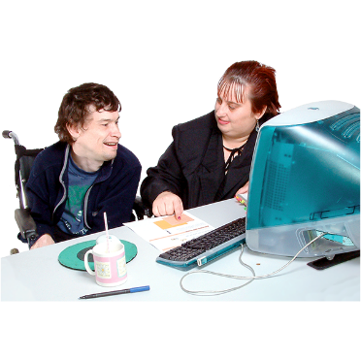
- study / qualifications
- ways you have supported disabled people before.

This information has been written by People First New Zealand Ngā Tāngata Tuatahi.

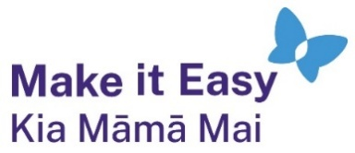
It has been translated into Easy Read by the Make it Easy Kia Māmā Mai service of People First New Zealand Ngā Tāngata Tuatahi.

All images used in this Easy Read document are subject to copyright rules and cannot be used without permission.


Make it Easy uses images from:

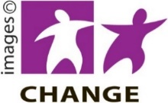
- Photosymbols

- Change Images


- Huriana Kopeke-Te Aho

- SGC Image Works

- T Wood

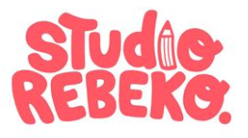
- Studio Rebeko

- Inga Kramer.

