

**Local Group Assistant**

**West Coast (Hokitika, South Island)**

**Part-time role – 8 hours a month**

**Are you interested in self-advocacy for people with a learning (intellectual) disability?**

People First West Coastis an established groups and is looking for an Assistant to work alongside people with learning disability to:

* hold monthly meetings in Hokitika
* encourage learning about self-advocacy and speaking up
* assist members to represent their peers in community forums
* promote the local group within the community.

*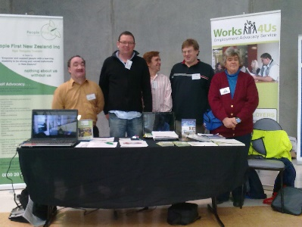***With your assistance, members will learn how to:**

* gain self-determination
* advocate for themselves
* develop leadership skills
* get involved in their community
* be a contributing member of New Zealand society.

**For more information and to view the job description or apply, please contact:**

Holland Gaston – Midsouth Regional Coordinator

Email: [hollandgaston@peoplefirst.org.nz](mailto:hollandgaston@peoplefirst.org.nz)

Phone: 027 2699276

**Applications close: 19th July 2025**