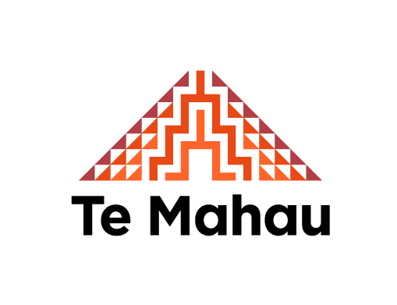
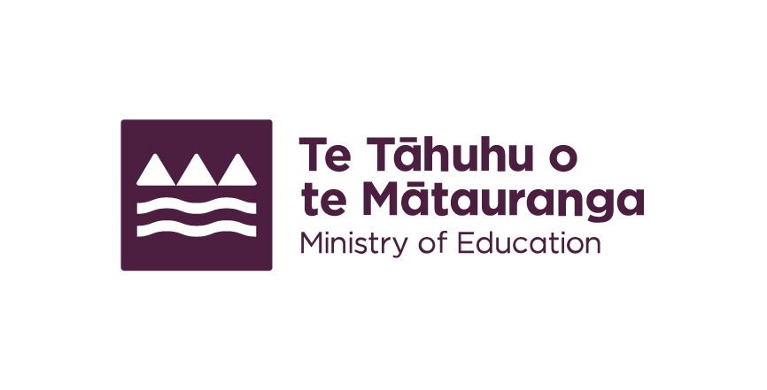
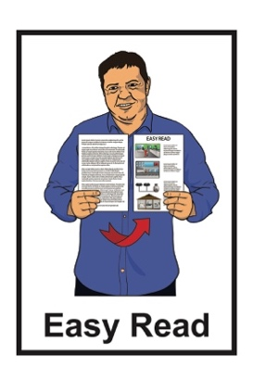

Summary: Action Plan for Pacific Education 2020 to 2030
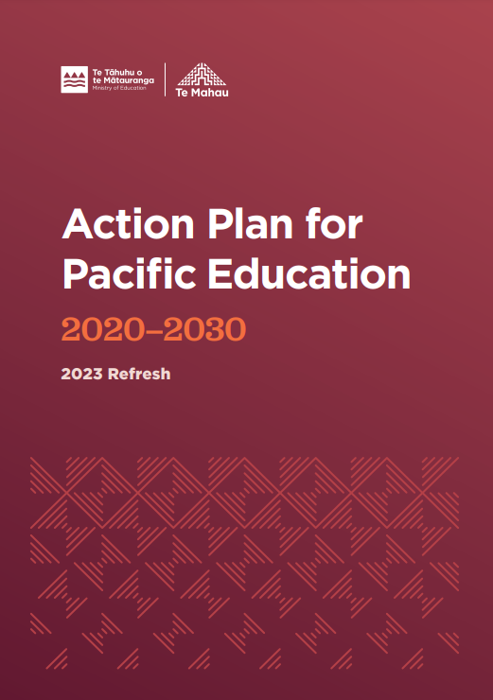
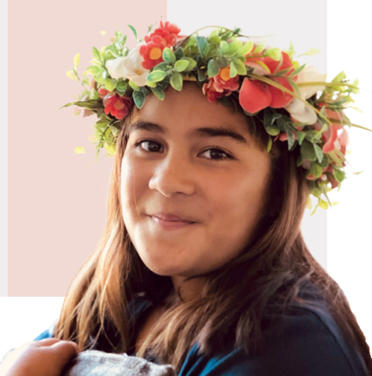
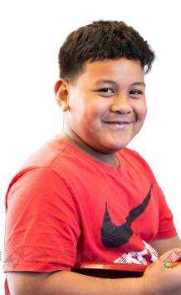

Published: November 2023

Who wrote this document?
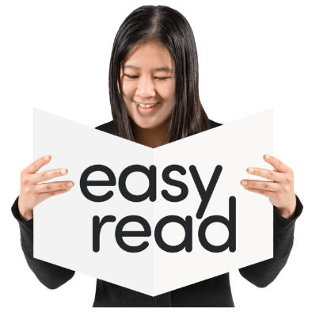

This Easy Read document is from
Te Tāhuhu o te Mātauranga – Ministry of Education.

Te Tāhuhu o te Mātauranga ̶ Ministry of Education is the part of the Government that looks after education in New Zealand.

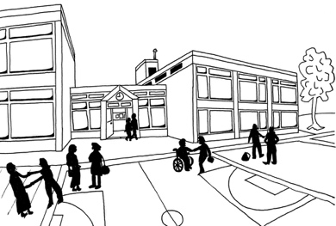
Education means all the learning you get at:
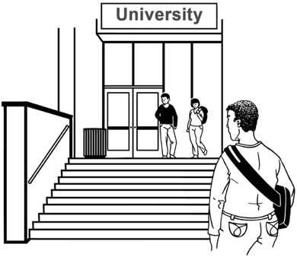
early learning places
schools
universities / training places.

In this document when we say MoE this means Te Tāhuhu o te Mātauranga ̶ Ministry of Education.

Te Mahau is the part of the MoE that supports educators.

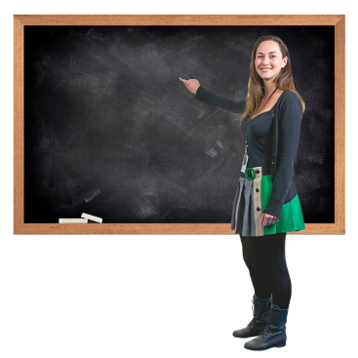
Educators are all the people who do jobs to do with education like:
teachers
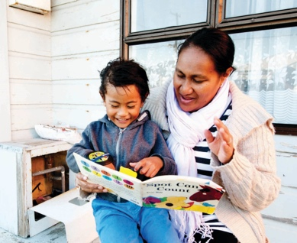
support staff
principals.

What is this document about?

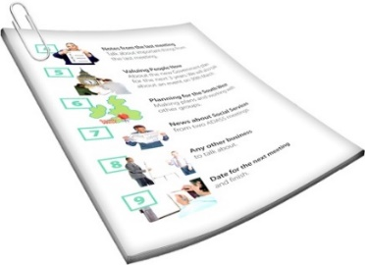
This document is a summary of a long document from the MoE /
Te Mahau.

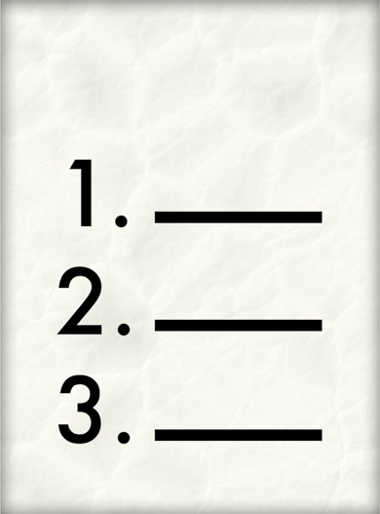
A summary:
is shorter than the full document
tells you the main ideas.

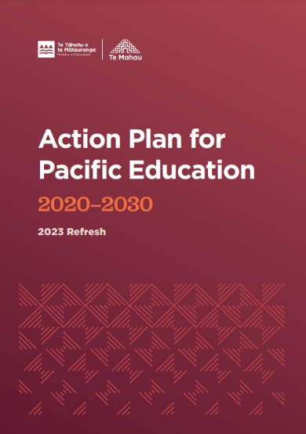
The long document is called:

Action Plan for Pacific Education 2020 – 2030
2023 Refresh

It tells you what the Government is doing to make education better for Pacific people in New Zealand.
Pacific Education means education for learners from Pacific cultures such as:
Sāmoa
Tonga
Fiji
Niue
Cook Islands
Tokelau.

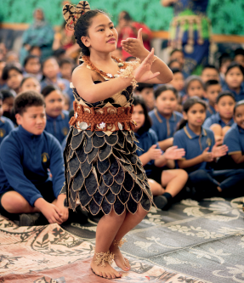
Culture is a way of:
- thinking that a group shares
- speaking that a group shares
- doing things as a group.

Vision for Pacific education

MoE has a vision for what education for Pacific learners should be like.

A vision is an idea for how we want things to be.

The vision for Pacific education is that all Pacific learners / their families are:
safe
treated as important
able to reach their learning goals.

Key shifts for Pacific education

MoE will make 5 key shifts to Pacific education in New Zealand.

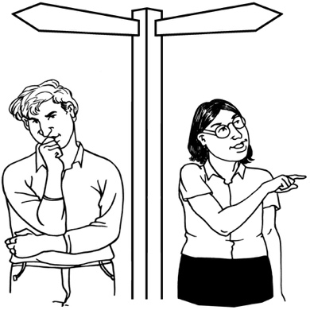
A key shift is an important change from 1 way of doing things to a new way.

The 5 key shifts will make education in New Zealand better for:
Pacific learners
their families.

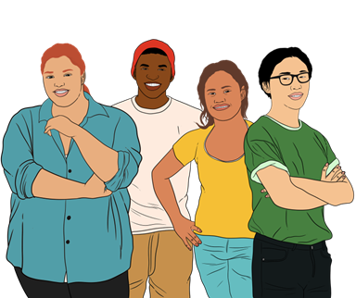
Key shift 1: Work with Pacific communities to find out about unmet needs

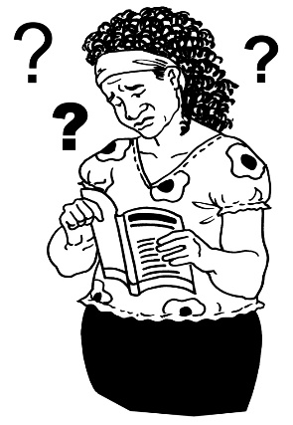
Finding out unmet needs means looking at what things make it hard to take part in education.

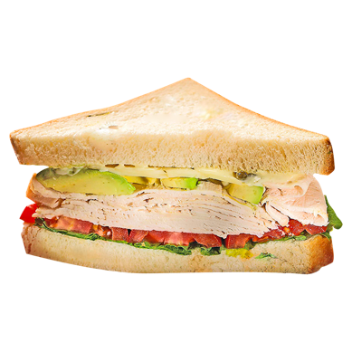
Unmet needs could be things like not having:
- food
- internet
- digital devices like computers or I-pads.

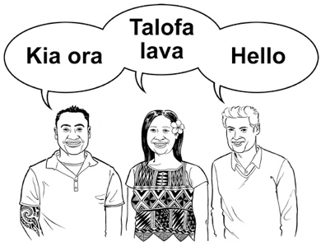
Looking at unmet needs would also include more chances to learn using Pacific languages in
- bilingual education settings
- immersion education settings.

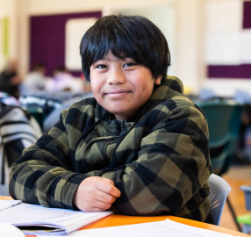
Bilingual education settings means that in a classroom the teachers / learners speak using 2 different languages.

For example speaking / teaching in Gagana Sāmoa and English.

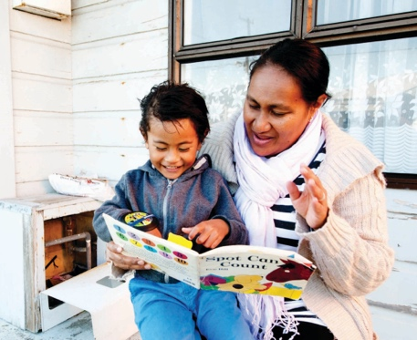
Immersion education settings means that in a classroom the teacher / learners speak mostly in 1 language.

For example speaking / teaching mostly in Gagana Sāmoa.

Key shift 2: Stand up against:

racism

discrimination

MoE wants changes to education so Pacific learners do not face:
racism
discrimination.

Racism means nasty or unfair treatment of someone because of:
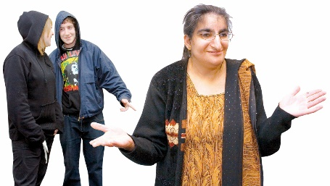
- where they come from
- their language
- their skin colour.

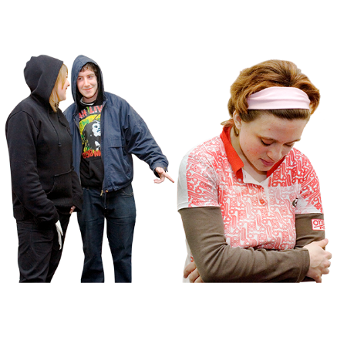
Discrimination is when people are treated differently because of things like:
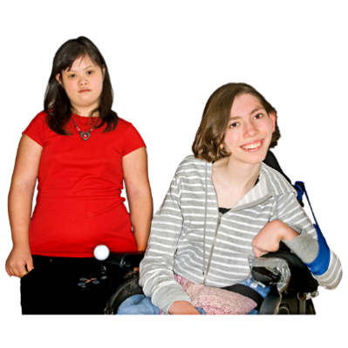
- their culture
- being disabled.

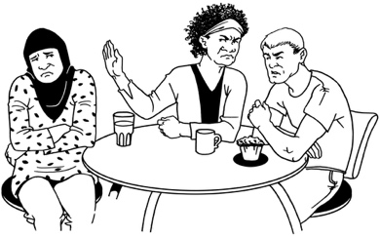
Discrimination often means people do not get the same chances as others because of who they are.

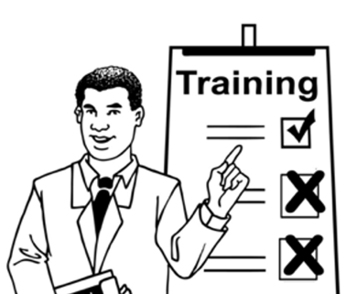
Key shift 3: Support educators to learn:
- about Pacific cultures
- the best ways to teach Pacific learners

MoE wants to have ways for educators to learn:
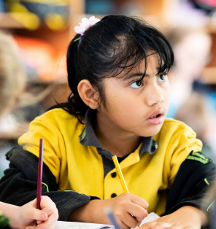
about all the different Pacific cultures
the best ways to support people from different Pacific cultures to learn
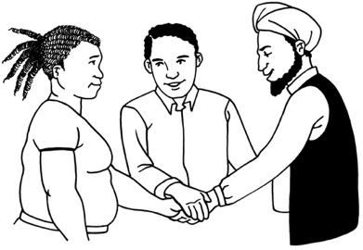
how to work together to make things better for Pacific learners / their families.

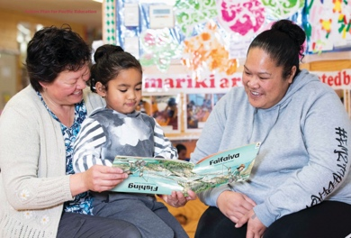
Key shift 4: Build strong relationships with Pacific families so they are a part of their children’s learning

MoE wants to support educators and families to work together to:
support Pacific learners to reach their goals
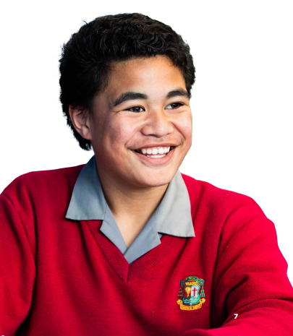
give Pacific learners a good education
make sure Pacific learners can get good work when they leave education.

Key shift 5: Make sure there are enough good educators who are Pacific people

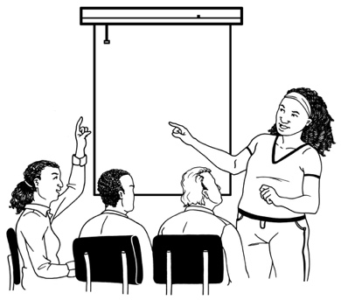
MoE wants to make sure Pacific people who are good educators can:
get even better at their work
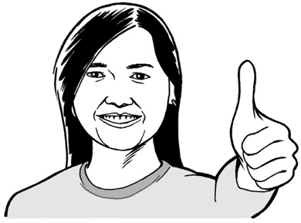
stay working in education jobs
feel that they are treated as important.
MoE also wants to make sure more Pacific people can become good educators.

What is MoE doing?

MoE will keep on working on ways to support Pacific learners like:
free school lunches through the Ka Ora Ka Ako / Healthy School Lunches programme
supporting educators to know how to stop racism
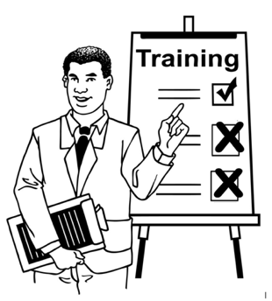
teaching Pacific early learning services how to run their services well
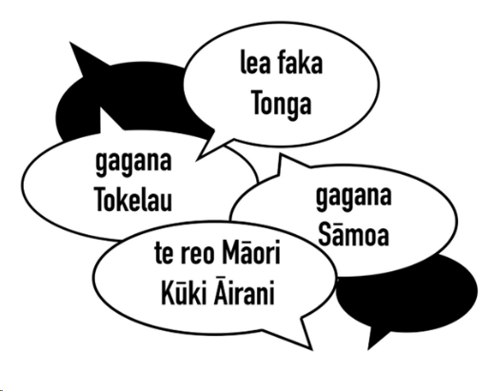
setting up new Pacific language subjects in high school like:
- Gagana Tokelau
- Vagahau Niue.

MoE will also keep working on:
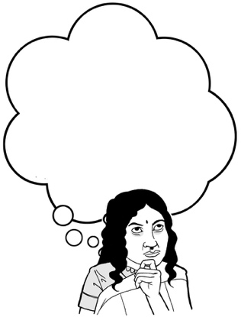
supporting teachers to learn the best ways to teach Pacific learners
working out what teachers need to be able to teach using Pacific languages
giving schools new resources to support Pacific high school leavers.

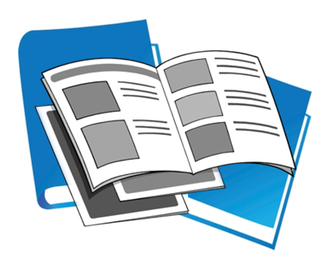
Resources are things like:
books
booklets
videos
websites.
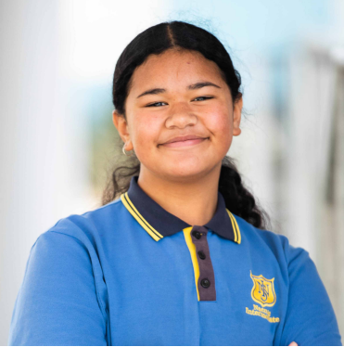
MoE will start working on ways to:
support Pacific school leavers to plan what to do next for:
- study
- work
make schools safe places for everyone to learn
support more educators to learn the best ways to teach Pacific learners
get more teachers who can speak / teach in a Pacific language.

Pacific languages

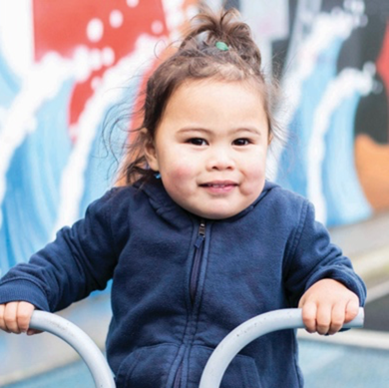
MoE wants to make sure educators use Pacific languages more at:
early learning places
schools
universities / training places.

This may be by using Pacific languages:
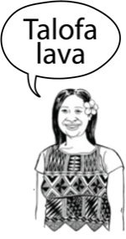
at the same time as another language
on their own.

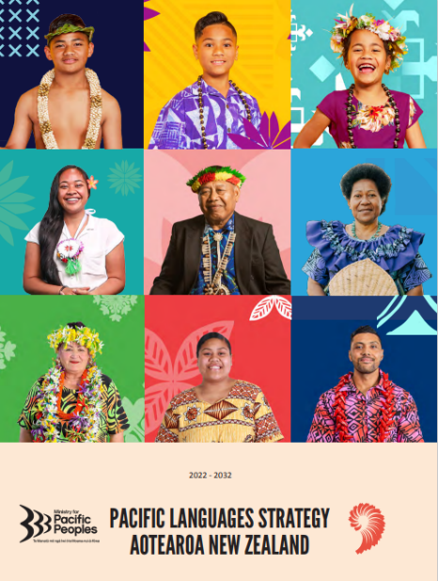
The Government has a strategy to support Pacific language use in New Zealand.

A strategy is a plan for how to do something to get a good result.

Some of the main ideas in the Action Plan for Pacific Education come from the Government strategy such as:
learners do better when they learn in their own language
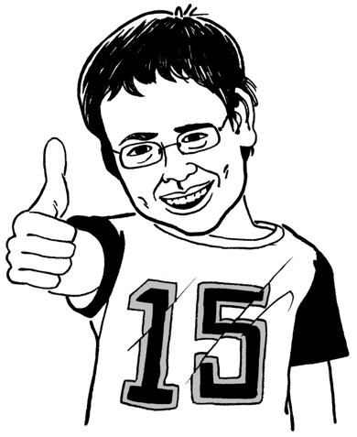
learning in your own language is good for everyone in New Zealand
using Pacific languages in education will help keep Pacific languages going.
MoE wants to support Pacific language groups to get to their goals for Pacific languages in education.

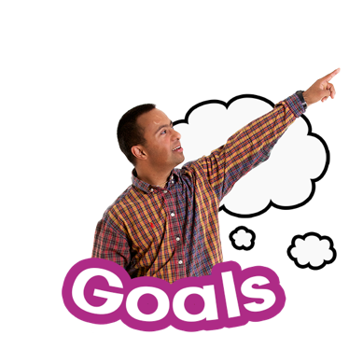
MoE will continue to support education choices for high school / university learners using:
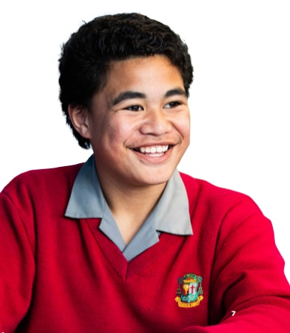
Gagana Sāmoa / language of Sāmoa
Lea Faka-Tonga / language of Tonga.

MoE will also continue to support early learning using:
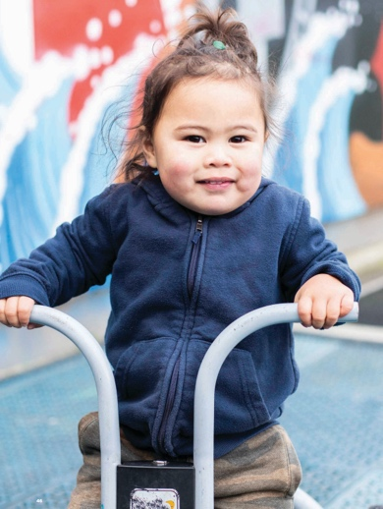
Gagana Tokelau / language of Tokelau
Vagahau Niue / language of Niue
Te reo Māori Kūki ‘Āirani / language of the Cook Islands.
MoE wants Pacific people to lead how Pacific languages are used in education.

MoE knows there is more work to do to support Pacific language use in education in New Zealand.

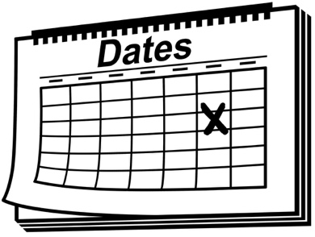
Every 2 years it will let people know how well the Action Plan for Pacific Education is working.

MoE will keep working on it.

More about this

You can find the full Action Plan for Pacific Education online at this website link:

https://tinyurl.com/yvfbrx2n

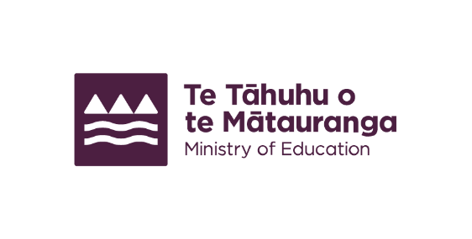
This information has been written by Te Tāhuhu o te Mātauranga – Ministry of Education.

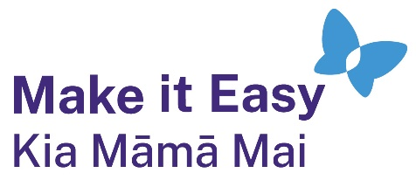
It has been translated into Easy Read by the Make it Easy Kia Māmā Mai service of People First New Zealand Ngā Tāngata Tuatahi.
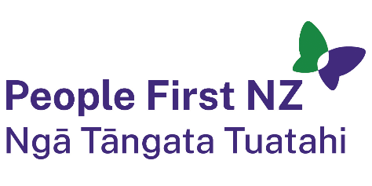
The ideas in this document are not the ideas of People First New Zealand Ngā Tāngata Tuatahi.
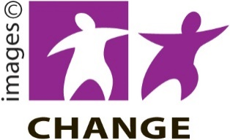
Make it Easy uses images from:

- Changepeople.org
            - Photosymbols.com

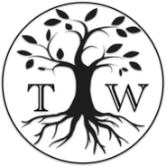
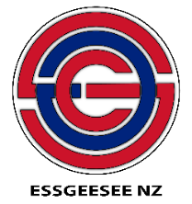
- SGC Image Works
- Huriana Kopeke-Te Aho
- T. Wood.
All images used in this Easy Read document are subject to copyright rules and cannot be used without permission.

