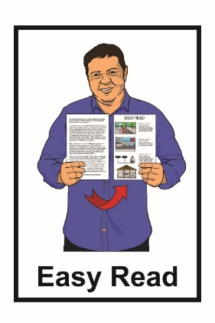

How to use QR codes

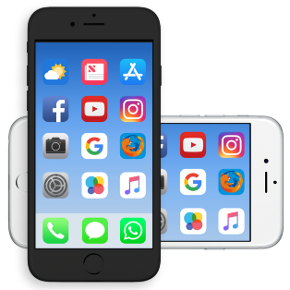A qr code with a few squares



Published: August 2024

# What is a QR code?

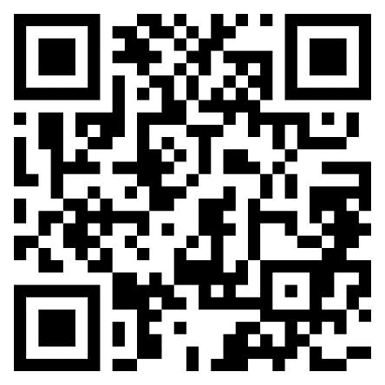

AQR code is the short way of saying Quick Response code.

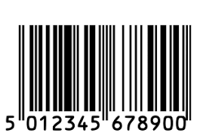QR codes are:

like **barcodes** that can store information

a way of sharing links to websites.

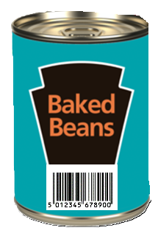

**Barcodes** are often used to share information on things like:

packaging for food

library books.

# Why do people use QR codes?



QR codes are used so people with a smartphone can open a link to a website.

They are an easy way to share links on:

paper documents

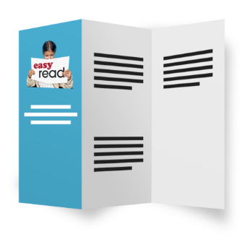signs / notices

leaflets.

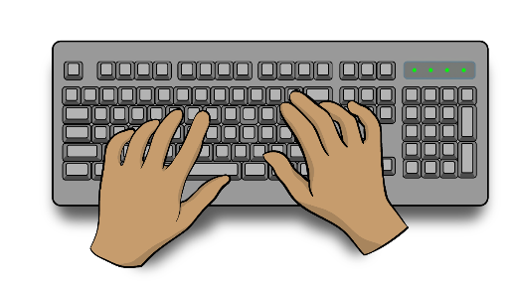

Using QR codes mean people do not need to type out / copy the full website link.

# How to scan a QR code



You can scan QR codes using the camera on most smart phones.

To scan the QR code start by opening the camera on your smartphone.

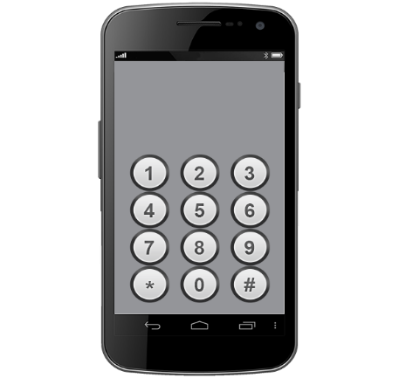

Point the camera at the QR code and make sure the image is:

* not blurry / easy to see
* straight

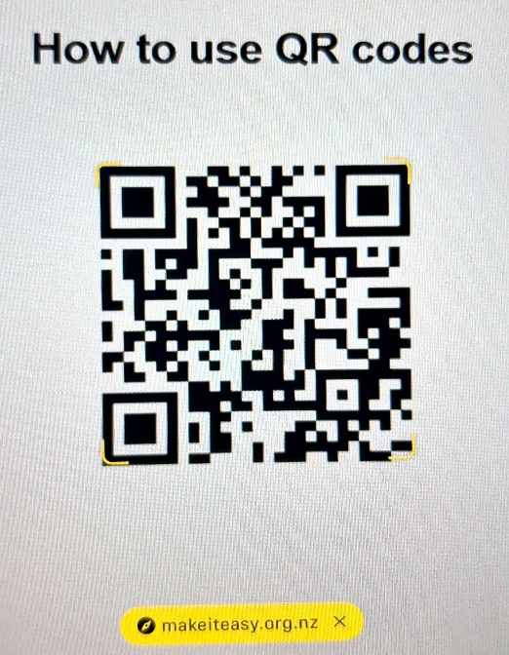

* showing the full QR code.

Some text will pop up to ask if you want to open the website link.  
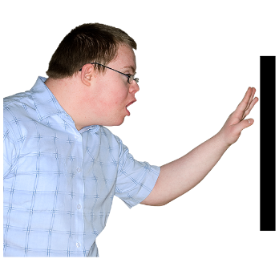You will need to touch the text to go to the link.



Only open the link if you think it is safe.

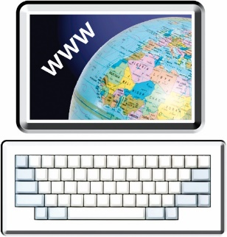

A website will open in your browser which is an app you use to look at things on the internet.

You can scan this QR code to see how it works.

This QR code will take you to the Make It Easy website for People First.

# If you need more support

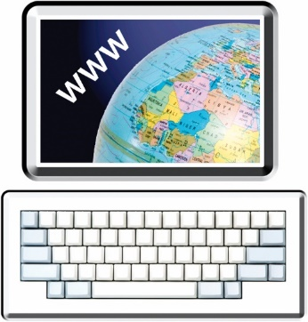You can contact People First NZ for support with using QR codes:

* on their **website** at:  
    
  [**www.peoplefirst.org.nz**](http://www.peoplefirst.org.nz)
* by **phone** on:  
    
  **0800 20 60 70**

This Easy Read information has been created by the Make it Easy   
Kia Māmā Mai service of People First New Zealand Ngā Tāngata Tuatahi.

Make it Easy uses images from:

* Changepeople.org

Photo SymbolsPhotosymbols.com

* SGC Image Works
* Huriana Kopeke-Te Aho
* T. Wood.

  
All images used in this Easy Read document are subject to copyright rules and cannot be used without permission.