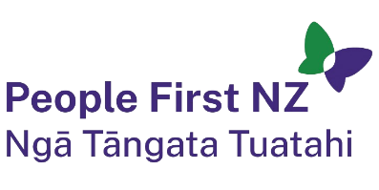
National Administrator
People First New Zealand Incorporated
Part time
People First New Zealand Ngā Tāngata Tuatahi is a Disabled People's Organisation (DPO) which means we are run by and for people with learning disability. Our work makes sure people with learning disability have and know their rights and that our communities are inclusive across Aotearoa New Zealand.
At People First, we are recruiting a National Administrator to work 20 hours per week, Monday to Friday, 10am to 2.30pm, in Central Wellington.
This role supports the organisation with administration. You will help the team with day-to-day office tasks and be the go-to person when people need assistance or information.
Your work will include responding to requests for information and resources from people inside and outside the organisation. You will organise travel, accommodation and prepare for team meetings by taking notes and supporting meeting tasks.
You will also provide secretarial support to our National Committee governance board using Microsoft Teams and Office 365.
You will talk with many different people who have different communication styles, so good communication is important. The role involves doing several tasks at once, solving problems, and enjoying new challenges. You will work in a small and busy office with a supportive team.
The full job description is available on our website https://www.peoplefirst.org.nz/join-us
We have the following alternate formats available on request:
- New Zealand Sign Language
- Easy Read
- Large Print
- Audio
- Braille (BRF)
End of information | National Administrator, Part-Time position, People First New Zealand Incorporated. This Large Print document is adapted by Blind Citizens NZ from the standard document provided by Disability Support Services, Ministry of Social Development

