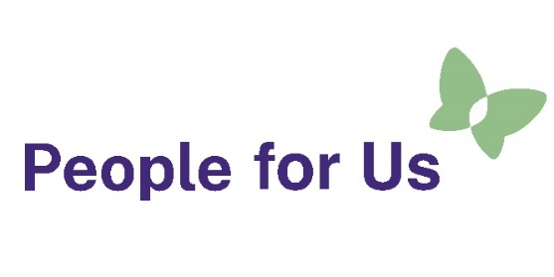
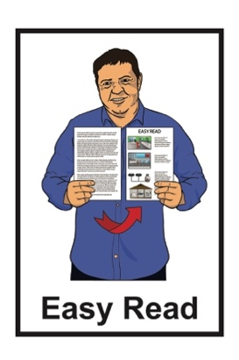

Job advertisement:

People for Us

Kaiāwhina / Assistant



Published: April 2026

About this Easy Read
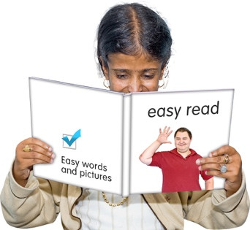

This Easy Read is a job advertisement.


A job advertisement tells people an organisation wants to hire someone to work for them.


This job advertisement is for the job of Kaiāwhina / Assistant for
People for Us.

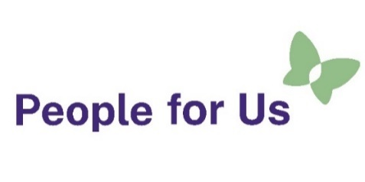
People for Us is a new service being run by People First New Zealand Ngā Tāngata Tuatahi.


People First New Zealand Ngā Tāngata Tuatahi is a Disabled People’s Organisation which is:

for people with learning disability
and
run by people with learning disability.


Where you see we / our / us in this document this means People for Us.

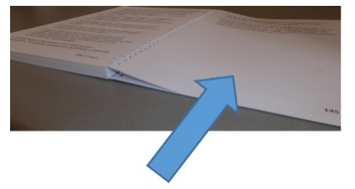
There is more information about People for Us on pages 3 to 4.

What is People for Us?


People for Us is a service that is:
all over Aotearoa New Zealand
run by disabled people.

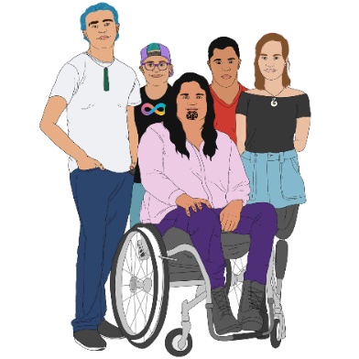
People for Us works with people who live in community residential support services who are:
disabled
tāngata whaikaha Māori.

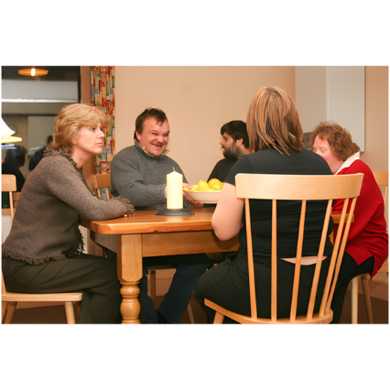
A community residential support service is where a disabled person:
lives in a group home
gets support from staff.

People for Us works to make sure people who are getting disability support services are:
safe

living a good life they choose
getting very good support.


We think it is very important to make good changes to disability support services in Aotearoa New Zealand.

About the Kaiāwhina / Assistant role
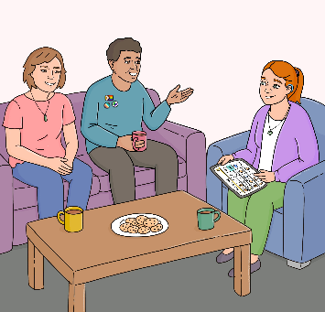

This job advertisement is for the job of Kaiāwhina / Assistant.

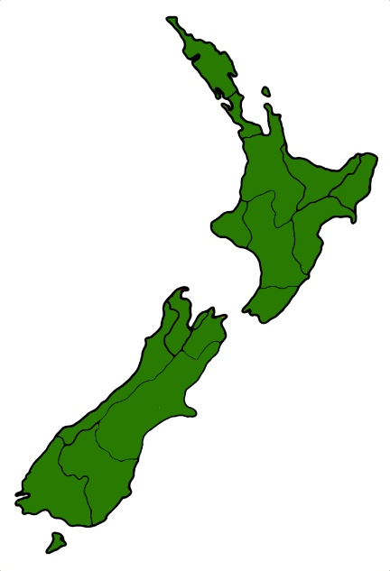
We are looking for Kaiāwhina / Assistants in:
Palmerston North


The Kaiāwhina / Assistant will be employed as permanent part time/ full time employees.

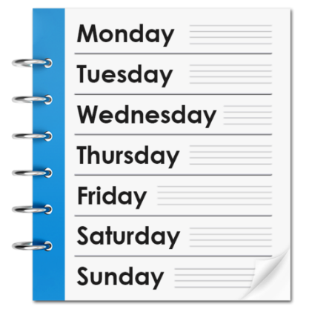
Here being a permanent part time employee means you:
work 15 hours per week
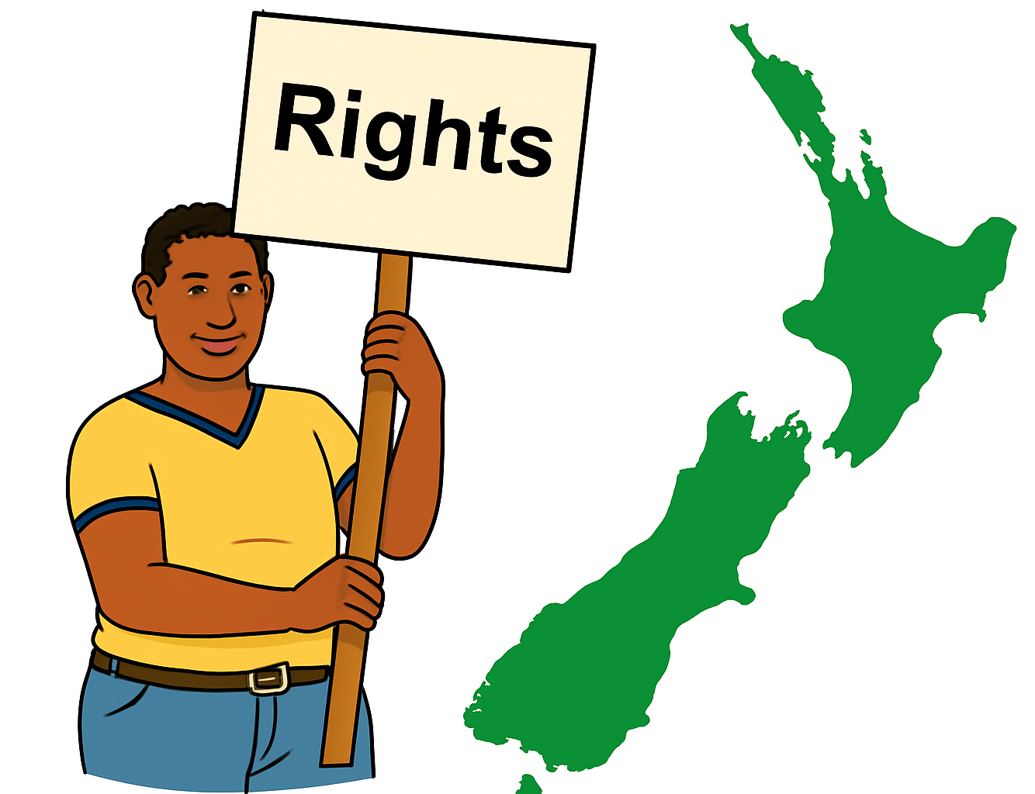
work the same number of hours each week
have the same work rights as full time employees.

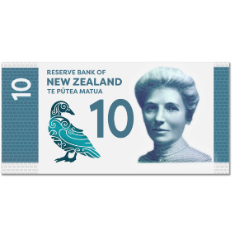



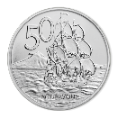

The Kaiāwhina / Assistant will be paid $33.50 for each hour they work.


As a Kāiawhina / Assistant you will be supporting the Kaiārahi / Peer Worker to visit disabled people in their homes.

In your role you will listen to disabled people about their experiences of:
safety
good support / care
what a good life means for them.


You can find out more about what a Kaiārahi / Peer worker does in the Easy Read document called:

Job description: People for Us


– Kaiārahi / Peer worker

You can find this Easy Read at:
https://www.peoplefirst.org.nz/join-us

Who can be a Kaiāwhina / Assistant?


To become a Kaiāwhina / Assistant you will need to:
have a disability OR

have a good understanding of the experiences of disabled people
get along with other people

be good at communicating / talking with people
want to make sure disabled people / tāngata whaikaha Māori:

- have good lives
- have good services / support
- are safe.

What you get as part of the job

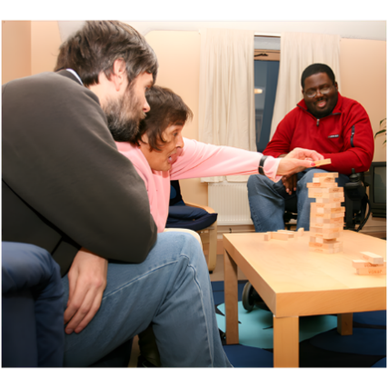
You will make a big difference to keeping disabled people in residential homes safe.


People for Us will make sure you get:
a lot of training
chances for professional development which means learning new things to do with your job.


You will be paid well for your work.


People for Us can work with you to make sure the hours you will be working meet your needs.

You will get supervision / support by talking with your manager about your work often.

You will have access to an Employee Assistance Programme.

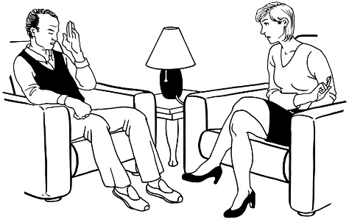

An Employee Assistance Programme is a free service for employees where you can talk to a counsellor if you are worried / stressed.

You can talk to the counsellor about:
your work
your life.

How to apply for the job


You need to submit your application by:

1 May 2026


You will need to apply online for the job through seek.


If you have any questions, you can email us to
info@peopleforus.org.nz


You could also contact us on phone for any information:

0800 241 241
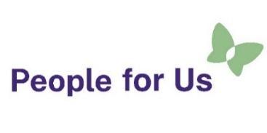
This information has been written by
People for Us.

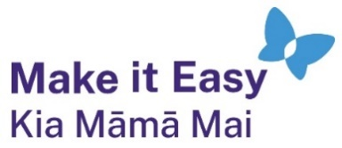
It has been translated into Easy Read by the Make it Easy Kia Māmā Mai service of People First New Zealand Ngā Tāngata Tuatahi.

All images used in this Easy Read document are subject to copyright rules and cannot be used without permission.


Make it Easy uses images from:


- Photosymbols

- Change Images


- Huriana Kopeke-Te Aho

- SGC Image Works

- T Wood

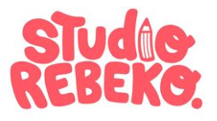
- Studio Rebeko

- Inga Kramer.

