


Mānawatia a Matariki


What is Matariki and why it is important in Aotearoa New Zealand

Published: June 2025

What is Matariki?


Matariki is a star cluster that marks the start of the Māori New Year.


A star cluster is a group of stars that are close together in space.


Since 2022 there has been a public holiday for Matariki in Aotearoa
New Zealand.

Public holidays are days when:

schools are shut
a lot of workplaces are shut
some shops may be shut.


Matariki happens every year when the star cluster Matariki is first seen in the sky.


Matariki is usually in:
June

or
July.


The Matariki public holiday is always on a Friday.


Māori astronomers have worked out when Matariki will be for a lot of years ahead.


Astronomers are people who know a lot about:
stars
space.

The Matariki public holiday will be on:

20 June 2025

10 July 2026

25 June 2027.


You can find more dates for the Matariki public holiday at this website:

https://tinyurl.com/4x7xdvrd

Everyone can celebrate Matariki.


You can celebrate Matariki in many ways.

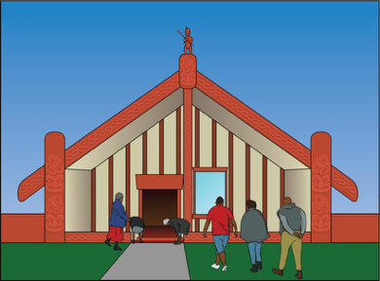
You may be able to join in Matariki celebrations run by:
town / city councils
marae

your workplace
the school your children go to.


You can say Mānawatia a Matariki to wish someone well at Matariki.

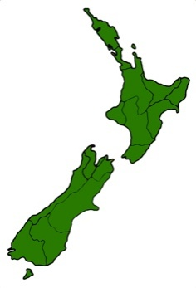
Matariki is hard to see from some parts of Aotearoa New Zealand.


People in those parts of
Aotearoa New Zealand celebrate Puanga instead of Matariki.

Puanga is a star that rises about the same time as Matariki.


You can celebrate Puanga in the same ways you celebrate Matariki.

The stars of Matariki


The Matariki star cluster is important to a lot of cultures.


Culture is a way of:
- thinking that a group shares
- doing things as a group.


It has lots of different names like:
the Seven Sisters in English
Pleiades in Greek
Makali’i in Hawaiian
Subaru in Japanese.

There are 9 stars in the Matariki star cluster.


Each star has a meaning:

Matariki is good health for:

- ourselves

- the world around us


Tupu-ā-rangi is food that comes from above like fruit

Tupu-ā-nuku is food that grows in the ground

Ururangi is the winds

Waipuna–ā-rangi is:

  - rain

  - snow.

The meanings of more Matariki stars are:

Hiwa-i-te-rangi is hopes / wishes

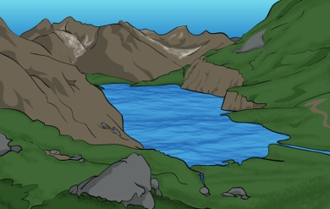
Waitī is fresh water like:

- lakes

- rivers

Waitā is the sea

Pōhutukawa is people who have died.


The best time to see the Matariki star cluster is just before the sun comes up.

To find Matariki look:
low in the sky near the horizon
towards the northeast
to the left of
Orion’s Belt / the Pot / Tautoru.

You can also look for Puanga.


Puanga is:
a very bright star
above Orion’s Belt / the Pot / Tautora
also known as Rigel.



This website has videos that show you how to find:
Puanga

Matariki

https://tinyurl.com/3m55awbc


There is a video in:
Māori
English.

Some people say that the way the stars of Matariki look in the sky can tell us what the coming year will be like.


For example if the stars are bright it will be a good year.

Ways to celebrate Matariki

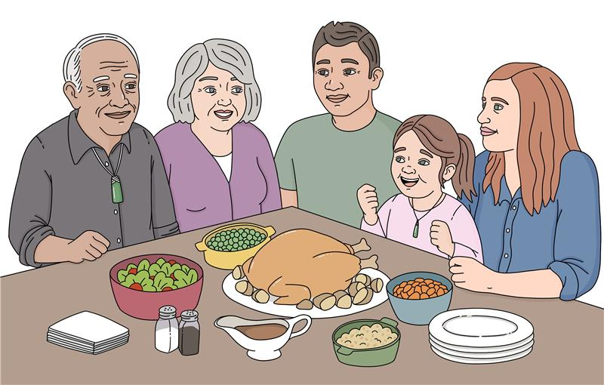
A Matariki whakataukī / saying is:

Matariki kāinga tahi, Matariki kai tahi.

Matariki brings us together to eat and share as one.
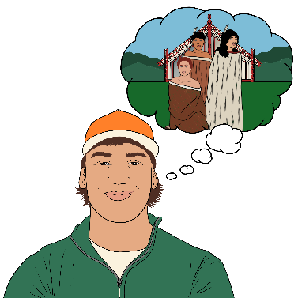

There are 3 important parts to celebrating Matariki:
remembering the past

celebrating the present / what is happening now
planning for the time to come.


To remember the past we think about:
loved ones who have died
what has happened in the year that has just been.


You could do things to remember someone who has died like:
talk to other people about them

look at photos of them
go somewhere that was special to them
tidy their grave / where they are buried.


To celebrate the present / what is happening now we:
spend time with:
- whānau / family
- friends
share kai / food.

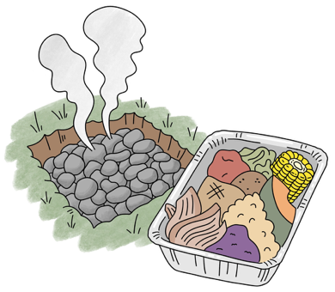
You could try some Māori kai / food like:
hangi – food cooked in the ground

fry bread
boil-up – a stew with:
- pork
- vegetables.

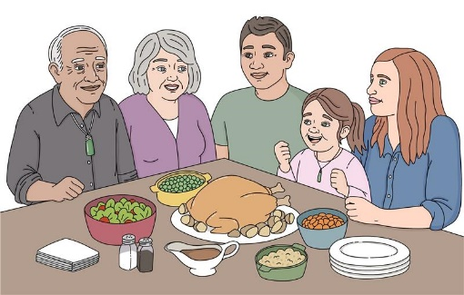
You could have a special meal with people you love.


You could do things with other people like:
make music

play games
tell / read stories.

To plan for the time to come we:
think about the things we will do in the year that is about to happen

make wishes.

You could write down your
wishes / hopes for the future.

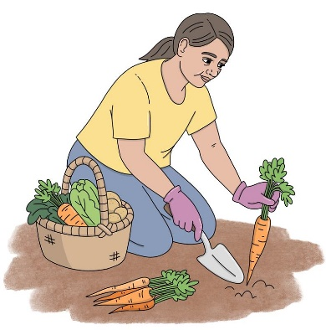
You could plan what you will plant in your garden when spring comes.


You could think about things you can do to take better care of the environment like:
pick up rubbish at the beach
plant a tree.


The environment is everything around us like:
land
air
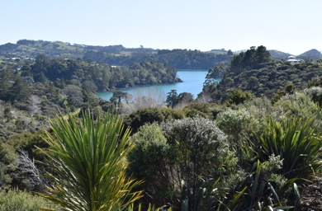
water
plants.

More information


You can find out more information about Matariki at these websites:

https://matariki.co.nz

https://www.matariki.com

https://tinyurl.com/3kanhnaw

https://matariki.twoa.ac.nz

https://tinyurl.com/35p6399c


These websites are not in Easy Read.


This information has been written by the Make it Easy Kia Māmā Mai service of People First New Zealand Ngā Tāngata Tuatahi.

All images used in this Easy Read document are subject to copyright rules and cannot be used without permission.


Make it Easy uses images from:


- Photosymbols

- Change Images

- Huriana Kopeke-Te Aho

- SGC Image Works

- T Wood


- Studio Rebeko

- Inga Kramer.

Nga mihi nui / thank you to Donald Beasley Institute and Ministry of Disabled People – Whaikaha for your support in creating this Easy Read.

