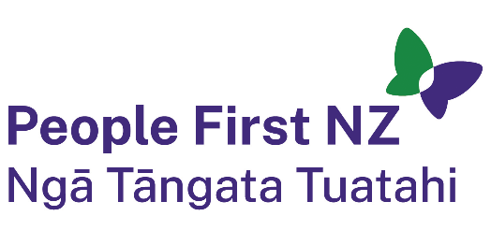
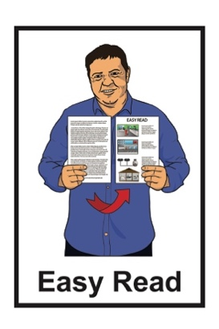

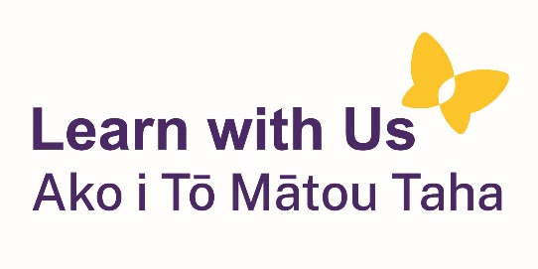

Enabling Good Lives:

Vision and Principles
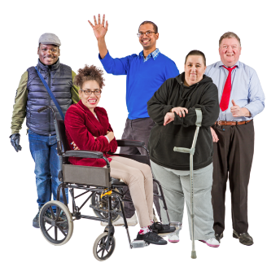

Published: October 2023

About this document

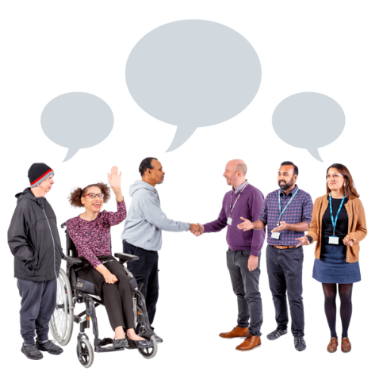
The Government and the disability sector of New Zealand are working together to change the way:
- disabled people get support
- whānau / families of disabled people get support.

Disabled people should be able to have good lives like everyone else.


This Easy Read document is about the Enabling Good Lives:
vision
principles.

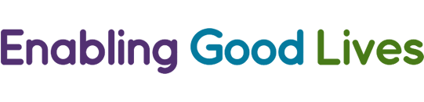
Enabling Good Lives is a different way of thinking about disability support.
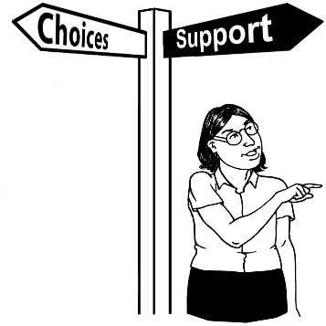
Enabling Good Lives is about having:
- choice and control in your life
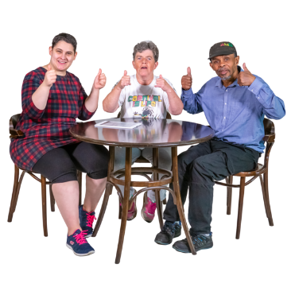
- the support you need and want.

Enabling Good Lives is sometimes called EGL for short.
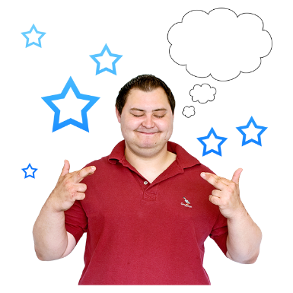

A vision is an idea about what you want the future / years ahead to look like.

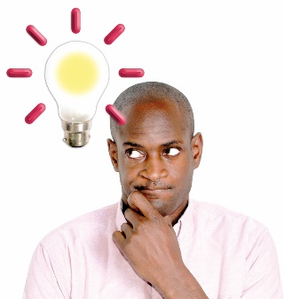
Principles are ideas that guides a group to reach its goal.

Vision
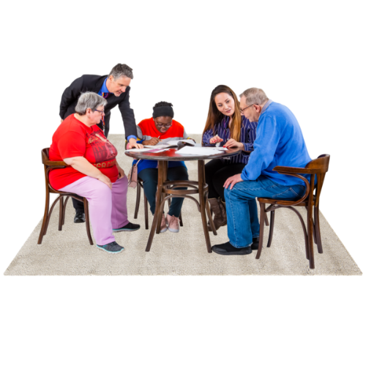

The Enabling Good Lives Leadership Group came up with a vision about what they want the future to look like.

The vision of Enabling Good Lives is to have better support for:
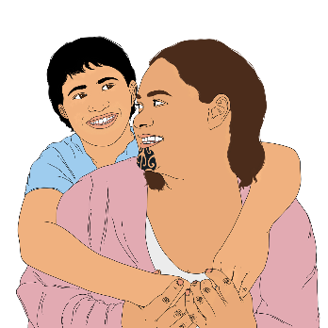
disabled people
whānau / families of disabled people.

This support should mean people have more:
choice and control over their lives
choice and control over their supports.
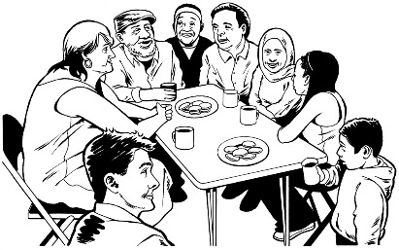
Disabled people should be able to make more use of natural supports like:
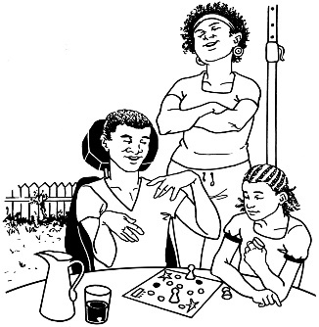
community support like social groups
support from relationships with people like:
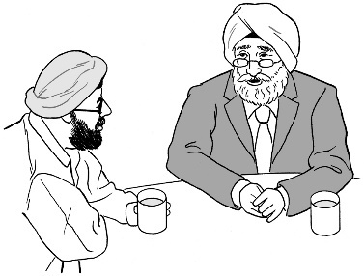
- whānau / family
- friends.
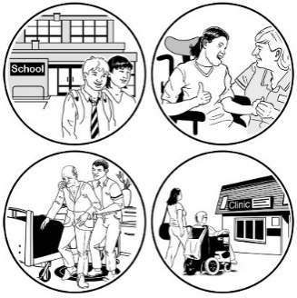
Disabled people should also be allowed to make more use of universally available supports.

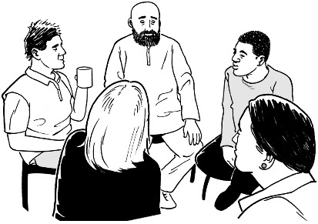
Universally available supports are services that everyone can use.

Principles
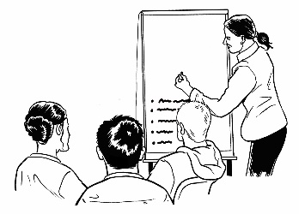


Enabling Good Lives has
8 principles.

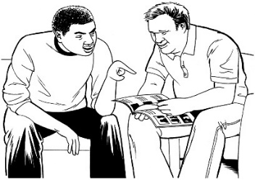

Principle 1: Self-determination

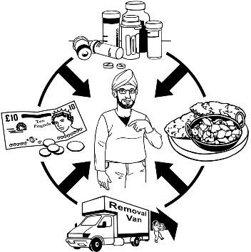
Self-determination means that disabled people have control over their own lives.

Principle 2: Beginning early
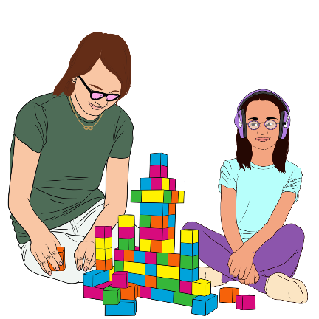

Beginning early means whānau / families should have support as soon as they find out their child has a disability.


Disabled children will have the support in place to:
live a good life
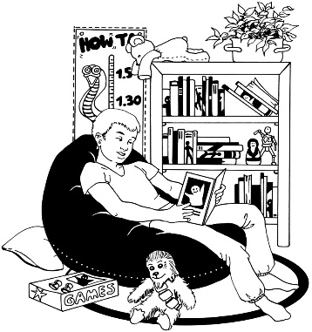
take part in their community
be independent.

Being independent means you can do things for yourself.

Principle 3: Person centred

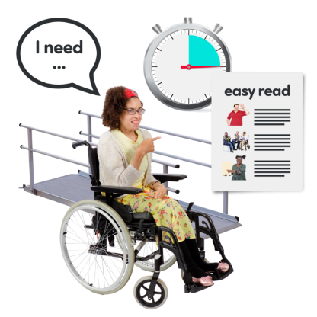
Person centred supports are made to work for disabled people:
when they want it
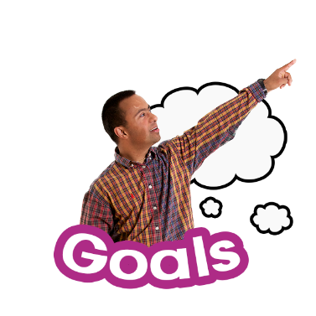
in the way that they want it.

The supports should assist disabled people to reach their own goals.

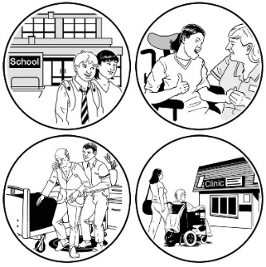
This means supports are tailored to what a disabled person needs.

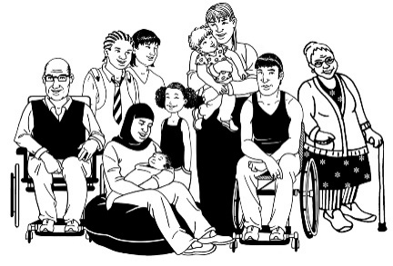
Tailored means that something is made differently for each person because everyone has different needs.

Principle 4: Ordinary life outcomes

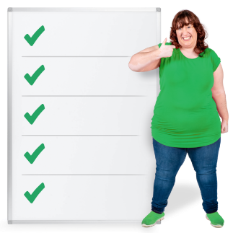
An outcome is something that happens after the work has been done.

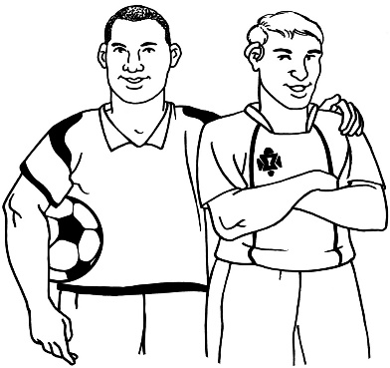
Ordinary life outcomes mean disabled people can do the same things that other people the same age as them are also doing.

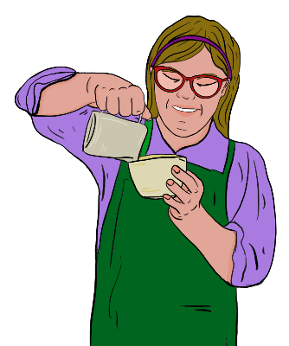
This means disabled people have the right support to do things like:
go to school
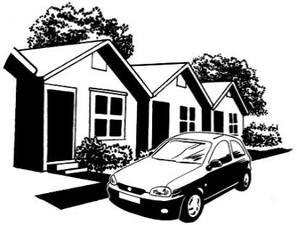
get a job
have a home.

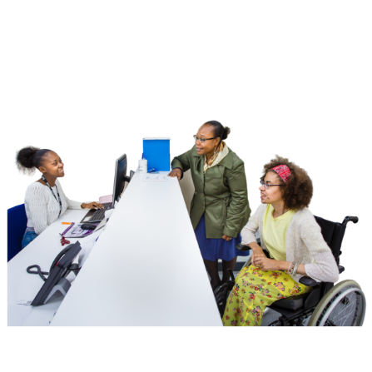
Principle 5: Mainstream first

Disabled people can use mainstream services.
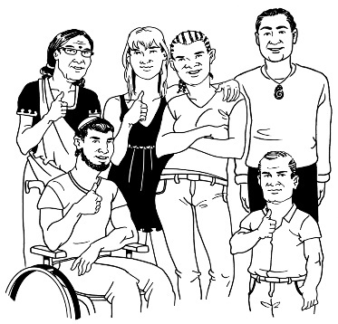

Mainstream services are services that can be used by everyone.

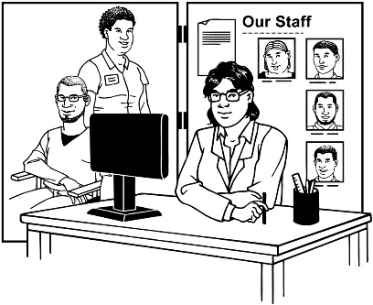
If mainstream services do not work for them then they can try services that are for disabled people.

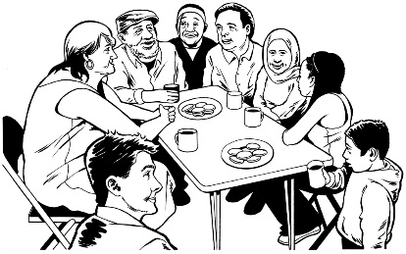
This means that disabled people:
can take part in their communities
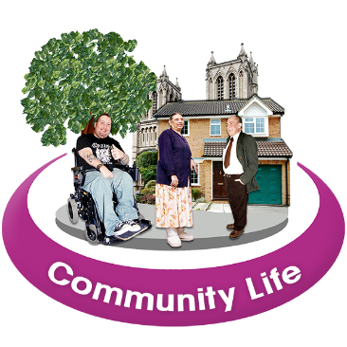
are part of their communities
have more choices about what they can do in their communities.

Principle 6: Mana Enhancing
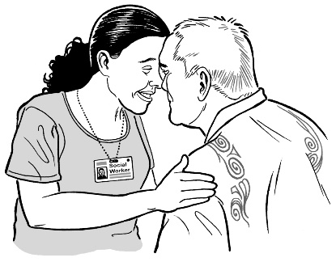

The mana enhancing principle is about respect.
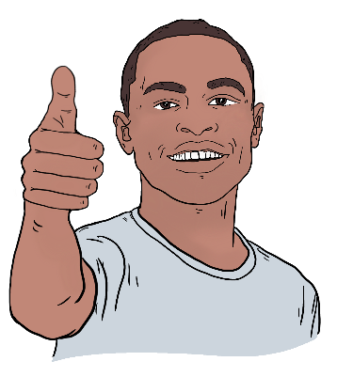

Mana enhancing means to make something better.

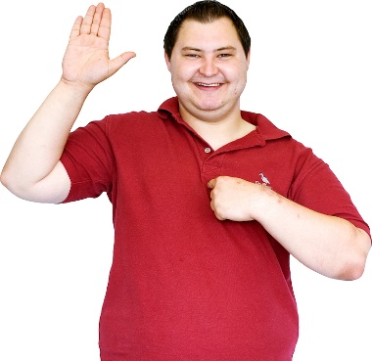
Respect means that people are valued for:
who they are
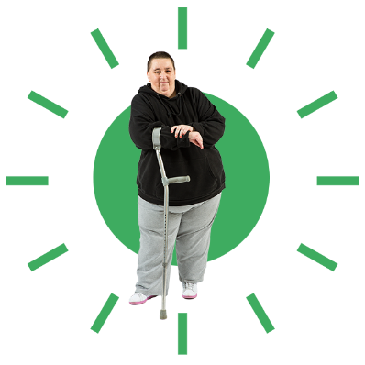
what they can do.

Respect needs to be shown to:
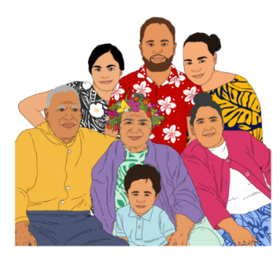
disabled people
whānau / families of disabled people.

Principle 7: Easy to use
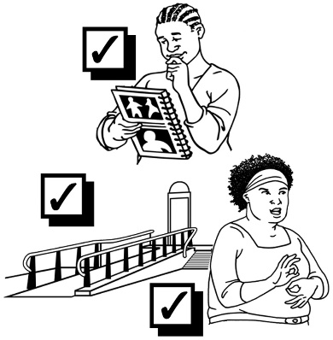

Supports for disabled people are:
easy to use
flexible.
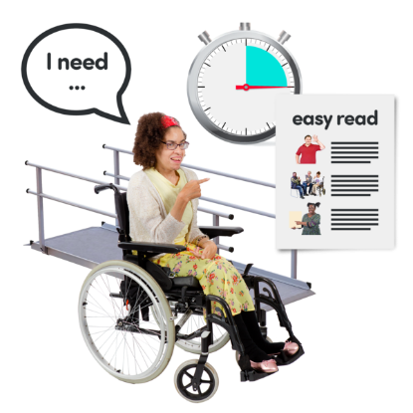

Flexible means that the disability supports fit around what the person needs.

Principle 8: Relationship building
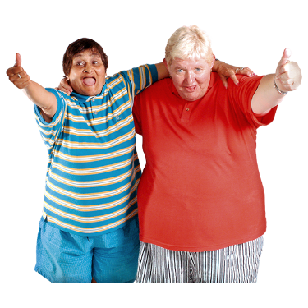

Relationship building supports are made so that disabled people can make stronger relationships.

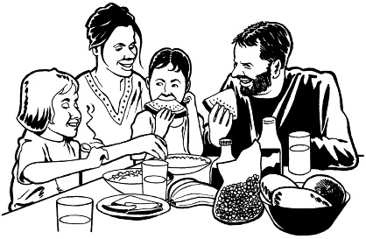
Disabled people often have important relationships with:
their whānau / families
their friends
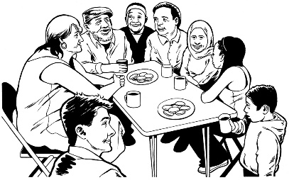
people in their community
other people that are important to them.

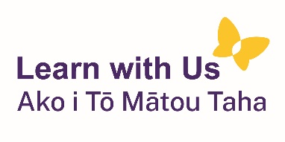
This information has been written by Learn with Us Ako i Tō Mātou Taha

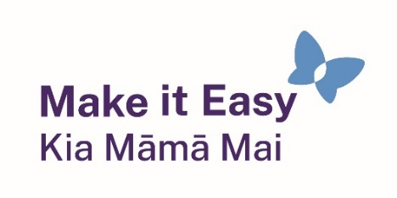
It has been translated into Easy Read by the Make it Easy Kia Māmā Mai service of People First New Zealand Ngā Tāngata Tuatahi.

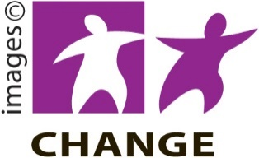
Make it Easy uses images from:


- Changepeople.org

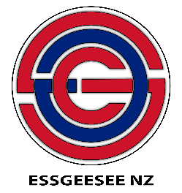
            - Photosymbols.com

- SGC Image Works

- Huriana Kopeke-Te Aho
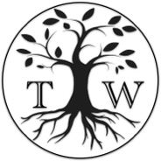
- T.Wood.

All images used in this Easy Read document are subject to copyright rules and cannot be used without permission.

