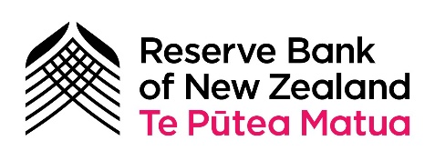
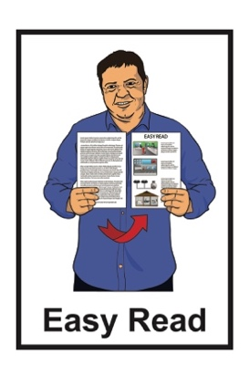

Information about Digital Cash in New Zealand

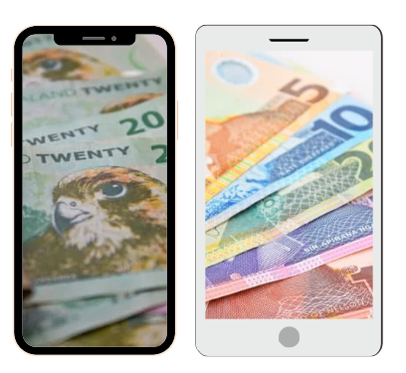
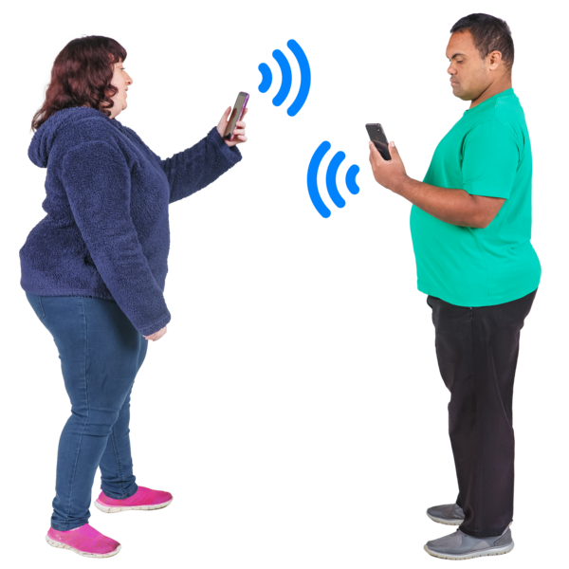

Published: August 2024

What is in here

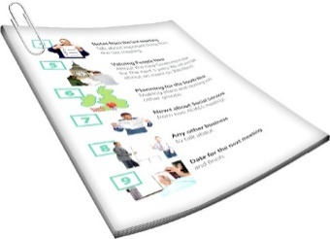
Page number:

What is this document about? 3

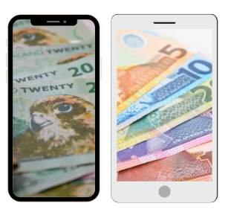
What is digital cash? 6

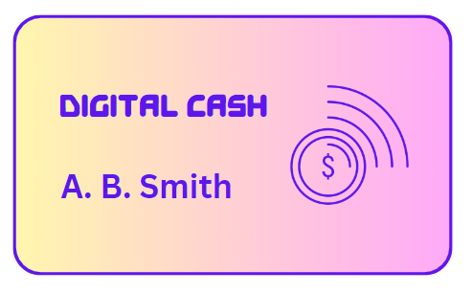
Examples of using digital cash 13

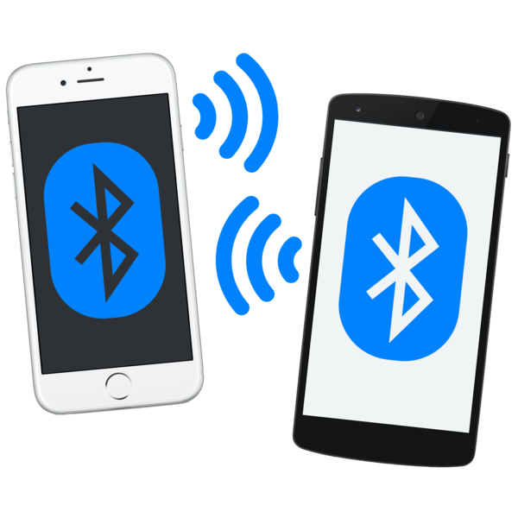
Using digital cash without
internet / power 22

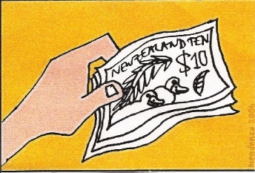
Making sure people trust
our money 26

Page number:
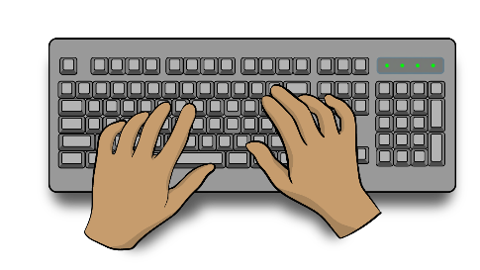

Tell us what you think 28
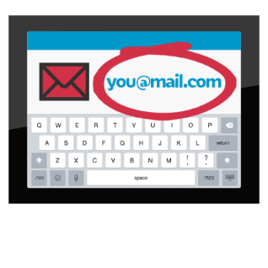

How to find out more 35

What is this document about?

At the Reserve Bank of New Zealand Te Pūtea Matua we are looking at digital cash.

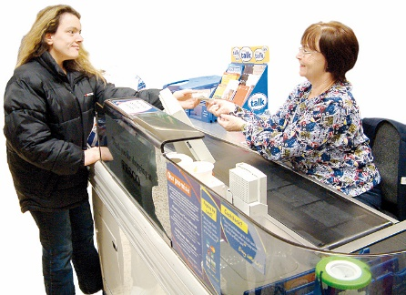
We will explain what digital cash is in the next part of the document.

The Reserve Bank of New Zealand Te Pūtea Matua is the central bank of New Zealand.
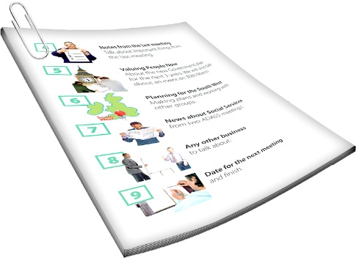

In this document we will call it the Reserve Bank.

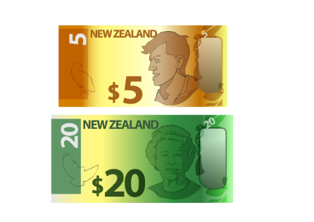
A central bank is the bank that
is in charge of making cash like coins / banknotes.
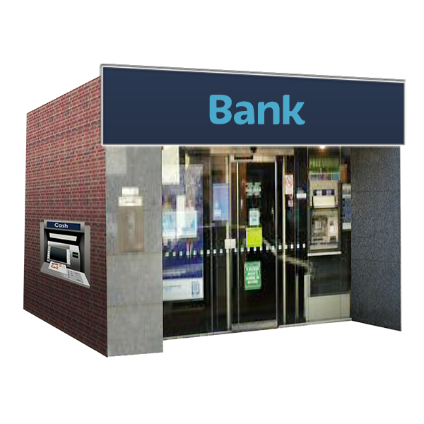

A central bank is different to the kind of bank you might keep your money in.

When we say we / our in this document we mean the Reserve Bank.

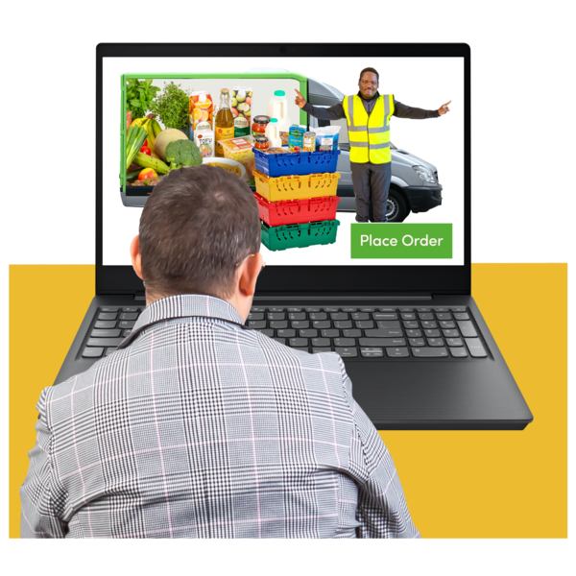
We are looking at digital cash because we know that how people pay for things is changing.

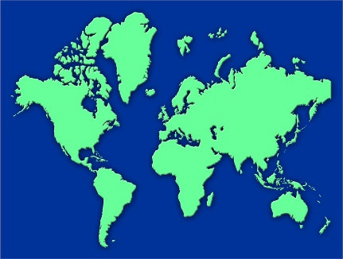
Central banks in other countries are also looking at digital cash.

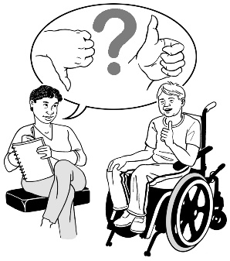
We want to know what you think about digital cash.

What is digital cash?

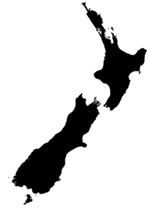
In New Zealand our money is the New Zealand dollar.

Your money might be in:
bank accounts
cash

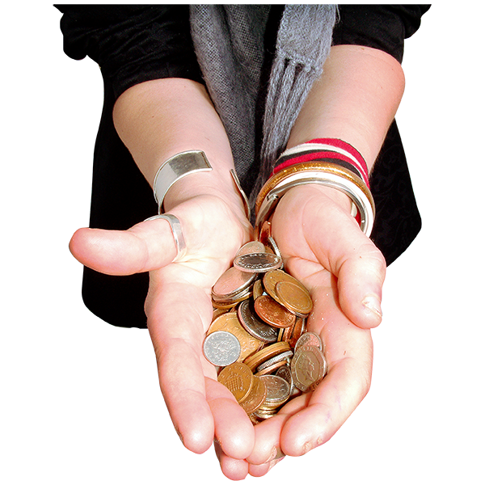
When we talk about cash we usually mean physical cash.

Physical cash is something you can hold in your hand like:
coins
banknotes.

1 dollar in your bank account is worth 1 dollar in coins.

Banks might close which could mean you cannot:
sent money to other people
change the money in your account into cash.

Digital cash is a new kind of money.


It is run by the Reserve Bank.

The Reserve Bank will not close.

Digital means it works using technology like:
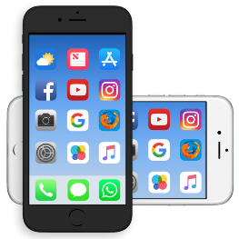
a card
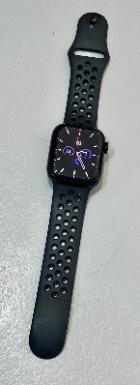
an app on your phone
another device like a smart watch.

Digital cash is more like banknotes and coins than money in your bank account.

It just works digitally.


It could make buying the things you want:
quicker
easier.

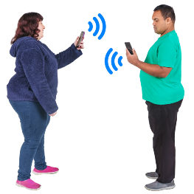
You could use digital cash to:
send money to other people
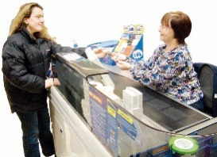
buy things in shops
pay for things online

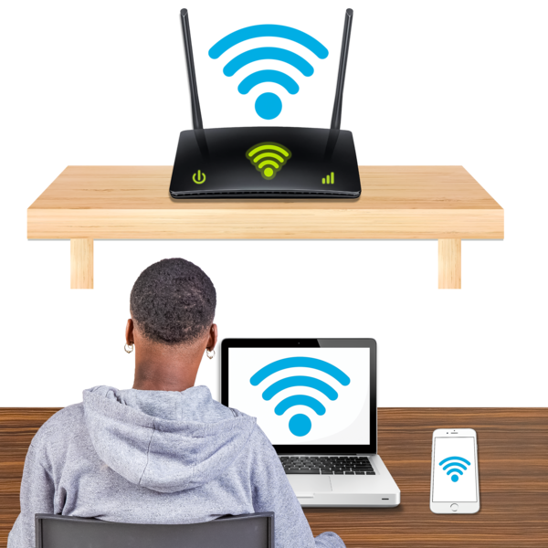
pay for things without connecting to the internet.

Digital cash would be different to the money in your bank accounts.


You could choose a digital cash provider to keep your digital cash with.

A digital cash provider is:
a bank
another organisation.
You do not have to have a bank account to use digital cash.

If New Zealand had digital cash people would still be able to use physical cash like:
coins
banknotes.

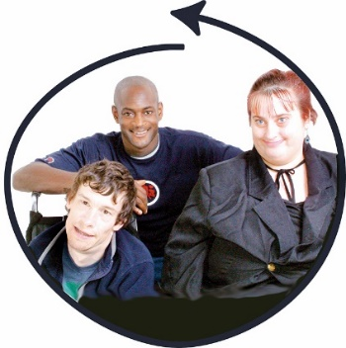
We want everyone to be able to use digital cash.

This includes people who do not have a bank account.

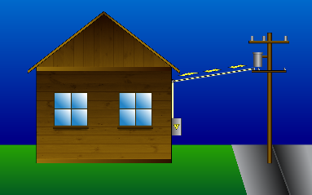
You would be able to use digital cash if there was no:
power / electricity
internet.

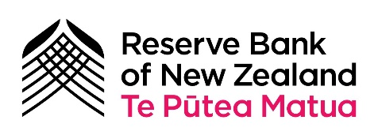
Digital cash will come from the Reserve Bank.

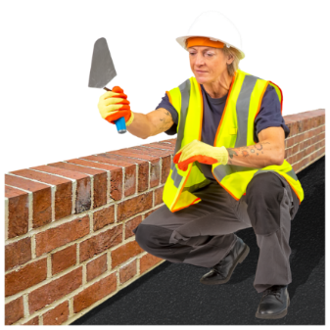
You will get it in the same ways you get other money like:
being paid for work
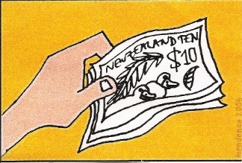
selling things to make money
swapping other money for it.

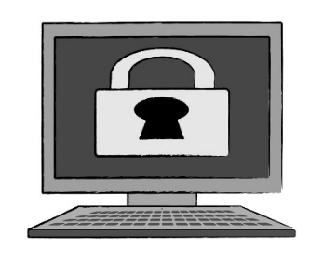
Digital cash will be private.

The Reserve Bank will not be able to:
see how you spend your money
control what you do with your money.

Examples of using digital cash

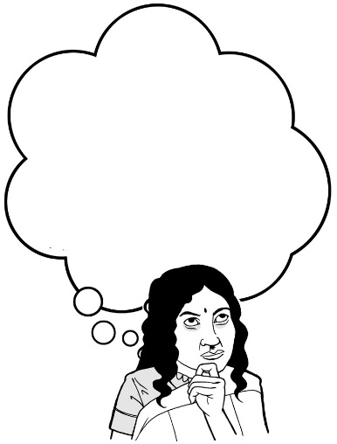
The people in these examples are not real.

We have made them up to show how people might use digital cash.

Grace

Grace has just opened an account with a digital cash provider.


She found getting digital cash:
quick
easy.

Having digital cash different from having an online bank account.

Grace uses internet banking to move money into her new digital cash wallet.


A digital cash wallet is where you keep digital cash.

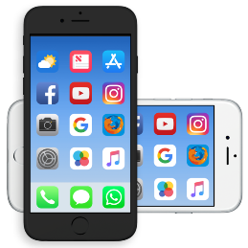
Grace can use her digital cash through:
her phone
online banking
a smart watch
a card a bit like an EFTPOS card.


She gives her work her digital cash information so she can be paid.

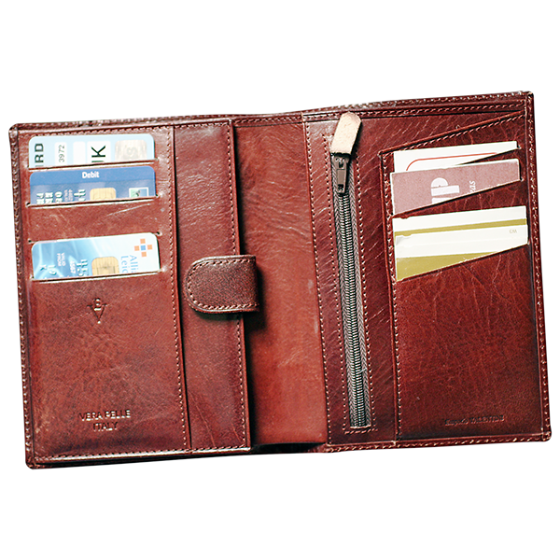
Later Grace finds some banknotes in her wallet.

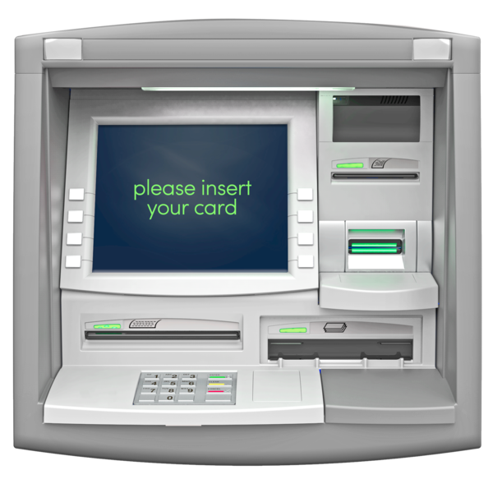
She goes to a Smart ATM to turn the banknotes into digital cash in her digital cash account.

A Smart ATM is an ATM:
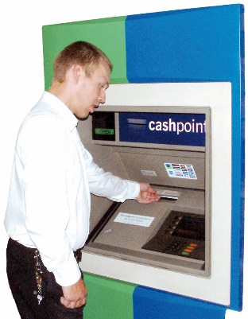
where you can get cash from your bank account
that also does other things like letting you pay money in.


Levi

Levi uses digital cash to pay for things.


Levi orders coffees for:
himself
his friend Grace.

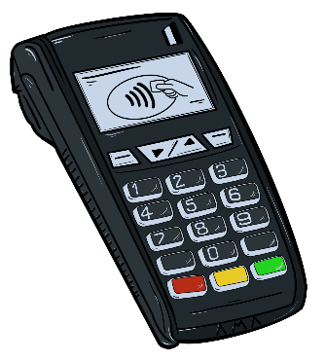
He can pay by holding his phone / smart watch against the EFTPOS machine.

He could also use a card.

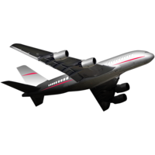
Levi books flights to Marlborough to visit his nan.

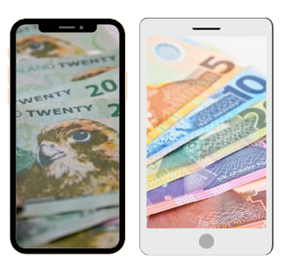
He pays with digital cash which is cheaper than paying by credit card.

Levi also wants to be able to get digital cash payments from people.

Grace can pay Levi back for the coffee by tapping their phones together.


The money is sent from Grace to Levi:
straight away
safely.

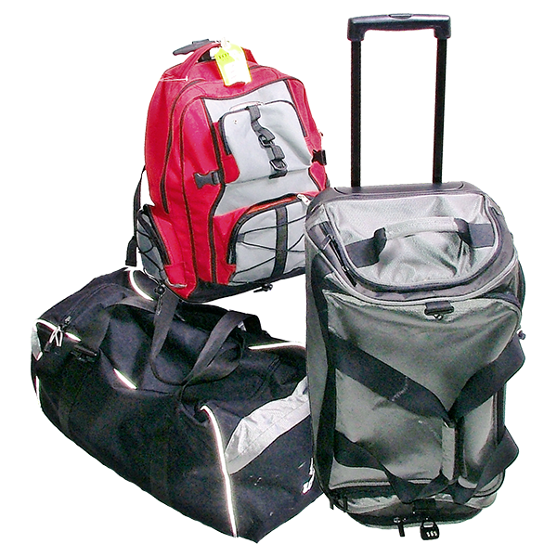
Levi is also going to take his digital cash card on holiday.

He can use his card to buy things even if he does not have any data left on his phone.

Maya


Maya can use the digital cash app on her phone to see where she is spending her money.


Maya wants to buy less coffee so she can save up for a new car.


The app can tell Maya:
how much she has spent buying coffee in the last month
if this is more or less than what she has spent on coffee in other months.

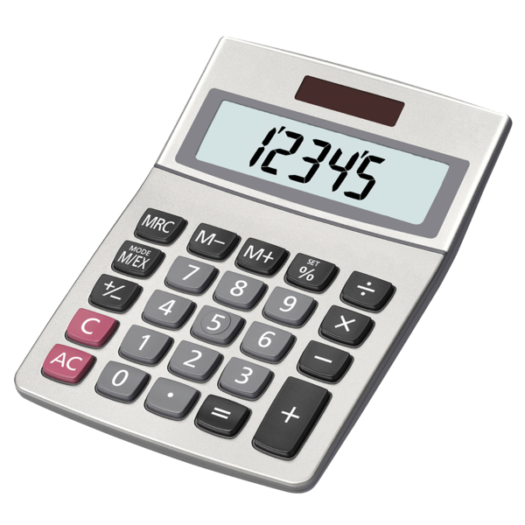
This is useful because she does not have to spend time:
- counting
- adding up what she has spent.

Maya sets things up so any digital cash left over at the end of each month gets moved into her savings account.


This means she earns interest on this money.

Interest is money a bank pays you for keeping money in your account.

This means she will be able to save faster for her car.

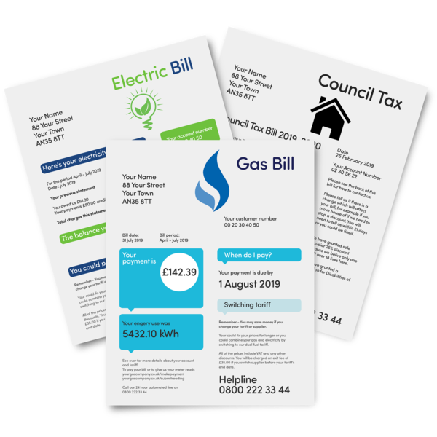
Maya also sets up automatic payments to move digital cash into the account she uses for paying bills.

Automatic payments are when you tell the bank to move your money:
every week
every month
at some other time that keeps happening.

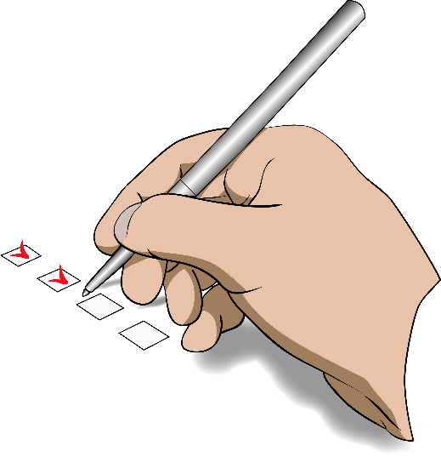
This means she can:
use the automatic payments she already has set up on her bank account
keep track of paying her bills.

Using digital cash without internet / power

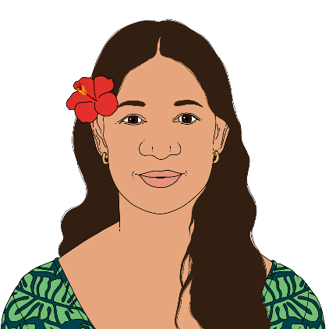
This is another story about how digital cash might be used.

Leilani is not a real person.

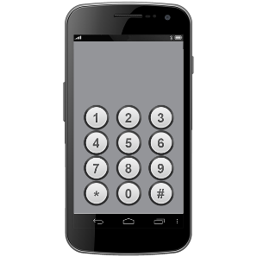
Leilani lives in a small town that does not have good mobile phone reception.

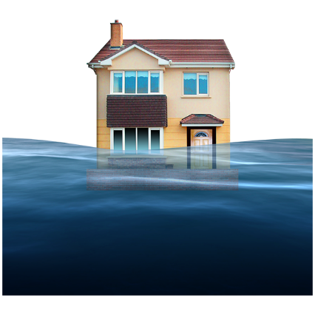
In her town there is sometimes very bad weather that causes problems like:
flooding
power cuts.

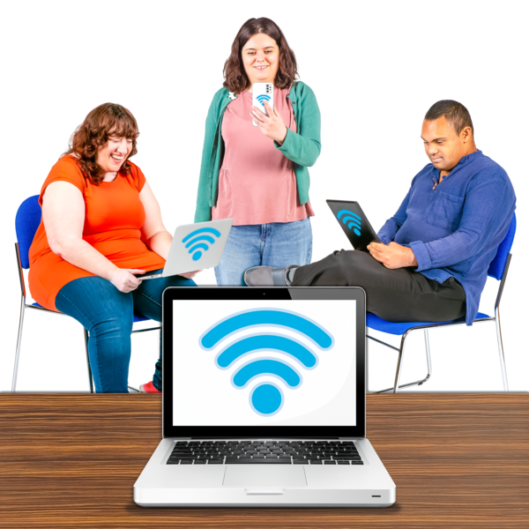
The last time there was very bad weather the town did not have:
internet access
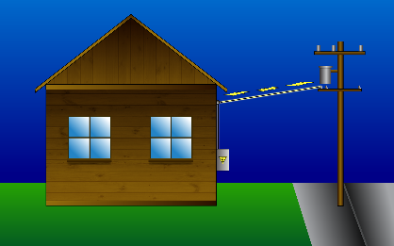
power.

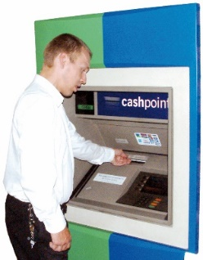
Without power people could not get cash from an ATM.

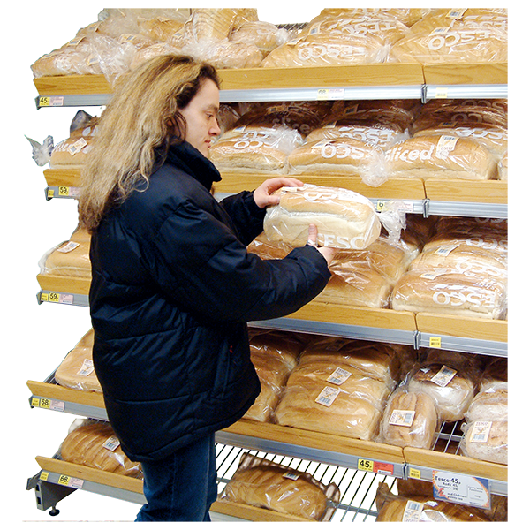
This made it hard for people to buy important things like food.

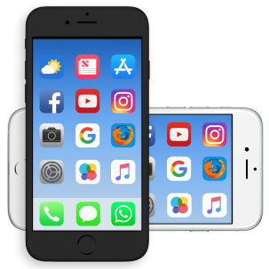
With digital cash people could still make payments.

They could pay using their:
phone
card.
They could also use Bluetooth to transfer the money.

Bluetooth is a way of connecting electronic items that are near each other like:
phones
computers
headphones.

You do not need internet to use Bluetooth.

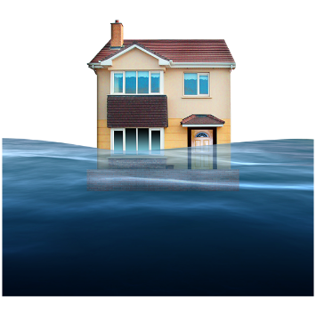
This means things would go better in communities if something like flooding happens.

People who are not comfortable using phones for payment could still use digital cash cards.

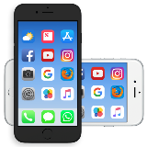

This means everyone would have more choice in how they make payments.

Making sure people trust our money


It is important people trust our money.

Trusting money means you feel:
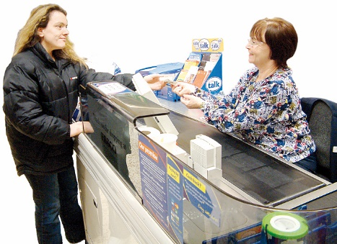
it is safe
you will always be able to use the money you have to pay for things.

Digital cash would be from the Reserve Bank so you do not have to worry about the bank closing down.

It will be based in New Zealand.

It will be in New Zealand dollars.

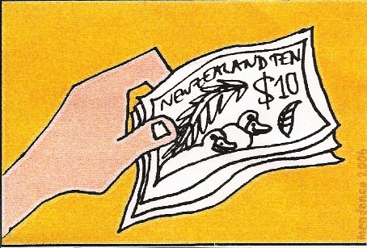
This means people will always be able to swap digital cash for the same amount of New Zealand dollars in:
banknotes
coins.

Tell us what you think

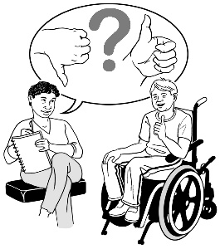
We want to know what you think about digital cash.

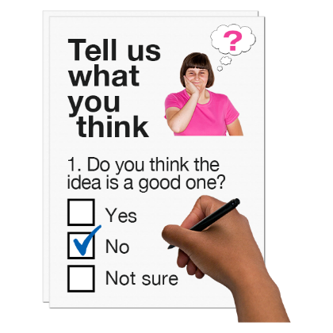
You can tell us what you think by filling in a survey.

A survey is a set of questions for you to answer.

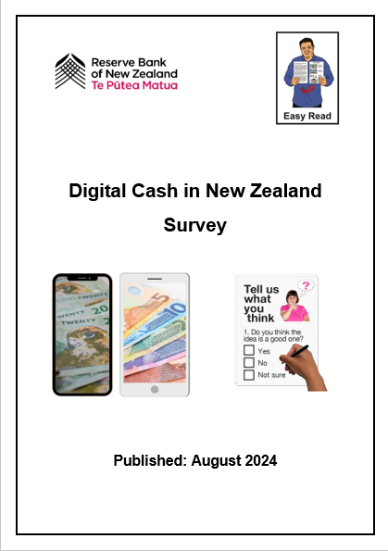
There is an Easy Read survey which you can find at:

www.rbnz.govt.nz/money-and-cash/digital-cash

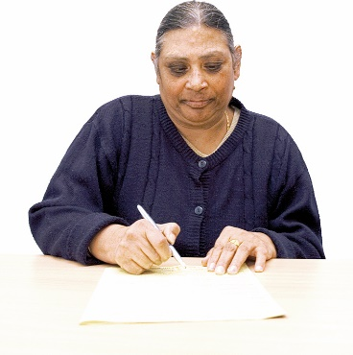
You can also write down what you think.

This is called making a written submission.

You can send your submission or survey to us:
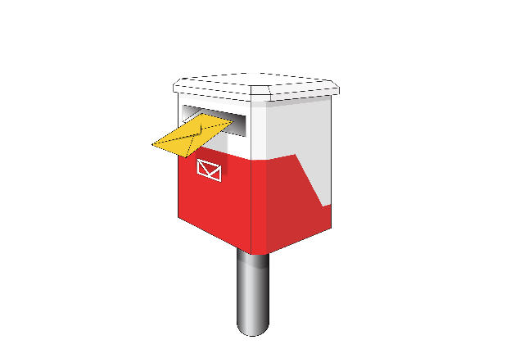
by post to:
Future of Money
Reserve Bank of New Zealand
PO Box 2498
2 The Terrace
Wellington 6140
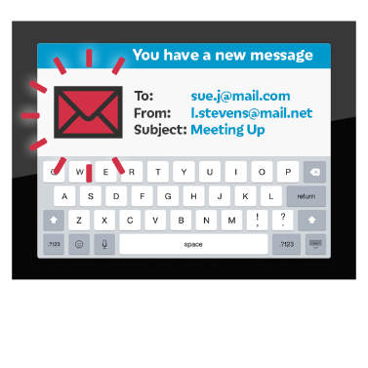
by email to:
futureofmoney@rbnz.govt.nz
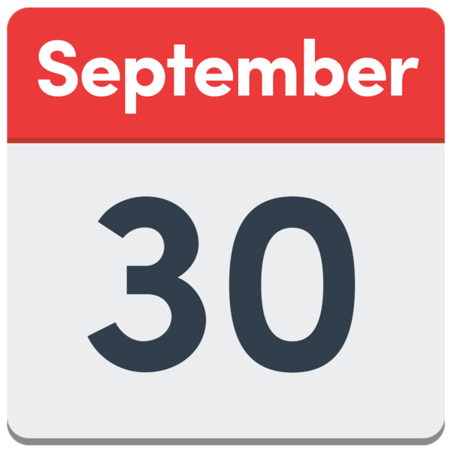
You need to send your submission to us by 30 September 2024.
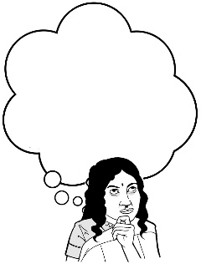
When you write your submission you may want to think about these questions.

Do you agree that money from the Reserve Bank should be:
something you can use digitally like on a phone
for everyone?

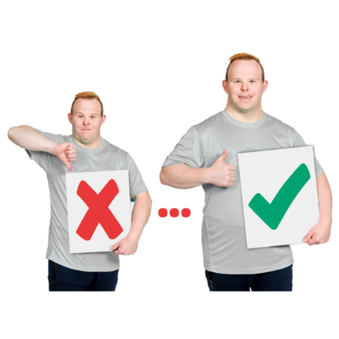
Do you agree that digital cash should:
make things work better
be something people can use when there are problems like:
- flooding
- power cuts?

When you write your submission you may also want to think about these questions.


Are there things about digital cash that:
worry you
you think might be problems?
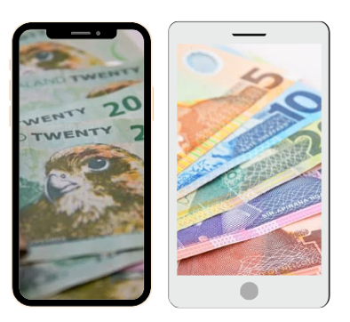

Are there ways digital cash could be done so it doesn’t have these problems?


Do you think digital cash can lead to new ways of doing things in New Zealand?


What sort of new ways of doing things would you like to see?
When you write your submission you may also want to think about these questions.


How can digital cash support digital financial inclusion?

Digital financial inclusion is about everyone being able to use:
digital money
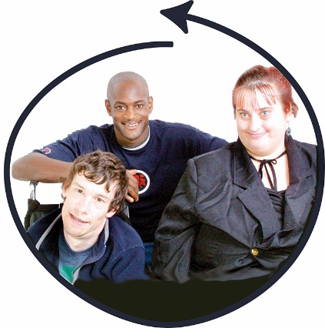
digital services to do with money like internet banking.

What needs to happen so digital cash can support digital financial inclusion?

When you write your submission you may also want to think about these questions.

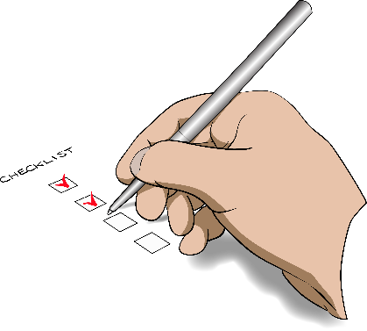
Do you think digital cash can make things more reliable?

Things are reliable if you know they are going to happen:

when they should
how they should.

What ways of making things reliable would you like to see?


How could digital cash help your organisation:
work better
deal with problems?

How to find out more

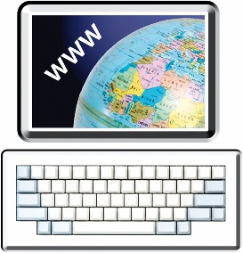
You can find more information on our website:

www.rbnz.govt.nz/money-and-cash/digital-cash

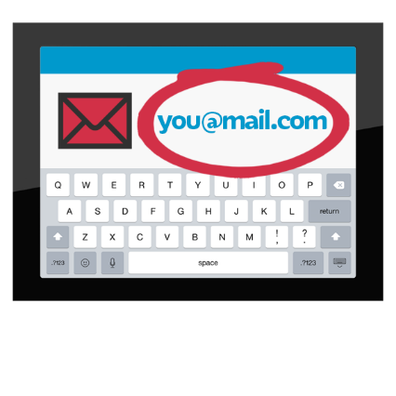
You can also contact us by:
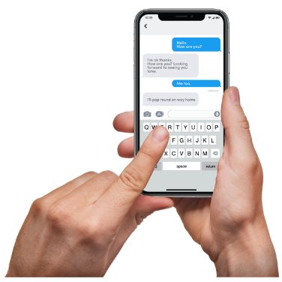
by email at:
futureofmoney@rbnz.govt.nz
by text to:
021 223 6062

by phone on:
0800 7269 7269
It does not cost you any money to call us on this number.

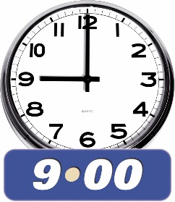
You can call us from Monday to Friday between:
9 in the morning
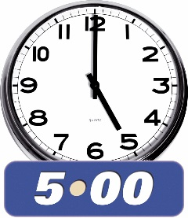
and
5 in the afternoon.


If you find it hard to use the phone the New Zealand Relay service is for people who are:

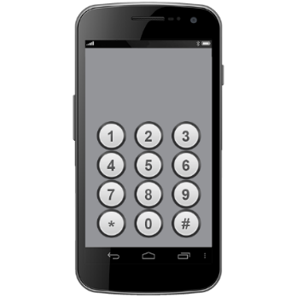
- Deaf / hard of hearing

- deafblind

- speech impaired / find it hard to talk.

You can find out more about the New Zealand Relay service at:

www.nzrelay.co.nz

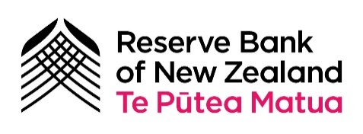
This information has been written by Reserve Bank of New Zealand Te Pūtea Matua.

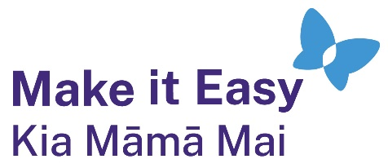
It has been translated into Easy Read by the Make it Easy Kia Māmā Mai service of People First New Zealand Ngā Tāngata Tuatahi.

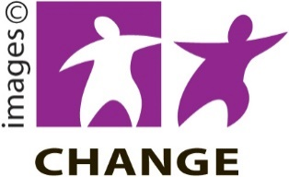
The ideas in this document are not the ideas of People First New Zealand Ngā Tāngata Tuatahi.

Make it Easy uses images from:


- Changepeople.org

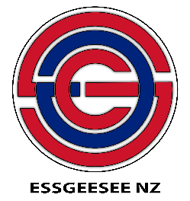
            - Photosymbols.com

- SGC Image Works
- Huriana Kopeke-Te Aho

- T. Wood.

All images used in this Easy Read document are subject to copyright rules and cannot be used without permission.

