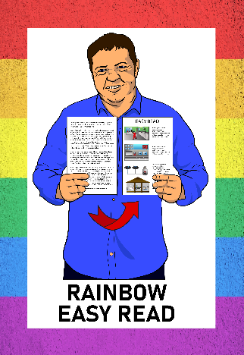

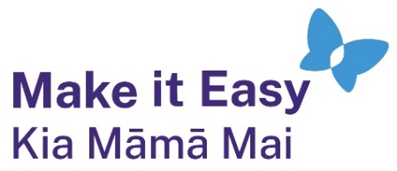

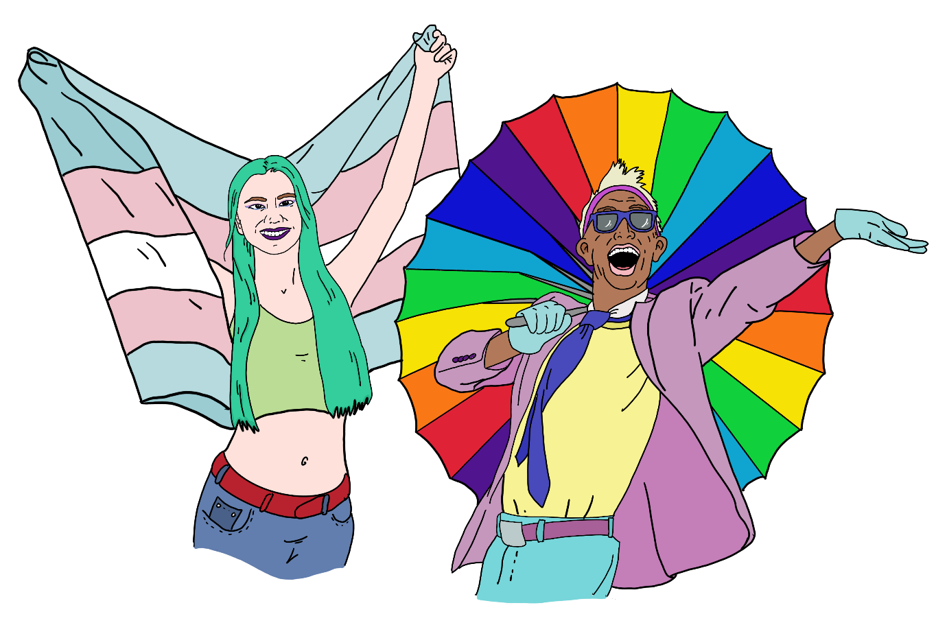Rainbow Easy Read:  
Getting started

Published: February 2025

# About this guide

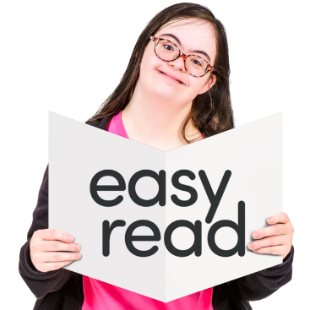

This guide is about the Rainbow Easy Reads.

It tells you more about:

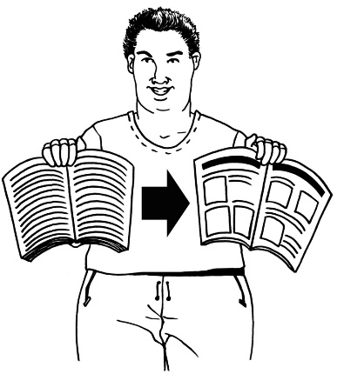what Easy Read is

what Rainbow Easy Reads there are

why we made these Easy Reads.

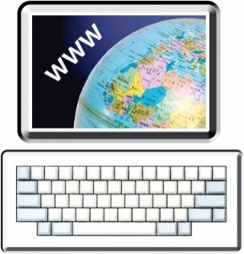You can find all the Rainbow Easy Reads at:

[**https://linktr.ee/rainboweasyread**](https://linktr.ee/rainboweasyread)

# What is Easy Read?

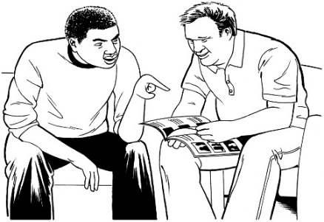

Easy Read makes information easy to understand.

It uses:

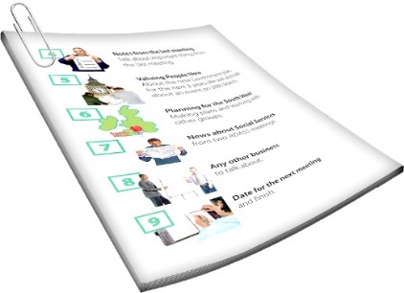short sentences

everyday language

pictures.

Easy Read is mostly meant for people with learning disability.



Lots of other people can find Easy Read useful too.

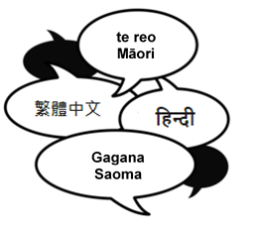Some of the people who might use Easy Read include:

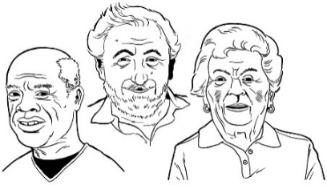people who speak English as a second language

some older people

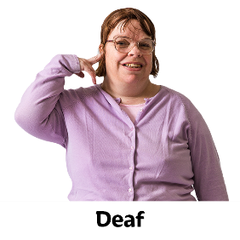some Deaf people

people who find reading hard because of conditions like dyslexia

anyone who wants things explained in a way that is easy to read.

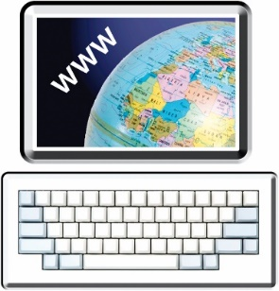

You can find out more about Easy Read at this **website**:

[**www.makeiteasy.org.nz**](http://www.makeiteasy.org.nz)

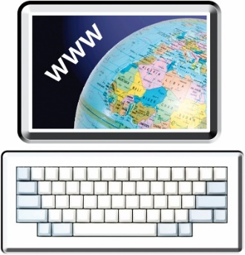You can find lots of Easy Reads in the People First NZ Easy Read Library at this **website**:

**www.peoplefirst.org.nz/easy-read-library/all-easy-read-resources**

# What are the Rainbow Easy Reads about?

There are 8 Rainbow Easy Reads.

These are:

the names of the Easy Reads

what the Easy Reads are about.

## Rainbow Easy Read: Getting started

This is the Easy Read you are reading now.

It tells you about the Rainbow Easy Reads.

## Rainbow Easy Read: Rainbow words and identities

This tells you what different words mean like:

lesbian

transgender

queer.

## Rainbow Easy Read: All about pronouns

This Easy Read tells you about the different **pronouns** rainbow people use.

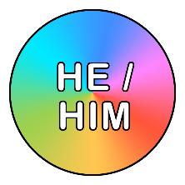**Pronouns** are words we use instead of names like:

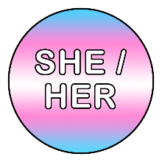he / him

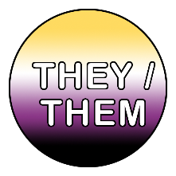she / her

they / them.

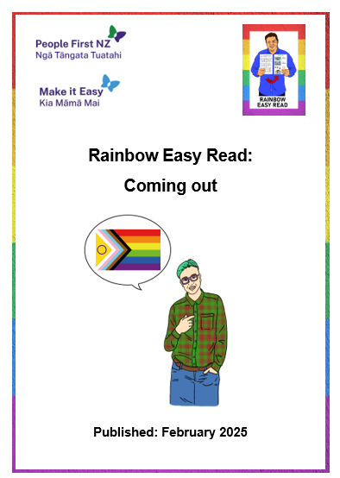

## Rainbow Easy Read: Coming out

Coming out is when you tell other people you are a rainbow person.



This Easy Read tells you:

how you might decide to come out

how to keep yourself safe.

## Rainbow Easy Read: What do I say?

This Rainbow Easy Read talks about some of the things you might say if people:

ask you questions

say rude things.

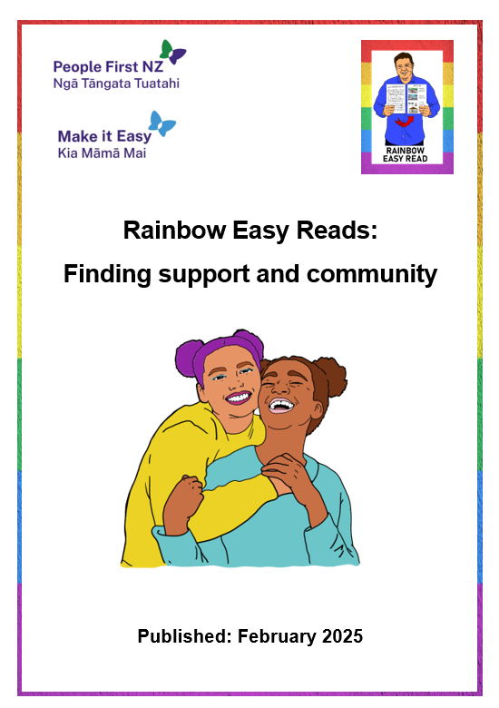

## Rainbow Easy Read: Finding support and community

This Easy Read talks about where you might go for support like:

organisations

different kinds of people.

## A poster of a group of people sitting at a table AI-generated content may be incorrect.Rainbow Easy Read: Your rights as a rainbow person

This Rainbow Easy Read tells you about:

your rights

what to do if people are not respecting your rights.

## Rainbow Easy Read: Supporting your rainbow friends and whānau

This Rainbow Easy Read tells you how you can support your rainbow:

friends

whānau / family.

# Who the Easy Reads are for



The Rainbow Easy Reads are for everyone who wants to understand more about the rainbow community.

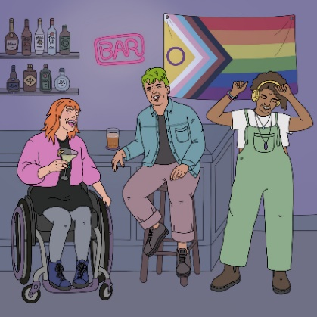Some people who might find these

Easy Reads useful are:

people who are in the rainbow community

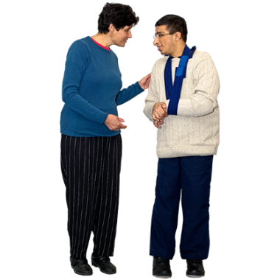people who are not sure if they are in the rainbow community

friends of people in the rainbow community

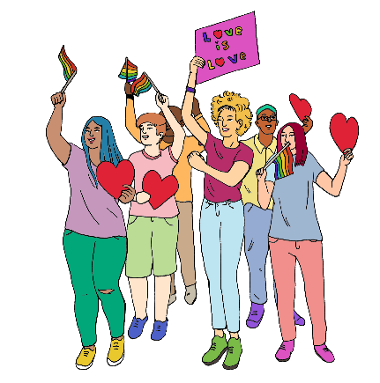whānau / families of people in the rainbow community

supporters of the rainbow community.

# How we made the Easy Reads

The Rainbow Easy Reads were made by Make it Easy Kia Māmā Mai.

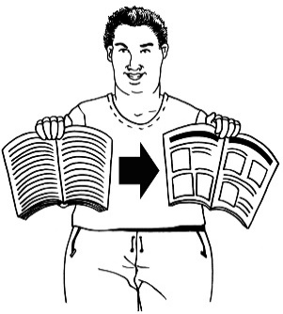

Make it Easy Kia Māmā Mai:

makes Easy Reads

is part of People First New Zealand Ngā Tāngata Tuatahi.



The **Rule Foundation** gave us some money to make the Easy Reads.

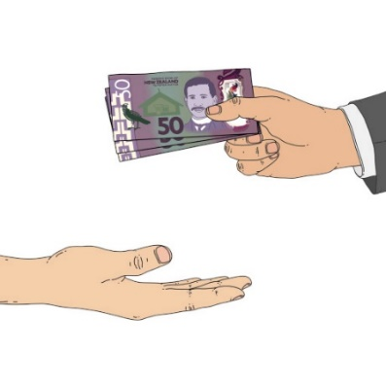

The **Rule Foundation** gives money to things that support rainbow communities to do well.

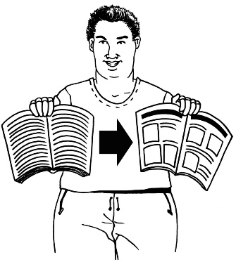Lots of people have worked together on these Rainbow Easy Reads including:

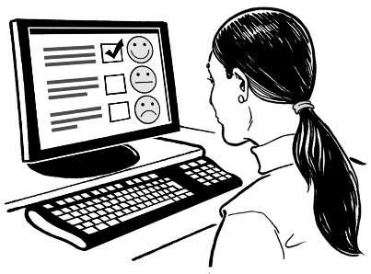Easy Read translators from   
Make it Easy – these are people who make Easy Read

**illustrators** who work for Make it Easy

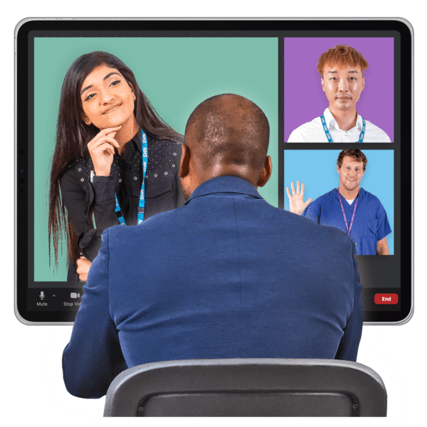**advisors** who are People First NZ members

other people who work for People First NZ.



**Illustrators** make the pictures we use in Easy Read.

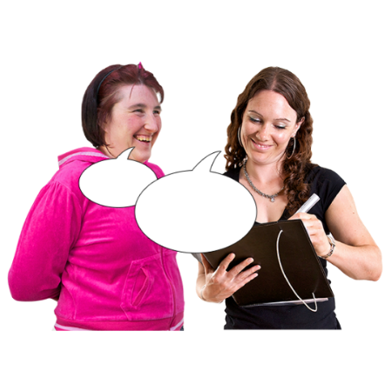**Advisors**:

give ideas about what Easy Reads are needed

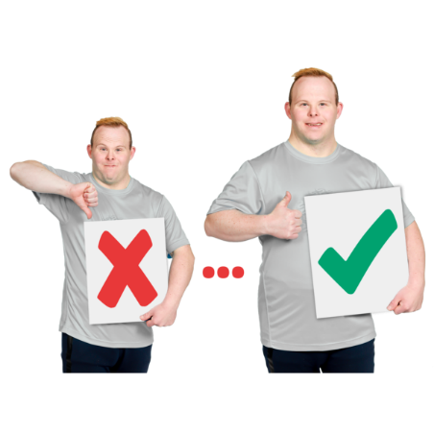look at how the Easy Reads are going

say how to make the Easy Reads better.

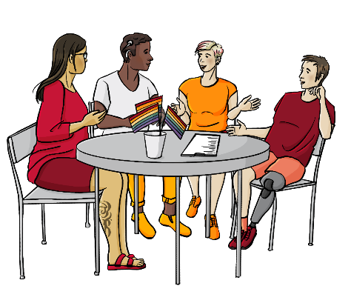

Many of the people who worked on these Easy Reads are also part of the rainbow community.

We hope to keep making more Easy Reads like this.

You can tell us what kinds of Easy Reads you want us to make by **emailing**:

**makeiteasy@peoplefirst.org.nz**

# More information

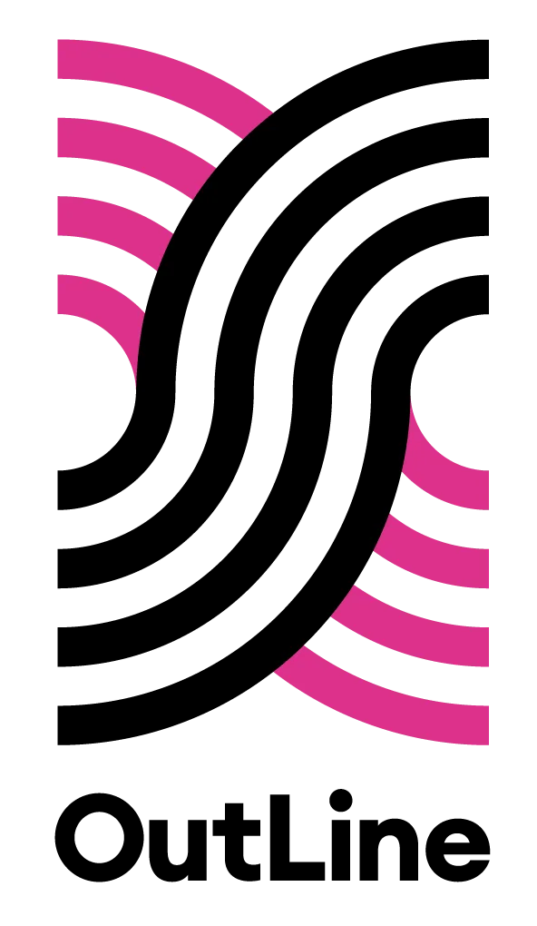You can contact OutLine for support if you:

are part of the rainbow community

think you might be part of the rainbow community.



You can contact OutLline every day between **6 pm** and **9 pm** in the evening:

by **phone** on:  
  
**0800 688 5463**

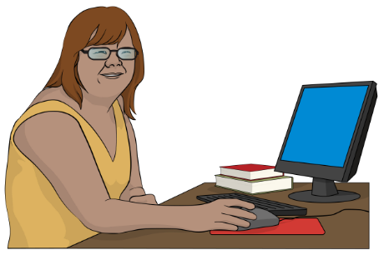using the text chat on their **website** at:  
  
**outline.org.nz/chat**

There is an Easy Read called:

**Rainbow Easy Read: Finding support and community**

It has information about more places you can contact for:

information

support.

You can find this Easy Read at:

[**https://tinyurl.com/RERcommunity**](https://tinyurl.com/RERcommunity)

# Thank you



Lots of people worked together on the Rainbow Easy Reads.

Thank you to the Rule Foundation for giving us the money to make the Rainbow Easy Reads.

Thank you also to:

the People First NZ members who worked as advisors

the People First NZ staff who supported them

everyone who has supported this mahi / work.

This information has been written by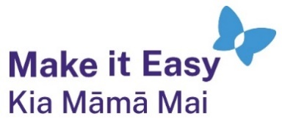 Make it Easy Kia Māmā Mai.



Make it Easy is a service of People First New Zealand Ngā Tāngata Tuatahi.

All images used in this Easy Read document are subject to copyright rules and cannot be used without permission.

Make it Easy uses images from:

* 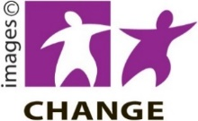Photosymbols
* 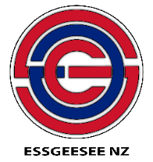Change Images
* SGC Image Works
* Huriana Kopeke-Te Aho
* 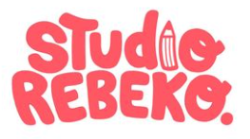T Wood
* Studio Rebeko
* Inga Kramer.