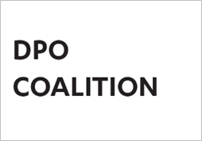
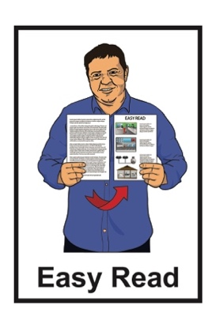

Statement about changes to

Whaikaha – Ministry of Disabled People Disability Support Services


Published: September 2024

What you will find in here

Page number:
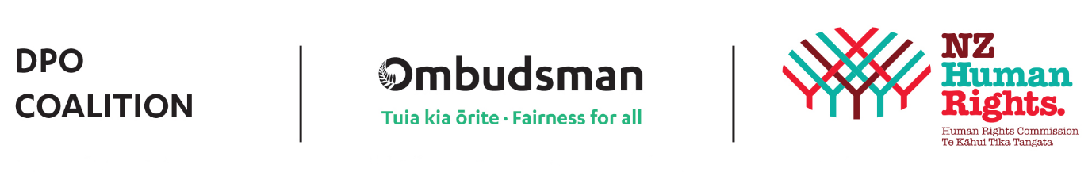
Who is the Disabled People’s
Organisations Coalition? 2


What this document is about 5

DPO Coalition statement 9
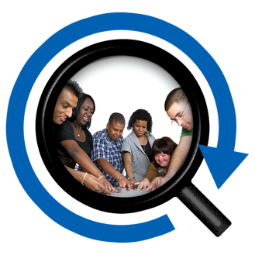

Research about Disability
Support Services 17


Get in touch 21

Who is the Disabled People’s Organisations Coalition?


The Disabled People’s Organisations Coalition is a group of people who come from different disability organisations.


A coalition is a group of organisations that work towards shared goals.

The Disabled People’s Organisations Coalition is also called the DPO Coalition.


When you see the words we / us in this document it means the DPO Coalition.

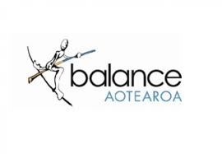
The DPO Coalition is made up of members from these 7 disability organisations:

Balance Aotearoa
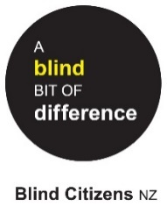

Blind Citizens New Zealand
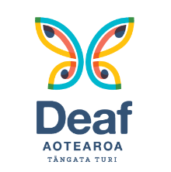

Deaf Aotearoa

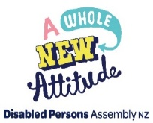
Disabled Persons Assembly NZ

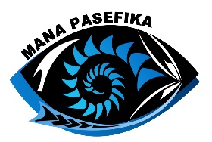
Mana Pasefika

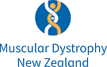
Muscular Dystrophy Association of New Zealand


People First New Zealand – Ngā Tāngata Tuatahi.


The DPO Coalition meets about every 6 weeks to talk about important things.

The DPO Coalition speaks up about disabled people getting their human rights.

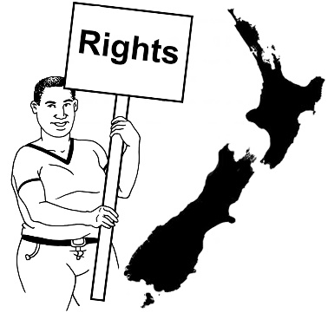
Human rights are things that the
law says every person should:
have
be able to do.

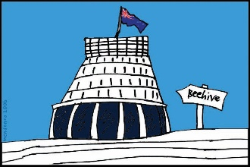
The DPO Coalition talks with the Government about things to do with disability.

What this document is about

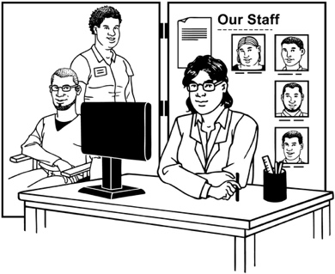
This Easy Read document is a statement about the changes the Government is making to:
- Disability Support Services

- Whaikaha - Ministry of Disabled People.
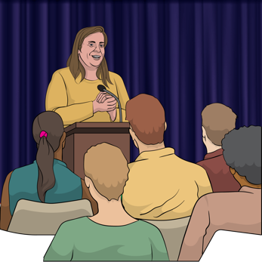

A statement is an official document to tell everyone what we think.

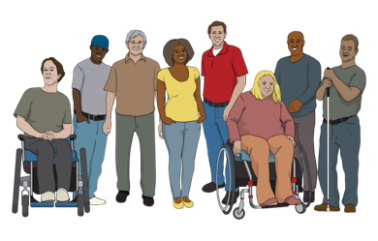
Whaikaha – Ministry of Disabled People is the part of the Government in charge of things to do with disabled people.


The Government has changed what you can spend your Disability Support funding on.

The Government has also changed where you get your Disability Support Services from.


Disability Support Services used to come from Whaikaha.

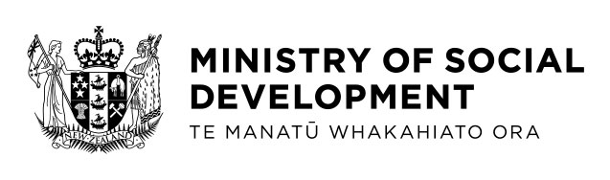
Now Disability Support Services come from the Ministry of Social Development.

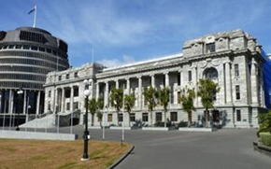
The Ministry of Social Development is the part of the Government in charge of things like:
benefits
student loans.

The Ministry of Social Development is also called MSD.


A benefit is money from the Government for people to live on.


In this document we will talk about why we are worried about these changes to Disability Support Services.


We will also talk about some research into Disability Support Services in Aotearoa New Zealand.

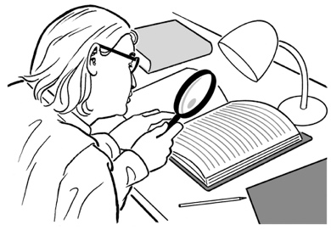
Research is when we:
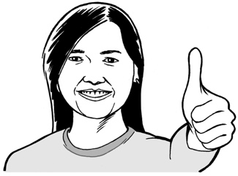
- look at what things have happened
- try to find ways to do things better.

DPO Coalition statement


When Whaikaha was first put together disabled people hoped it would give them:
a good standard of living

dignity
a say in how Disability Support Services work.


Standard of living means how much you have of:
things you need like:

- money
- food
things that are nice to have.

Dignity means being treated like you are important / matter as a person.


The government is making Whaikaha not responsible for funding disability support services.

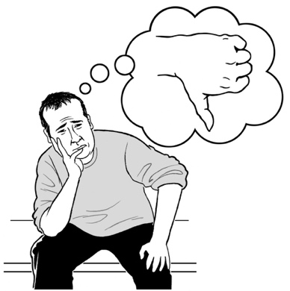
We are worried this will make it harder for disabled people to have a good life.

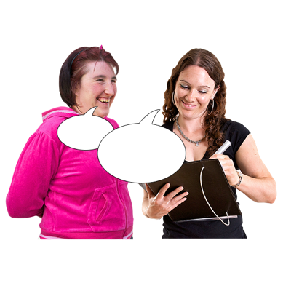
The Government should have talked to disabled people before making changes to Disability Support Services.

We think the Government has failed disabled people.


Here failed means they:
did not do what they should have
let disabled people down very badly.


The Government has some important obligations it has not met.

Obligations means things someone must do.

We will talk about these obligations on the next 5 pages.

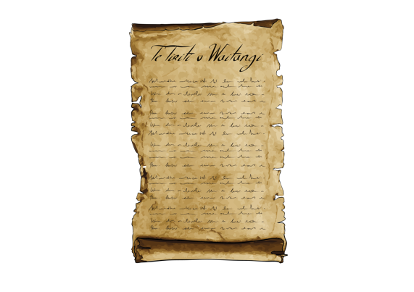
Te Tiriti of Waitangi / the Treaty of Waitangi means the Government has an obligation to think about the needs of Tāngata Whaikaha Māori / Māori disabled people.

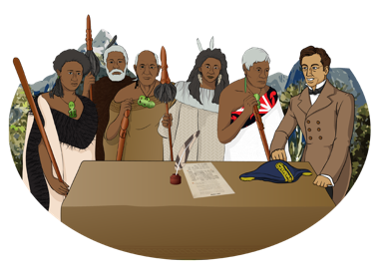
Te Tiriti o Waitangi / the Treaty of Waitangi is an important agreement between Māori and the British Crown.

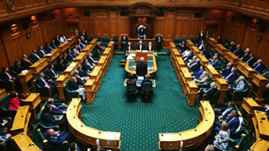
It is about Māori and the New Zealand Government:
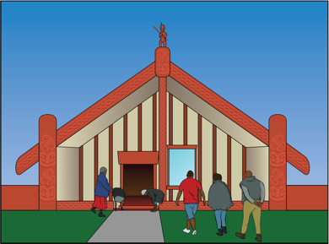
making decisions together
protecting things that are important to Māori.
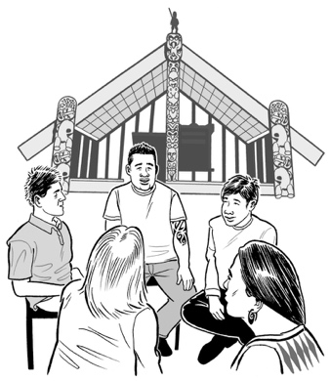

The Government did not talk to Tāngata Whaikaha Māori / Māori disabled people before it changed Disability Support Services.
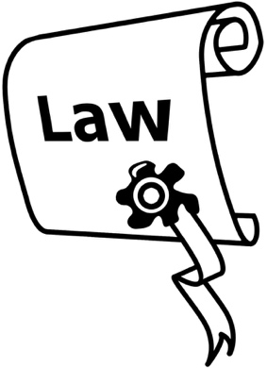
The United Nations Convention on the Rights of Persons with Disabilities is a law lots of countries including Aotearoa New Zealand have agreed to.
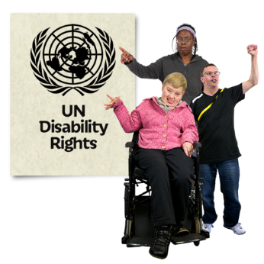

The United Nations Convention on the Rights of Persons with Disabilities is also called the UNCRPD.

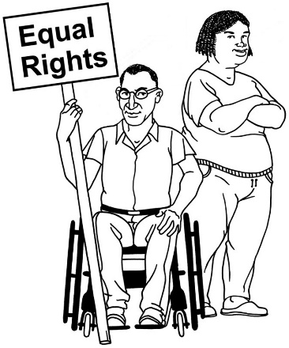
The UNCRPD says what governments must do to make sure disabled people get the same rights as everybody else.

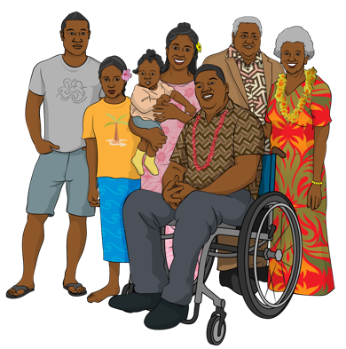
The UNCRPD says the government has to work with:
disabled people
whānau / families of disabled people.


The Government did not do this when it made changes to Disability Support Services.
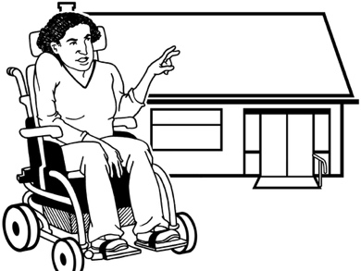

The UNCRPD says disabled people have the right to:
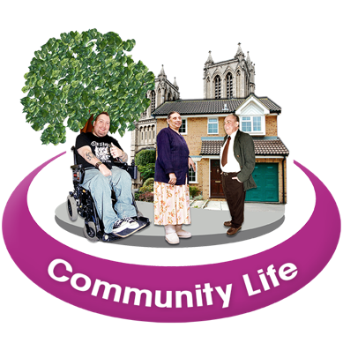
live independently
be included in the community.


Live independently means having the same choices as everyone else about:
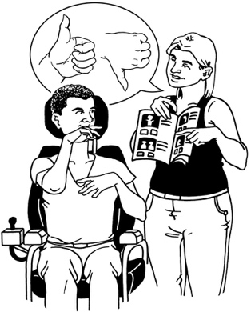
where you live
who you live with
what support you get.
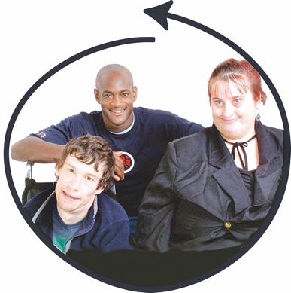

Included means being able to take part in the same things as everyone else.
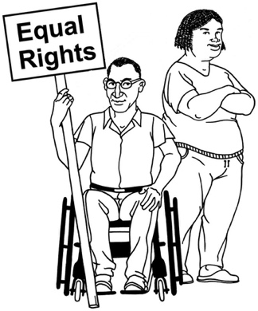

We think the changes to Disability Support Services make it harder for disabled people to get their rights.


We are asking the Minister for Disability Issues not to make any more changes to Disability Support Services without talking to:
disabled people
whānau / families of disabled people
disabled people’s oragnisations.

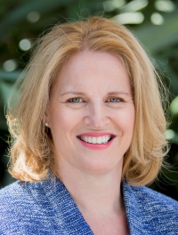
The Minister for Disability Issues is the Member of Parliament in charge of things to do with disabled people.

The Minister for Disability Issues is Louise Upston.

Research about Disability Support Services

The Donald Beasley Institute is doing research about how well Disability Support Services in Aotearoa New Zealand fit with what the UNCRPD says.
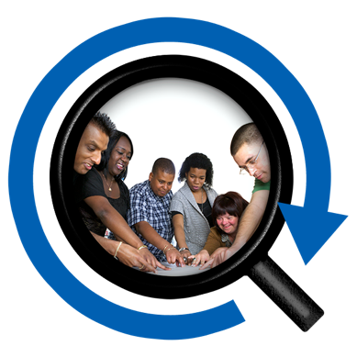

The Donald Beasley Institute does research with disabled people about their lives.

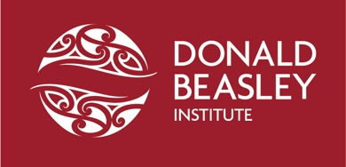
The Donald Beasley Institute is also called the DBI.

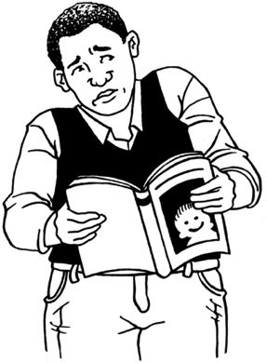
The DBI found that it can be hard to find accessible information about Disability Support Services.


Accessible information means information that:
you can understand

is in a format that works for you like:
- Easy Read
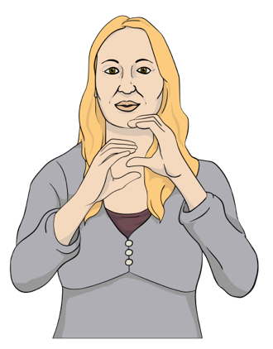
- braille
- sign language
tells you the things you need to know.


They also found that disabled people do not have enough choices about the support they get.
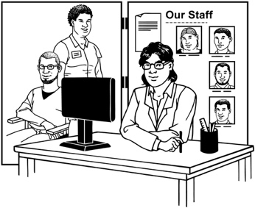
DBI found that people with some disabilities could not get any Disability Support Services at all.

A big problem is that the Government has not spent enough money on Disability Support Services for many years.


The DBI has made some recommendations about how the Government could make Disability Support Services better.
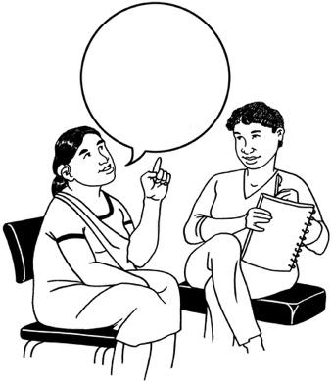

Making recommendations means someone saying what they think is the best thing to do.

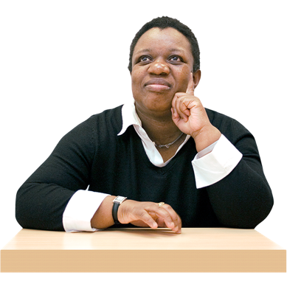
DBI said that disabled people should have leadership roles in:
Disability Support Service agencies
government.

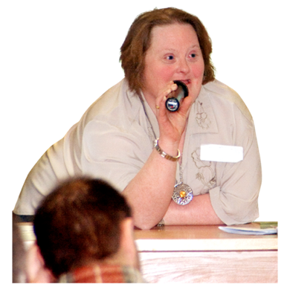
Leadership roles are jobs where you:
make decisions
are in charge of other people.

They also said disabled people should be in charge of how Disability Support Services work.


They said the Government should put more money into support for disabled people.

Get in touch


You can get in touch with the DPO Coalition by email at:

us-dpo@groups.io


You can find more information about the DPO Coalition on this website:

https://tinyurl.com/3ww6acze
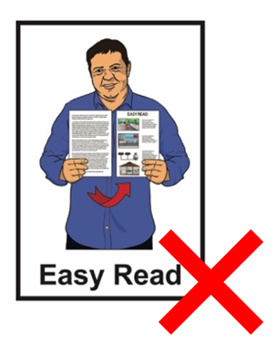

The website is not in Easy Read.

This information has been written by Disabled People’s Organisations Coalition.

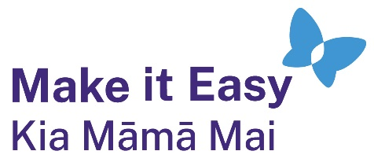
It has been translated into Easy Read by the Make it Easy Kia Māmā Mai service of People First New Zealand Ngā Tāngata Tuatahi.
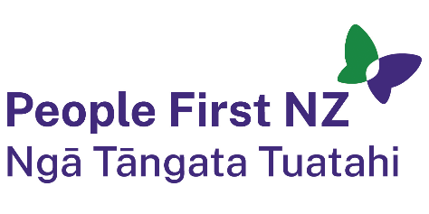
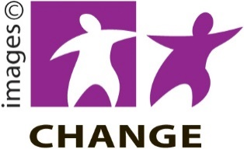
The ideas in this document are not the ideas of People First New Zealand Ngā Tāngata Tuatahi.

Make it Easy uses images from:


- Changepeople.org


            - Photosymbols.com

- SGC Image Works
- Huriana Kopeke-Te Aho

- T. Wood.

All images used in this Easy Read document are subject to copyright rules and cannot be used without permission.

