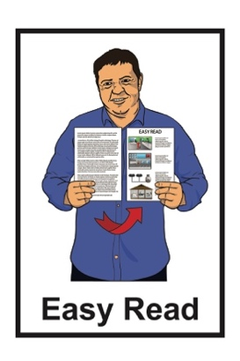
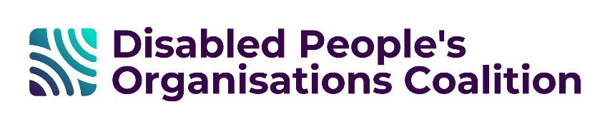

Disabled People’s
Organisations Coalition:
Key Messages:

March and May 2026
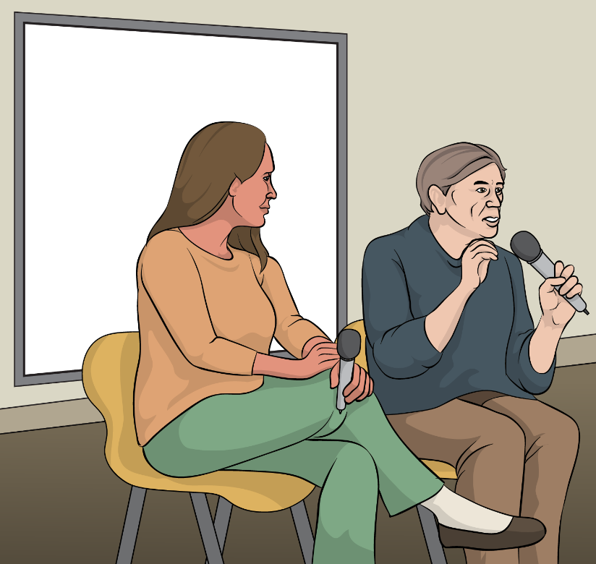

Published: August 2026

Before you start

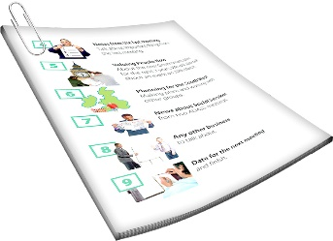
This is a long document.

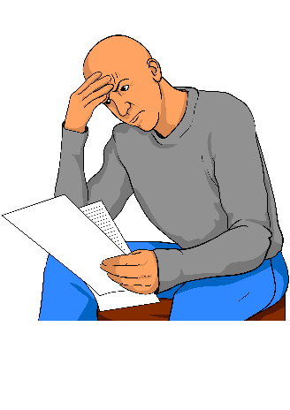
It can be hard for some people to read a document this long.

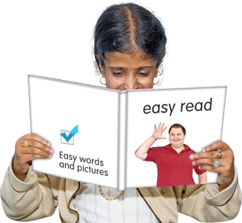
Some things you can do to make it easier are:
read it a few pages at a time
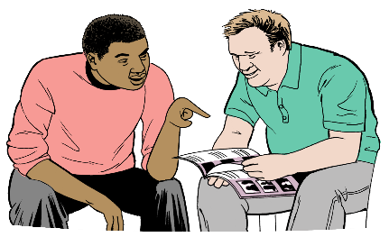
set aside some quiet time to look at it
have someone read it with you to support you to understand it.

What is in this document

Page numbers:
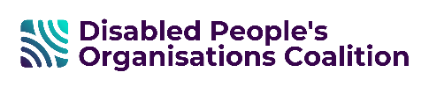
The Disabled People’s
Organisations Coalition 4
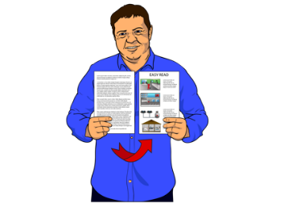

What this document is about 7

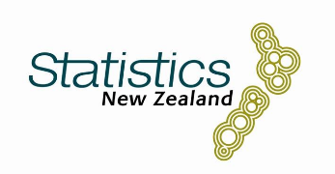
Stats NZ 10

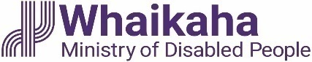
Whaikaha – Ministry of Disabled
People 14
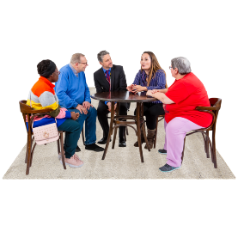

Public Health Agency 20

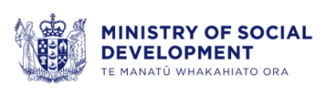
Ministry of Social Development 24

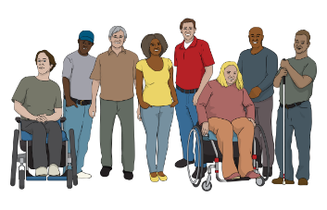
Ministry of Social Development and
ThinkPlace 26

Page numbers:
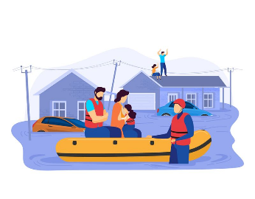

Emergency Management 30
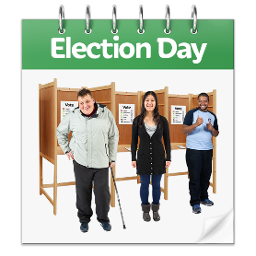

Electoral Commission 32

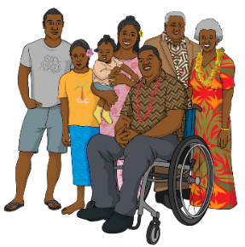
Voices of disabled people 34

The Disabled People’s
Organisations Coalition

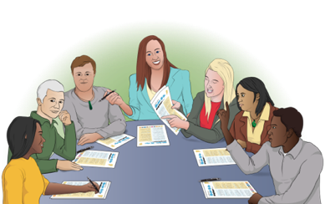
The Disabled People’s Organisations Coalition is a group of people who come from different disability organisations.

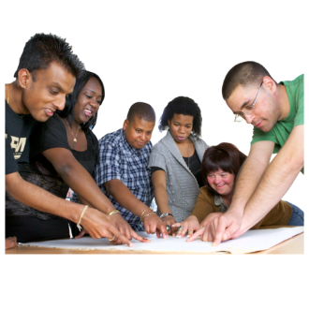
A coalition is a group of organisations that work towards shared goals.


The Disabled People’s Organisations Coalition is also called the
DPO Coalition.

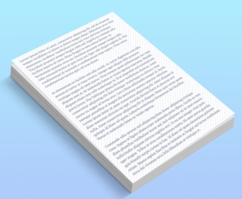
When you see the words we / us in this document it means the
DPO Coalition.

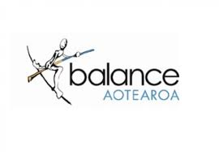
The DPO Coalition is made up of members from these 7 disability organisations:
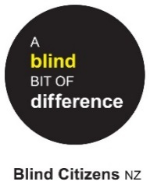
Balance Aotearoa
Blind Citizens New Zealand
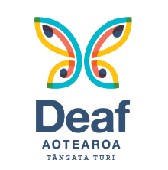
Deaf Aotearoa
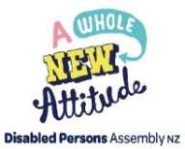
Disabled Persons Assembly NZ
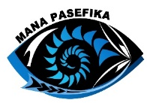
Mana Pasefika
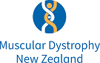
Muscular Dystrophy Association of New Zealand
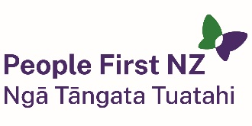
People First New Zealand – Ngā Tāngata Tuatahi.

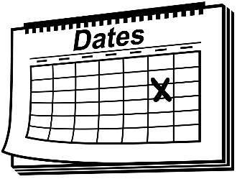
We meet about every 6 weeks to talk about important things.


We speak up about disabled people getting their human rights.

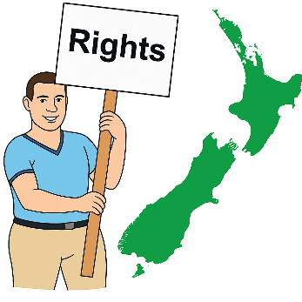
Human rights are things that
the law says every person should:
have
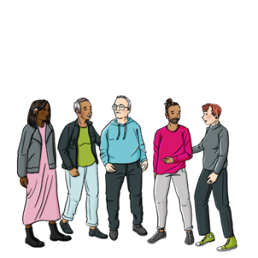
be able to do.

Human rights are things like:
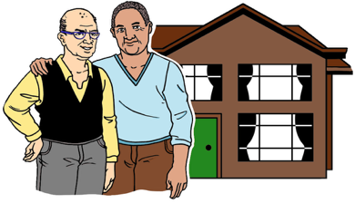
having a safe place to live
being able to get married.

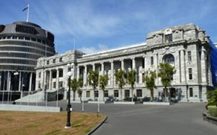
We also talk with the Government about things to do with disability.

What this document is about

This Easy Read is about some of the
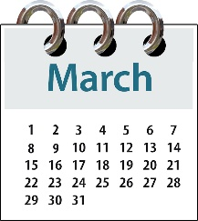
most important things the DPO Coalition talked about at our meetings in:
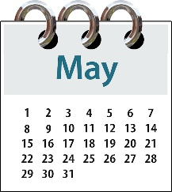
March 2026
May 2026.

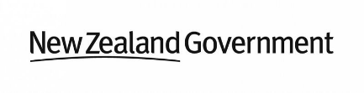
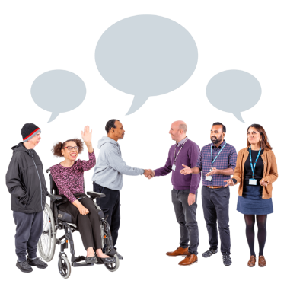
During these meetings we talked to lots of:
Government agencies
other community organisations.

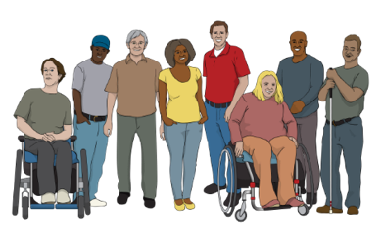
These meetings are to make sure the lives of disabled people in Aotearoa
New Zealand are getting better.
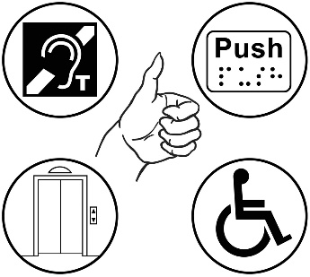
2 important things we often talk about are:
accessibility
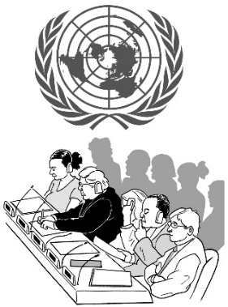
the rights of disabled people in New Zealand under the United Nations Convention on the Rights of Persons with Disabilities.

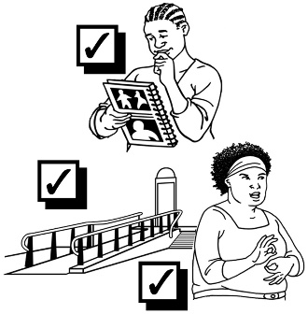
Accessibility means making sure everyone can use things in ways
that are:
easy
safe.

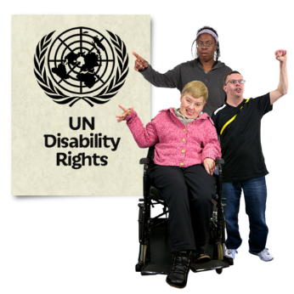
The United Nations Convention
on the Rights of Persons with Disabilities:
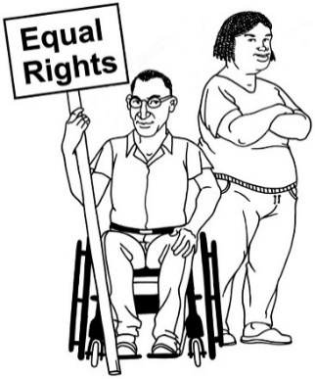
says what governments must
do to make sure disabled
people get the same rights as everybody
is an agreement lots of
countries follow
is also called the UNCRPD.

Stats NZ

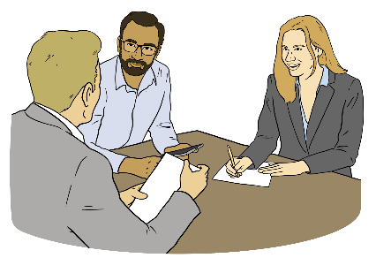
We met with a big group from
Stats NZ on 26 March 2026.

Stats NZ is the Government agency that collects data about people in Aotearoa New Zealand.
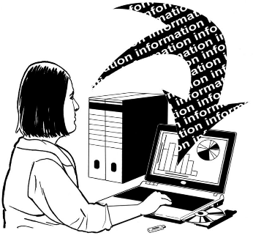

Data means information that is collected to support people to understand something.

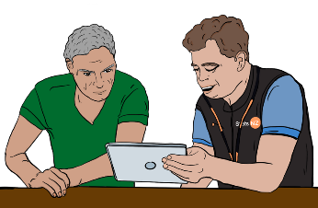
Stats NZ talked with us about the census consultation.


The census is a big survey / list of questions about people who live in Aotearoa New Zealand.
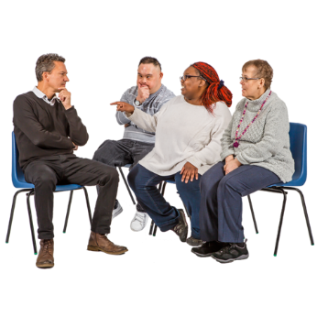
A consultation is when an organisation asks people what they think about something.

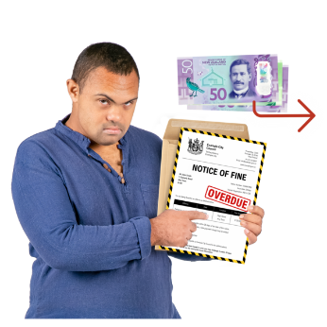
Stats NZ also talked to us about the infringement policy consultation.


An infringement policy is a policy about fines / making people pay for breaking Stats NZ rules.

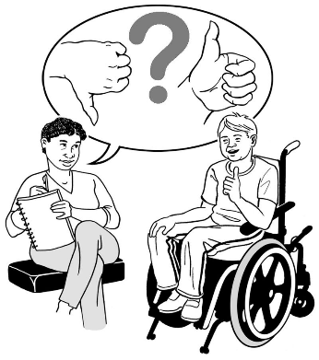
Stats NZ wanted to hear what disabled people think about their plans for making people pay fines for not doing compulsory surveys.

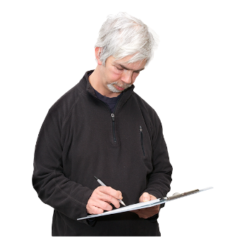
Here compulsory means you have to fill in the survey / list of questions.

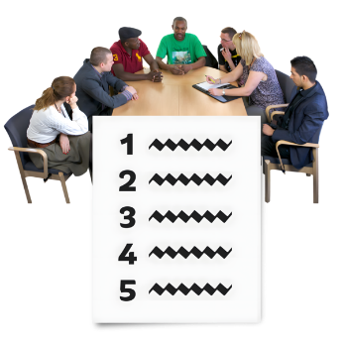
Our discussion with Stats NZ about the infringement policy was our submission.


A submission is when people say what they think as part of a consultation.

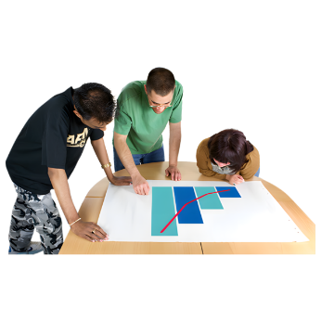
Stats NZ also talked to us about a report about disability data.

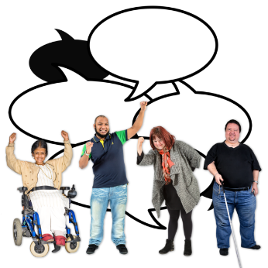
We told Stats NZ how disability organisations use data to speak up for disabled people.

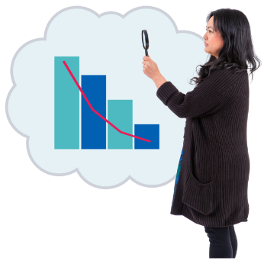
We talked about how changes to the way data is collected could make it harder for the DPO Coalition to use data to speak up for what people need.

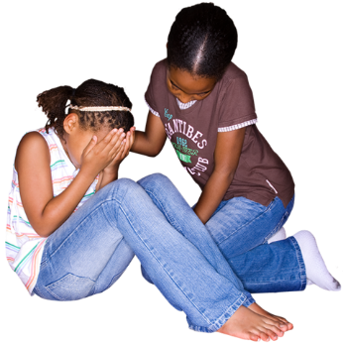
Stats NZ also talked to us about child poverty statistics.

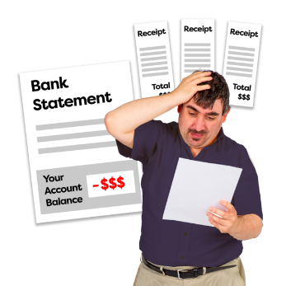
Poverty is when people do not have enough money to live.

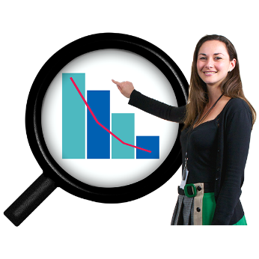
Statistics are numbers that tell us information.

Stats NZ listened to our feedback.

We will keep building a good relationship with Stats NZ.

Whaikaha – Ministry of Disabled People

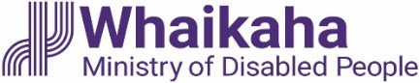
We met with Whaikaha – the Ministry of Disabled People in March 2026.
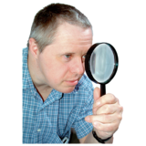

We talked about reviewing the Accessibility Charter.

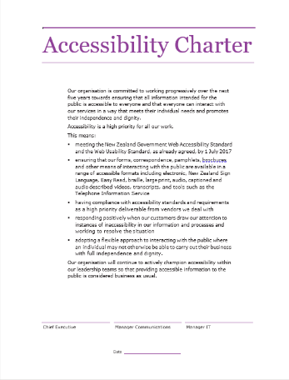
The Accessibility Charter is a document that says what organisations will do to support accessibility.


The Accessibility Charter was signed on 30 July 2014.

We talked about the important history of this charter.

We will work with Whaikaha to update the charter.

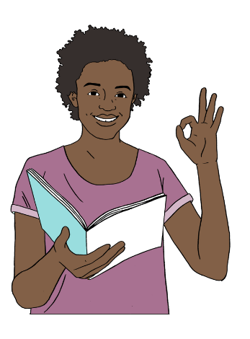
We want the charter to be:
short
clear
focused on the most important things.
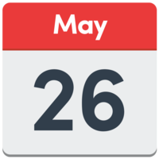

We also met with Whaikaha in May 2026.

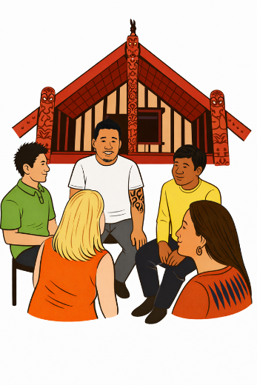
We talked about how we can have more Māori in the Independent Monitoring Mechanism.

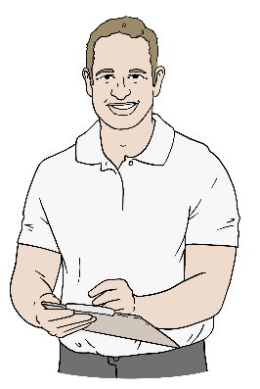
The Independent Monitoring Mechanism checks how well Aotearoa New Zealand is doing at following the UNCRPD.

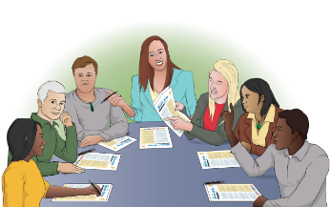
Whaikaha invited 2 Māori members of the DPO Coalition to come to a
hui / meeting.

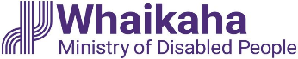
The hui will be with:
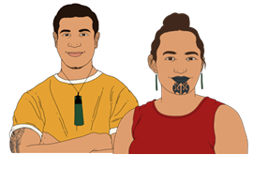
Whaikaha
Māori DPOs
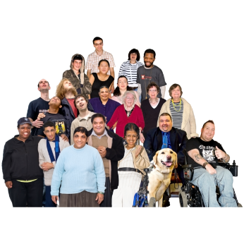
other key rōpū / groups.


The DPO Coalition chose who would speak for them in this mahi /work.

We hope this work means more Māori voices will be heard in the Independent Monitoring Mechanism.

We also met with Whaikaha leaders to talk about other important issues.


We talked about how the fuel crisis is affecting disabled people.

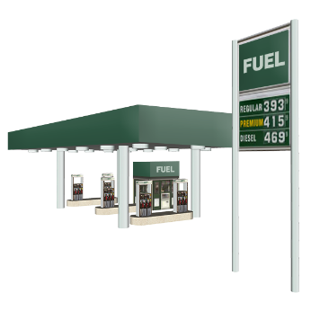
A fuel crisis means there is a problem with:
getting fuel / petrol

how much fuel / petrol costs.

Whaikaha said it would talk about the fuel crisis with the Minister for Disability Issues.

We also heard about the Whaikaha stewardship role.


A stewardship role means Whaikaha gives advice to the Minister for Disability Issues about Government:
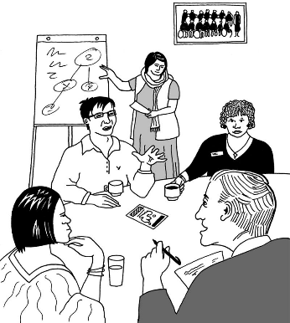
plans
decisions
rules.

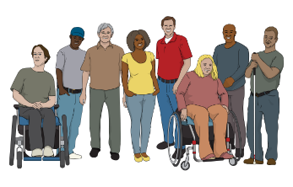
Whaikaha also supports other Government agencies to serve disabled people better.
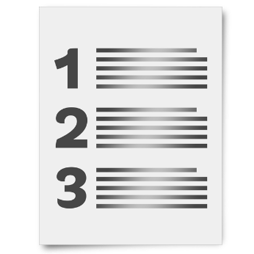

Whaikaha also showed us their policy work programme.

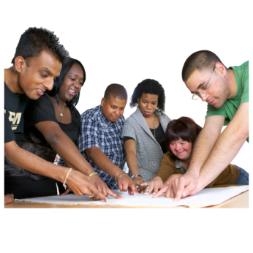
A policy here is a plan that says what the Government is going to do.

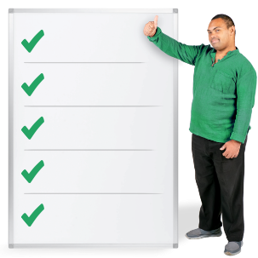
A work programme means a list of work an organisation plans to do.

Public Health Agency

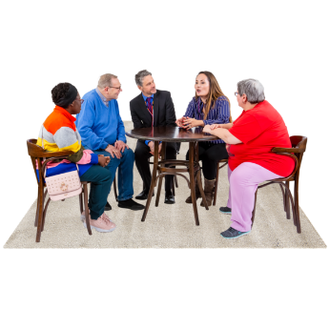
We had a meeting with the Public Health Agency in March 2026 to talk about Guiding Principles.

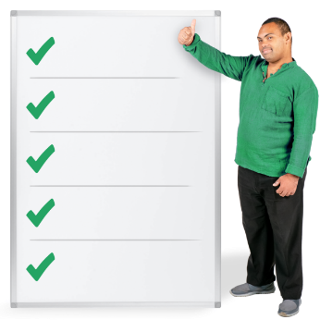
Guiding Principles are important ideas that let people decide how to do their work.

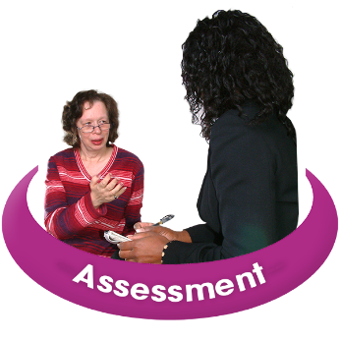
These Guiding Principles are about:
work capacity assessments
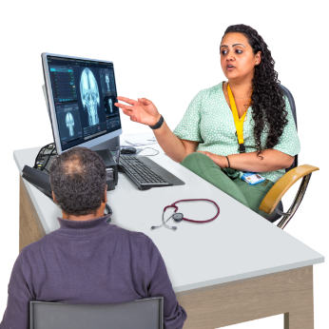
recovery
vocational rehabilitation.

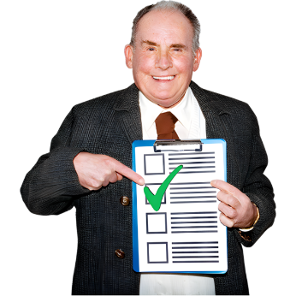
A work capacity assessment says what work a person is able to do.
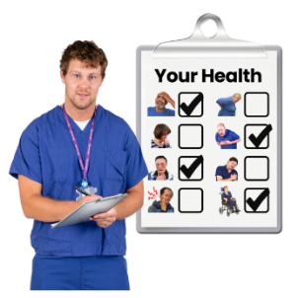
Recovery means getting better after:
an illness
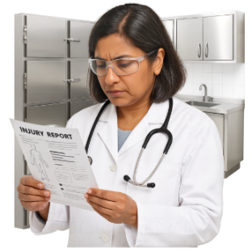
an injury
another health issue.

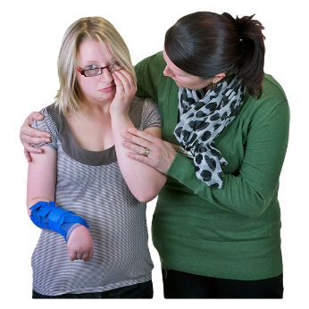
Vocational rehabilitation means support for someone to get ready to go back to work.

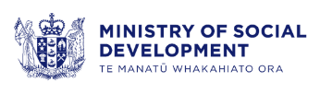
The Guiding Principles will be used by:
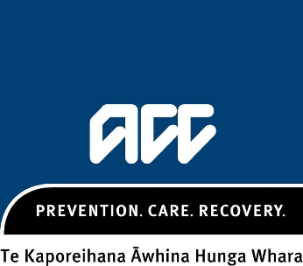
the Ministry of Social Development
the Accident Compensation Corporation / ACC.

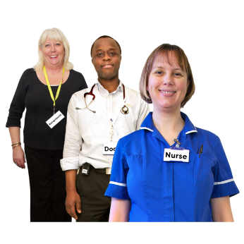
The Guiding Principles are for:
general practitioners / GPs
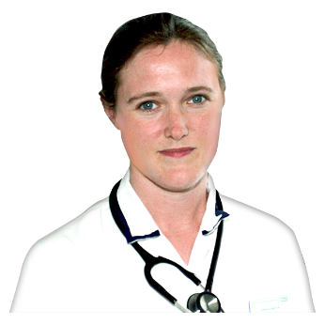
nurses
physiotherapists.

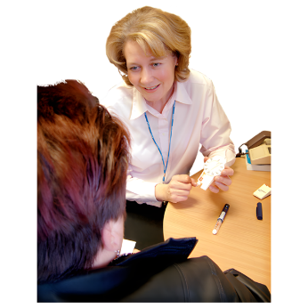
A general practitioner / GP is a doctor who works in the community.

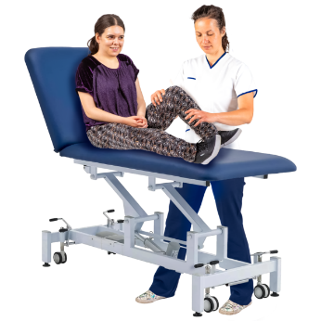
A physiotherapist is a health worker who supports people with:
movement
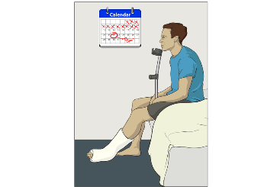
pain
getting better after an injury.

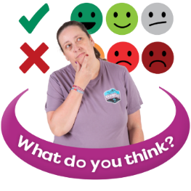
The Public Health Agency asked us to tell them what we think of the draft Guiding Principles.

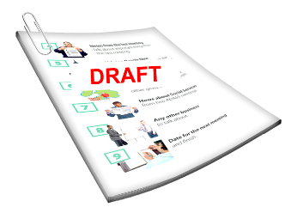
A draft means a document that is not finished yet.

We met again with the Public Health Agency in May 2026.

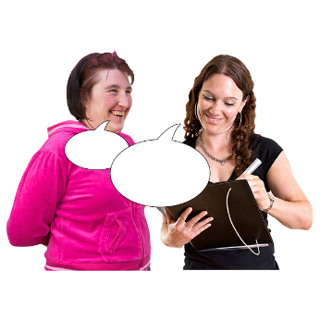
We told them what we thought about the draft Guiding Principles.

Ministry of Social Development

We met with the Ministry of Social Development / MSD in May 2026.

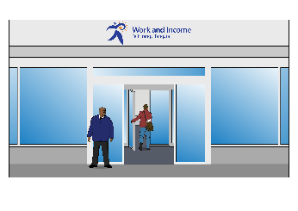
MSD is the Government agency that deals with support services like Work and Income.


MSD told us about a special food information form.

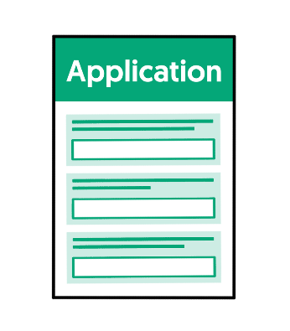
The form is for people to know more about how to apply for money for special food requirements.


A special food requirement means a person needs certain food for:

health needs
disability needs.

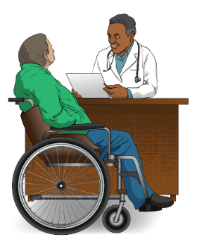
A general practitioner / community doctor can now sign off on special food requirements.


We also heard about a new Disability Inclusion Guide.

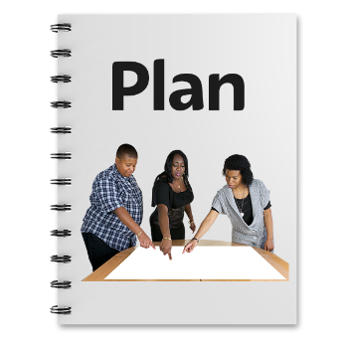
The Disability Inclusion Guide is a guide about designing things that work for disabled people like:
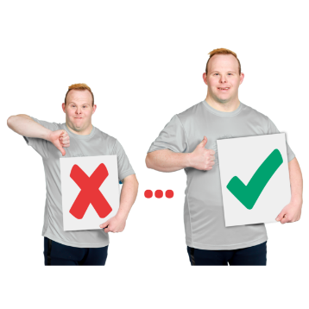
services
supports
products.

Ministry of Social Development and ThinkPlace

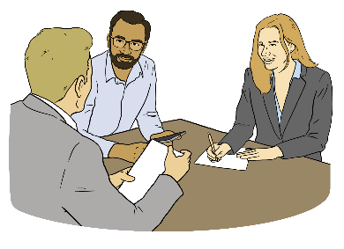
In May we talked about the Disability Employment Support Products Redesign project with:
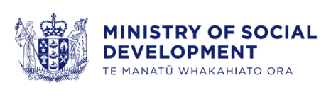
the Ministry of Social Development
ThinkPlace / an organisation that works with the Government.

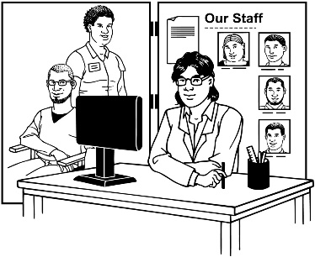
The Disability Employment Support Products are different services that focus on the employment barriers disabled people expereince when:
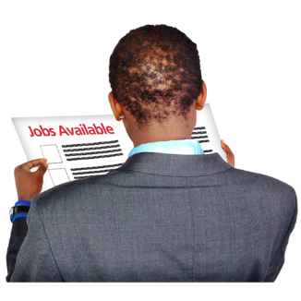
looking for a job
trying to keep their job.
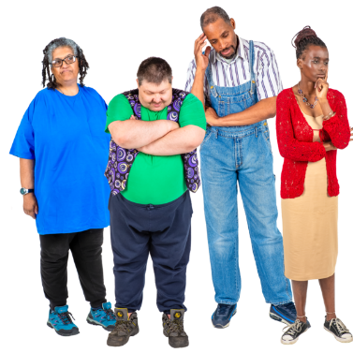
Employment barriers are things
that:
stop disabled people from:
- getting a job
- keeping a job
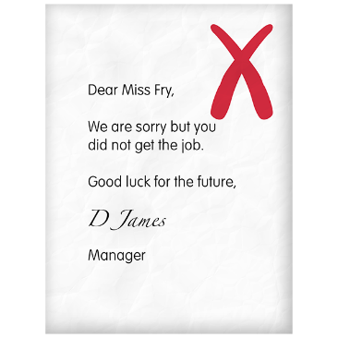
make it harder for disabled people to:
- get a job
- keep a job.

Here redesign project means the Ministry of Social Development is looking at these services to see how they can make them better.

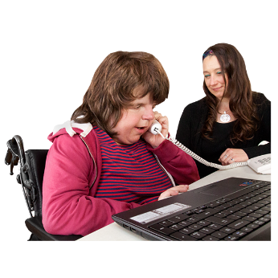
The project is looking at disability employment support products like:
Specialist Employment Service
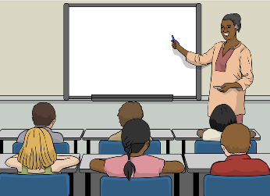
Employment Service in Schools
Mainstream Wage Subsidy
some parts of:
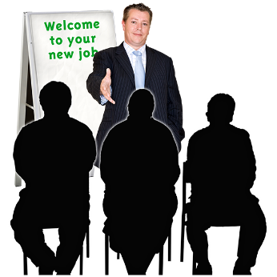
- Job Support Funds
- Training Support Funds
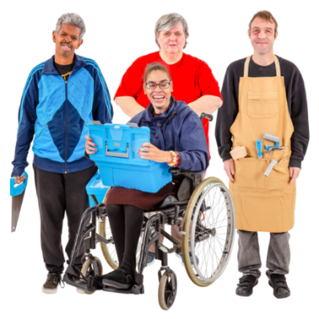
what Disability Enterprises do to support disabled people to get work in open employment.

Disability Enterprises are places where only disabled people work.

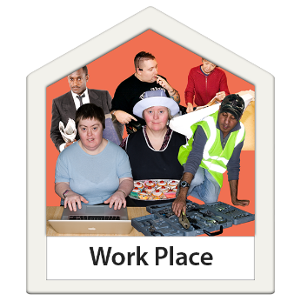
Open employment means jobs in the community where disabled people work with workers who are not disabled.


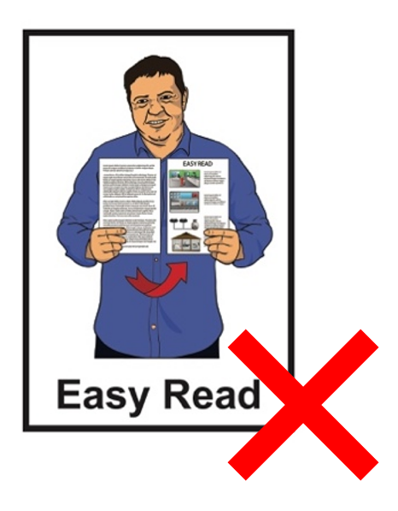
You can find out more about the Disability Employment Support Products Redesign project on this website:

tinyurl.com/yrk8yv9z

This information is not in Easy Read.

Emergency Management

In May 2026 we met with:
Whaikaha
the Wellington Regional Emergency Management Office.

Emergency management means planning for an emergency like:
a flood
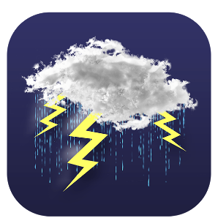
an earthquake
a storm.
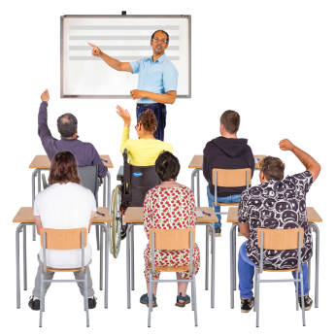

They will run some workshops about emergency plans.

The workshops will support disabled people to make emergency plans for themselves.

Electoral Commission

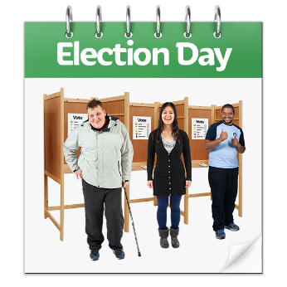
The Electoral Commission runs elections in Aotearoa New Zealand.

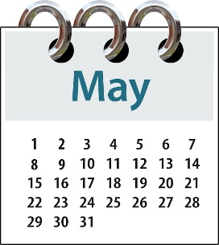
We met with the Electoral Commission in May 2026 to talk about the 2026 General Election.

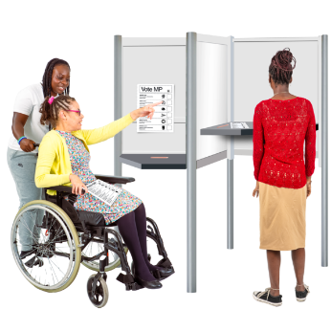
A General Election is when people vote for who they want in Parliament.

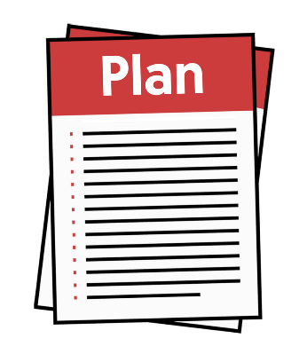
The Electoral Commission told us about Access 2026 which is the draft Accessibility Action Plan for the 2026 General Election.

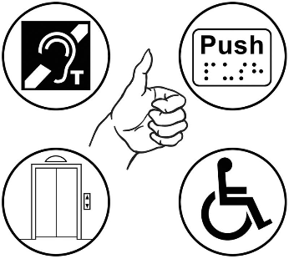
Access 2026 says how they will make the election more accessible.
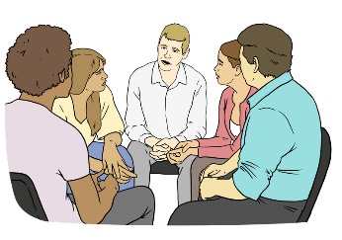
The Electoral Commission also told us about what they are doing to ge more people enrolled to vote.

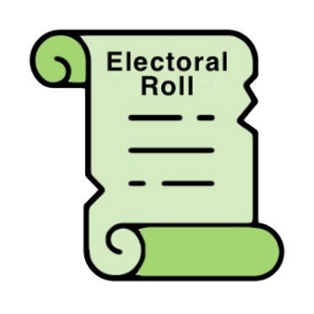
Enrolled means you are signed up
to vote.

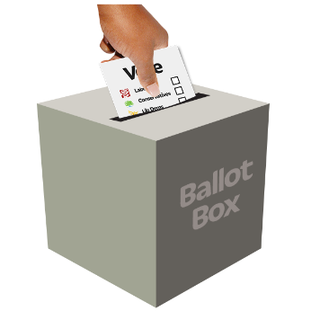
They also told us about their plans to update how they run elections.


The Electoral Commission will talk directly to different communities
about voting in the 2026 General Election.

Voice of disabled people

The Government meets with the DPO Coalition so disabled people can have a say in the decisions being made about them.
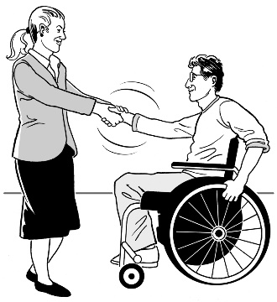

The DPO Coalition is always looking for new DPOs to join us.

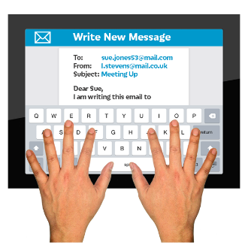
You can contact us by emailing:

us-dpo@groups.io


This information has been written by the DPO Coalition.

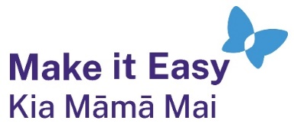
It has been translated into Easy Read by the Make it Easy Kia Māmā Mai service of People First New Zealand Ngā Tāngata Tuatahi.
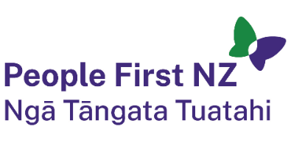
The ideas in this document are not the ideas of People First New Zealand Ngā Tāngata Tuatahi.

All images used in this Easy Read document are subject to copyright rules and cannot be used without permission.

Make it Easy uses images from:

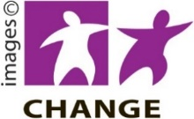
- Photosymbols

- Change Images

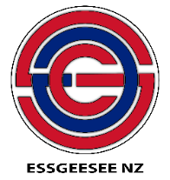
- Huriana Kopeke-Te Aho
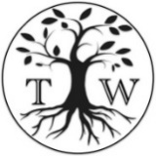
- SGC Image Works

- T Wood

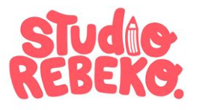
- Studio Rebeko

- Inga Kramer.

