

Local Group Assistant
Hamilton
Part-time role – 8 hours a month
Are you interested in self-advocacy for people with a learning (intellectual) disability?
People First Hamilton is established groups and is looking for an Assistant to work alongside people with learning disability to:
- hold monthly meetings in Hamilton
- encourage learning about self-advocacy and speaking up
- assist members to represent their peers in community forums
- promote the local group within the community.
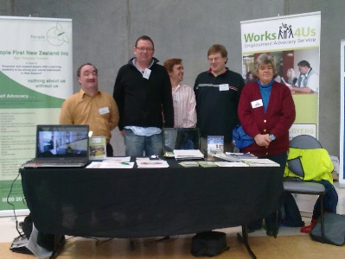
With your assistance, members will learn how to:
- gain self-determination
- advocate for themselves
- develop leadership skills
- get involved in their community
- be a contributing member of New Zealand society.
For more information and to see the job description apply:
Contact: Yi Liang Small – Midland Regional Coordinator
Email: Yi@peoplefirst.org.nz
Phone: 0275263387

Applications close: 25th June 2025

