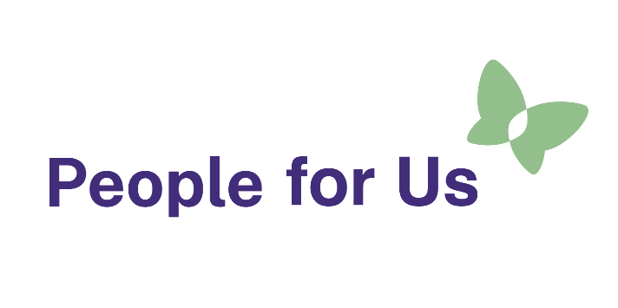
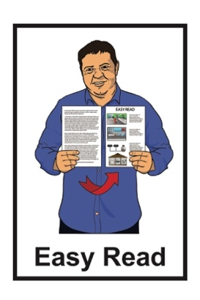

What is People for Us?
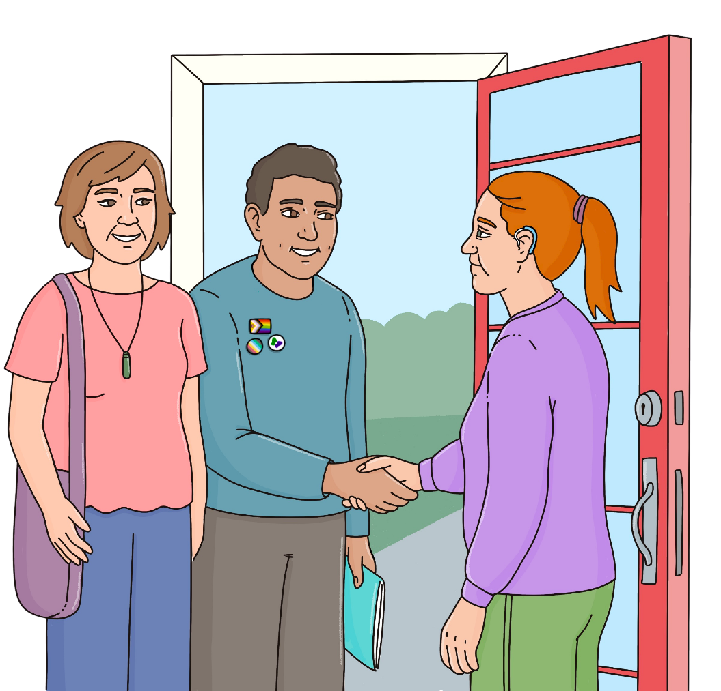

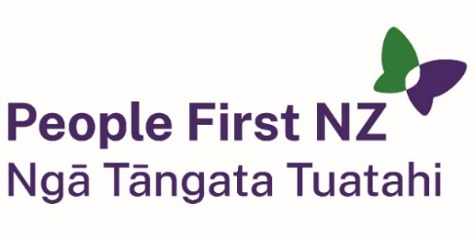
Published: November 2025

What is People for Us?

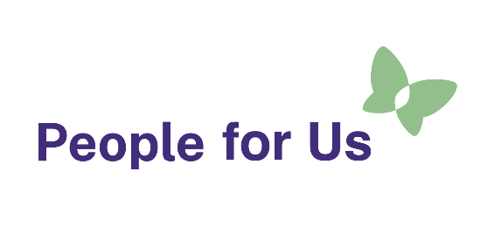
This Easy Read is about the peer visiting service called People for Us.

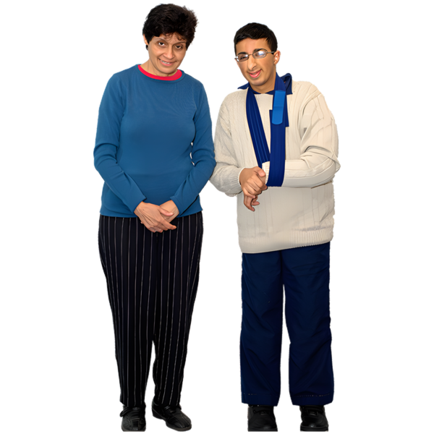
Peer means someone who has a lot of things in common with another person like being disabled.

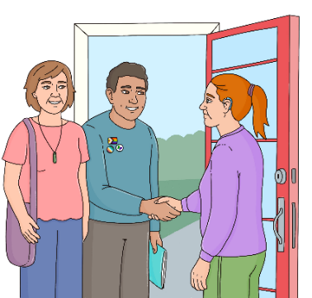
A visiting service is where someone from People for Us comes to your home to check how you are.



People for Us visits people living in homes funded by Disability Support Services who are:
disabled adults
tāngata whaikaha Māori.

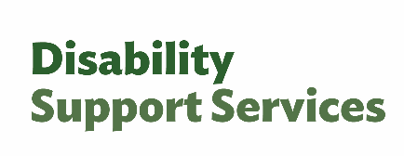
Disability Support Services is a part of the Ministry of Social Development.

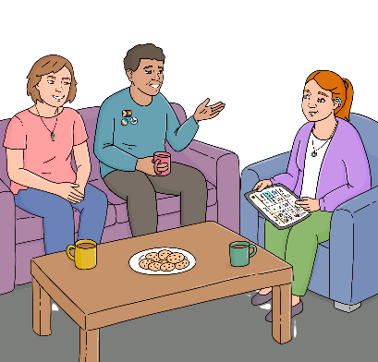
People for Us wants to find out if the people they visit are:
living a good life
getting good support
safe.

People for Us visitors

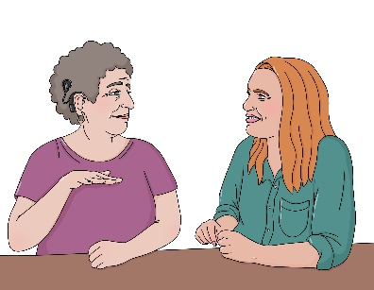
For the peer visiting service there are 2 People for Us visitors who meet with the disabled person in their home.


These 2 visitors are called:
          - Kaiārahi who is a disabled person that leads the visit
          - Kaiāwhina who is the assistant to the kaiārahi.

The visiting team:
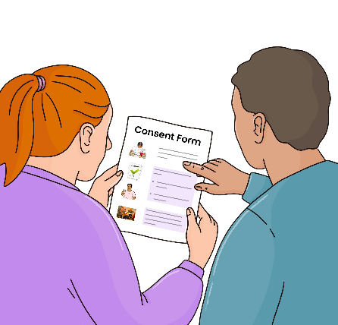
gets to know the disabled person
talks with the disabled person about the disability support services they use.
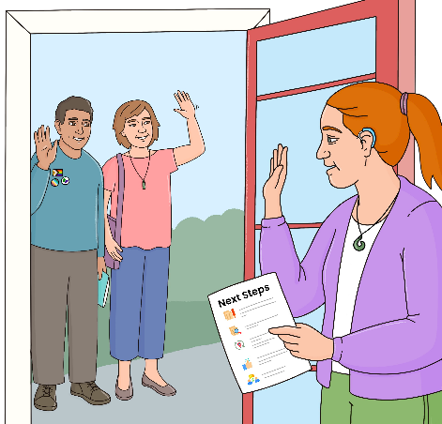
The visiting team:
assists the disabled person to make choices about their needs
talks with the disabled person about where to get more assistance if they need it.

How to get in touch with People for Us

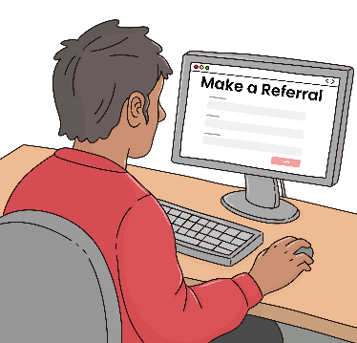
You can find more information about People for Us on our website:

wwww.peopleforus.org.nz

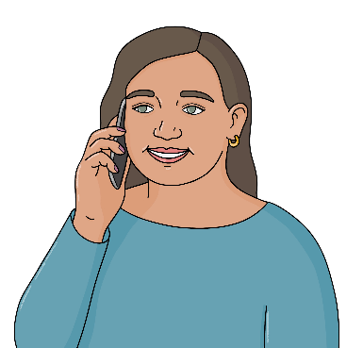
You can get in touch by:

phone:
0800 241 241

email:
info@peopleforus.org.nz

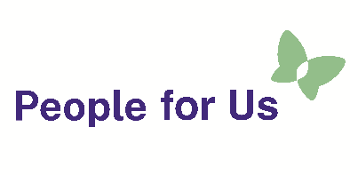
This information has been written by the People for Us service of People First New Zealand Ngā Tāngata Tuatahi.

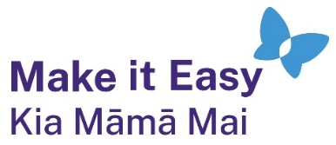
It has been translated into Easy Read by the Make it Easy Kia Māmā Mai service of People First New Zealand Ngā Tāngata Tuatahi.

All images used in this Easy Read document are subject to copyright rules and cannot be used without permission.

This Easy Read uses images from:

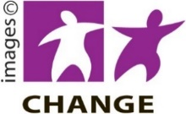
- Photosymbols

- Change Images


- Huriana Kopeke-Te Aho

- Studio Rebeko

