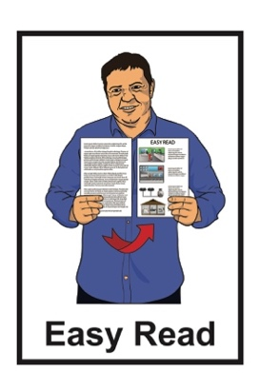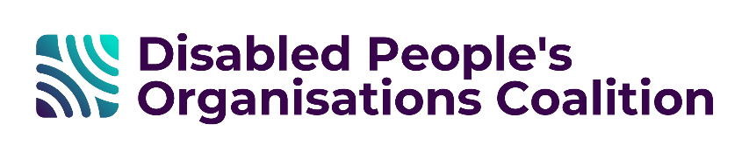

Disabled People’s  
Organisations Coalition:  
Key Messages May 2025

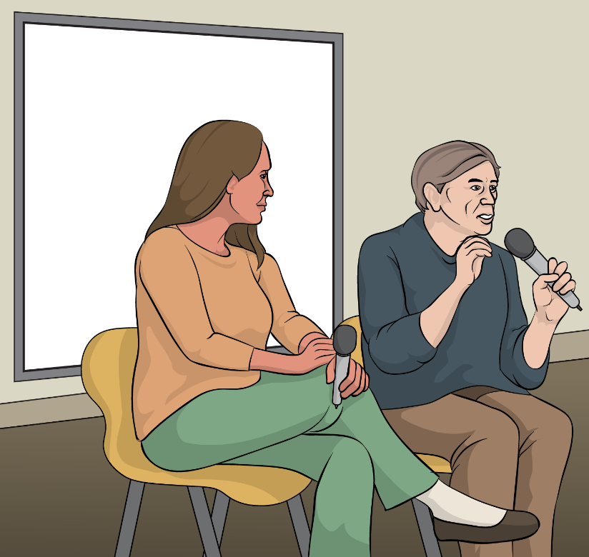

Published: August 2025

# The Disabled People’s Organisations Coalition

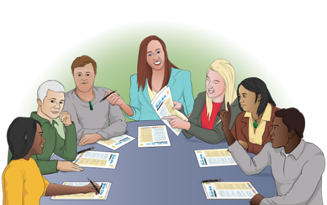The **Disabled People’s Organisations Coalition** is a group of people who come from different disability organisations.

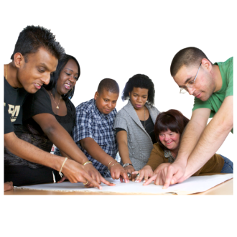

A **coalition** is a group of organisations that work towards shared goals.

The Disabled People’s Organisations Coalition is also called the   
**DPO Coalition.**



When you see the words **we / us** in this document it means the   
DPO Coalition.

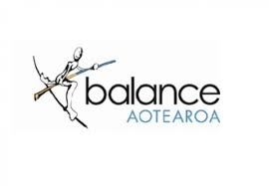The DPO Coalition is made up of members from these 7 disability organisations:

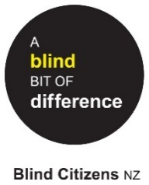Balance Aotearoa

Blind Citizens New Zealand

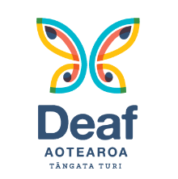Deaf Aotearoa

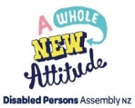Disabled Persons Assembly NZ

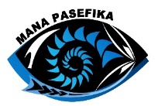Mana Pasefika

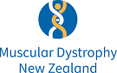Muscular Dystrophy Association of New Zealand

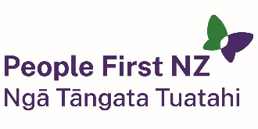People First New Zealand – Ngā Tāngata Tuatahi.

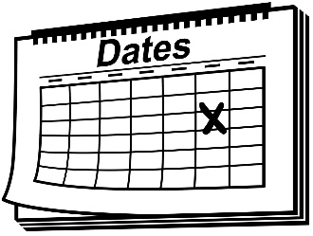We meet about every 6 weeks to talk about important things.

We speak up about disabled people getting their **human rights.**

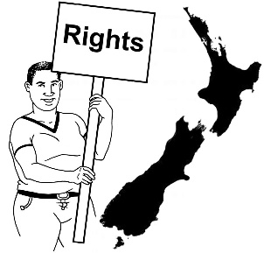**Human rights** are things that the law says every person should:

have

be able to do.

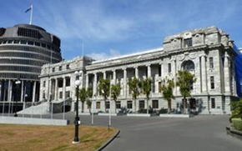

We also talk with the Government about things to do with disability.

# What this document is about

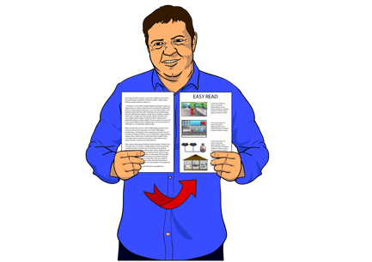

This is an Easy Read document.

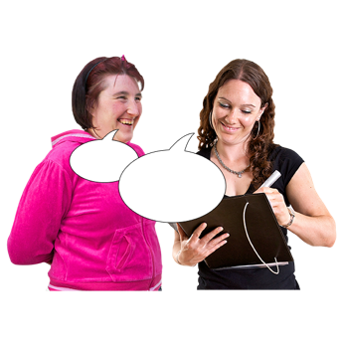It tells you about some of the key messages from the DPO Coalition meetings we had in March 2025.

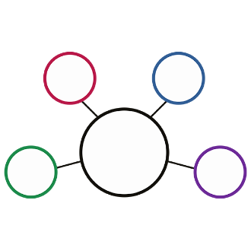During these meetings we met with lots of:

government agencies

other community organisations.

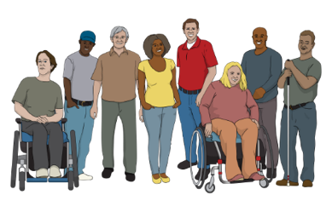

These meetings are to make sure the lives of disabled people in   
New Zealand are getting better.

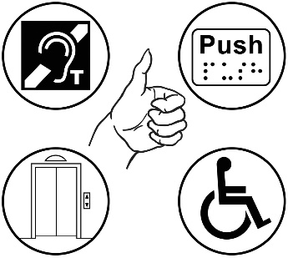2 important things talked about often are:

**accessibility**

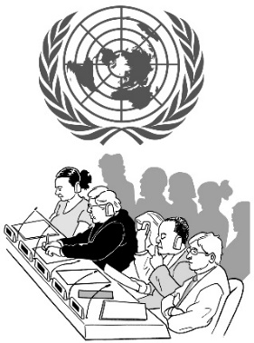the rights of disabled people in New Zealand under the **United Nations Convention on the Rights of Persons with Disabilities**.

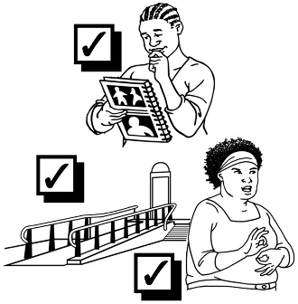

**Accessibility** means making things easy / safe for everyone to use.

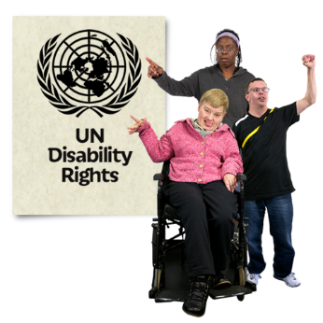The **United Nations Convention on the Rights of Persons with Disabilities:**

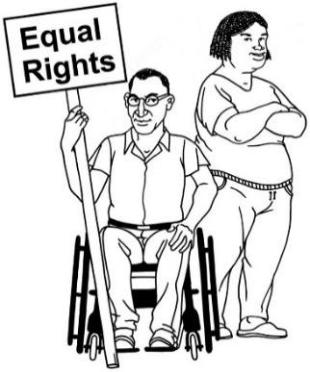says what governments must do to make sure disabled people get the same rights as everybody

is an agreement lots of countries follow

is also called the **UNCRPD**.



It takes time for our key messages to become available in Easy Read.



We are sorry for the long wait.

# Whaikaha – Ministry of Disabled People

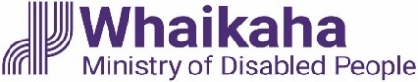We met people from Whaikaha for 2 different things:

a **workshop** on the new Disability **Strategy**

our regular meeting.

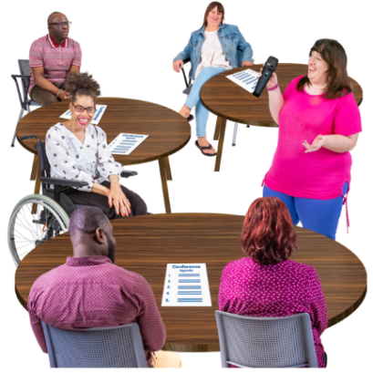

A **workshop** is like a meeting where ideas about something are talked about.

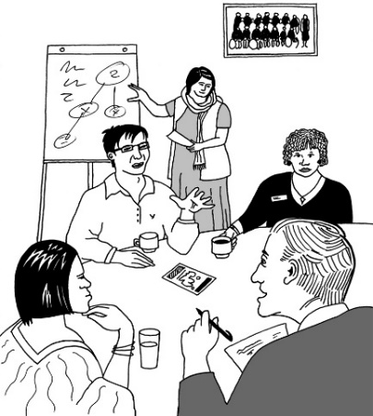In our workshop on the new Disability Strategy we worked with:

Whaikaha

Te Amokura.

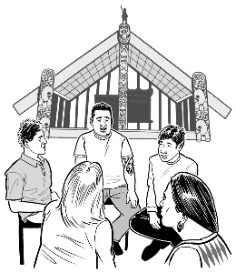Te Amokura supports people to better understand a Māori way of doing things.

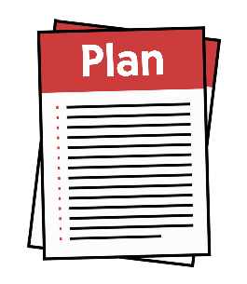

A **strategy** is a set of long term plans that are made to reach a goal.

In the workshop we talked about what we think should be part of the new:

vision – what the Disabilty Strategy should be about

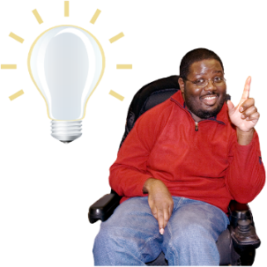principles – ideas / beliefs that tell us what we should do

approach – how we should do things.

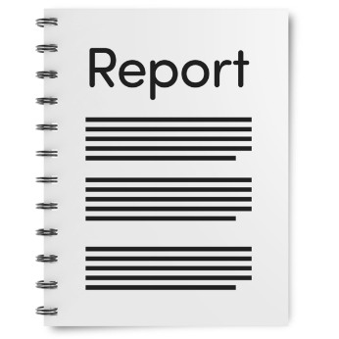In June 2025 Whaikaha will make a report called **Draft Vision and Principles** with the things we talked about in the workshop.

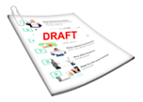A **draft** is the first version of a document.

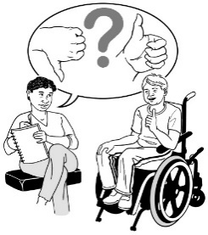

We will give them feedback on what we think about the report.



We said it was okay to take photos during the workshop.

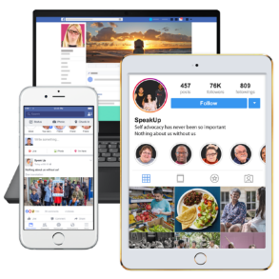

We shared the photos on social media sites.

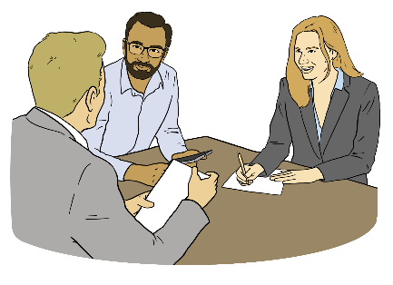In our regular meeting with Whaikaha we met with:

Paula Tesoriero – Chief Executive

* Ben O’Meara – Deputy Chief Executive Policy and Insights
* Rebecca Elvy – Deputy Chief Executive Outreach and Innovation.

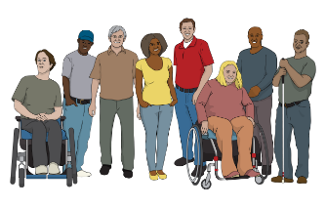We talked about a lot of things including issues that disabled people go through like:

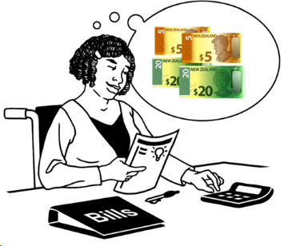the cost of living in Aotearoa   
New Zealand while being disabled

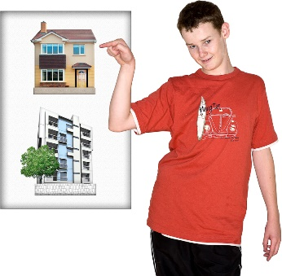accessibility to:

* housing
* education
* 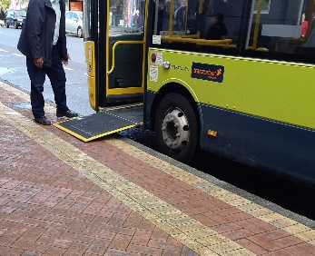transport
* mental health services.

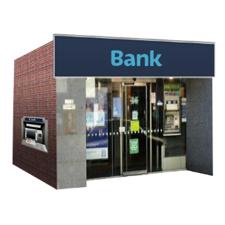Other things we talked about is the issues disabled people experience with:

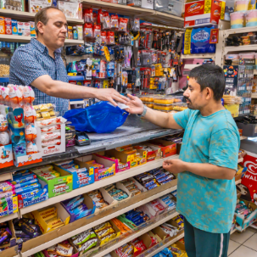banks

shops / shopping.

These issues were about   
banks / shops not:

all having the same rules about using identification

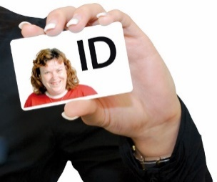knowing about the Kiwi Access Card

letting disabled people use their Kiwi Access Card as a form of identification.

We also talked about the Conference of State Parties the Chief Executive is going to.

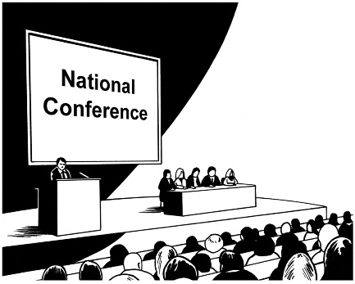

This conference is in:

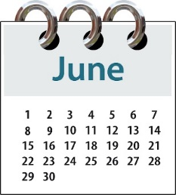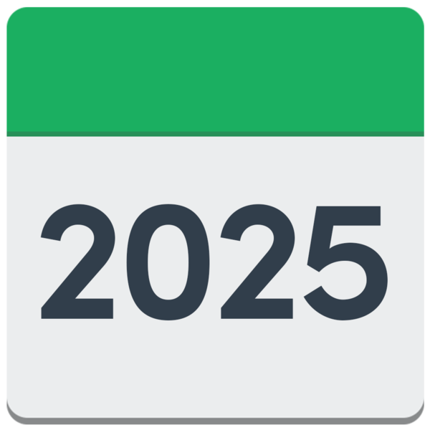

New York

early June 2025.

# Refreshing the Lead Toolkit

We met with:

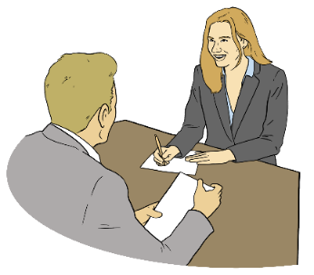Lilian Singson – Programme Lead Employment Pathways

Loren Savage – Senior Advisor to the Chief Executive Employment Pathways.



We talked about what is happening with **refreshing** the **Lead Toolkit**.

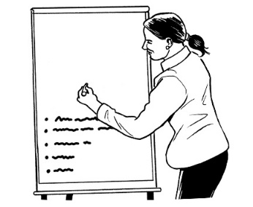Here **refreshing** means seeing what needs to be changed / added to the Lead Toolkit.

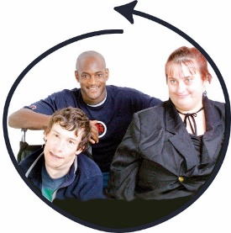The **Lead Toolkit** is about making   
an inclusive / welcoming space for disabled people.



The Lead Toolkit will be a great support for:

employers / companies

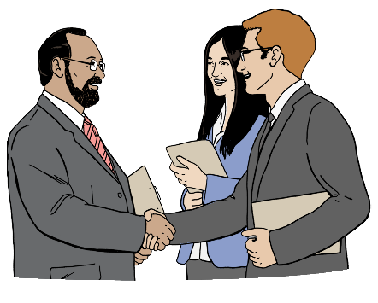leaders

managers.

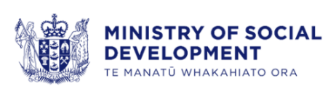

The Lead Toolkit was started:

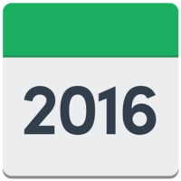by the Ministry of Social Development

in 2016.

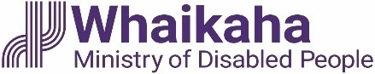

It is now being led by Whaikaha.

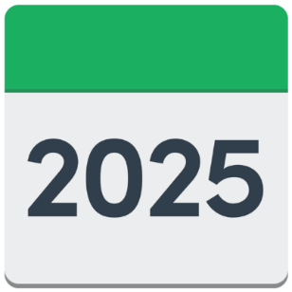1 of the main things the Lead Toolkit is looking at in 2025 is the employment of disabled people in public service.

The **public service** is made up of organisations that support the Government to do its work.



Lead Toolkit will become part of the Inclusive Recruitment Guidance.

The Inclusive Recruitment Guidance was recently drafted by Whaikaha.

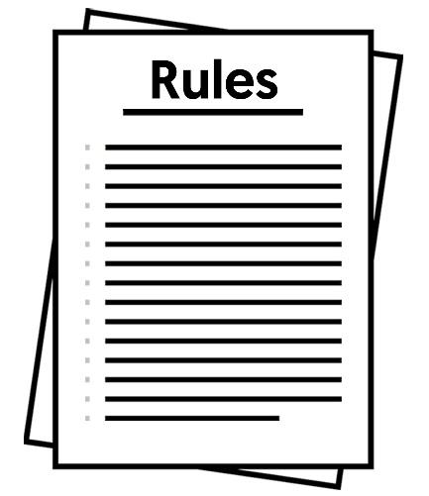Both of these make accessible employment **guidelines.**

**Guidelines** are like rules to follow.

These guidelines will be available:

online

as printable documents.



We welcomed being able to give our thoughts on this work.

# Health Quality and Safety Commission

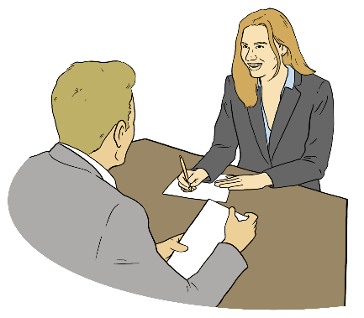

We met with the Senior Manager of the Health Quality and Safety Commission.

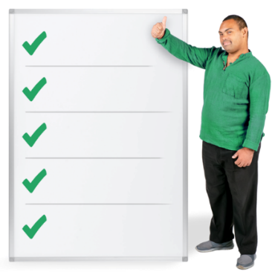We gave our thoughts about 5 questions.

These 5 questions are to assist with the development of a national system safety strategy.

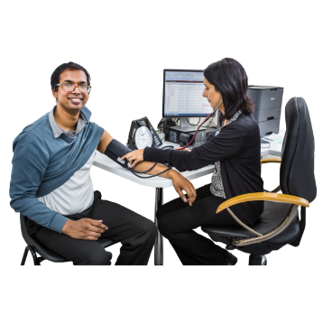

This safety strategy will be used for the health and disability system in Aotearoa New Zealand.

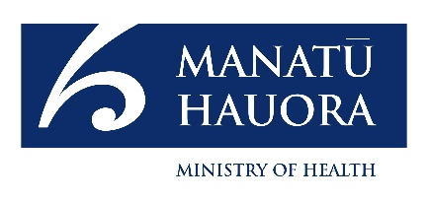The Minister of Health asked for this strategy to be made to support the

Government Policy Statement.

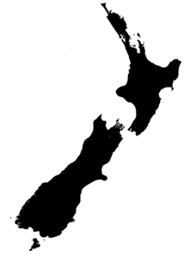

The Government Policy Statement supports the promise Aotearoa   
New Zealand has made to:

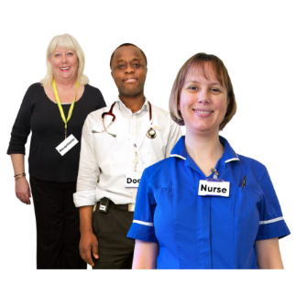make sure people get hurt less

make health care better.

# Department of Internal Affairs

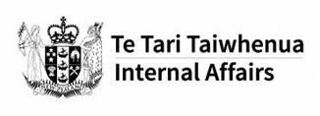We met with the Senior Advisor of the Department of Internal Affairs.

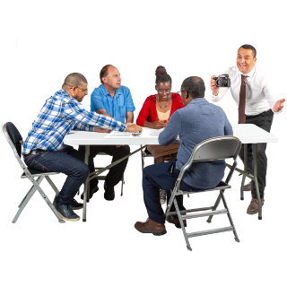We talked about what is happening with the outcomes framework the  
**Te Puna Tahua** **Lottery Grants Board** is working on.

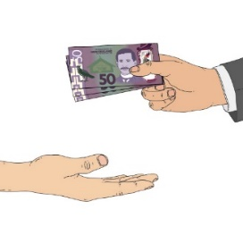

The **Lottery Grant** gives money to communities.

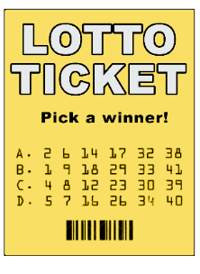

The money comes from the money made from lotteries like Lotto.

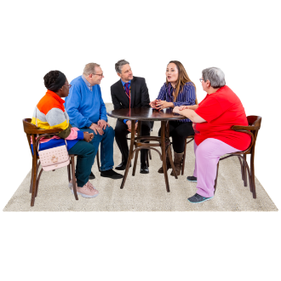

A **board** is a group of people who make decisions about something.

We were told about a new way Lottery Grant information will be available online.

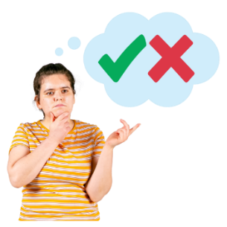This online information will:

support how the Lottery Grants Board makes decisions

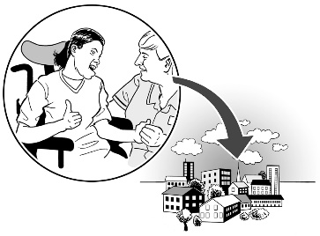show where the Lottery Grant funding is most needed in the community.

# Ministry of Social Development



We met with the Ministry of Social Development:

Principal Disability Advisor

disability team.

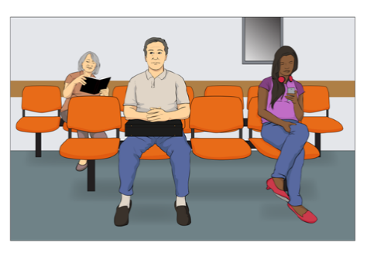

We talked about the issues to do with benefit:

changes

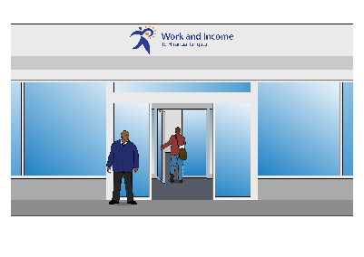**sanctions**.

Here **sanctions** means people having to follow rules to get their benefits.

If the rules are not followed properly the benefit might get:

cut

stopped.

We were told about:

changes in the benefits sytstem

how benefits will be kept going over a long time

how **artifical intelligence** might be used.

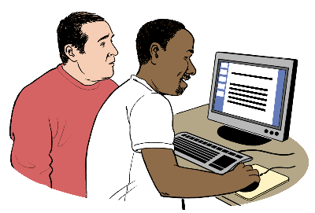**Artificial intelligence** means computer programs that can do some of the things humans can do like:

learning

solving problems.

# Voice of disabled people

The Government meets with the DPO Coalition so disabled people can have a say in the decisions being made about them.

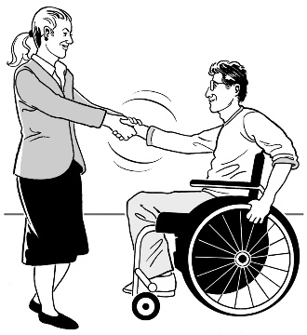

The DPO Coalition is always looking for new organisations to join us.

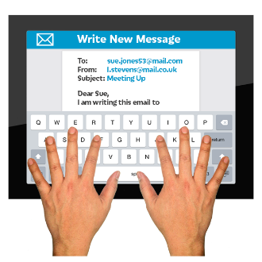

You can contact us by **emailing**:

[**us-dpo@groups.io**](mailto:us-dpo@groups.io)

This information has been written by the DPO Coalition.

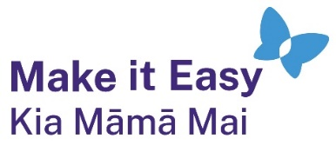It has been translated into Easy Read by the Make it Easy Kia Māmā Mai service of People First New Zealand Ngā Tāngata Tuatahi.

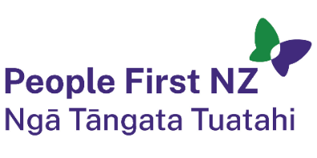

The ideas in this document are not the ideas of People First New Zealand Ngā Tāngata Tuatahi.



All images used in this Easy Read document are subject to copyright rules and cannot be used without permission.

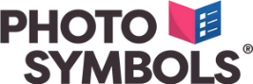

Make it Easy uses images from:

* 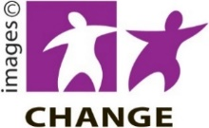Photosymbols
* Change Images
* Huriana Kopeke-Te Aho

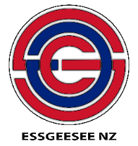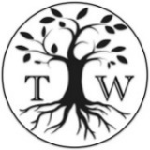

* SGC Image Works
* T Wood
* 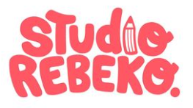Studio Rebeko
* Inga Kramer.