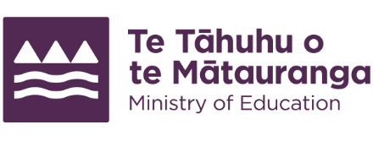
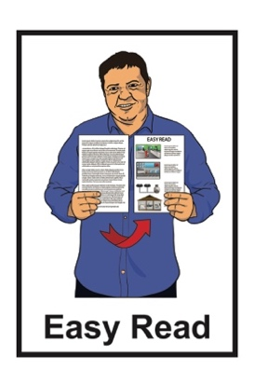

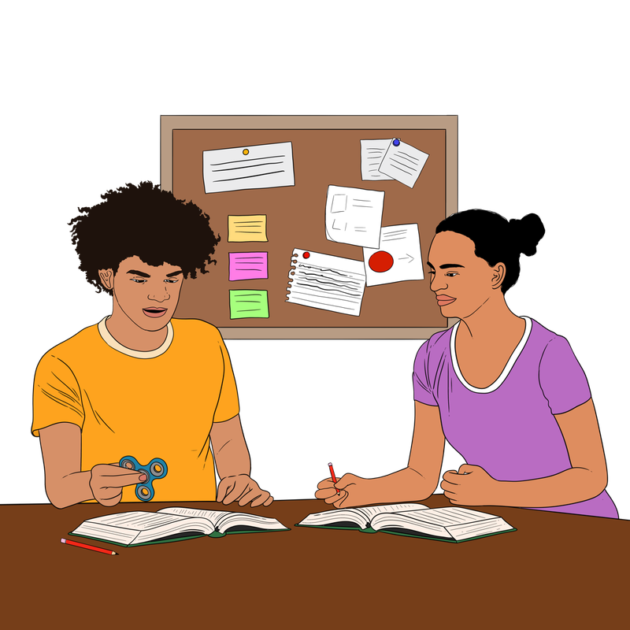
Let’s Get Accessible:
How disabled students feel about tertiary education

Published: April 2024

What you will find in here

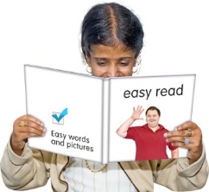
Page number:

What this document is about 2
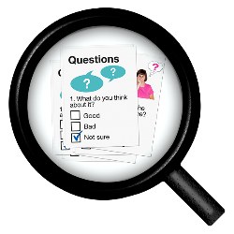

What the research looked at 4

Tell us what you think
How the research was done 8

Key findings 15

More research needed 24
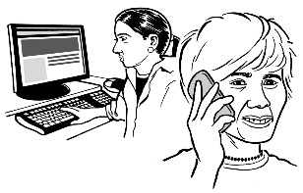

Where to find more information 26

What this document is about

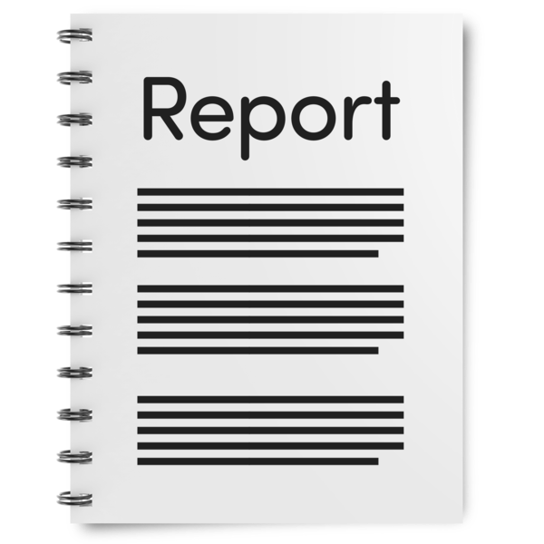
This Easy Read document is a summary of the report called:
Let’s Get Accessible: Disabled students’ experiences navigating the tertiary education system

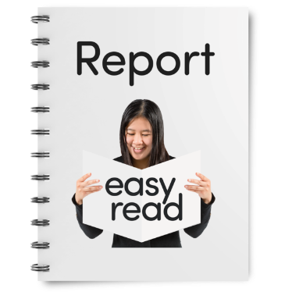
A summary:
is shorter than the full report
tells you the main ideas.
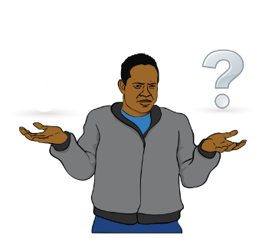

This summary talks about:
why the report was made
what important things were found
ideas for further research.
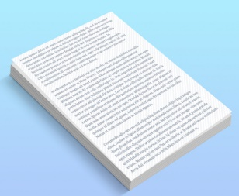
You can get the full report at this website:
www.educationcounts.govt.nz/243364

What the research looked at

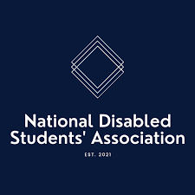
Let’s Get Accessible is a research project done by:
the National Disabled Students’ Association / NDSA
the Ministry of Education
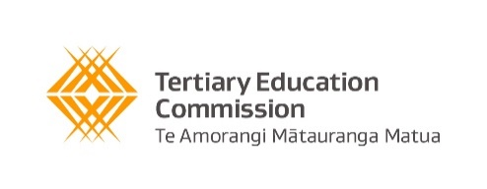
the Tertiary Education Commission / TEC
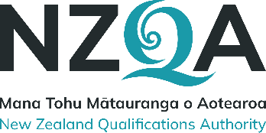
the New Zealand Qualifications Authority / NZQA.

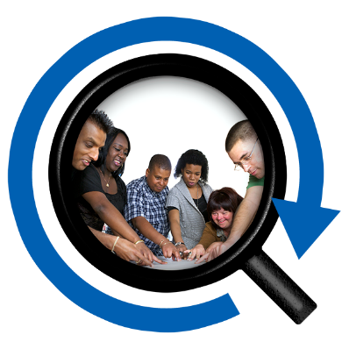
A research project is when people / groups work together to
learn new things about a topic by:
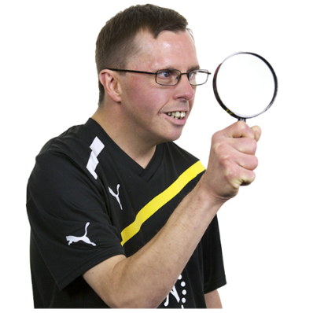
asking questions
looking over information
studying different parts of the topic.

The report looks at:
what life is like for disabled students
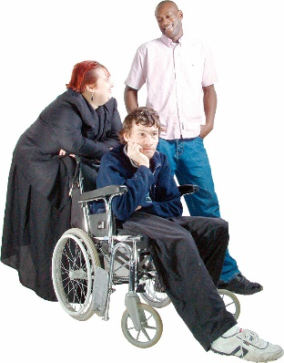
stories about the problems disabled students face when trying to take part in tertiary education
how disabled students feel left out of things because of their disability.

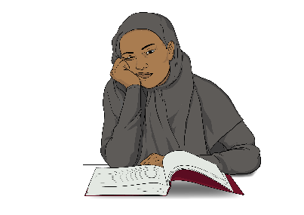
Tertiary education is the level of learning above high school where students study for a qualification.

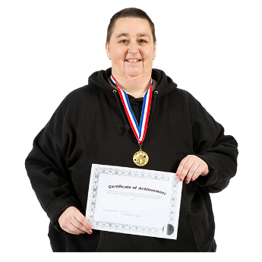
A qualification is like a certificate that shows you have:
completed learning about a subject
the skills to do a particular job.

Students take part in tertiary education in places like:
universities
colleges
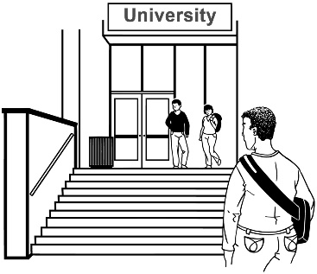
polytechnics
trade schools.

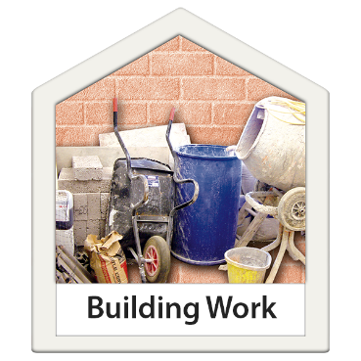
A trade school is a tertiary education school where you go to learn about things like:
building / construction
plumbing
electrical work
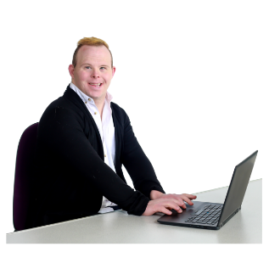
car repair
computer programming.

How the research was done

The information in the Let’s Get Accessible report comes from answers given by disabled students.

Tell us what you think
They shared their thoughts by filling out an online survey from July 2023 to August 2023.

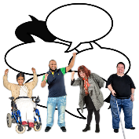
Some more information came from group discussions with students in September 2023.
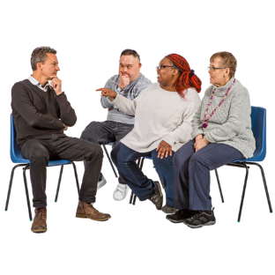

These extra discussions were done both:
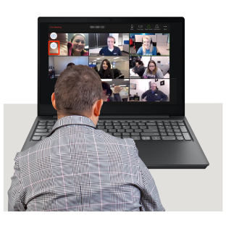
in person
over the internet.
235 people filled out the survey.
235
Tell us what you think

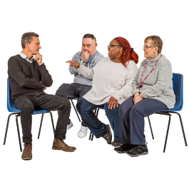
10
10 people took part in the group discussions.

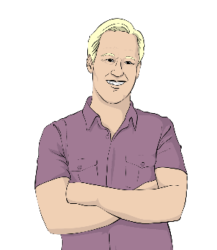
Most of the people who answered the survey said they were Pākehā / European.

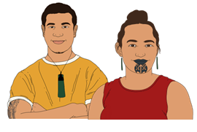
Māori were the 2nd largest group who answered the survey.

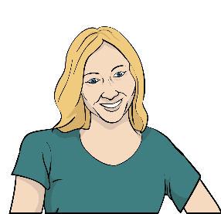
More than half of the people who answered the survey said they were female.

Most of the people who shared their thoughts were university students.

There were 4 parts to the information being collected.

- Accessibility
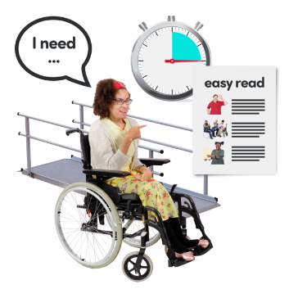
Accessibility is when things are to access for disabled people like:
buildings
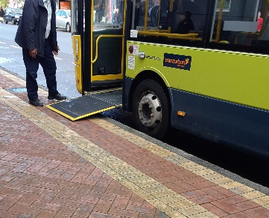
information
public transport.

- Consistency / Reliability
✓

Consistency is when something happens the same way each time.
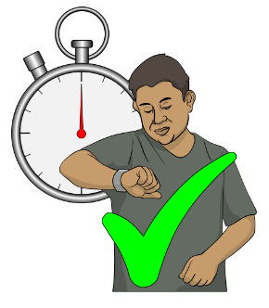

Reliability is being able to trust that things will work properly every time.

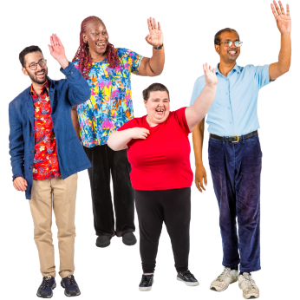
- Social inclusivity / the wider student experience

Social inclusivity means:
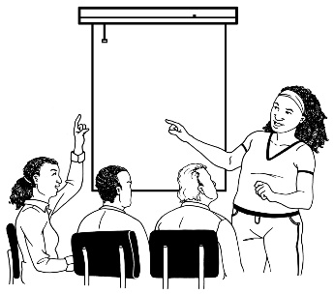
making sure everyone is welcome / included in social activities that happen:
- in class
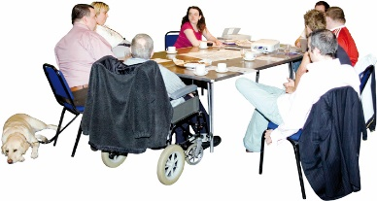
- at clubs
- at events.

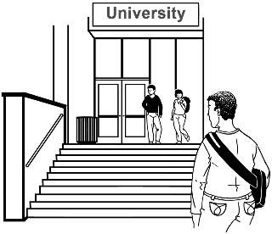
The wider student experience is the things that affect all students during their time in tertiary education.

- Student advocacy
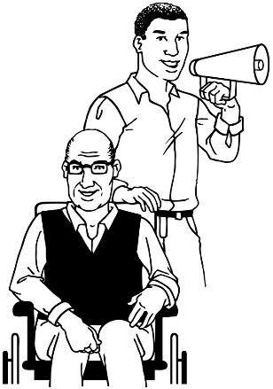
Advocacy is when:
someone helps you to speak up for yourself
you help someone to speak up.
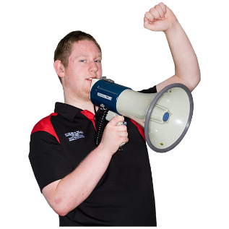

Student advocacy is when students speak up:
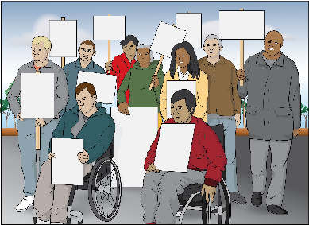
for themselves
for other students.
There were some limitations with the way this research was gathered.

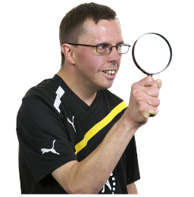
Limitations are things that make it hard to collect all the information needed for research.
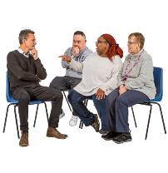
1 limitation was that the survey / group discussions did not involve a random selection of disabled students.
Tell us what you think

A random selection means people are chosen without any plan / pattern.

This is done so the study shows how a range of people from different backgrounds feel about things.

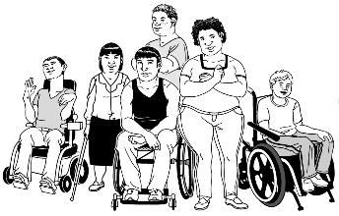
This means that the report:
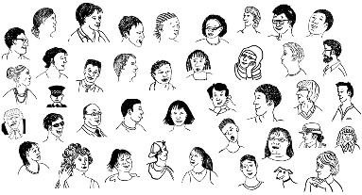
only shows the thoughts of certain disabled students
does not show the thoughts of all disabled students.

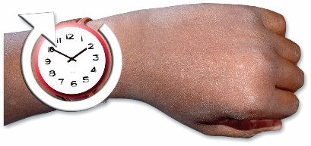
The number of disabled students who took part in the group discussions was low.

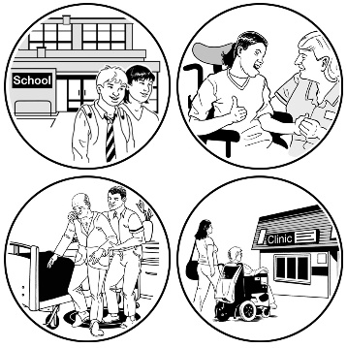
This is because disabled students who attended the groups were only those who:
had enough time to take part
had their support needs met
were interested in the topic
had the energy to take part.

Key findings

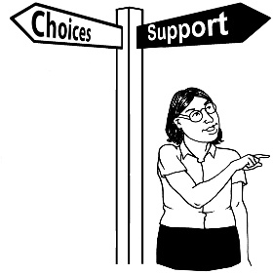
Accessibility

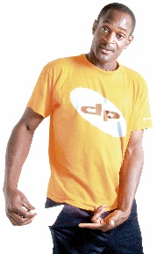
Disabled students said they find it hard to get the support they need for different reasons like:
physical barriers
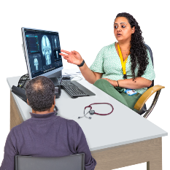
money problems
not having a diagnosis
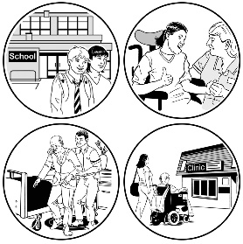
not having access to the things they need to live their life.

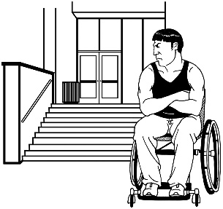
Physical barriers are things that make it hard for disabled people to access buildings / places.

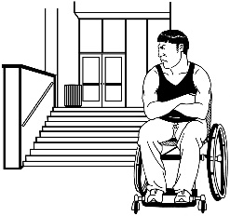
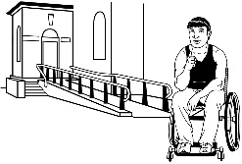
An example of a physical barrier is when a building has steps instead of a ramp.

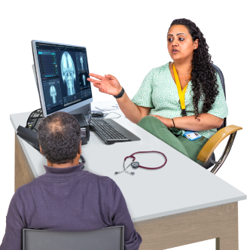
A diagnosis is when a doctor runs tests to figure out why someone might be finding things hard.

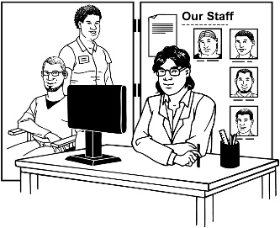
Disabled students also said that having to tell others about their disability is a barrier to getting the support they need from:
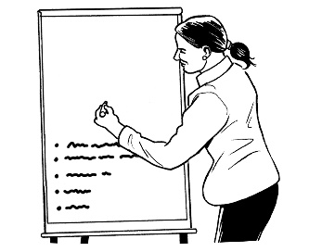
disability service providers
their teachers.

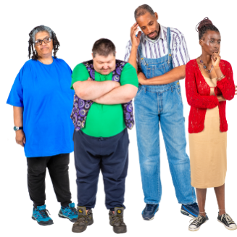
A barrier is something that makes it hard for students to take part in events at the place they study.

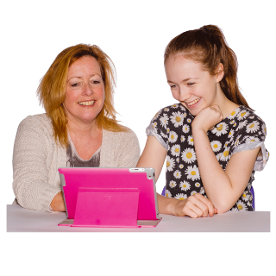
Disabled students felt that:
if they could get regular support:
- their time in tertiary education would be better
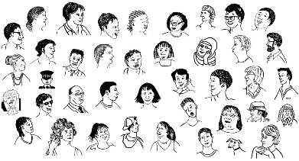
- more disabled students would take part in tertiary education
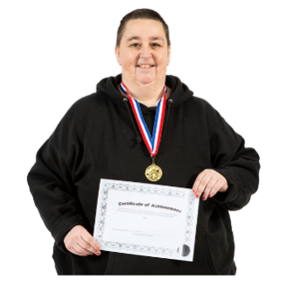
- disabled students would complete more of their courses
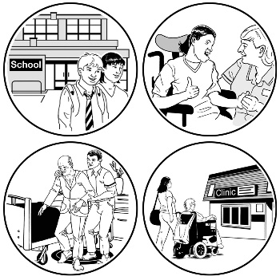
the things that get in the way of getting the support they need are whether their disability service providers:
- are willing to offer support
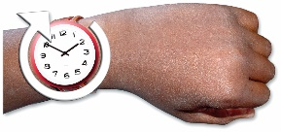
- have enough staff / time to offer the right support.

Consistency / Reliability
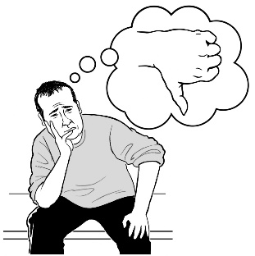
Disabled students who took part in the survey / group discussions said the support they got was different at different times.

The students found that the level of support they got was different between their:
disability service provider
teaching staff.

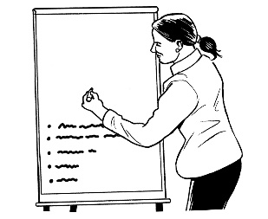
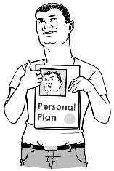
They found that teachers sometimes:
ignored the support plans made by disability service providers
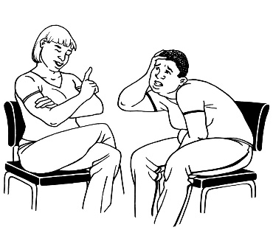
made students tell them personal things about their disability before they would support them.
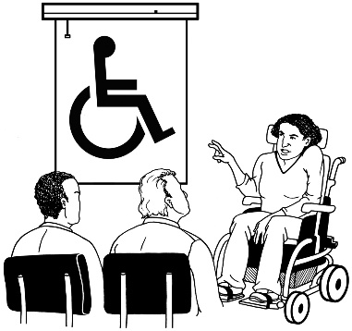
The students also found that:
teachers do not have enough training in disability issues to know how to properly support disabled students.

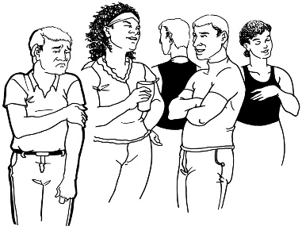
This is making it harder for disabled students to:
join in
do well in their study.

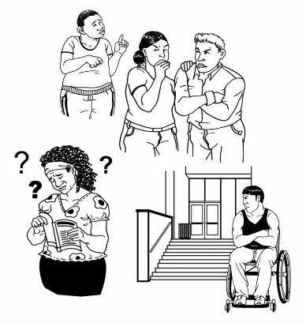
Social inclusivity / the wider student experience

Disabled students can face many barriers during their time in tertiary education.

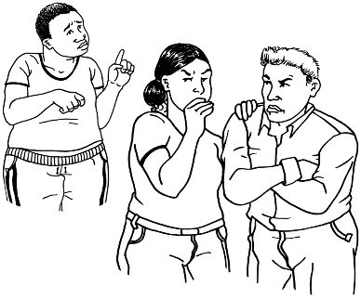
The students who took part in the survey / group discussions spoke about some of these barriers.
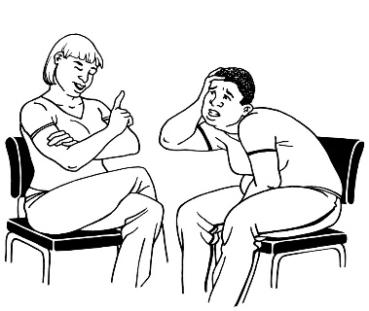

1 barrier was discrimination because of their disability.

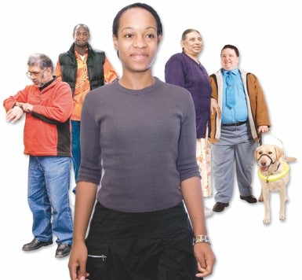
Discrimination is when people are treated differently because of things
like:

if they are disabled

how old they are

if they are a man / woman / someone of another gender.
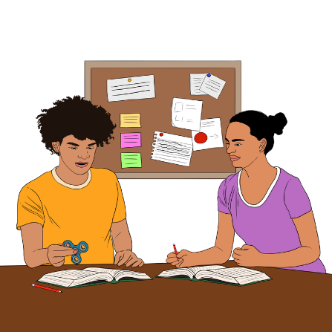
The students who took part in the survey / group discussions also said some more barriers were:
feeling like they have to prove they are really disabled
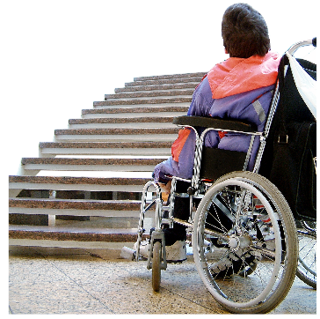
- not being able to go to events because they:
- are in buildings that are not accessible
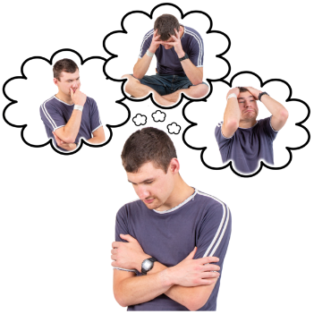
- make disabled students feel unwelcome
- make disabled students feel unsafe.

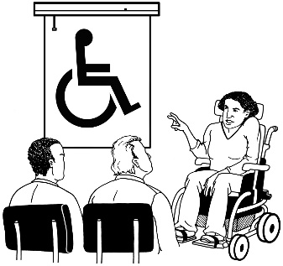
Some disabled students felt left out because there is not enough training for staff on disability.

Student advocacy

There are not many ways for disabled students to speak up because of the way power works between:
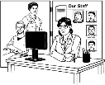
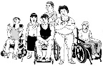
students
teaching staff
service providers.

This makes some disabled students feel unsafe in tertiary education.

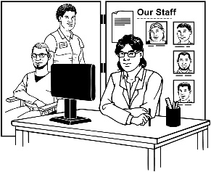
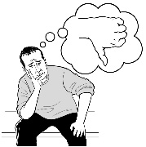
Providers often do not:
ask disabled students what they need
know much about the rules set in place by the Education Code of Practice 2021.
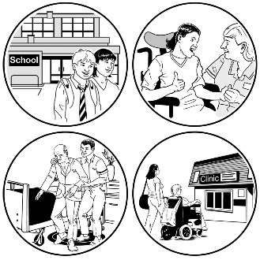
The Education (Pastoral Care of Tertiary and International Learners) Code of Practice 2021 is a set of rules that makes sure all students feel:
safe
supported.
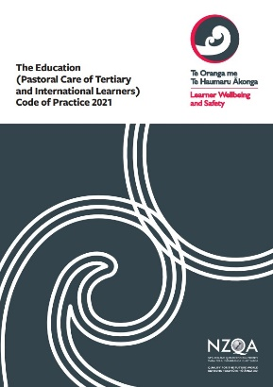
It is also called the Code.

The Code sets out what schools / universities / polytechnics must do to support the wellbeing of their students.

You can find out more about the Code at this website:

https://www2.nzqa.govt.nz/tertiary/the-code

More research needed

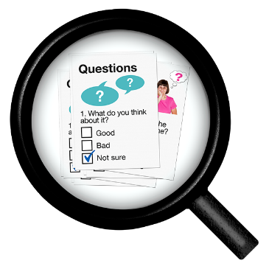
This project has given useful information about what things are like for disabled students.

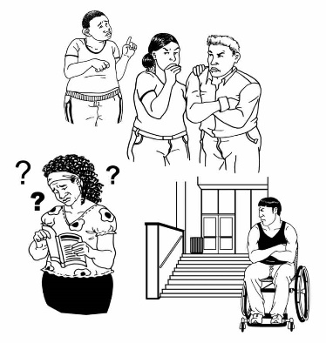
More information is needed about disabled students who:
stop studying because of the barriers
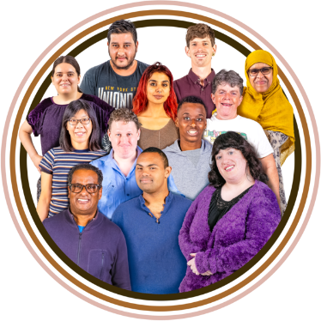
never start study
are of different cultural / ethnic backgrounds
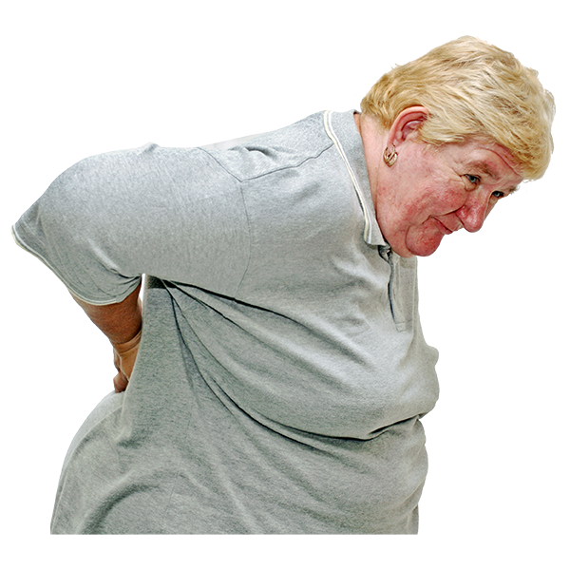
are enrolled in places like wānanga
have chronic illnesses / rare diseases.
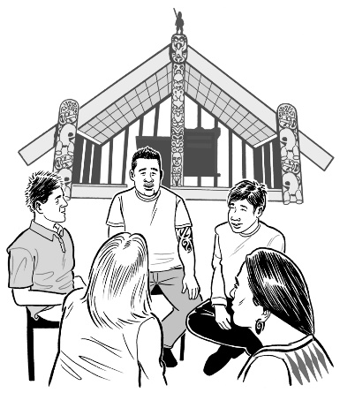
Wānanga are learning places that use styles of teaching / learning that are based in Māori:
culture
tikanga / practices.

Chronic illnesses are health problems that:
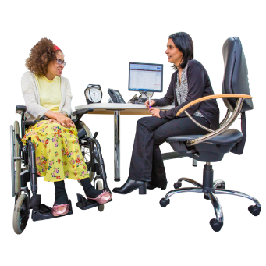
last a long time
need regular care from doctors.

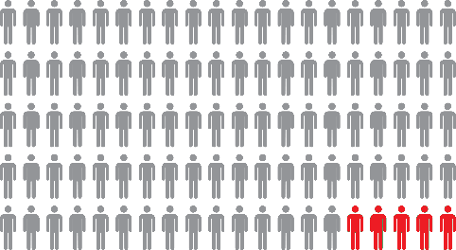
Rare diseases are health problems that are:
not often seen
not found in many people.

Where to find more information

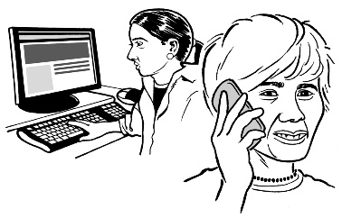
If you have any questions about this report you can get in touch in 3 ways:

Write an email

Send your question to this email address:

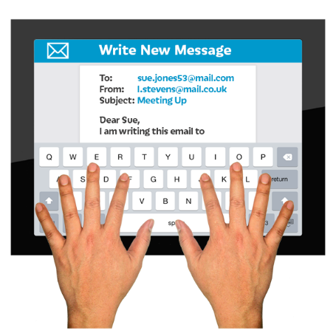
enquiries.national@education.govt.nz
To: enquiries.national@education.govt.nz
From: you@mail.com
Subject: Let’s Get Accessible

In the subject line you need to write:

Let’s Get Accessible

Call on the phone

The number to call is:

0800 4711 711

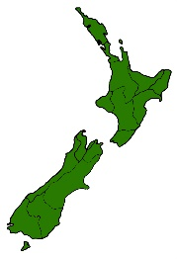
You will need to:
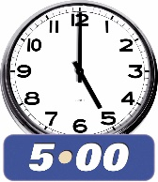
be in New Zealand
call from 9 am to 5 pm.
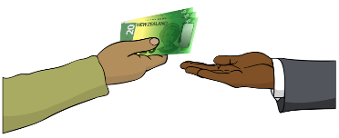

It is free to call.

New Zealand Relay service

If you find it hard to use the phone the New Zealand Relay service is for people who are:

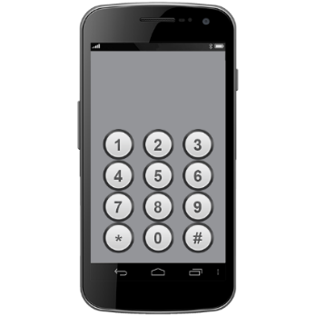
- Deaf / hard of hearing

- deafblind

- speech impaired / find it hard to talk.

You can find out more about the New Zealand Relay service at:

www.nzrelay.co.nz

This information has been written by
Te Tāhuhu o te Mātauranga – Ministry of Education.

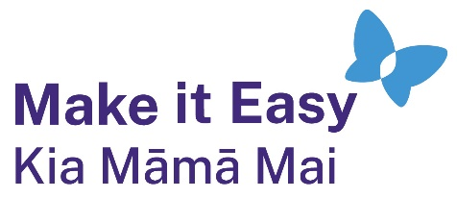
It has been translated into Easy Read by the Make it Easy Kia Māmā Mai service of People First New Zealand Ngā Tāngata Tuatahi.
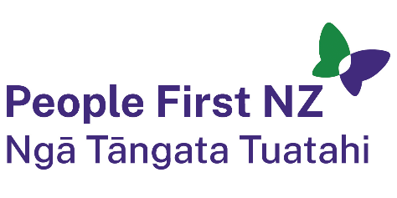
The ideas in this document are not the ideas of People First New Zealand Ngā Tāngata Tuatahi.
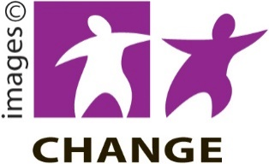
Make it Easy uses images from:

- Changepeople.org

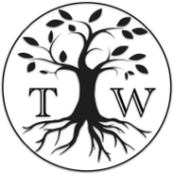
            - Photosymbols.com

- SGC Image Works
- Huriana Kopeke-Te Aho
- T. Wood.
All images used in this Easy Read document are subject to copyright rules and cannot be used without permission.

