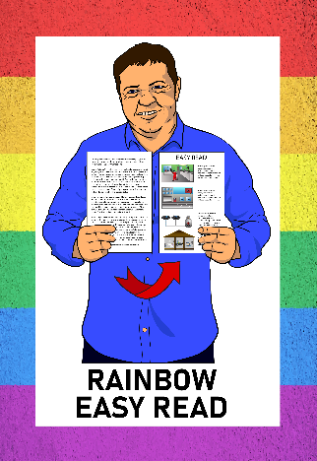

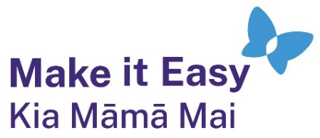

Rainbow Easy Read:
Supporting your
rainbow friends and whānau
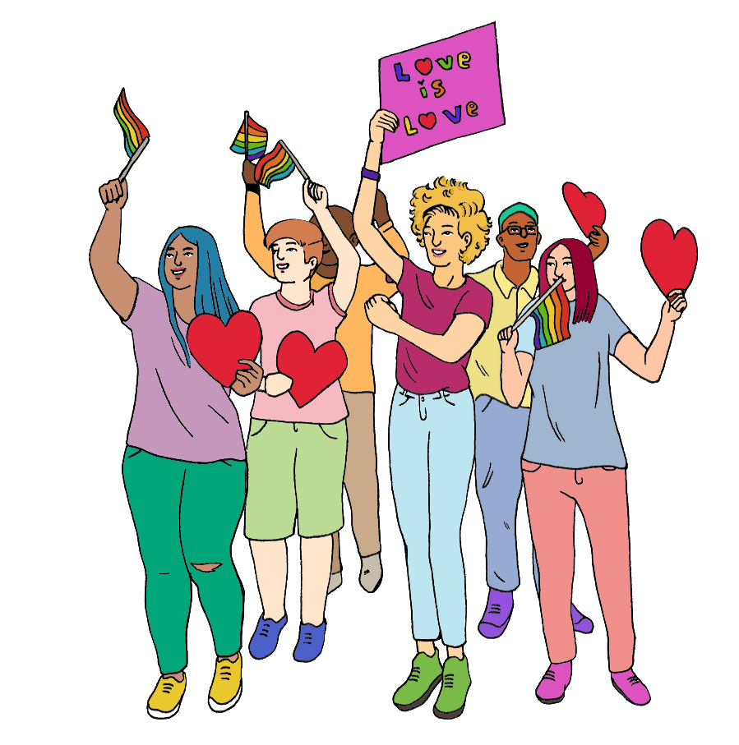

Published: February 2025

What is in here

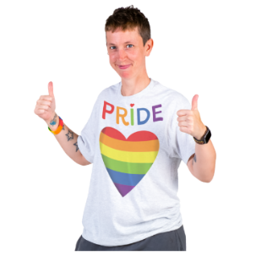
Page number:

About this Easy Read 3
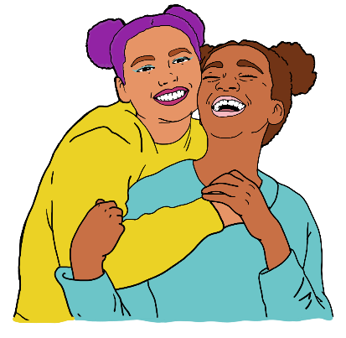

Why rainbow people need support 5

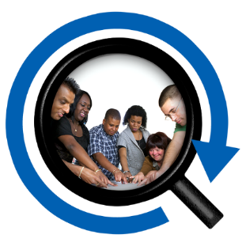
Getting started 9


Support when things are hard 13

Being a support person 16


Support when people treat
others badly 20


Page number:

Making communities better 25

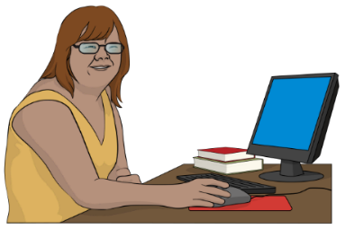
More information 28


Thank you 30

About this Easy Read

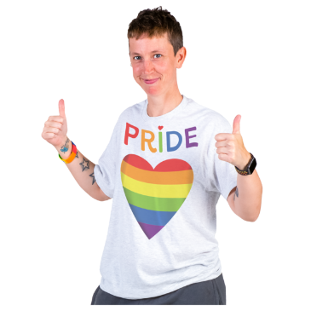
This is a guide to how to support people in the rainbow community.

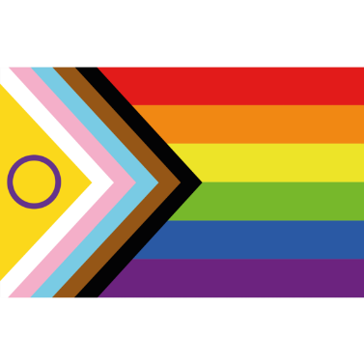
The rainbow community is also sometimes called the LGBTQIA+ community.


You might find this guide useful to know more about how to:
support your rainbow:
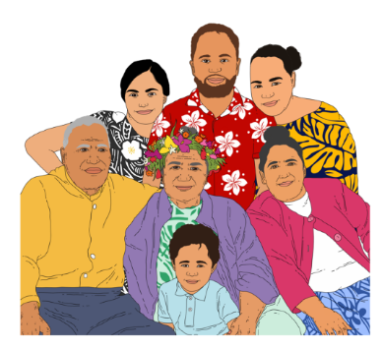
- friends
- whānau / family
make things better for all rainbow people.

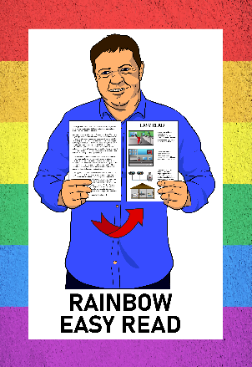
This guide is part of the Rainbow Easy Read Project.

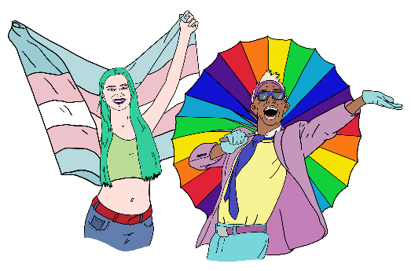
The Rainbow Easy Read Project is a group of Easy Reads for:
people in the rainbow community

their friends
their whānau / families
people who support them.


You can find all the Rainbow Easy Reads at:

https://linktr.ee/rainboweasyread

Why rainbow people need support

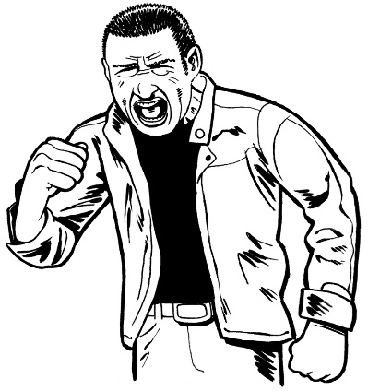
In the past rainbow people experienced a lot of bad things like:
discrimination
hate speech
violence
not being allowed to be with the people they love
laws against them
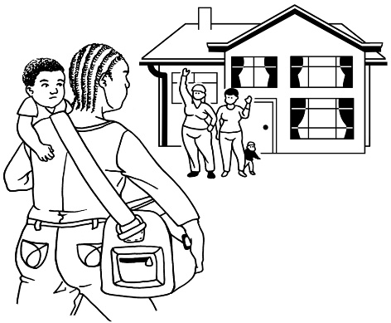
being made to leave their:
- families
- communities.

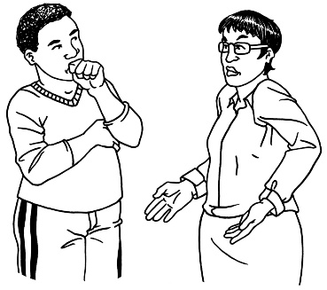
Here discrimination means treating people unfairly because they are part of a rainbow community.

Hate speech is saying bad things to a person or group of people for example because they are rainbow.

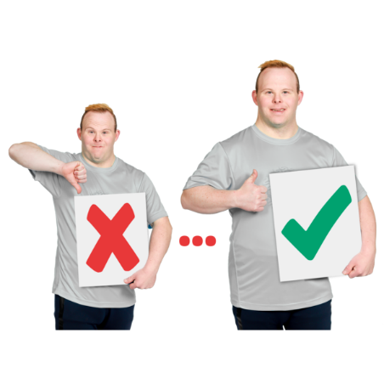
Things are a lot better for most rainbow people than they used to be.

Things can still be hard.


Family members may still not be supportive.

People can lose friends when they come out.


Coming out is when you tell someone you are part of the rainbow community.


Rainbow people can still experience discrimination:

at work
going to the doctor
getting support services

finding a place to live.

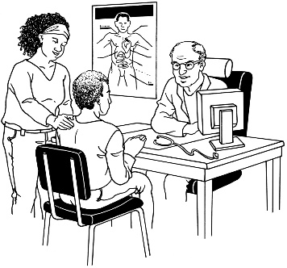
People might face barriers like:
not being able to get the healthcare they need

having to fill in forms that do not have space for their gender.

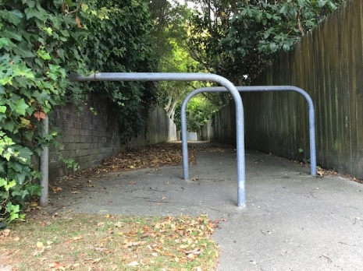
Barriers are things that make it harder for disabled people to have a good life.

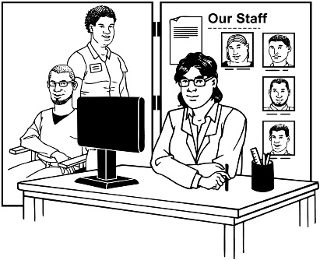
Some places to get support may not be friendly to rainbow people.


Everyone can support:
rainbow people who are having a hard time
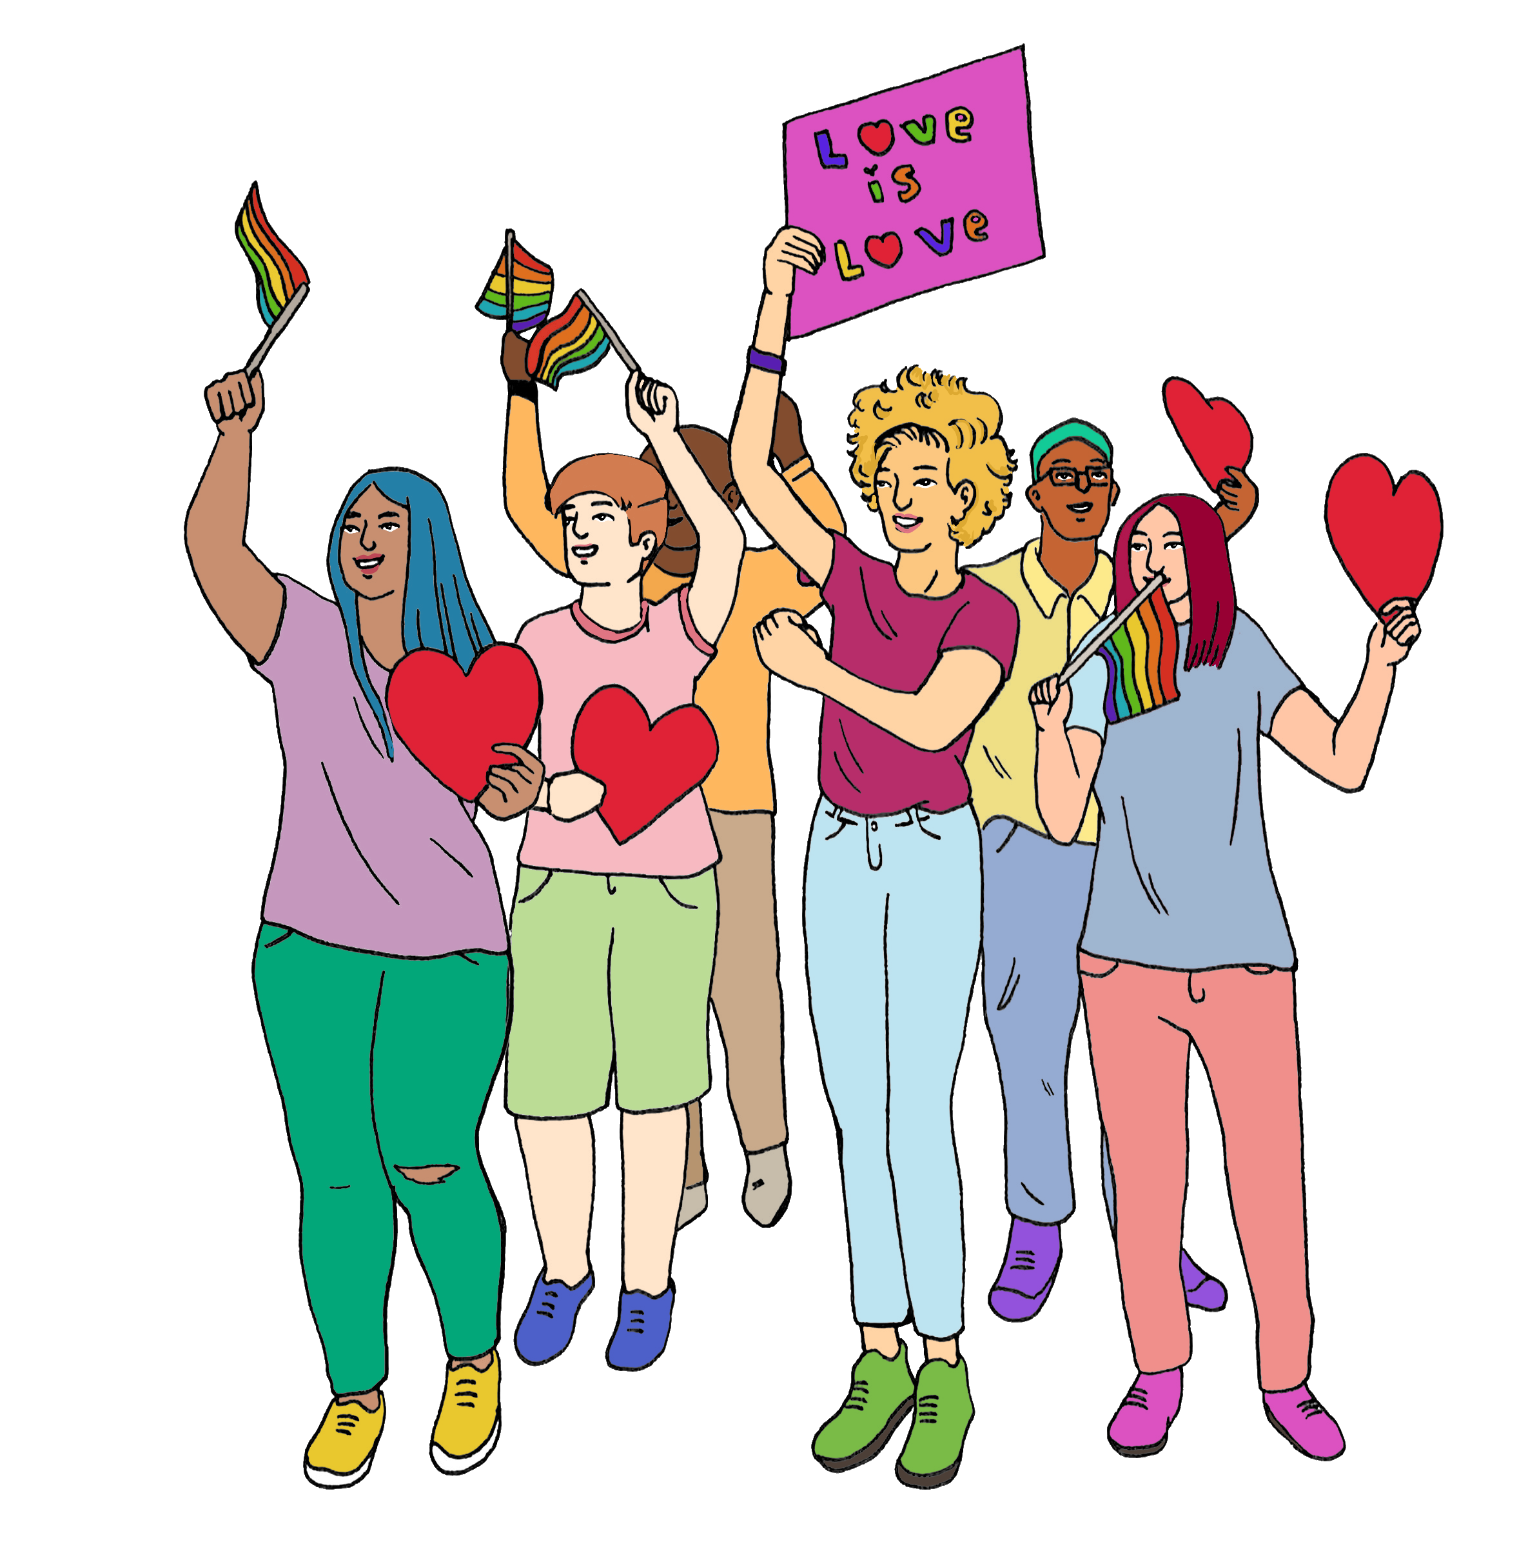
taking away barriers
making the world better for rainbow people.

Getting started

This guide is for everyone including people who:

are part of the rainbow community
are not part of the rainbow community

are not sure if they are part of the rainbow community.

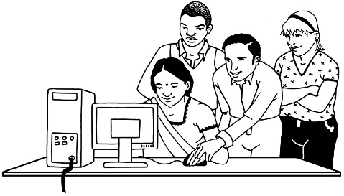
An important place to start is learning more about the rainbow community.

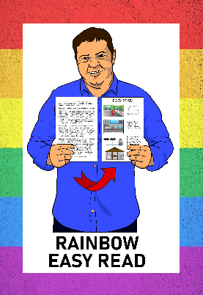
You can use our other Rainbow Easy Read guides to learn more.

You can find these Easy Read guides at:

https://linktr.ee/rainboweasyread
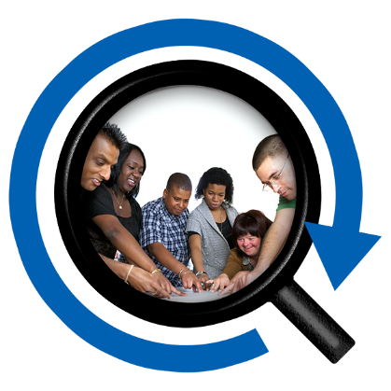

Another thing you can do is talk in a way that includes everyone.


For example people used to say:

Do you have a husband / wife?

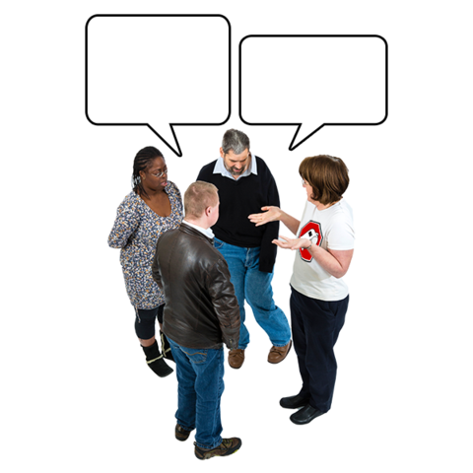
Now it is better to say:
do you have a partner?
or
are you dating anyone?

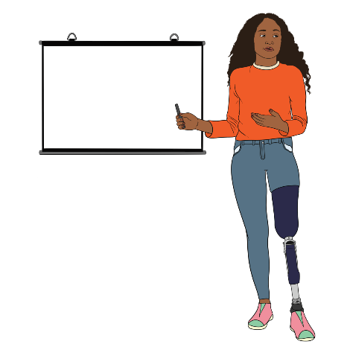
People used to start talking to groups of people by saying:

Ladies and gentlemen.

Now it is better to say:

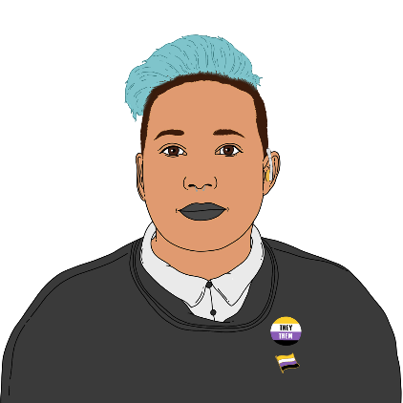
Hello everyone.

Saying this is inclusive of non-binary people.

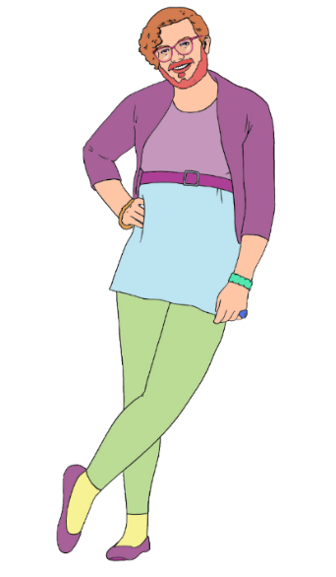
Non-binary people are:
not always just men
and
not always just women.


Sometimes it is hard for rainbow people to tell who is supportive.

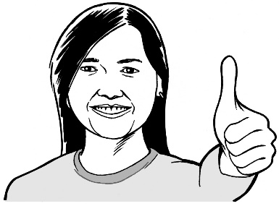
Talking in a way that includes everyone lets them know they can trust you.

Support when things are hard


Sometimes someone you know might be having a hard time.

Experiencing things like discrimination can make everything harder.


You can ask them what they need.


You can ask them if they want:
someone to just listen
support solving a problem
distraction – doing something fun to take their mind off it
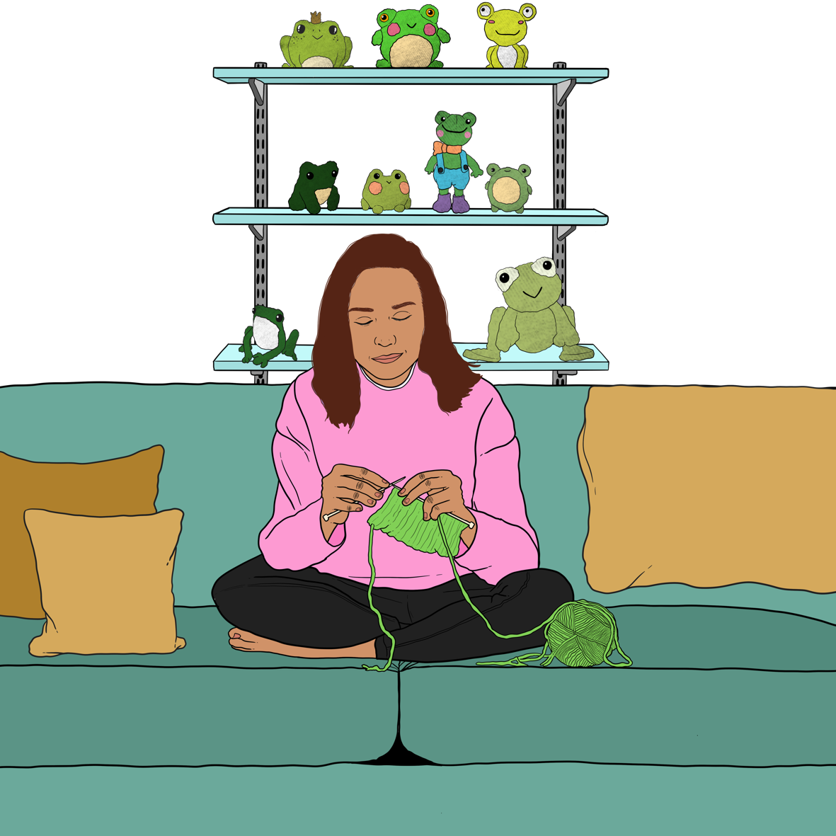
to be left alone.

If they want to be left alone:
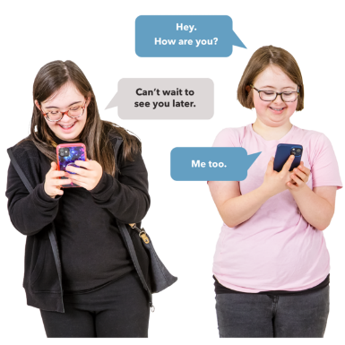
give them some time alone
but
get in touch soon to see how they are.


You might want to tell them about organisations that can support them.

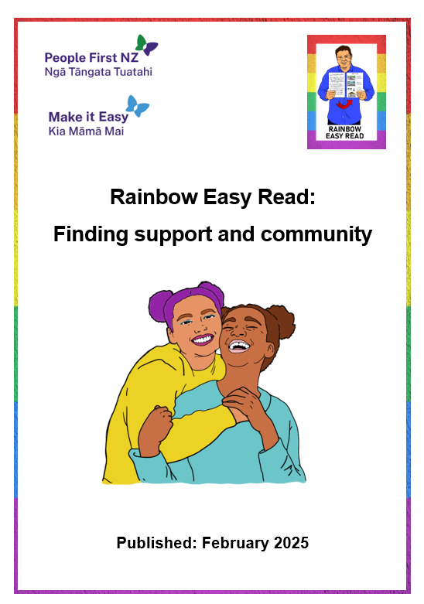
There is more information about support organisations in a Rainbow Easy Read called:

Rainbow Easy Read: Finding support and community

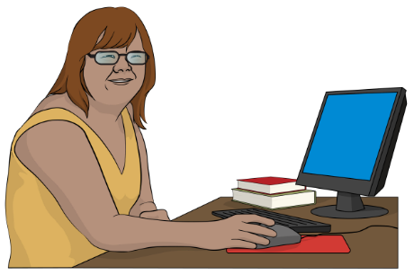
You can find this Easy Read at:

https://tinyurl.com/RERcommunity

Being a support person


You might want to ask someone if they need a support person for something like:
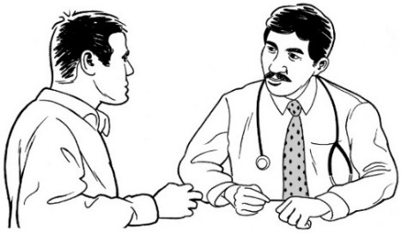
coming out to a family member
going to the doctor.

A support person can:
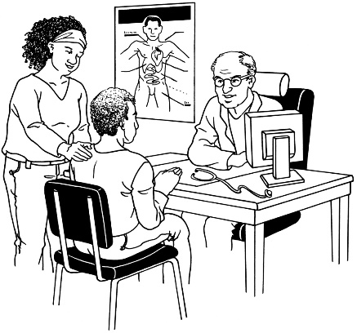
talk if the person finds it too hard
stick up for the person
just be someone they know cares about them.

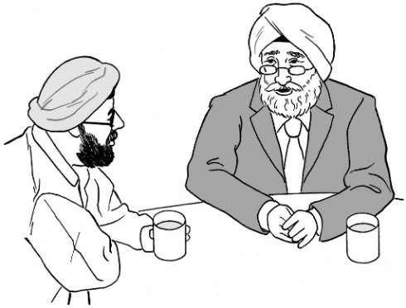
It is a good idea to talk to the person you are supporting first so you know:
if they want you to say anything
what they want you to do if there is a problem.


After you have talked about hard things you might want to suggest doing something you enjoy like:

getting takeaway together
watching a movie

listening to music.

This can make the person feel better.


Someone might want a friend to come with them to a rainbow event like:
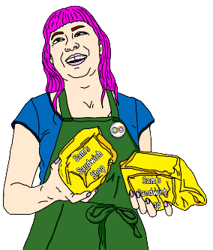
a show
a fair / market
Pride.


Pride is a time when people come together to show their support for the rights of rainbow people.

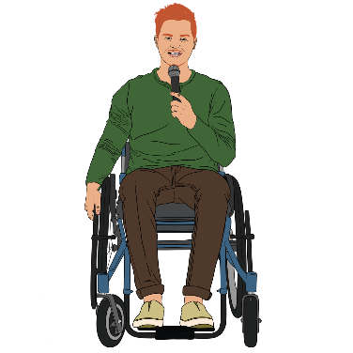
People march through lots of cities.


There are usually other events as well like:
talks
dancing.

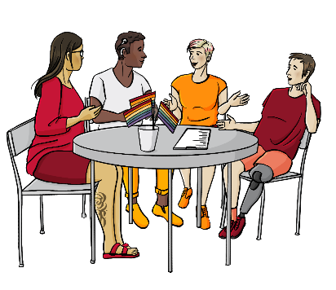
Some rainbow events are for rainbow people only.

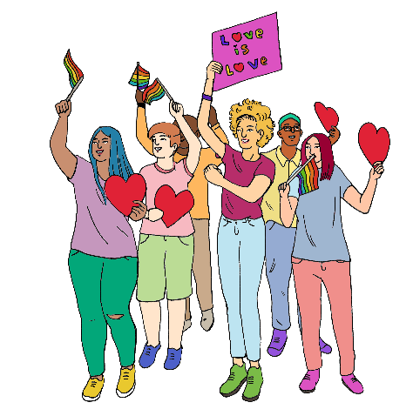
Most are open to everyone.

You can have a fun time there together whoever you are.

Support when people treat others badly

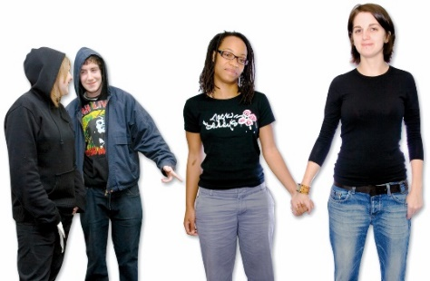
Sometimes people might treat your friend or whānau member badly like:
treating them unfairly

calling them names
telling them they are a bad person
threatening to hurt them.

Ask the person how they want to deal with it.


They might want to:
tell the people why they are wrong
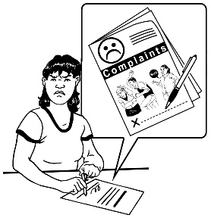
complain to someone else who is in charge
ignore them and do something else.


If the person treating them badly is part of their family they might want to:
try and talk to them
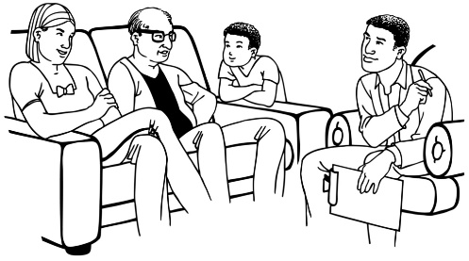
ask another family member to talk to them.

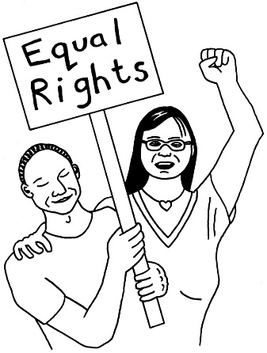
They might want to learn more about their rights if the person being a problem is someone like:
someone they work with
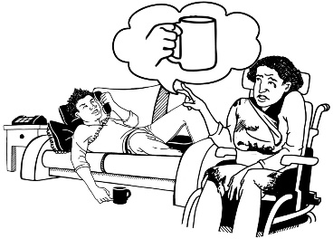
their landlord
a support worker
a doctor.
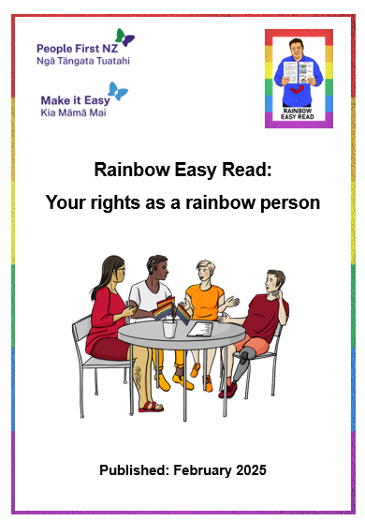
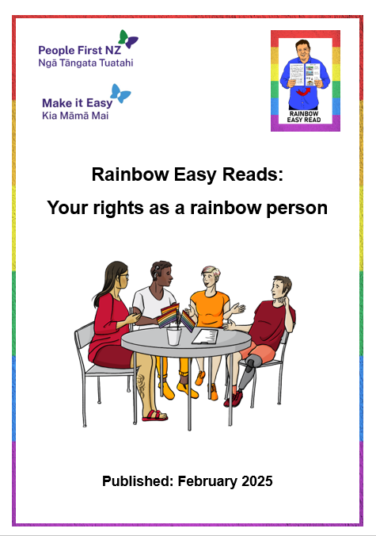
They can find out more about their rights in the Easy Read called:

Rainbow Easy Read: Your rights as a rainbow person

You can find this Easy Read at:

https://tinyurl.com/RERrights


The person might be breaking the law if they:

are violent
will not leave you alone
use hate speech.

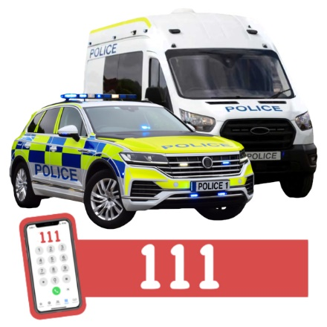
If someone is in danger right now you can call:

111

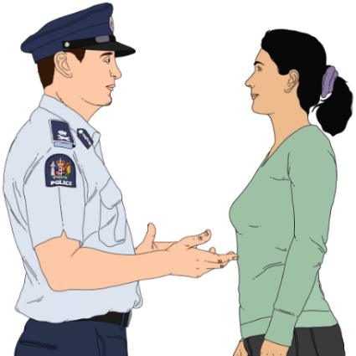
Otherwise you can report it to the police:
by calling 105
on their website:
www.police.govt.nz/use-105

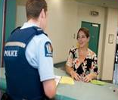
Diversity Liaison Officers are police who work with rainbow communities.


If you want to speak with one of them you can email:
DLOs@police.govt.nz

Making communities better


Rainbow people who are well known can have people saying bad things about them.


You might have a favourite public figure who is rainbow like a:
- sports person
- musician
- actor.


If you do you can:
- cheer loudly for them
- tell your friends about why you like what they do.

This shows that you:
support them
are supportive of other rainbow people.
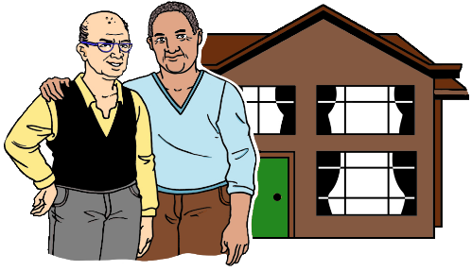

Listen to rainbow people about some of the barriers they still experience.

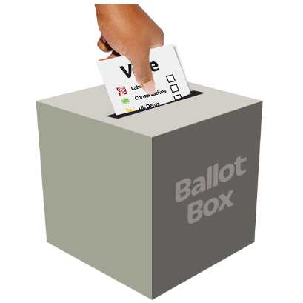
When you vote in government elections you might want to think about what the different political parties do for rainbow people.

You might want to wear a badge that:
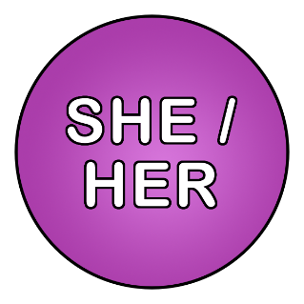
says you support the rainbow community
tells people your pronouns.

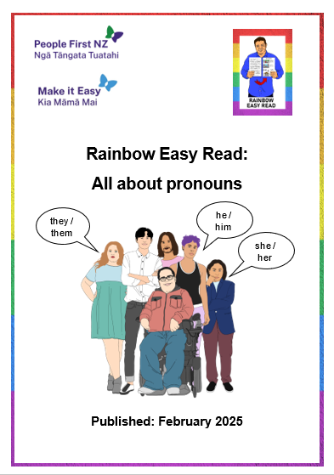
You can read more about pronouns in the Easy Read called:

Rainbow Easy Read: All about pronouns

You can find this Easy Read at:

https://tinyurl.com/RERpronouns

More information

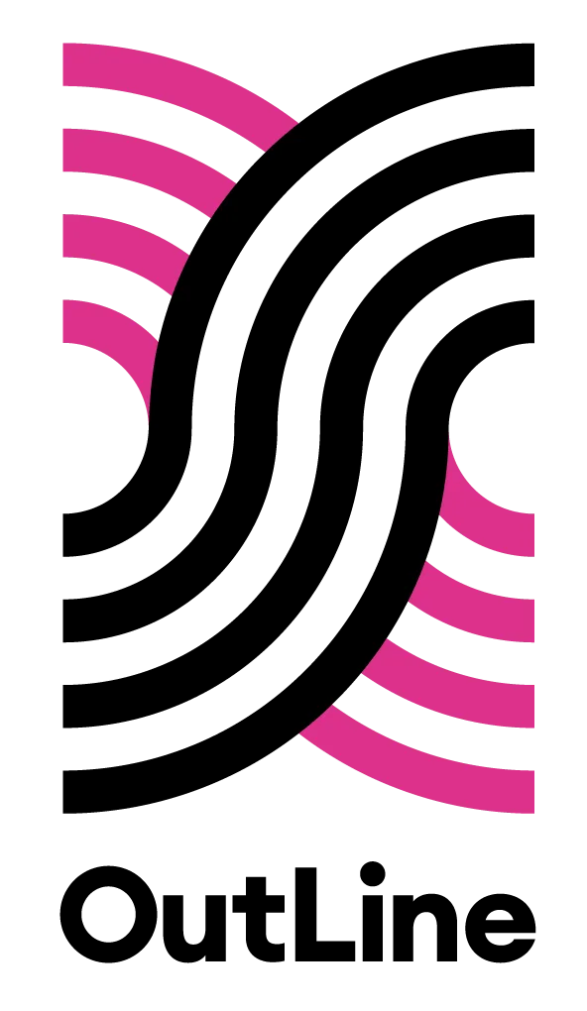
You can contact OutLine for support if you:
are part of the rainbow community
think you might be part of the rainbow community.


You can contact OutLine every day between 6 pm and 9 pm in the evening:
by phone on:
0800 688 5463
using the text chat on their website at:
outline.org.nz/chat
There is an Easy Read called:

Rainbow Easy Read: Finding support and community

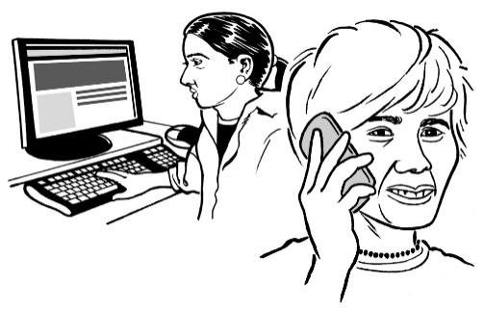
It has information about more places you can contact for:
information
support.

You can find this Easy Read at:

https://tinyurl.com/RERcommunity

Thank you

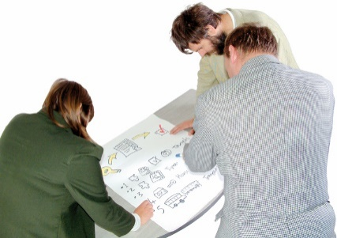
Lots of people worked together on the Rainbow Easy Reads.


Thank you to the Rule Foundation for giving us the money to make the Rainbow Easy Reads.

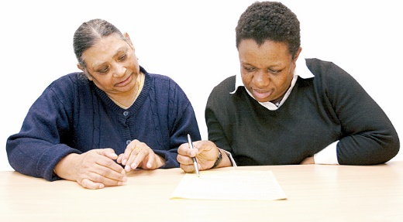
Thank you also to:
the People First NZ members who worked as advisors
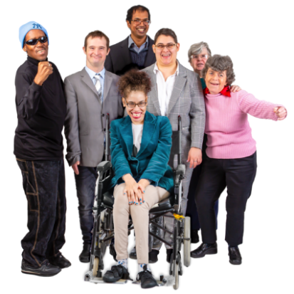
the People First NZ staff who supported them
everyone who has supported this mahi / work.

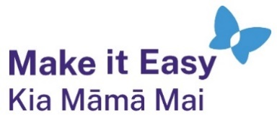
This information has been written by Make it Easy Kia Māmā Mai.


Make it Easy is a service of People First New Zealand Ngā Tāngata Tuatahi.


All images used in this Easy Read document are subject to copyright rules and cannot be used without permission.


Make it Easy uses images from:

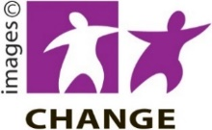
- Photosymbols


- Change Images

- SGC Image Works


- Huriana Kopeke-Te Aho

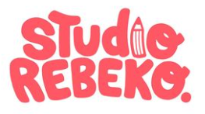
- T Wood

- Studio Rebeko

- Inga Kramer.

