
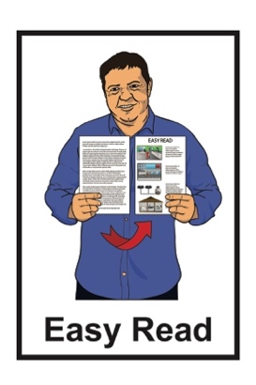

How to use Zoom

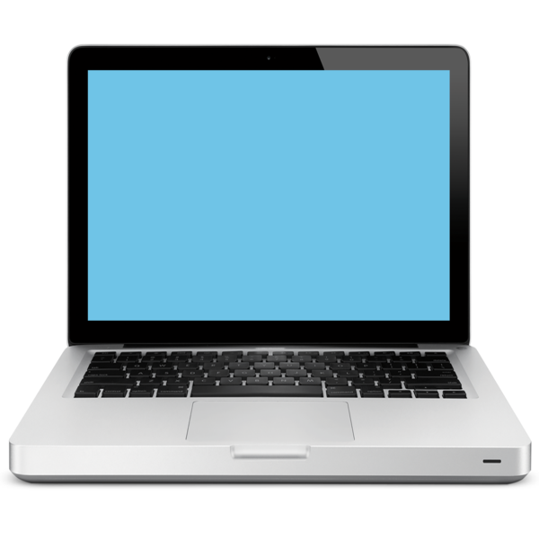

on your laptop or computer

Published: October 2025

Before you start

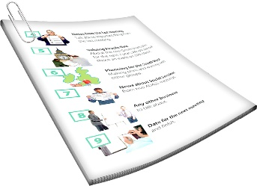
This is a long document.


It can be hard for some people to read a document this long.


Some things you can do to make it easier are:
read it a few pages at a time
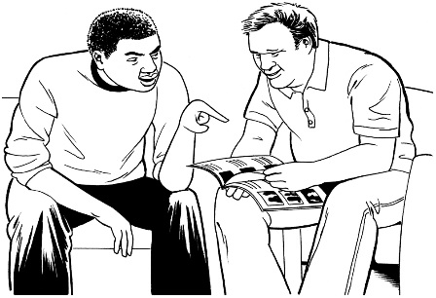
set aside some quiet time to look at it
have someone read it with you to support you to understand it.

What is in this document

Page number:

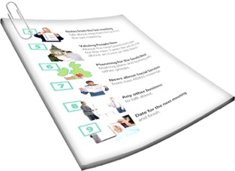
About this Easy Read 4

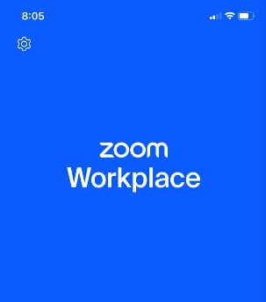
What is Zoom? 6

Things your laptop / computer
need to use Zoom 9

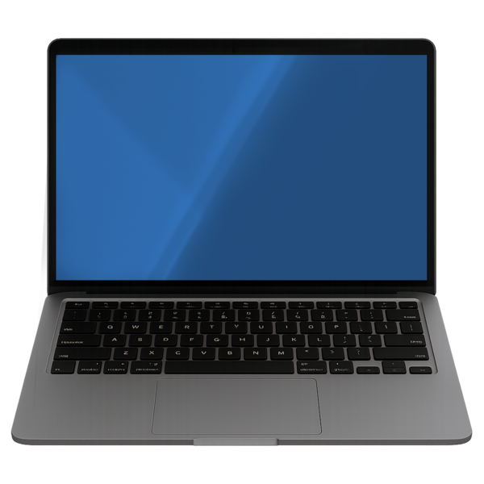
Connecting to the internet 11

How to download Zoom 13


How to join a Zoom meeting 24

Page number:


Using Zoom controls 32
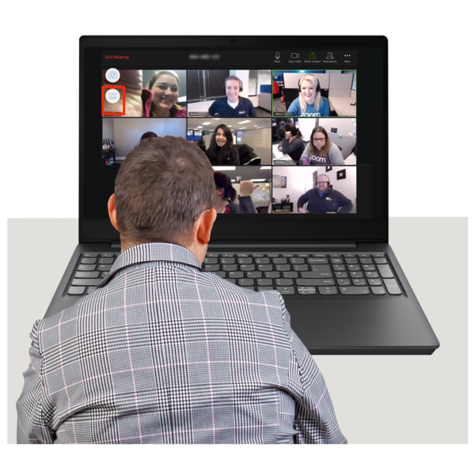

Tips for using Zoom 47

About this Easy Read

This Easy Read guide is about how to use Zoom.

It tells you:
what Zoom is
how to use Zoom on your:
- laptop
- computer.

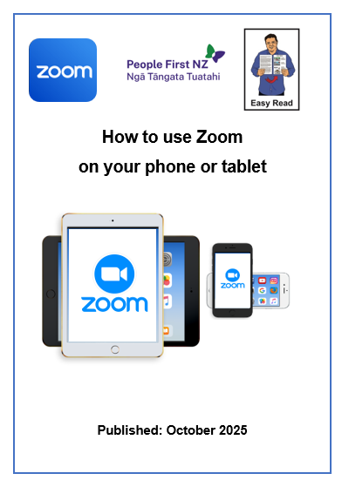
There is another Easy Read called How to use Zoom on your phone or tablet.

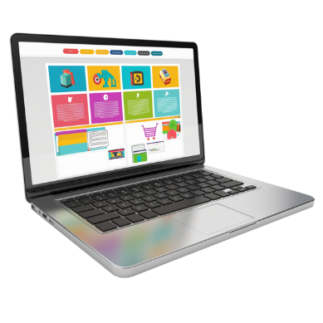
You can read this Easy Read at this website:

https://tinyurl.com/ZoomTabletPhone

This Easy Read has been made by People First NZ.

What is Zoom?

Zoom is an app that you can make video calls on.

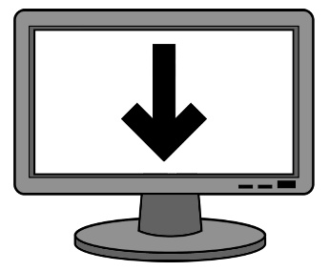
An app is a program that you can download to your device.

Here a device is a:
laptop
computer.

The full name of the Zoom app is the Zoom Workplace app.

It is usually called Zoom for short.

On Zoom you can meet up with:

1 person
lots of people.



When you meet up using the Zoom app it is called a Zoom meeting.

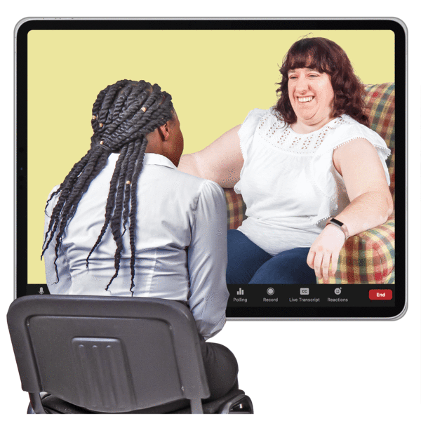
When you meet with other people on Zoom you can:
see them
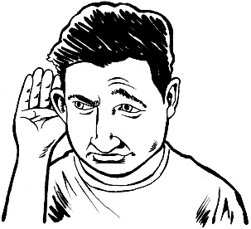
hear them
send them messages on
Zoom chat.

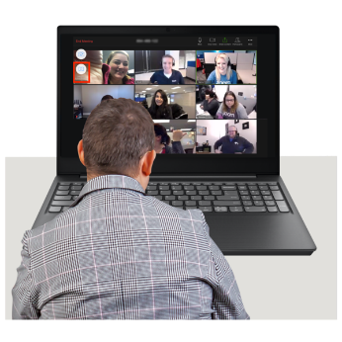
You can use Zoom for things like:
meetings
talking with your friends
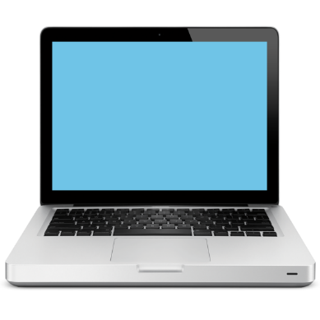
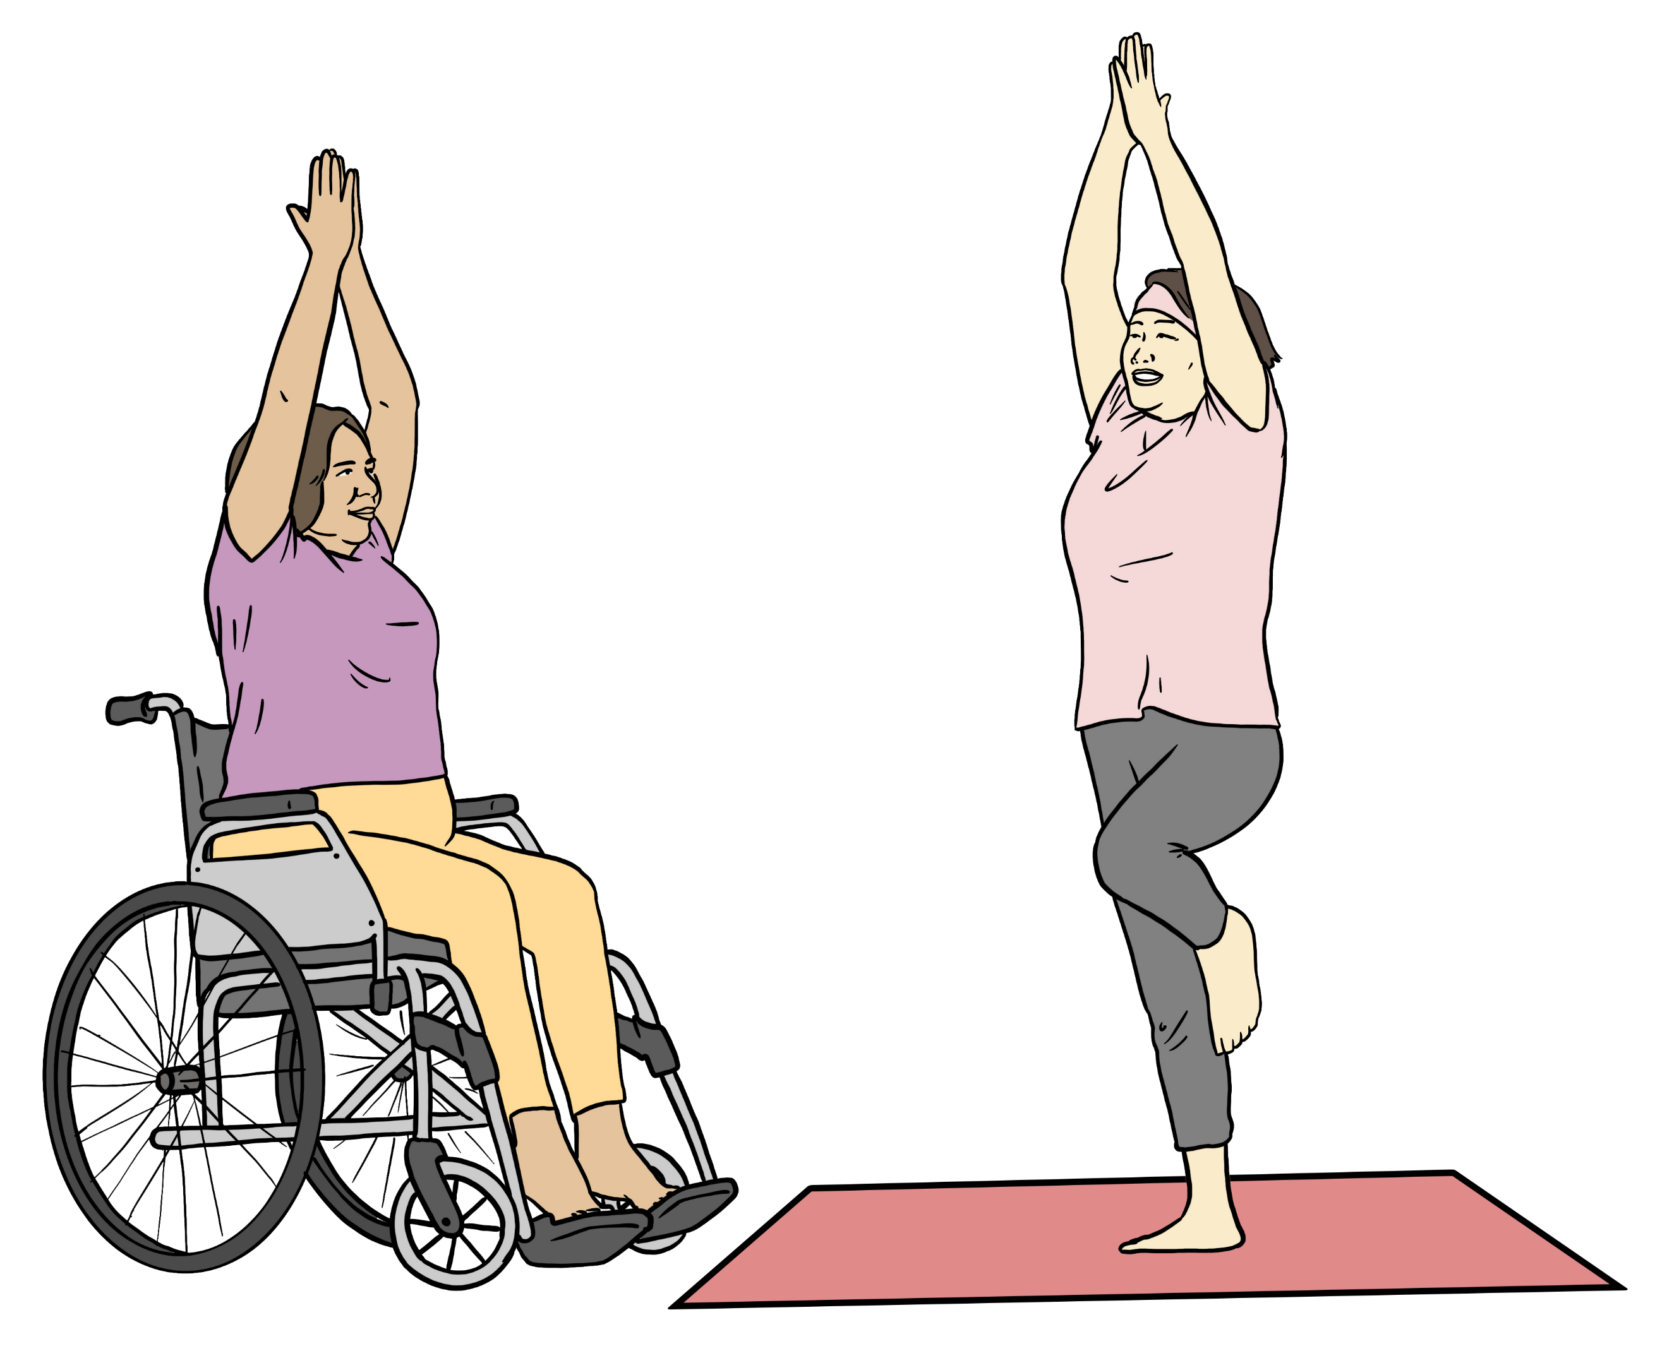
joining support groups
taking a class online to learn to do something.

Things your laptop / computer
need to use Zoom

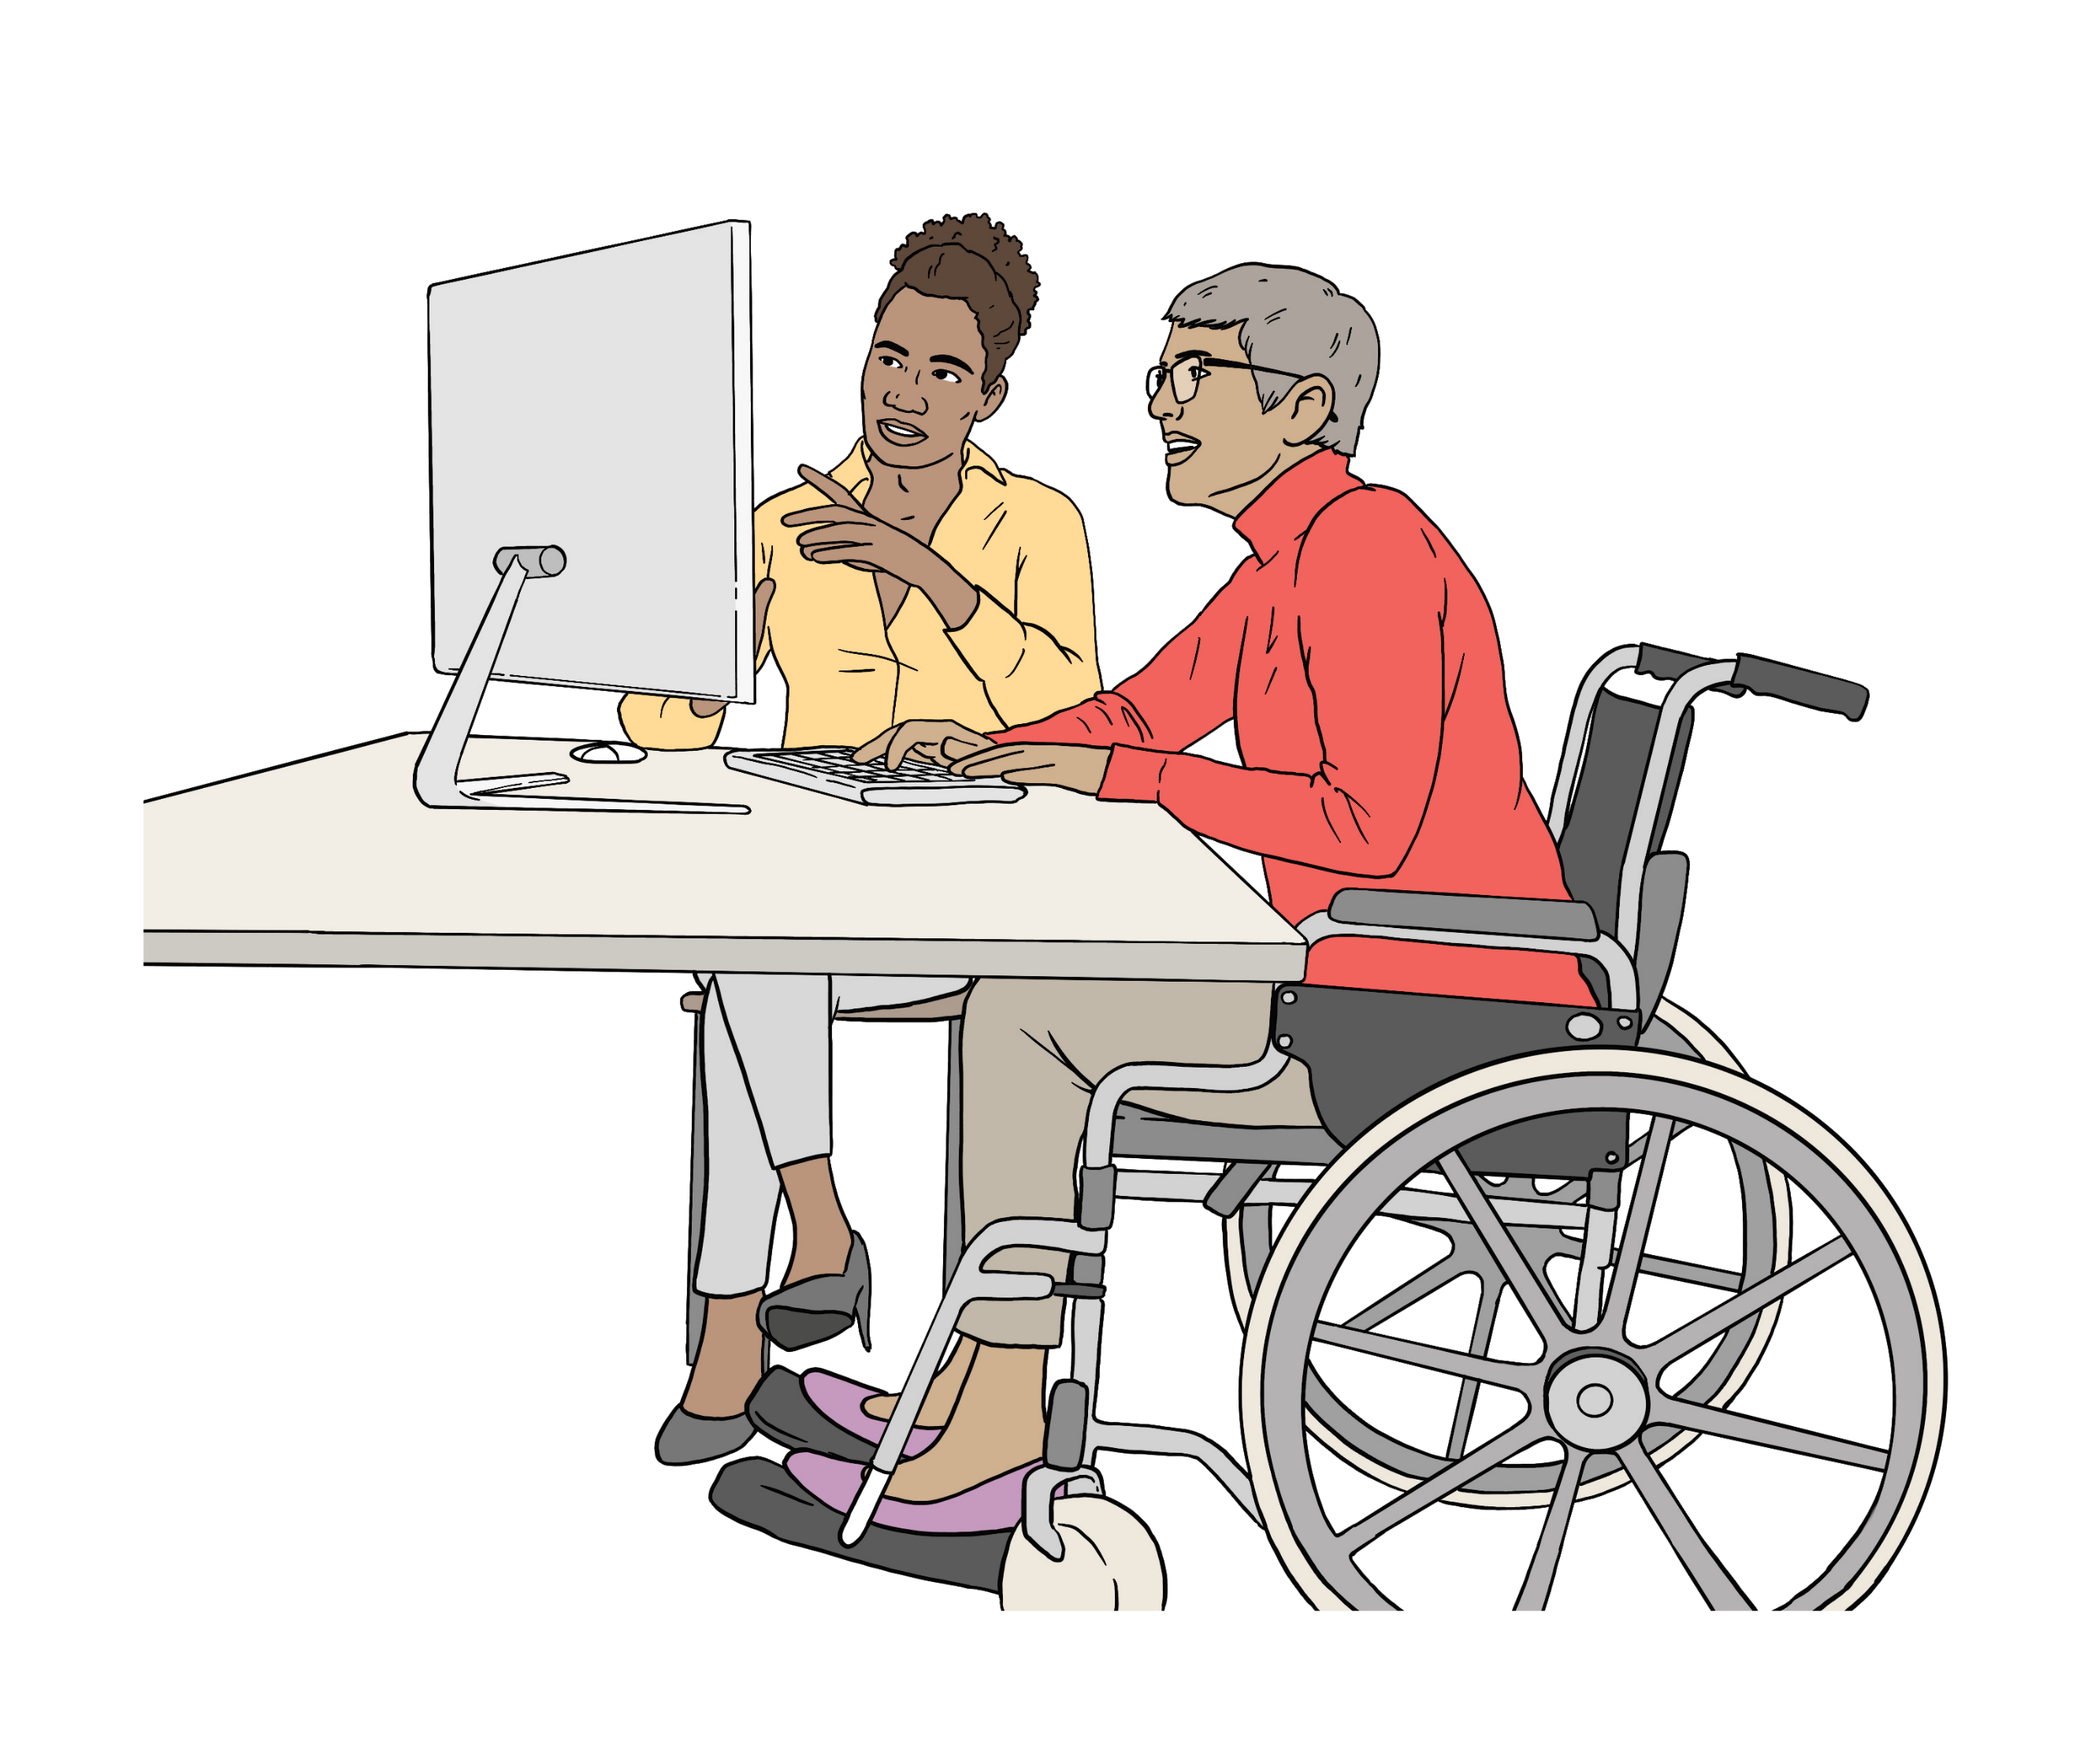
Check your desktop computer has the things you need to use Zoom.

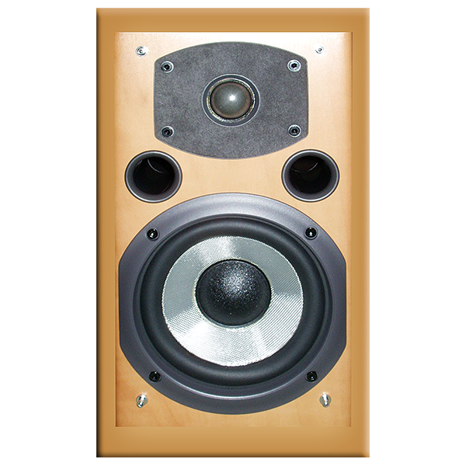
To use Zoom on a desktop computer you need a:
webcam
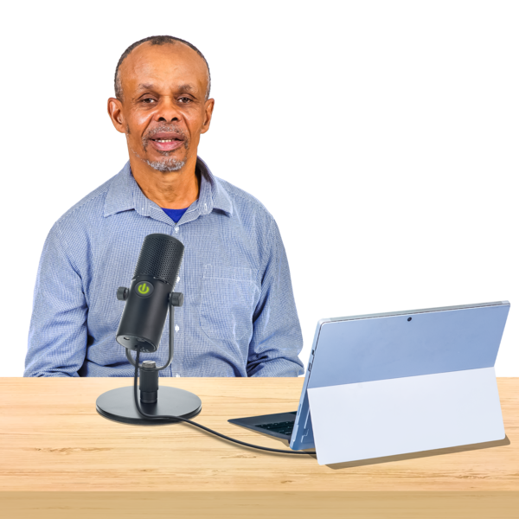
speaker
microphone.

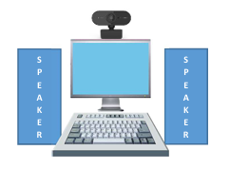
You may need to:
get these things for your desktop computer
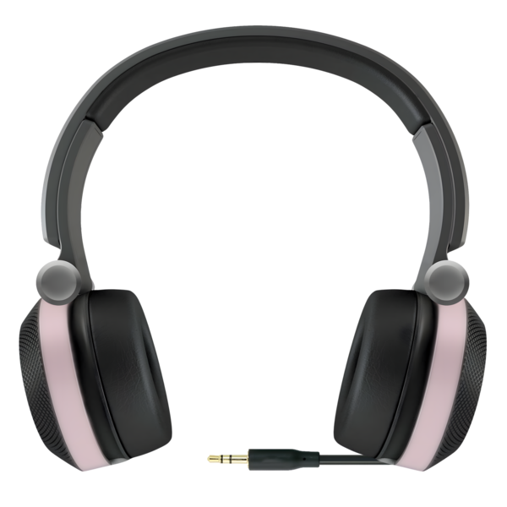
connect these things to your desktop computer.
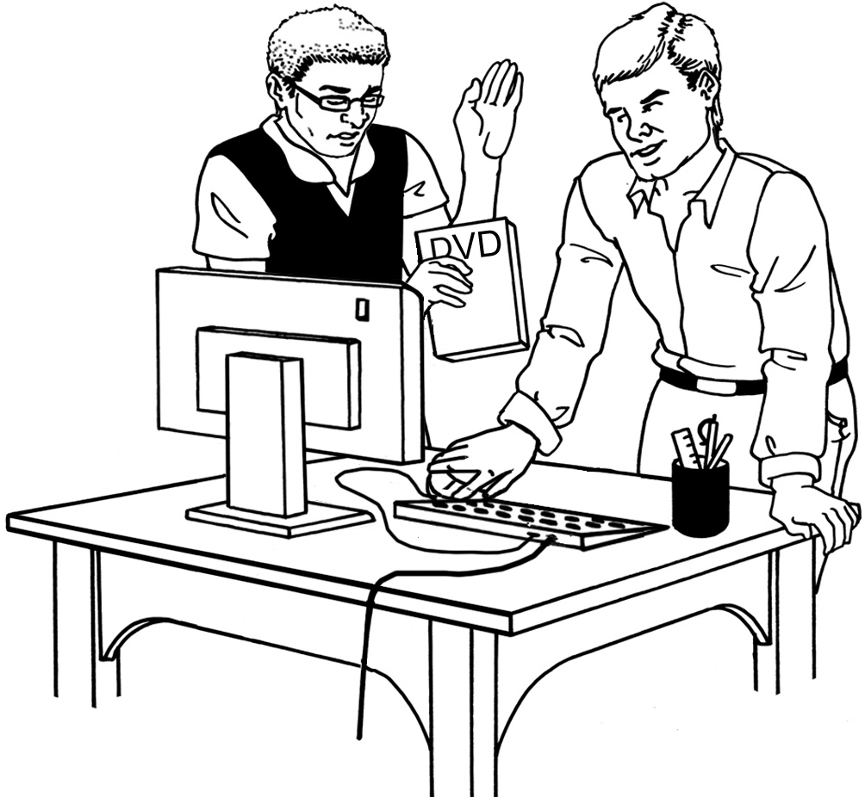
You can ask someone to support you to connect these things to your desktop computer.


Most laptops have all the things you need to use Zoom built into them.

Connecting to the internet


You need to be connected to the internet to:
download Zoom to your device
use Zoom.
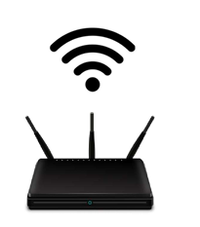

The internet is the network where you can find or share information online.

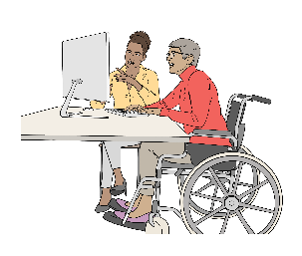
If you are using an internet router at home you may need to sit closer to it.

An internet router is a box that:
connects your devices to the internet
uses Wireless Internet / Wifi.
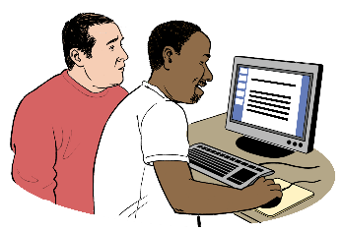
If you need support to connect to the internet you can ask:

a friend
a whānau / family member
your support worker.

How to download Zoom

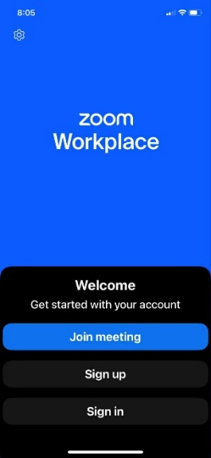
Download the Zoom Workplace app onto your device.



It does not cost you money to do this.

First open your internet browser.


An internet browser is a program you can use on your computer to get the internet.


You might have more than 1 browser on your computer like:
Firefox
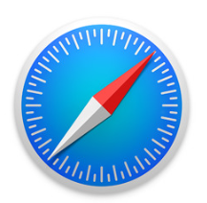
Google Chrome
Safari

Edge.

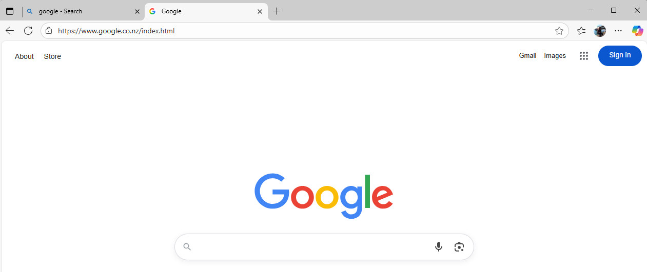

Type in zoom.us/download into the address bar on the browser screen.

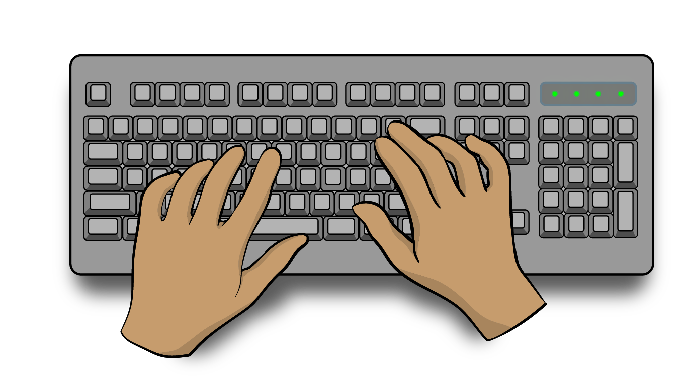
An address bar is where you can type in a:

website address
search word / words.

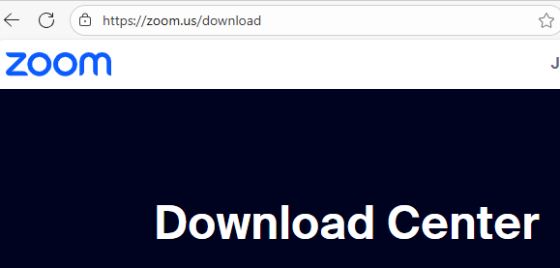

This takes you to the Zoom Download Centre.


The Zoom Download Centre is different for:

a Windows / Android device
an Apple Mac device.


When you click on the link from your device you will be taken to the right place to download Zoom.

Download Zoom on a
Windows / Android device
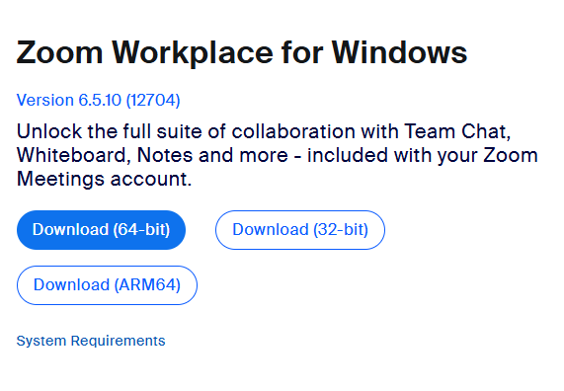

If you are using a Windows / Android device the link will take you to this page.

Click on the blue Download button to get Zoom on your device.
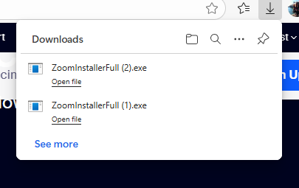

Click on the Open File link to download Zoom.

Zoom will open when it has finished being downloaded.

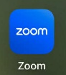

The Zoom Workplace app picture
/ icon will now show on the home screen of your device.

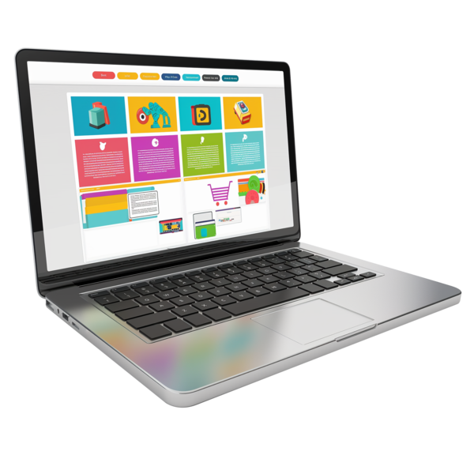
The home screen in the main screen on your device.

You can find your apps on the home screen.

Download Zoom on a
Apple Mac device
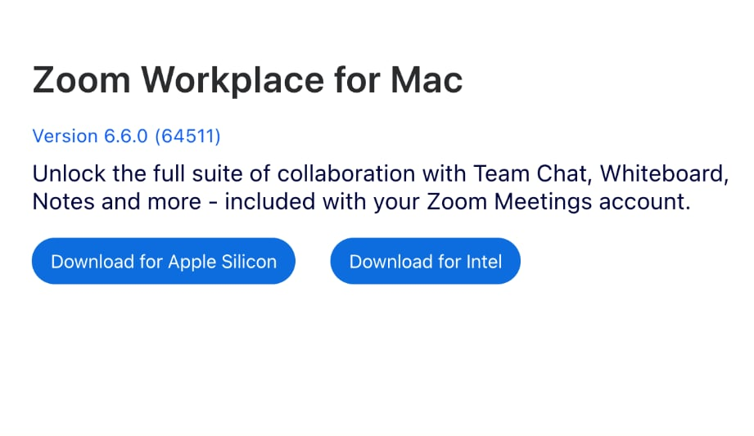

If you are using an Apple device the link will take you to this page.

There are 2 buttons you can click to download Zoom on this screen:
Download for Apple Silicon processor
or
Download for Intel processor.


The processor is like a brain that controls a computer.

How to find out what your Apple Mac processor is
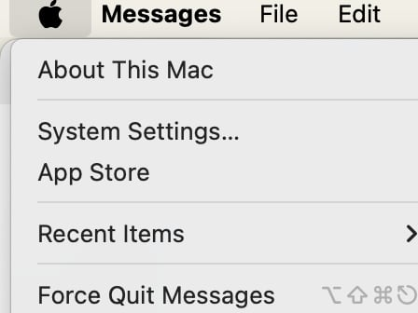

Click the apple picture at the top of the screen.

Click About this Mac.

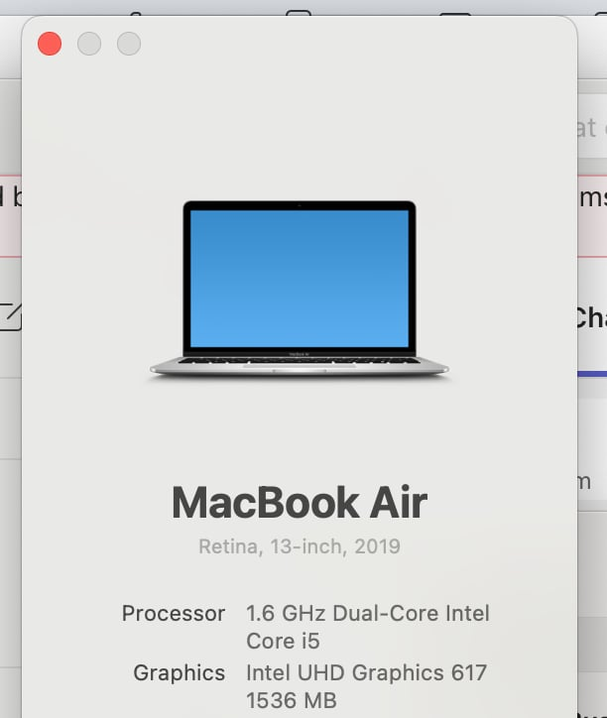

You will see the name of the processor here.
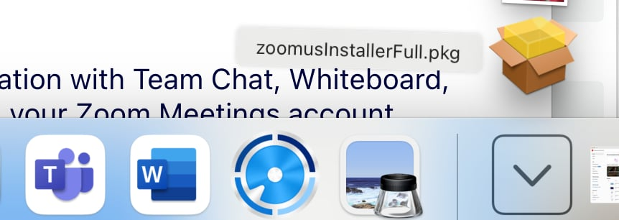

Double click on the link that will pop up on your screen to load Zoom.

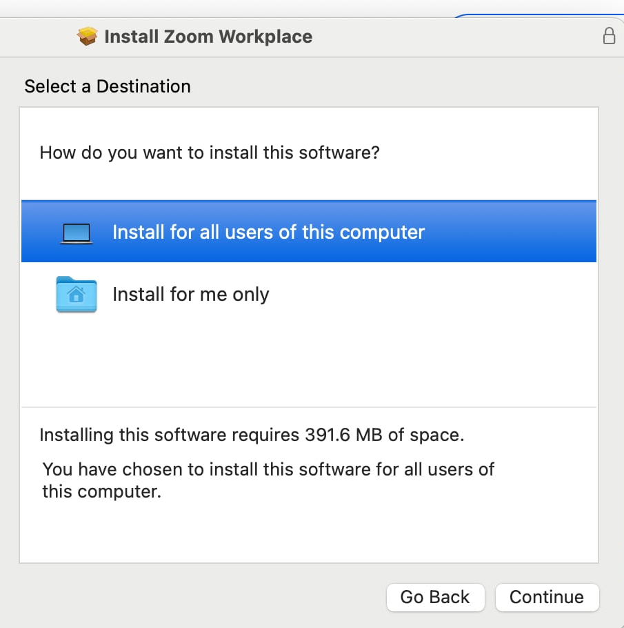

Click 1 of the options on screen then click the Continue button.

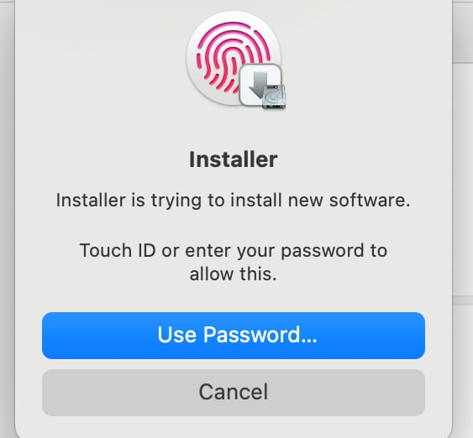

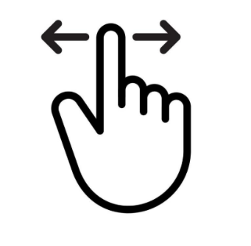
To install Zoom use:
touch ID by touching the black key at the top right on your keyboard
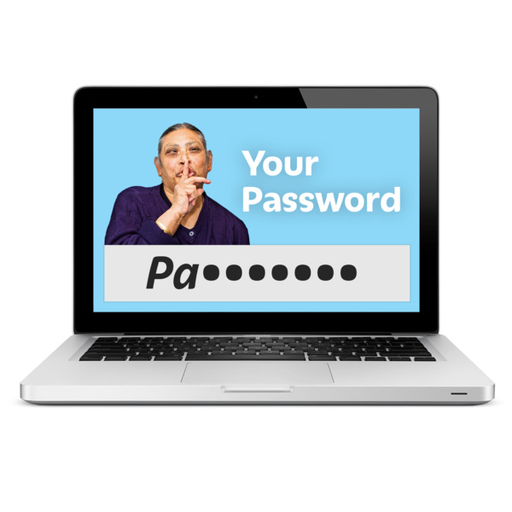
or
the password for your device.

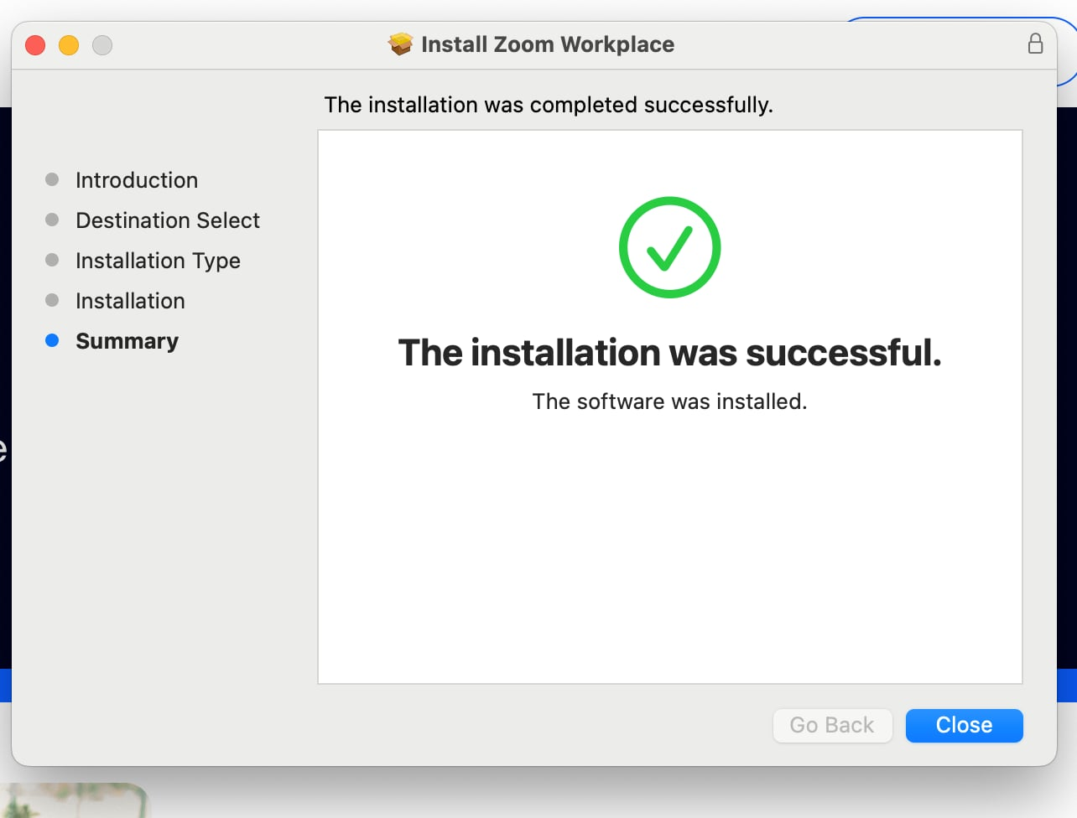

Zoom is now installed on your Apple Mac device.

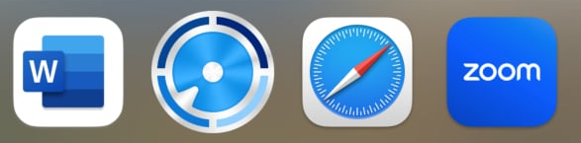

The Zoom Workplace app picture
/ icon will now show on the dock at the bottom of your screen.

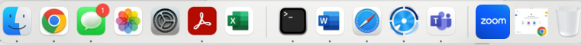

The dock is the menu bar at the bottom of the screen on your Apple Mac.
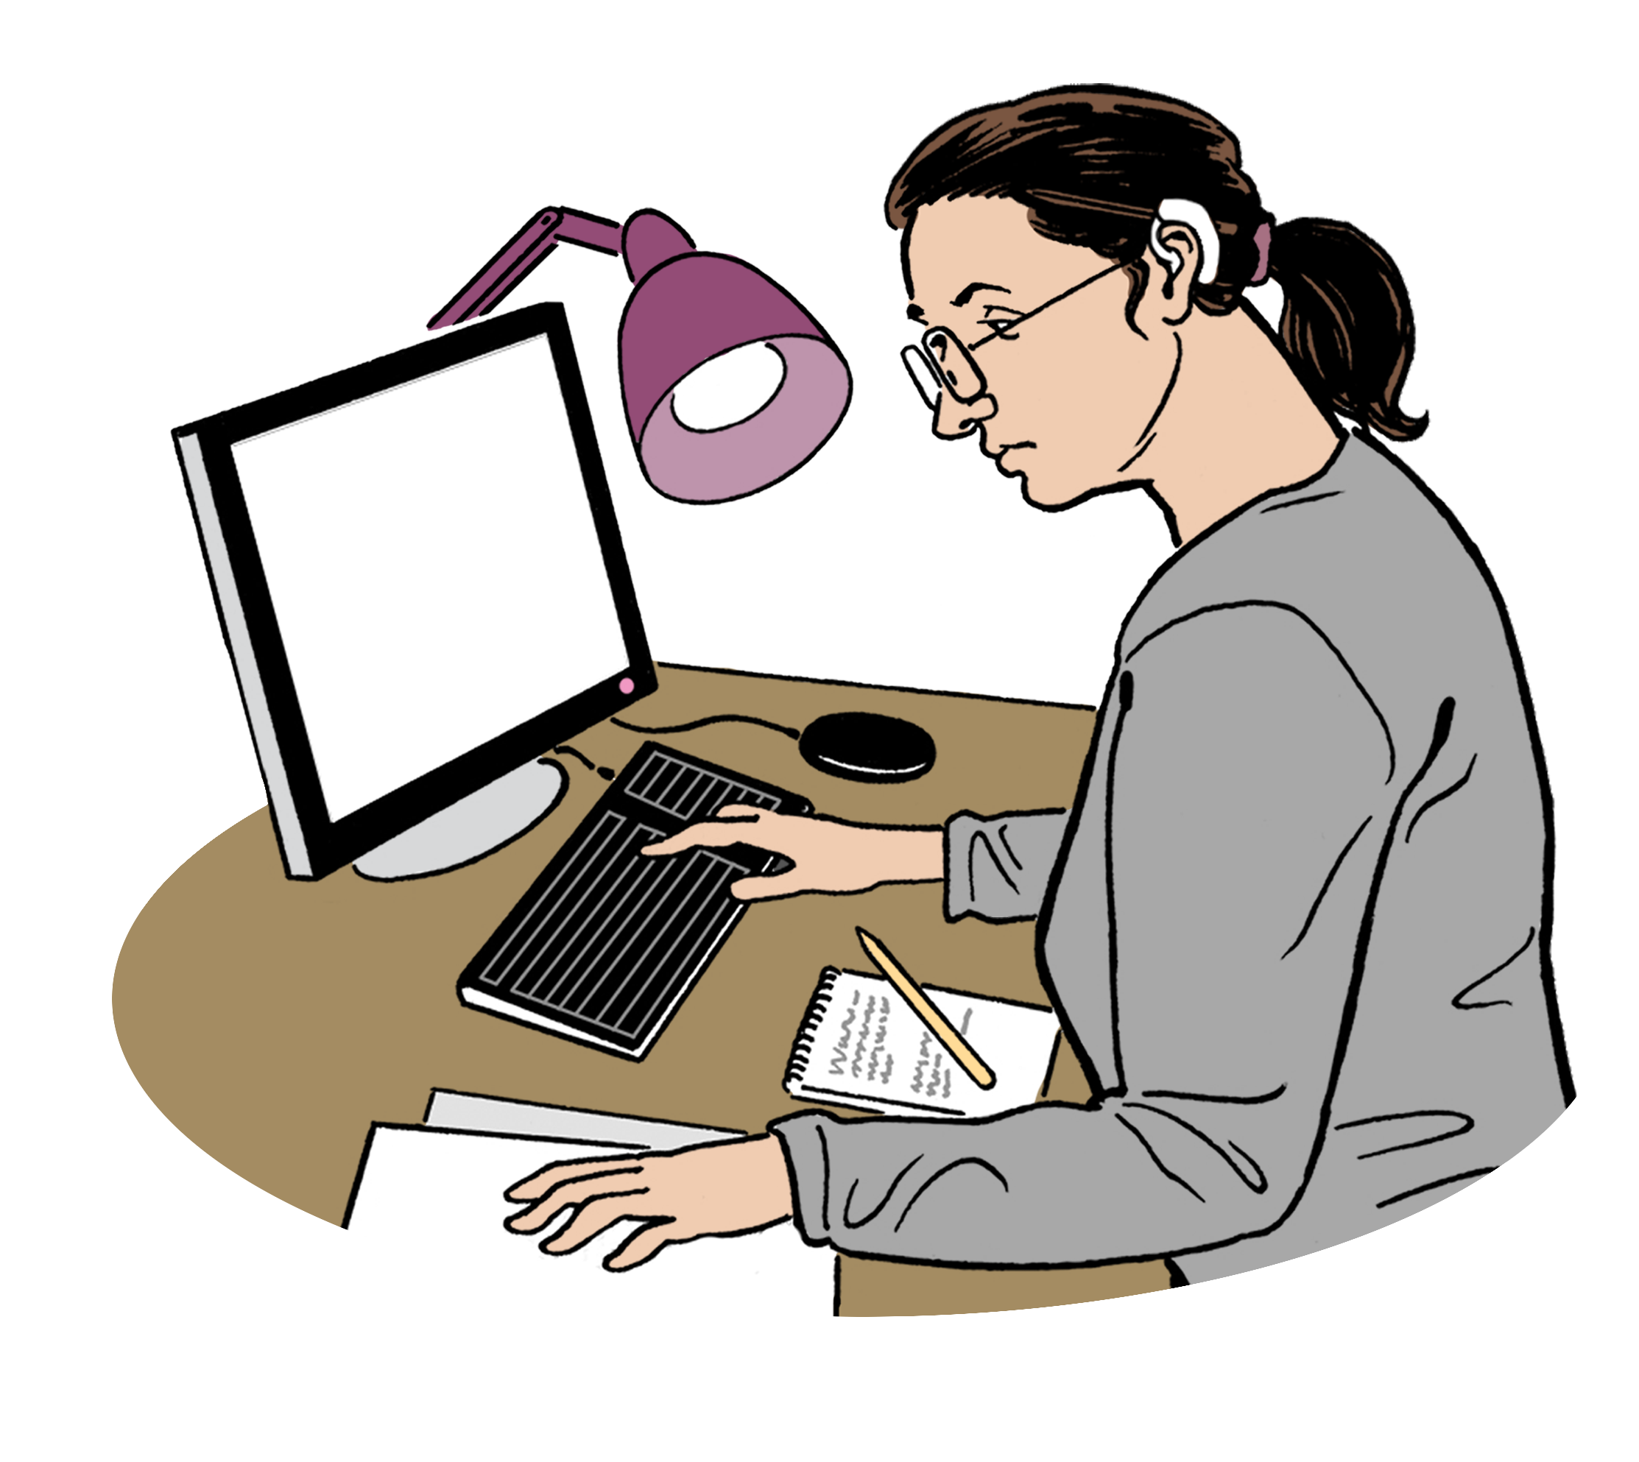
Find out more information about how to download Zoom at this website:
https://tinyurl.com/ZoomDLInfo
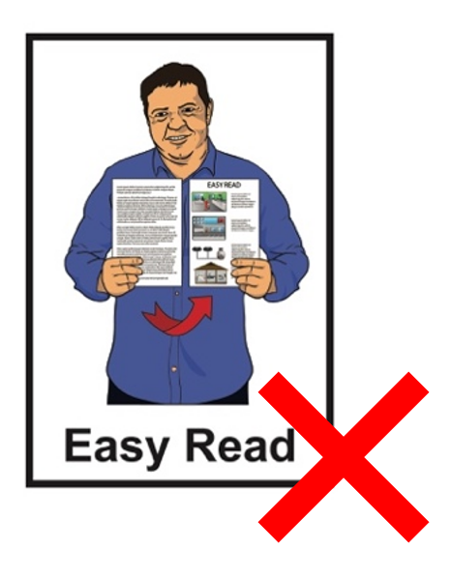

This website is not in Easy Read.

How to join a Zoom meeting
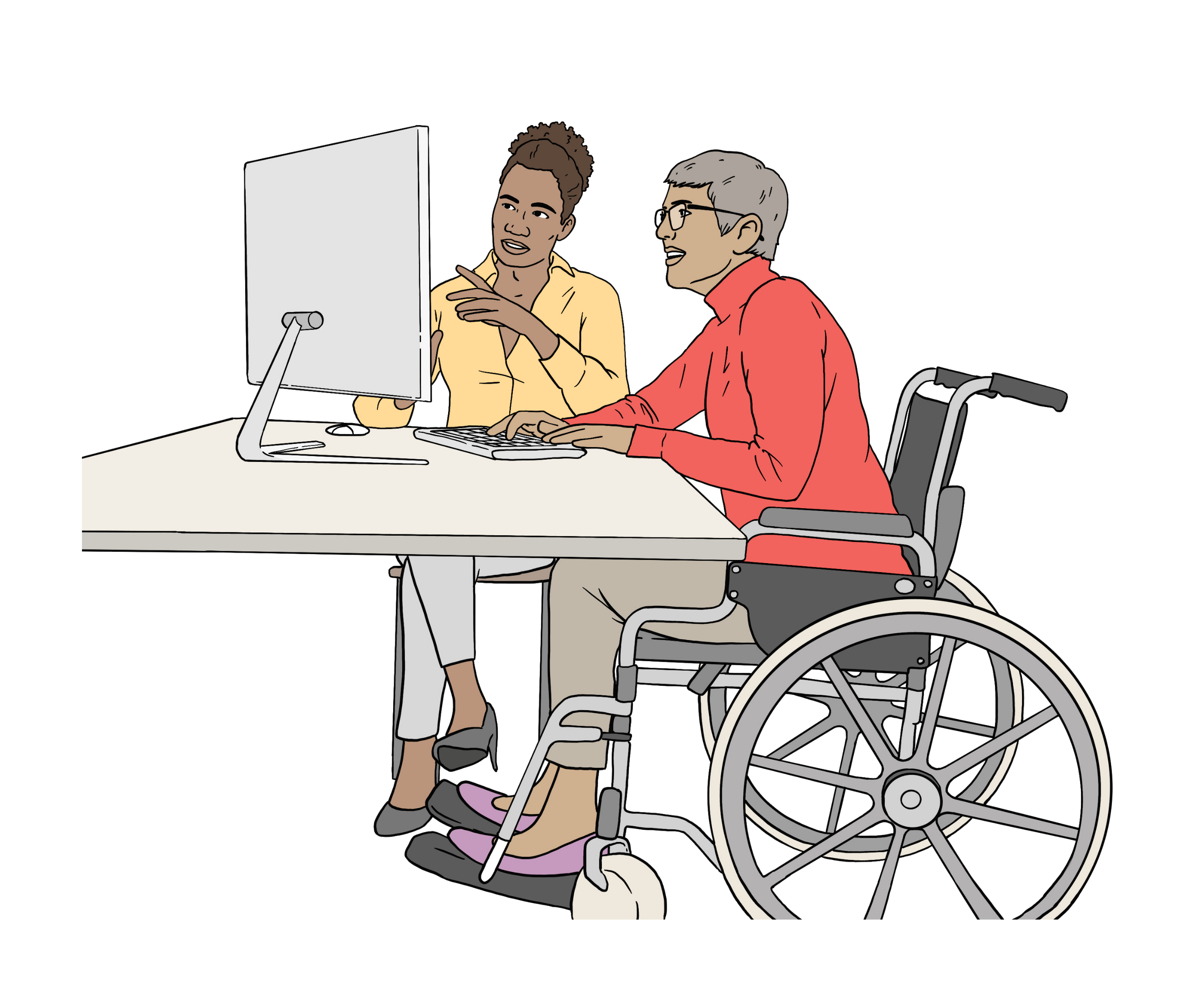

Someone will invite / ask you to join a Zoom meeting.

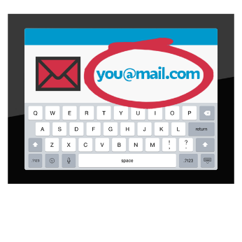
The invite will usually have a link to a Zoom meeting in something like an:
an email
a message.


A link takes you to a website address like Zoom when you click on it.


We tell you some of the ways to join a Zoom meeting on the next pages.


Join using a meeting invite link
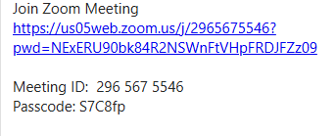

Join the Zoom meeting by clicking the link in the message / email.

Zoom will open on your device.

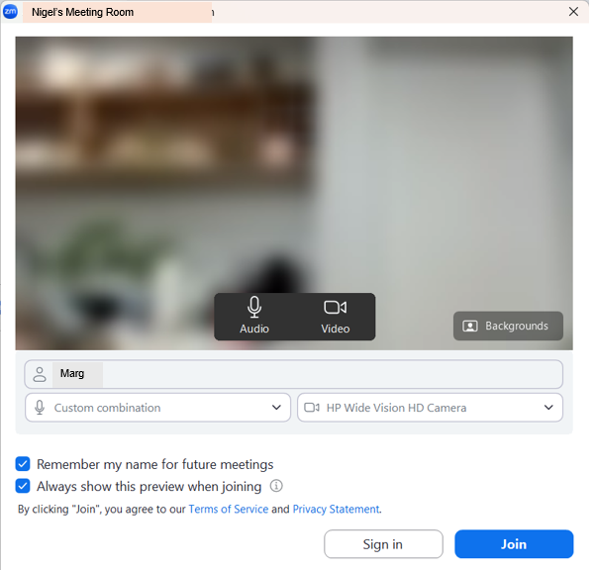
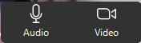

Click the Join button.

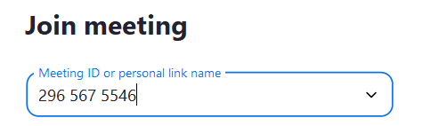

When you have clicked the Join button you may need to put in the Meeting ID.

The Meeting ID is a 10 or 11 number code.

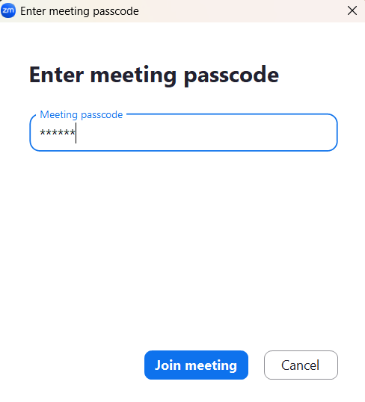

Put in the meeting Passcode if asked.

Here the Passcode is a code made up of:
numbers
letters.


Using a passcode makes sure only people who are invited get into the meeting.

Click the Join meeting button.

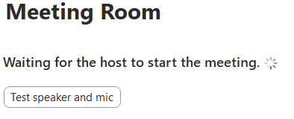

You may be put in a meeting room to wait for the meeting to start.

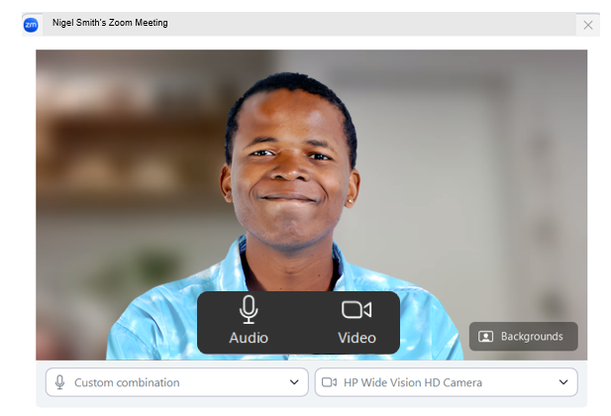


The meeting host will let you into the Zoom meeting.

The meeting host is the person who is running the meeting.

Join using the Zoom app

On the home screen click the Zoom button to open the app.

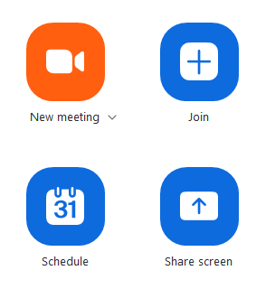

Click the Join button.

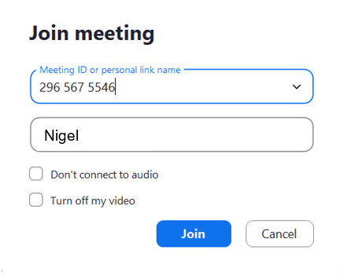

Put in the Meeting ID then click the
Join button.
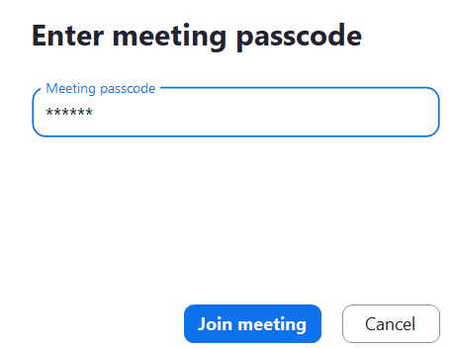

Type in the passcode if passcode box pops up.

The meeting host will let you into the Zoom meeting.

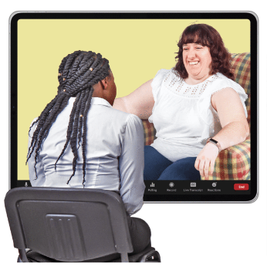
Find out more information about joining a Zoom meeting at this website:

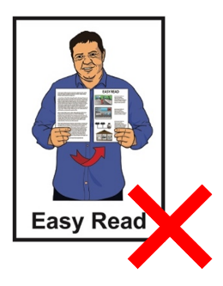
https://tinyurl.com/JoinZmMtg

This website is not in Easy Read.

Using the Zoom controls

You will see a lot of different control buttons on the screen when you join a Zoom meeting.

You will see some on the control bar that is usually at the bottom of your screen.

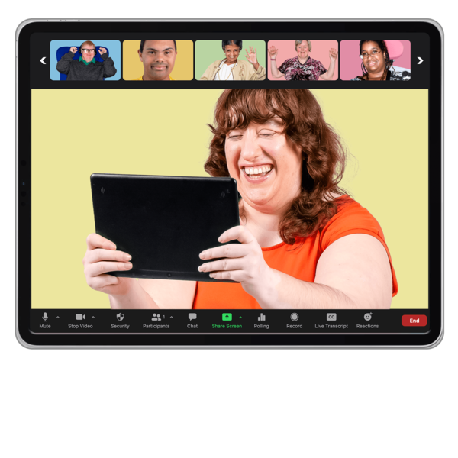
The most important controls to know how to use are the:
microphone

video
switch views.

Other important things to know how to use are the:
Zoom chat
reactions.


Here reactions are pictures that show how you feel about something that has happened in the meeting.


Using the microphone

The microphone is controlled by the Audio button on Zoom.


Audio means sound.

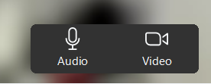
Click the Audio button to mute the microphone.

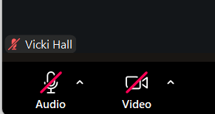
Mute is when your microphone is turned off and no one at the meeting can hear you.

There is a red line on the Audio button when the microphone is on mute.

Unmute your microphone when you want people at the meeting to hear you talk.

Unmute is when you turn the microphone on.

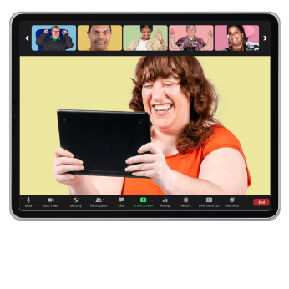
Using the video

The camera on your device is controlled by the Video button on Zoom.

Click the Video button to turn the camera on or off.

When your camera is off the Video button has a red line through it.

When you want people in the meeting to see you click the Video button.

When your camera is on there is no red line on the Video button.


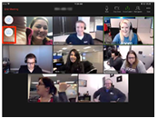
Using switch views

You can switch views in a Zoom meeting to see people in different ways on your screen.


We tell you about 2 of these views.

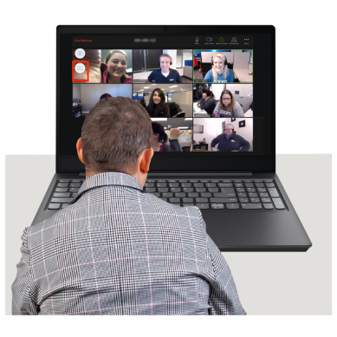
You can switch your view to:
the Speaker view
a Gallery view.

Speaker is when the person shown on the screen:
is the person speaking

and
is shown in a bigger box.
Gallery view is when you can see the people at the meeting in small video squares.

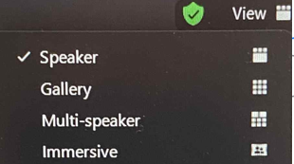
To switch views:
go the top right of the screen
and
choose which view you want to see on screen.

You can switch views as many times as you like in a Zoom meeting.

When you start Zoom on your device it will usually show Speaker view.

The Speaker view works well if you only want to see 1 person like a teacher on screen.


If you are having a hard time finding the controls / buttons ask for support from:

a friend
a whānau / family member
your support worker.

The meeting host can control some things on your Zoom during the meeting like turning your:
audio on / off
video on / off.

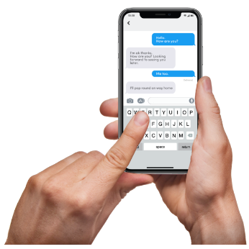
Using chat on Zoom

You can message other people during a Zoom meeting.

This control is called Chat.

You can send messages to:
1 person in the meeting
some people in the meeting
to everyone meeting.

People can send messages to you too.

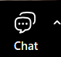

Click the Chat button to message others in the meeting.

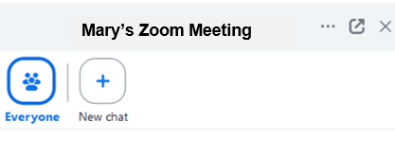

The chat window will pop up.


Choose the person / people you want to send a message to.

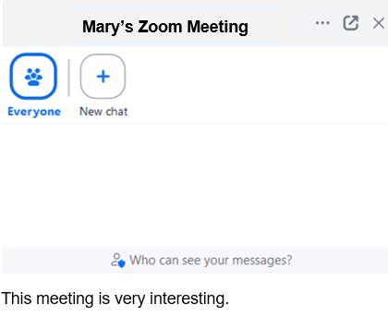
Type your message in the message box.
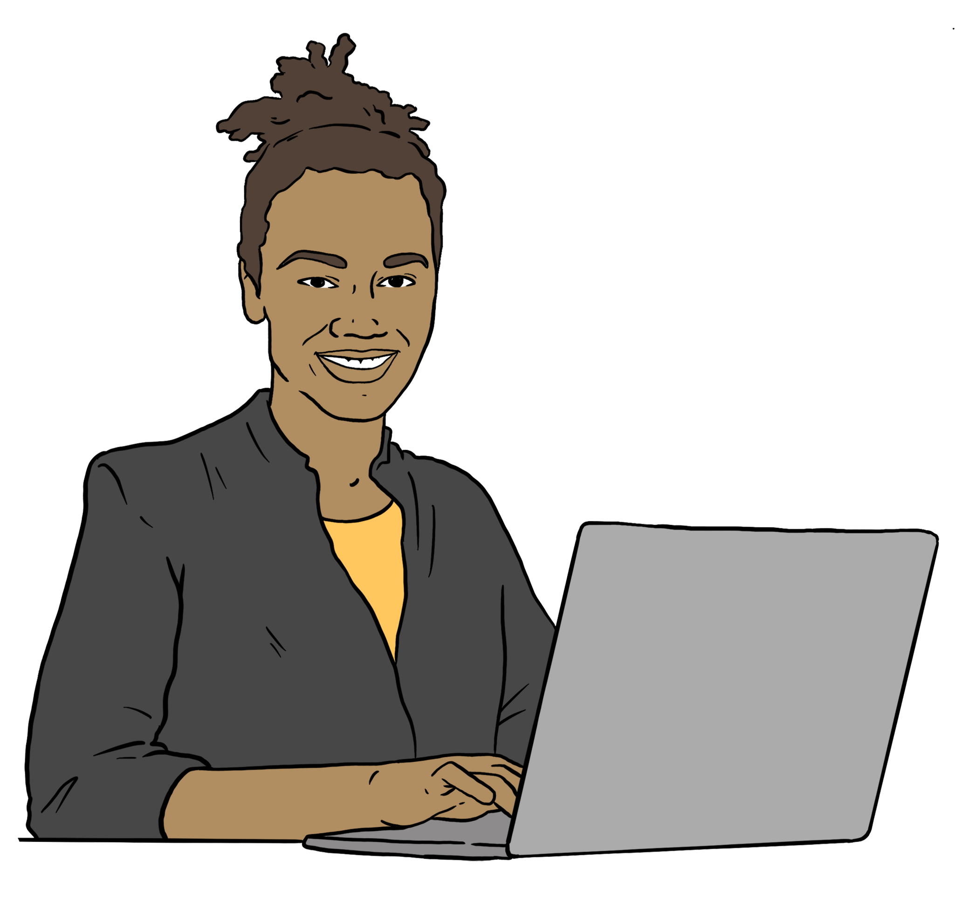

Check your message is being sent to the person / people you want it to go to.

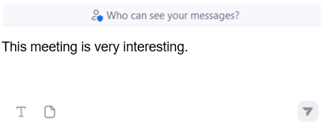

Click the Arrow button to send your message.

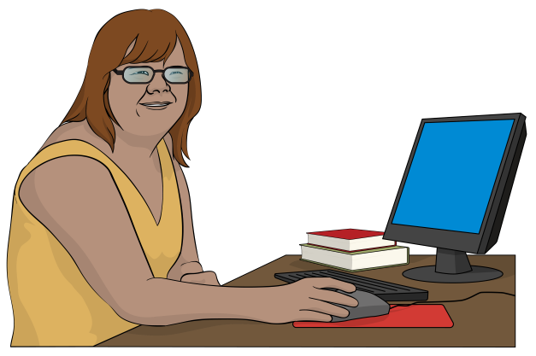
You can use Chat to message your meeting assistant for support during a Zoom meeting.


Reactions

Reactions are like emojis.

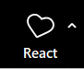

To choose a reaction click the React button.

Choose 1 of the reactions.

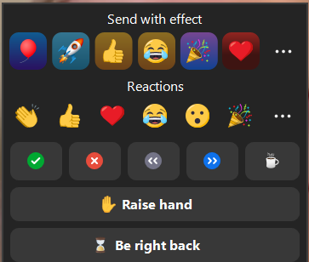

Click the 3 dots if you want to see more reactions.

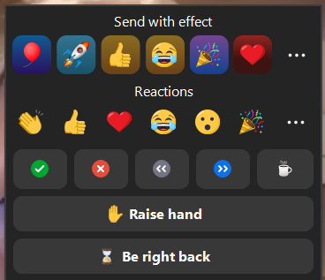

If you would like to ask a question use the Raise hand reaction.

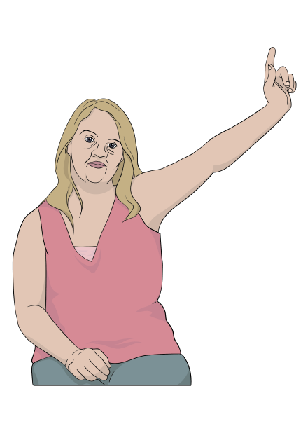
This is like raising your hand when you are at meeting in person.

Doing this lets the meeting host know you want to ask / say something.

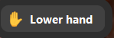
When you have spoken click
Lower hand button at the bottom of the screen to turn it off.


You can leave the Zoom meeting by clicking the leave button on your screen.

Tips for using Zoom
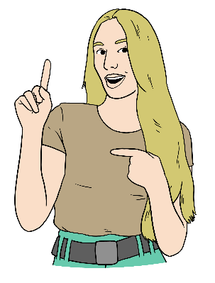

Here are some tips / ideas to support you to have a good Zoom meeting.

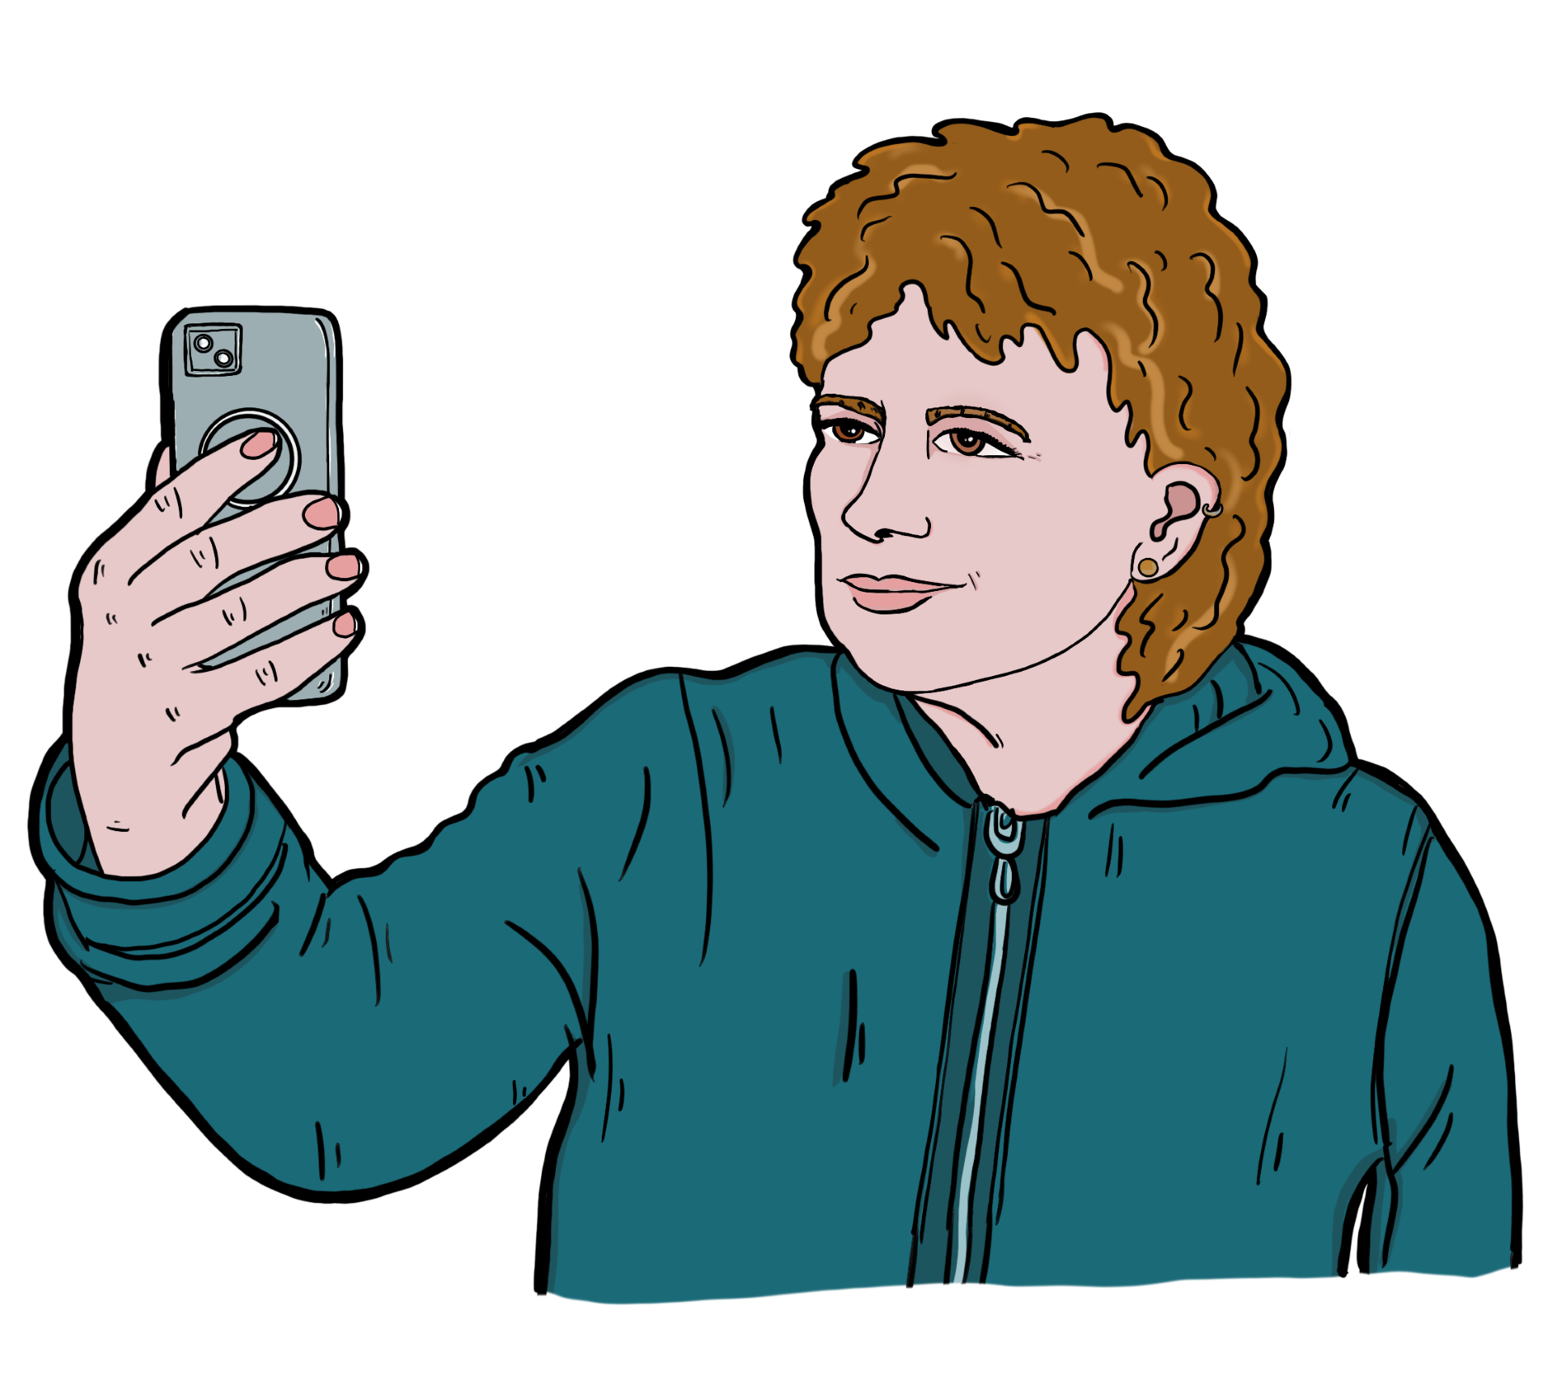

- It is important to keep safe on the internet.
Make sure you only join a Zoom meeting if it is:
with someone you know
a class or group you have signed up to.
- Mute your microphone when you are not talking.

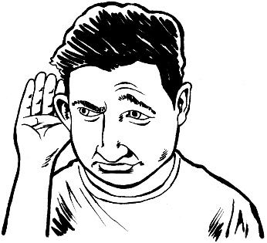
It can be hard to hear what is being said when there is a lot of noise.

- Turn off your video if you need to leave the meeting for a quick break.
Turn your video back on when you get back to the meeting.


This information has been written by
Make it Easy Kia Māmā Mai.

Make it Easy Kia Māmā Mai is part of
People First New Zealand Ngā Tāngata Tuatahi.


All images used in this Easy Read document are subject to copyright rules and cannot be used without permission.


Make it Easy uses images from:


- Photosymbols

- Change Images


- Huriana Kopeke-Te Aho

- SGC Image Works

- T Wood


- Studio Rebeko

- Inga Kramer.

