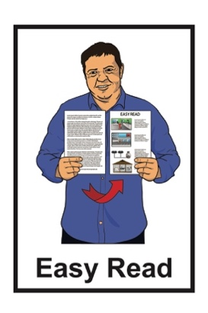
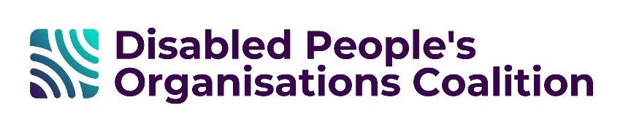

Disabled People’s
Organisations Coalition:
Key Messages February 2026
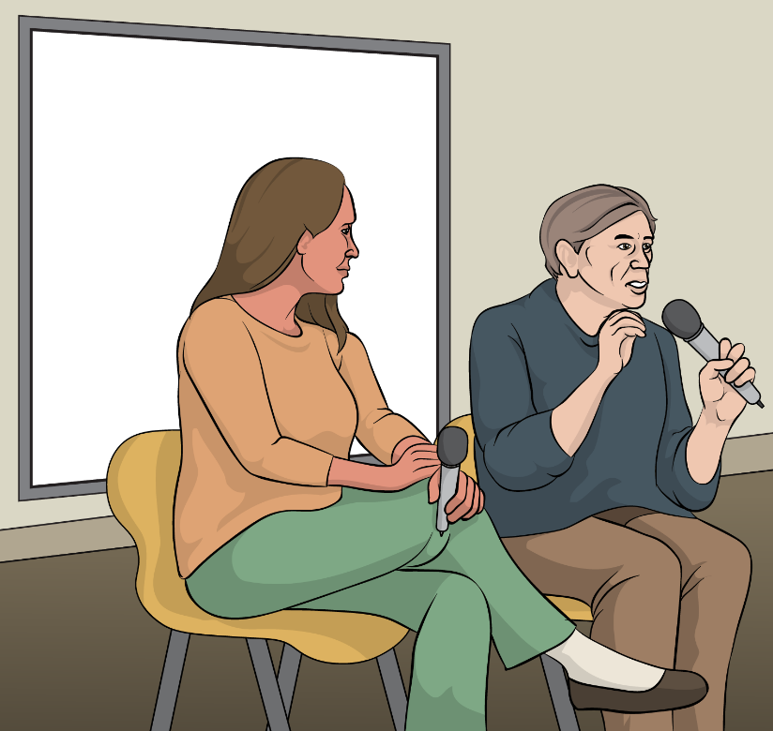

Published: June 2026

What is in this document

Page numbers:

The Disabled People’s
Organisations Coalition 2
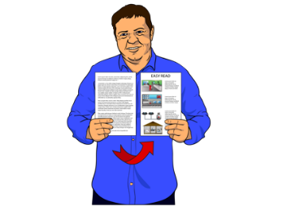

What this document is about 5

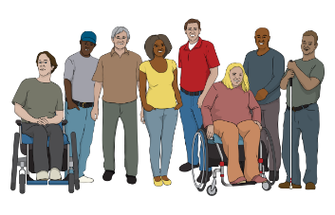
Minister for Disability Issues 8

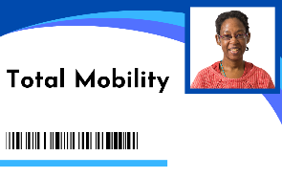
Ministry of Transport team and
Total Mobility Scheme review 12

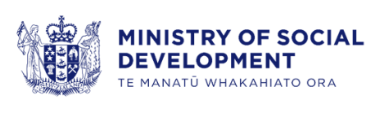
Ministry of Social Development and
ThinkPlace 15

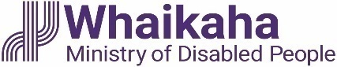
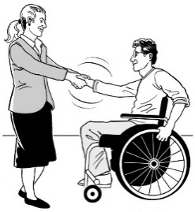
Whaikaha – Ministry of Disabled
People 20

Voices of disabled people 25

The Disabled People’s
Organisations Coalition

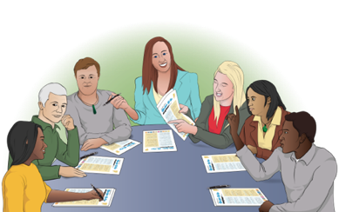
The Disabled People’s Organisations Coalition is a group of people who come from different disability organisations.

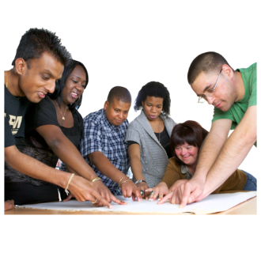
A coalition is a group of organisations that work towards shared goals.


The Disabled People’s Organisations Coalition is also called the
DPO Coalition.

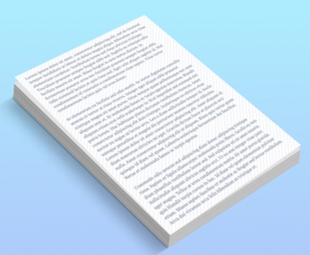
When you see the words we / us in this document it means the
DPO Coalition.

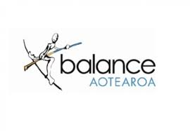
The DPO Coalition is made up of members from these 7 disability organisations:
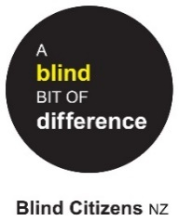
Balance Aotearoa
Blind Citizens New Zealand
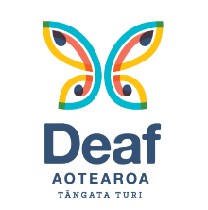
Deaf Aotearoa
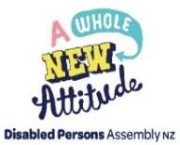
Disabled Persons Assembly NZ
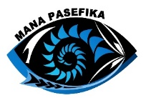
Mana Pasefika
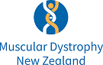
Muscular Dystrophy Association of New Zealand
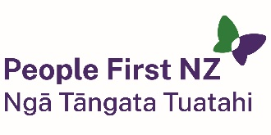
People First New Zealand – Ngā Tāngata Tuatahi.

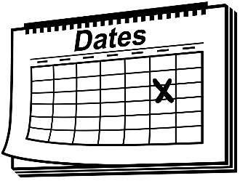
We meet about every 6 weeks to talk about important things.


We speak up about disabled people getting their human rights.

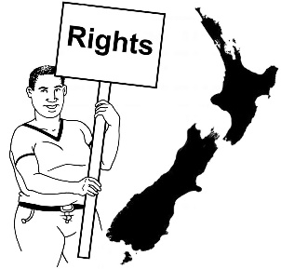
Human rights are things that
the law says every person should:
have
be able to do.

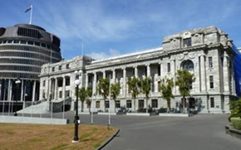
We also talk with the Government about things to do with disability.

What this document is about
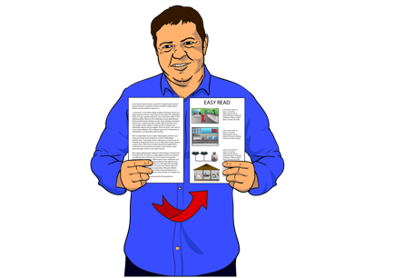

This is an Easy Read document.

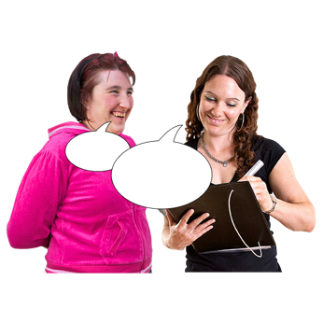
It tells you about some of the key messages from the DPO Coalition meetings we had in February 2026.

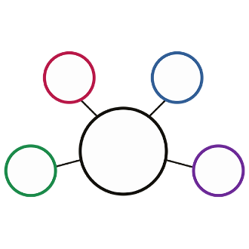
During these meetings we met with lots of:
Government agencies
other community organisations.

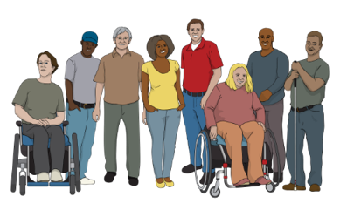
These meetings are to make sure the lives of disabled people in Aotearoa
New Zealand are getting better.

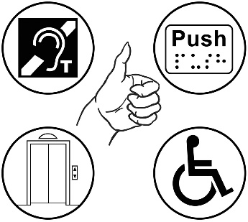
2 important things talked about often are:
accessibility
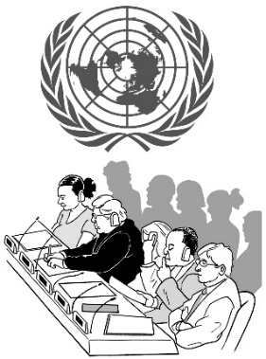
the rights of disabled people in New Zealand under the United Nations Convention on the Rights of Persons with Disabilities.

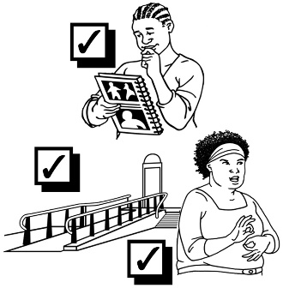
Accessibility means making sure everyone can use things in ways
that are:
easy
safe.

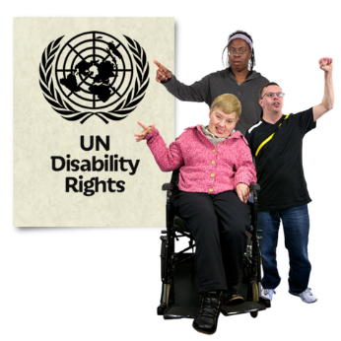
The United Nations Convention
on the Rights of Persons with Disabilities:
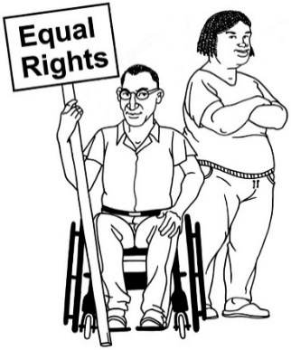
says what governments must
do to make sure disabled
people get the same rights as everybody
is an agreement lots of
countries follow
is also called the UNCRPD.

It takes time for our key messages to become available in Easy Read.


We are sorry for the long wait.

Minister for Disability Issues

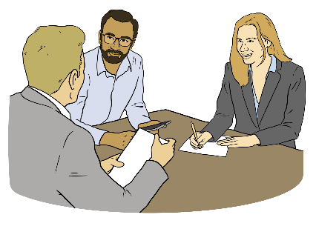
We met with the Minister for Disability Issues Hon Louise Upston.

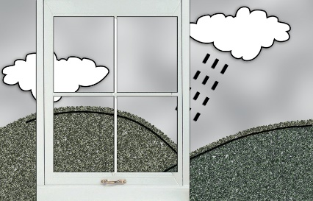
The Minister talked to us about the experiences disabled people had during the recent weather events across the top of the North Island of Aotearoa New Zealand.

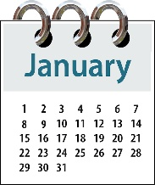
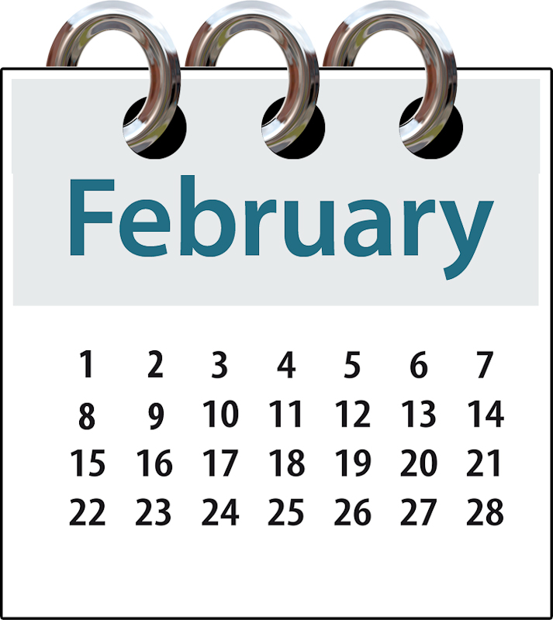
This was when the weather was stormy in:
January 2026
February 2026.


We talked about the importance of information being available:
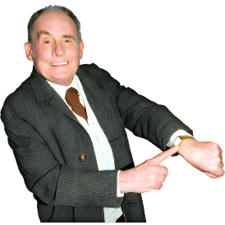
in alternate formats like Easy Read
quickly.

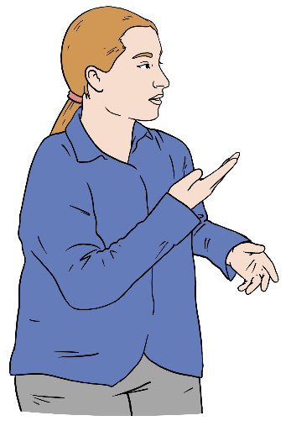
This includes the need for
New Zealand Sign Language interpreters to be available for media communications like:
news videos
social media posts.

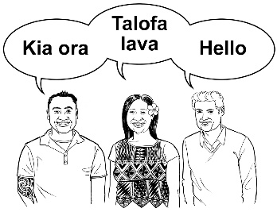
Interpreters support people who speak different languages to talk
to each other.

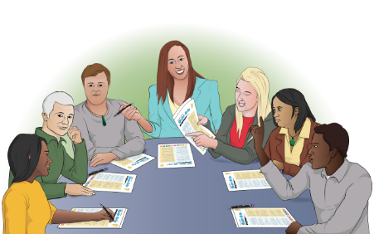
We also asked the Minister to remind the people she works with about the importance of:
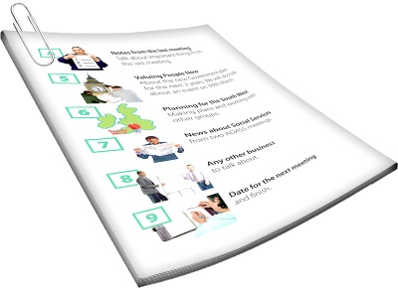
the New Zealand Disability Strategy
actions which should lead to:
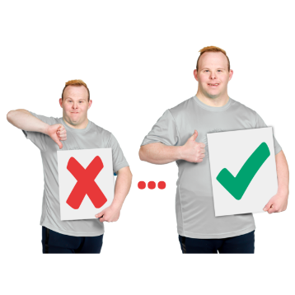
- useful changes
- good changes.

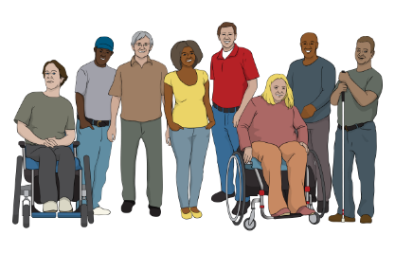
The New Zealand Disability Strategy tells the Government how to make things better for disabled people in Aotearoa New Zealand.


Easy Read information on the
New Zealand Disability Strategy is available here:

tinyurl.com/ywbtbc6v

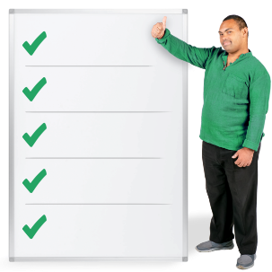
Actions are things done as part of meeting a goal.

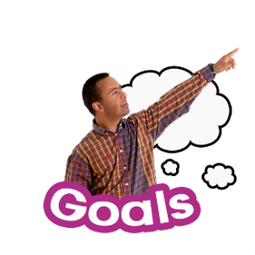
Here a goal is how the
New Zealand Disability Strategy
want things to be.


We also talked about how it is important that all the actions in the New Zealand Disability Strategy are being worked on.

Ministry of Transport team and
Total Mobility Scheme review


We met with the Ministry of Transport to talk about the Total Mobility Scheme proposals open for public consultation.

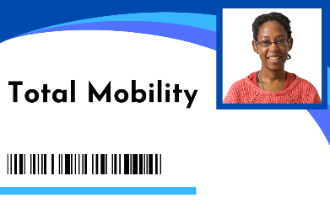
The Total Mobility Scheme proposals are improvements the Ministry of Transport have
suggested for Total Mobility.

Improvements means to:
change things
make things better.


Total Mobility supports disabled people to move around by paying part of the cost of taxi trips.

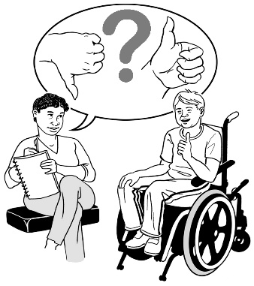
Public consultation means the Ministry of Transport is asking
people what they think about their proposal.

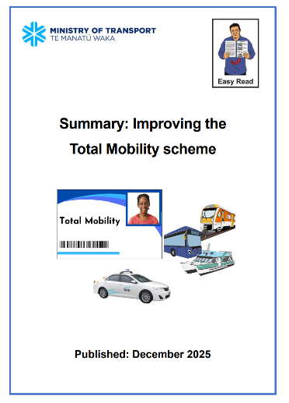
There is an Easy Read document called Summary: Improving the Total Mobility scheme available here:

tinyurl.com/4mc3fnmh

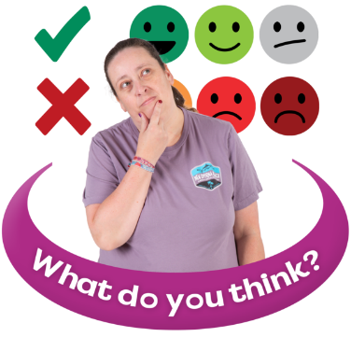
We told the Ministry our feedback on the 6 proposals.

Feedback means saying what you think about something.
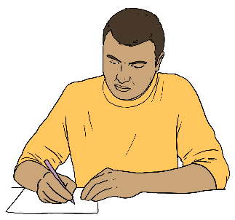
Individual DPOs shared that they would:

send their thoughts about the proposals as part of the public consultation
tell their members to send their thoughts as part of the public consultation.
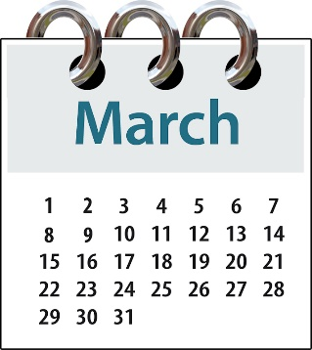

The public consultation closed on
22 March 2026.

Ministry of Social Development and ThinkPlace

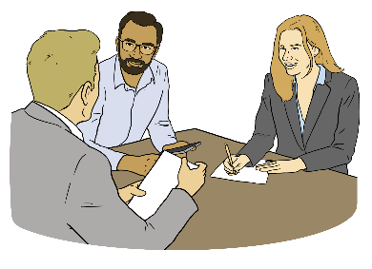
We talked about the Disability Employment Support Products Redesign project with the:
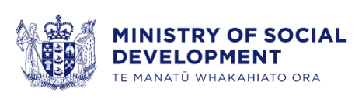
Ministry of Social Development
ThinkPlace.

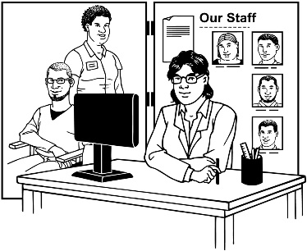
The Disability Employment Support Products are different services that focus on the employment barriers disabled people expereince when:
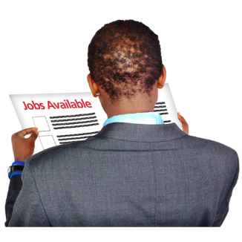
looking for a job
trying to keep their job.


Employment barriers are things
that either:
stop disabled people from:
- getting a job
- keeping a job
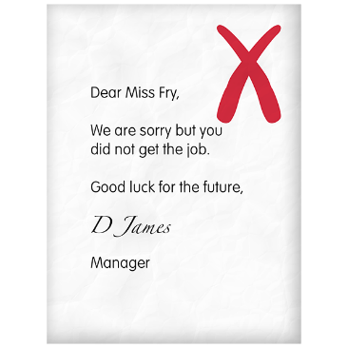
make it harder for disabled people to:
- get a job
- keep a job.

Redesign project means the Ministry of Social Development is looking at these services to see how they can make them better.

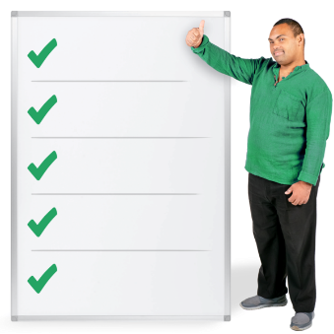
This work is part of the actions of the New Zealand Disability Strategy 2026 to 2030.


More Easy Read information on employment in the New Zealand Disability Strategy is available here:

tinyurl.com/z82tu62c

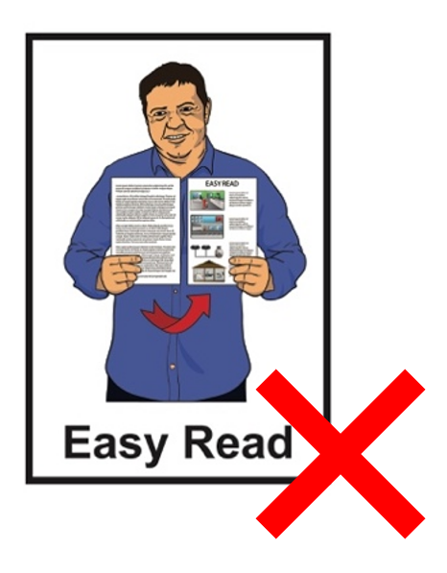
More information about the Disability Employment Support Products Redesign project is available here:

tinyurl.com/yrk8yv9z

This information is not in Easy Read.

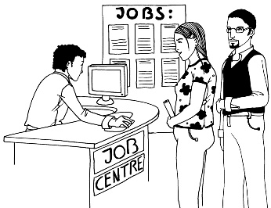
The Redesign project includes looking at these 4 services:
specialist employment service
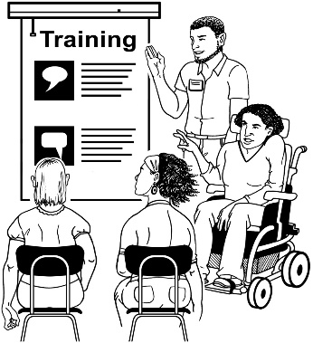
employment service in schools
mainstream wage subsidy
job and training support funds.

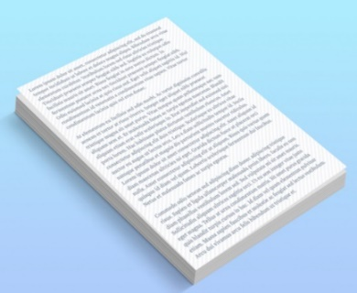
We talked about this work is part of Employment Action 2 of the New Zealand Disability Strategy.

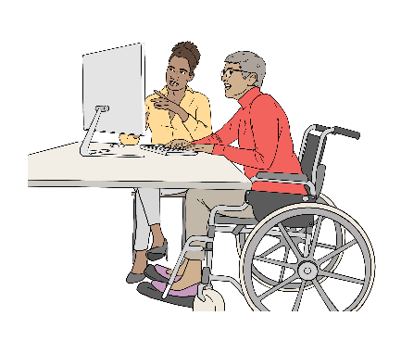
Employment Action 2 is about making sure specialist
employment supports are working to make employment better for disabled people.

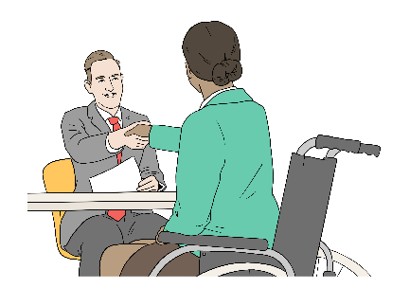
Specialist employment supports are supports for disabled people to make it easier for them to work.

More Easy Read information on employment in the New Zealand Disability Strategy is available here:

tinyurl.com/z82tu62c


We will continue to be part of the redesign process.

We are looking forward to meeting with officials on the redesign project.

Whaikaha – Ministry of Disabled People

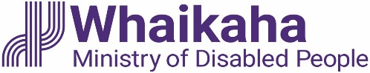
We talked with Whaikaha about its feedback on the New Zealand Disability Strategy Implementation Plan.


Implementations are when the actions of a plan are being done.


Easy Read information about the New Zealand Disability Strategy Implementation Plan is available here:

https://tinyurl.com/4m84xf3f
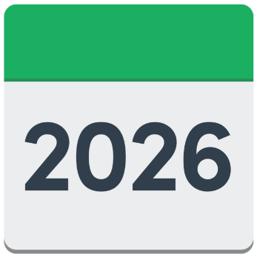

Whaikaha said that 11 actions will be finished this year.

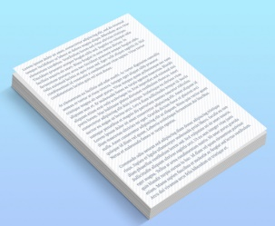
We talked about how important it was that all actions were started during the time agreed to in the Disability Strategy.

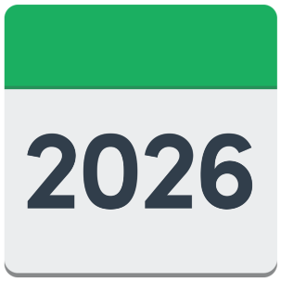
The newest Disability Strategy was agreed this year.

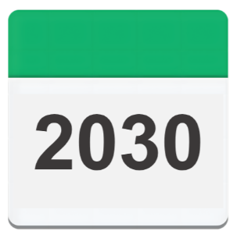
It was agreed to be worked on for the next 5 years until 2030.


We will continue to be part of the implementation of the Disability Strategy process.

We also talked about the Accessibility Work Programme for this year.

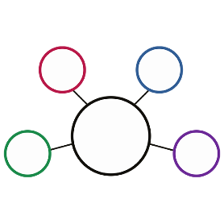
The Accessibility Work Programme is a mix of different projects that focus on:
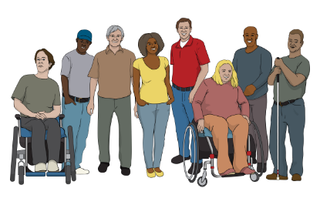
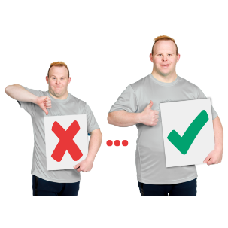
working on accessibility barriers in New Zealand for disabled people
making changes that support disabled people.

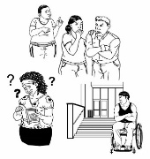
Accessibility barriers are things that stop something from being accessible.

More information on the Accessibility Work Programme is available here:

https://tinyurl.com/3fje45nj

This information is not in Easy Read.

The Accessibility Work Programme will focus on:
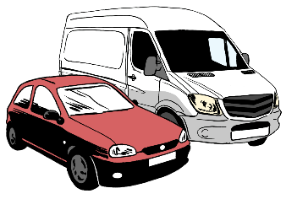
transport
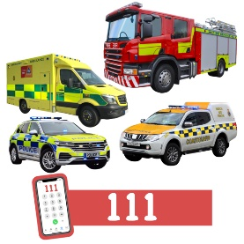
the built environment
emergency management
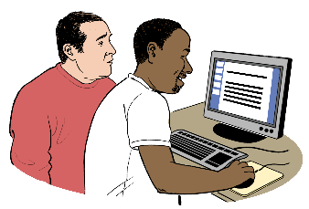
digital information.

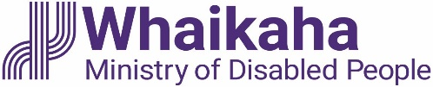
We expect Whaikaha to share this information with more people.

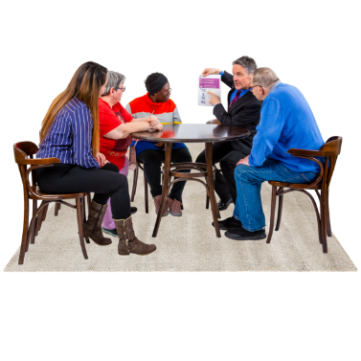
We are happy to have 2 people from the DPO Coalition on the Accessibility Advisory Group.

More information on the Accessibility Advisory Group is available here:

tinyurl.com/4kuvn4zj

This information is not in Easy Read.

Voice of disabled people

The Government meets with the DPO Coalition so disabled people can have a say in the decisions being made about them.
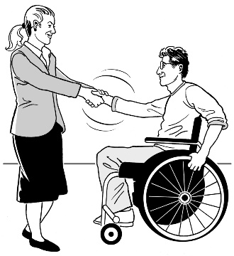

The DPO Coalition is always looking for new DPOs to join us.

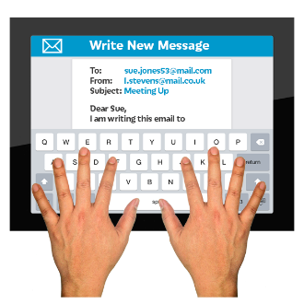
You can contact us by emailing:

us-dpo@groups.io


This information has been written by the DPO Coalition.

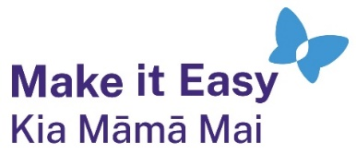
It has been translated into Easy Read by the Make it Easy Kia Māmā Mai service of People First New Zealand Ngā Tāngata Tuatahi.
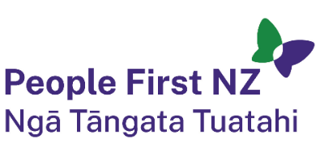
The ideas in this document are not the ideas of People First New Zealand Ngā Tāngata Tuatahi.

All images used in this Easy Read document are subject to copyright rules and cannot be used without permission.

Make it Easy uses images from:

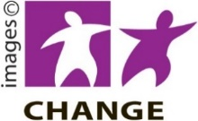
- Photosymbols

- Change Images

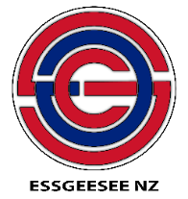
- Huriana Kopeke-Te Aho
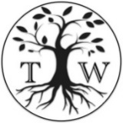
- SGC Image Works

- T Wood

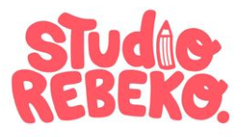
- Studio Rebeko

- Inga Kramer.

