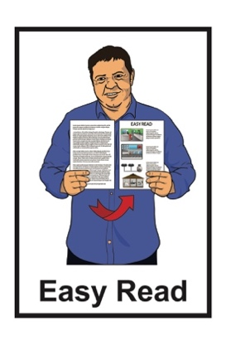

Information about how schools make plans and reports

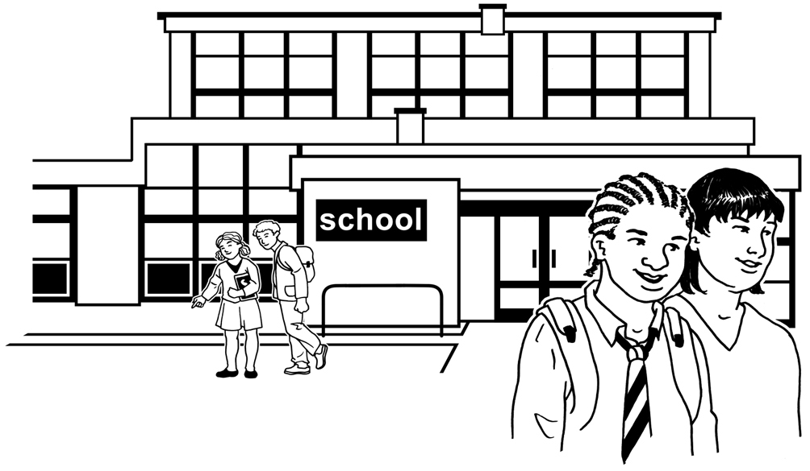

Published: September 2023



# What is this document about?



This Easy Read document is from

**Te Tāhuhu o te Mātauranga – Ministry of Education**.

**Te Tāhuhu o te Mātauranga – Ministry of Education** is the part of the New Zealand Government that is in charge of schools.

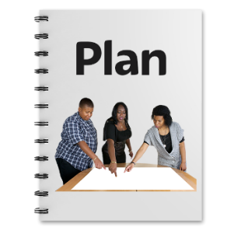

This Easy Read document is about how schools:

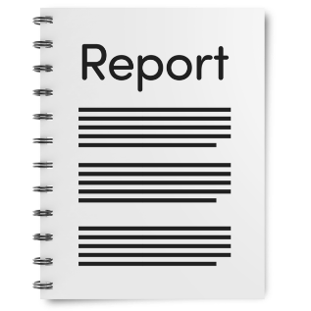make plans

report on the plans that were made.

# Why are plans and reports important?

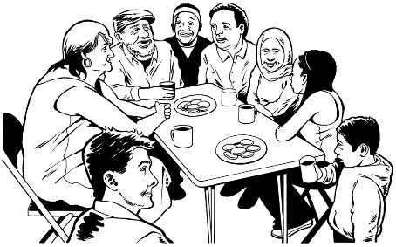

Schools need to work with people in their community to plan for the **future**.



The **future** is a time that has not happened yet.

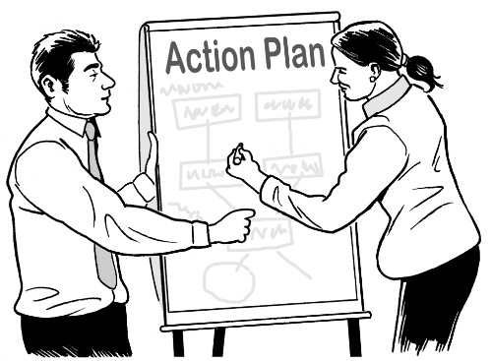Schools:

* makeplansso they can set **goals** for the school
* 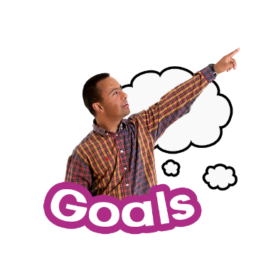write reports so they can see if they have met their goals.

**Goals** are things that schools want their **learners** to do well at.

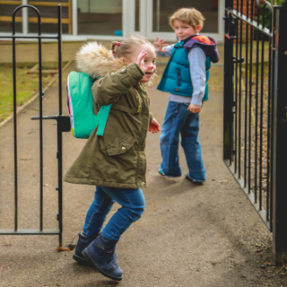

In this document a **learner** means a person who goes to:

primary school

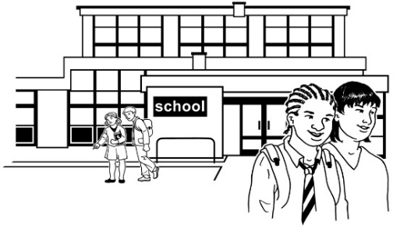intermediate school

college / high school.



The goals of a school think about:

the needs of the learners

the best way to support the learners.

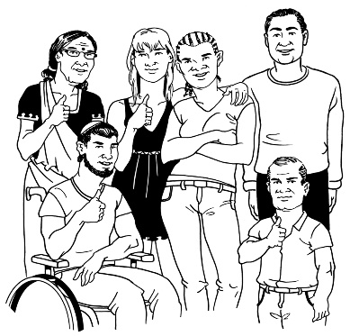Everyone can have their say about the goals for a school.

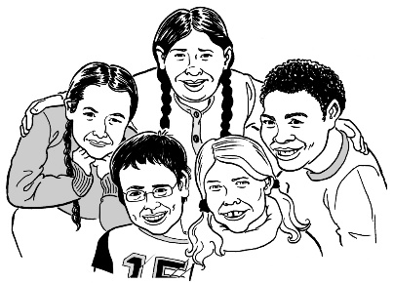The people who can be part of choosing the goals include:

children / young people

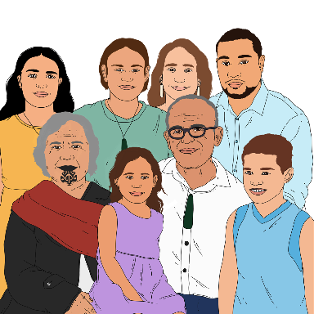parents

whānau / family

the wider community

you.

What you say can support the school to make the school goals better.



This will give all learners the best school experience.

# What do schools have to do?

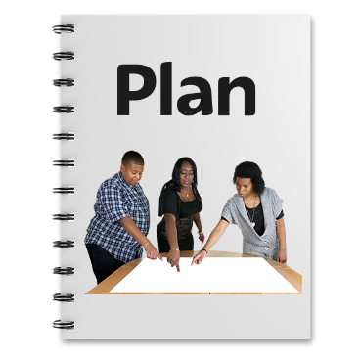Schools need to put together plans that are both:

**annual**

**and**

**long** **term**.



**Annual** means something that happens every year.



**Long term** means something that happens over a longer amount of time.

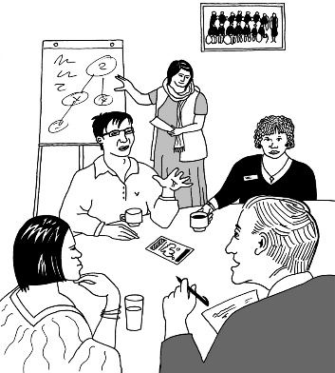These plans are based on:

what people have told the school

what school **data** tells them is important.

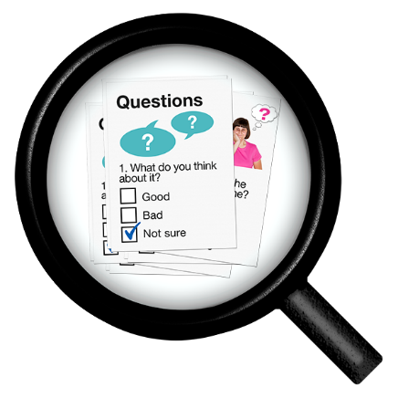**Data** is information that shows things like:

how well the learners are doing

which learners need more support.

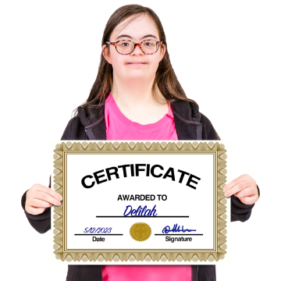

The school must use the plans to make sure:

every learner can do their best

the school is a safe place

learners get their **human rights** met.

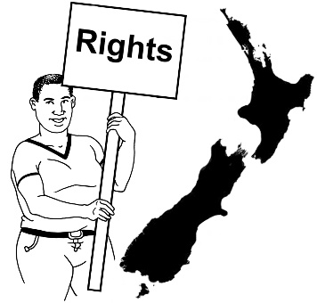**Human rights** are rights everyone has like:

the chance to learn / go to school

being able to have ideas about the things that are important to them.

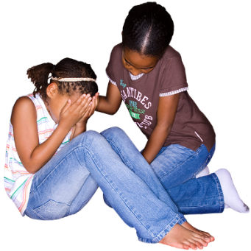

The school must also use the plans to make sure things are done to stop:

**racism**

**bullying**

other **discrimination.**

**R****acism** means nasty or unfair treatment of someone because of:

* where they come from
* their language
* skin colour
* religion / their beliefs
* their **culture**.

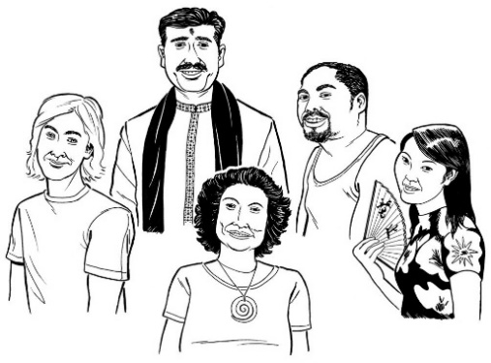 **Culture** is a way of:

* thinking that a group shares
* doing things as a group.

**Bullying** is when 1 person or a group of people treats someone in a bad way.

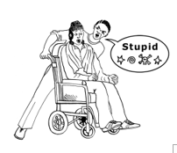

Bullying can be things like:

saying nasty things to you / about you

being ignored or left out

being hit / kicked / pushed

telling lies about you.

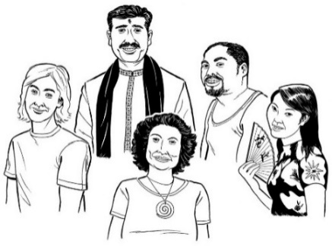

**Discrimination** is when people are treated differently because of things like:

their culture

being disabled.

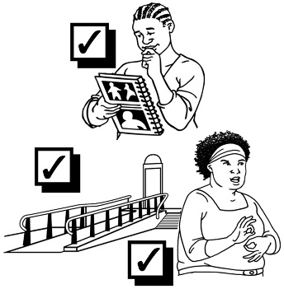The school must also use the plans to make sure learners with learning support needs are included / supported.

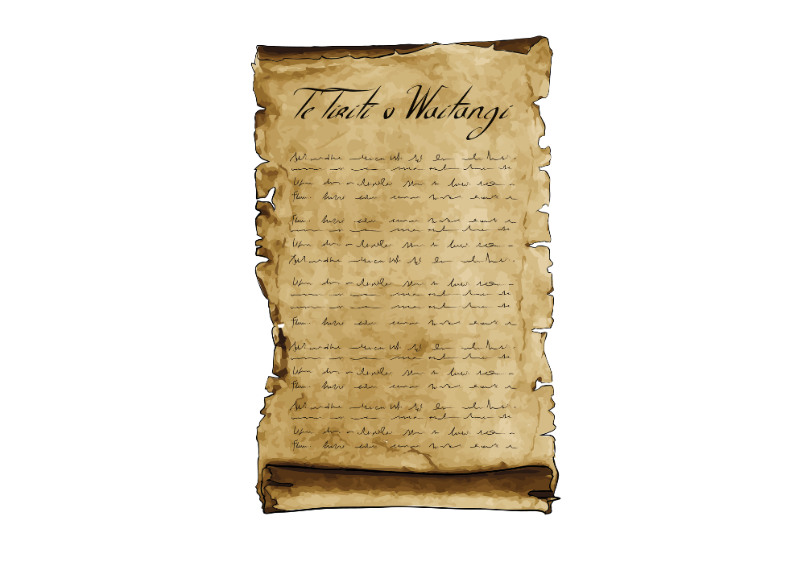

The school must also think about **Te Tiriti o Waitangi / The Treaty of Waitangi**.

**Te Tiriti o Waitangi / The Treaty of Waitangi** is an important agreement between Māori and the Aotearoa New Zealand Government.

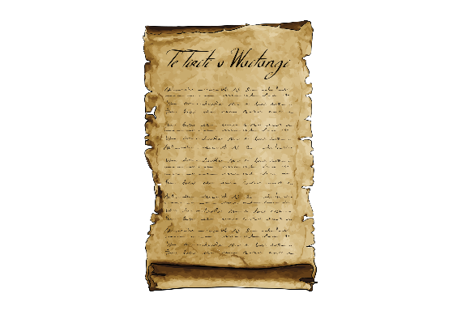Thinking about Te Tiriti / The Treaty means schools should include these things in their plans:

**tikanga** which means ways of doing things that are important to Māori

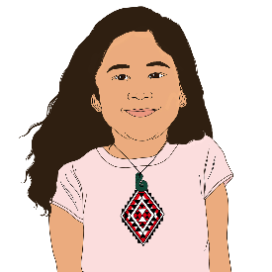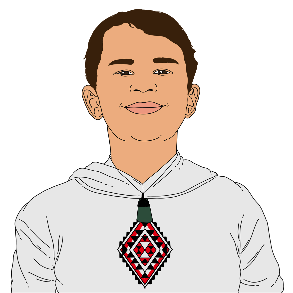

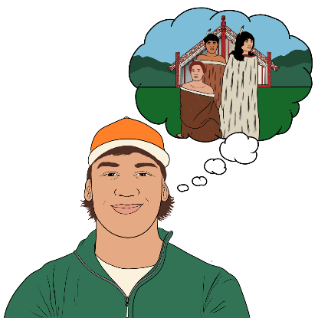**mātauranga** which means knowledge about things that are important to Māori

**te ao Māori** which means how Māori think about the world / their place in the world.

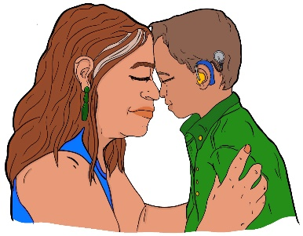

Thinking about Te Tiriti o Waitangi means the school should do as much as they can to teach:

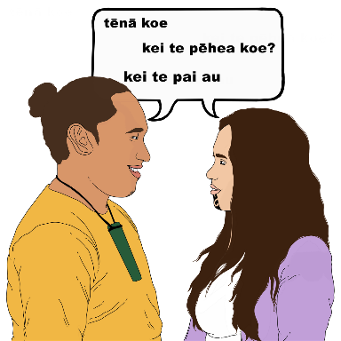tikanga

te reo Māori / Māori language.

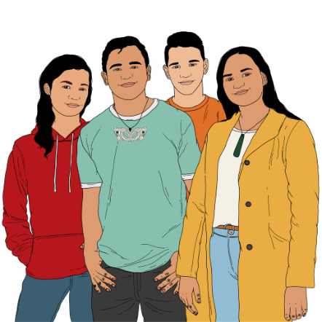Thinking about Te Tiriti o Waitangi means the school must work on making sure Māori students do as well in school as students who are not Māori.

# What to expect from your school

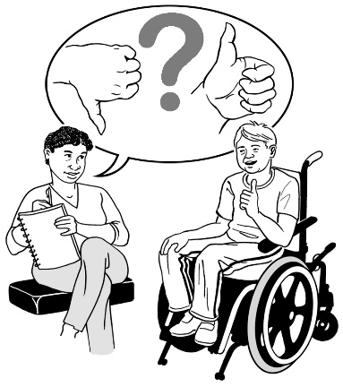You should expect your school to tell you what is:

working

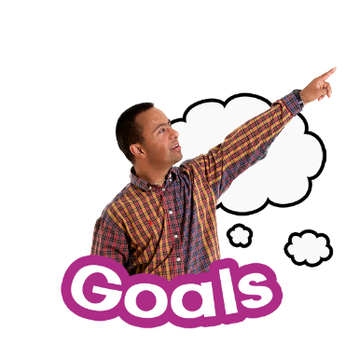not working.

This can help your school to work out their goals.



The school plan must be written in a way that is easy to understand.



The school plan must be available online on the school website.

The school must report each year on how the school is doing with meeting the goals in the plan.

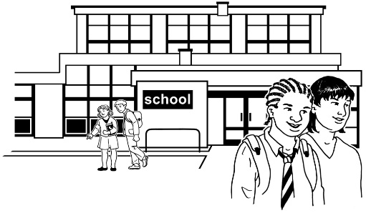

The report must include how the learners are doing at school as a whole



This report is different to the school report that learners take home to their parents / care givers about their own learnings.

# Where to find more information

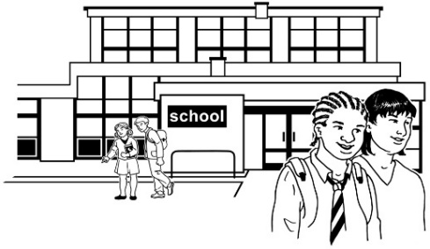

You can talk to your school to find out more about how they make their plans.



The Ministry of Education has more information about how schools make plans / write reports.

You can find the information on the Ministry of Education website:

**www.education.govt.nz/school/  
schools-planning-and-reporting**

**This information has been written by the Ministry of Education.

It has been translated into Easy Read by the Make it Easy Kia Māmā Mai service of People First New Zealand Ngā Tāngata Tuatahi.

The ideas in this document are not the ideas of People First New Zealand Ngā Tāngata Tuatahi.

Change logo.
Change is the name of the organisation.Make it Easy uses images from:

* Changepeople.org
* Photosymbols.com
* SGC Image Works
* Huriana Kopeke-Te Aho.

All images used in this Easy Read document are subject to copyright rules and cannot be used without permission.