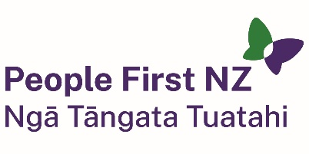
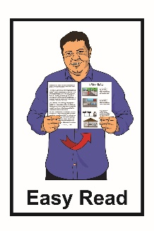

Job advert: Regional Coordinator

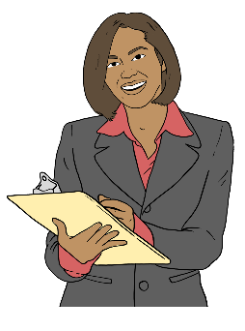

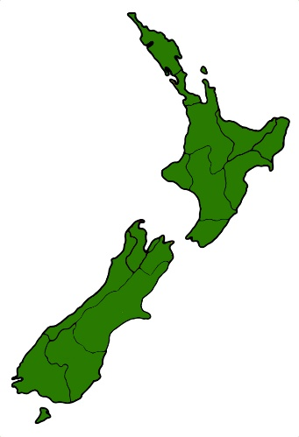

This is an Easy Read job advert for a Regional Coordinator at People First New Zealand.

We are looking for a new Regional Coordinator in the Midsouth area of New Zealand.

A Regional Coordinator supports people who are part of People
First NZ groups in their region like:
members / people with learning disability
the local assistant for each group.

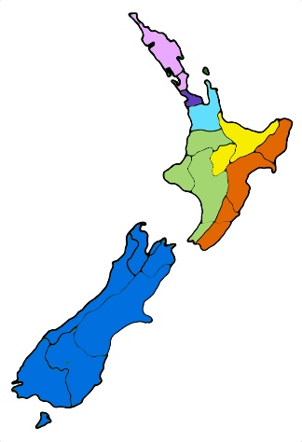
A region is a big part of New Zealand like:
- Waikato
- Auckland.

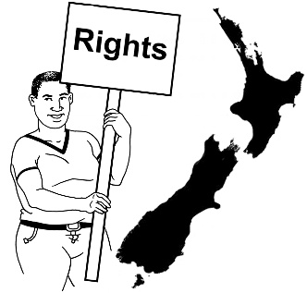
This could be a good job for you if you are interested in:

human rights / the things the law says everyone should have
social justice / people being treated fairly.
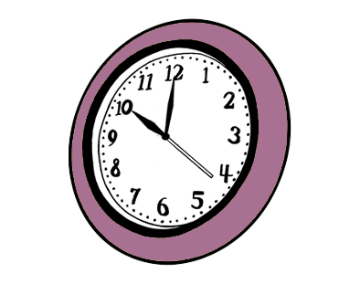

This job is part-time which means it will only be 15 hours each month.


Some of the things the Regional Coordinator will do are:
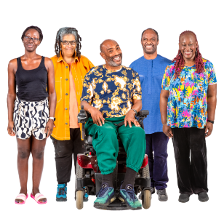
set up / support local groups
manage people like
local assistants / volunteers
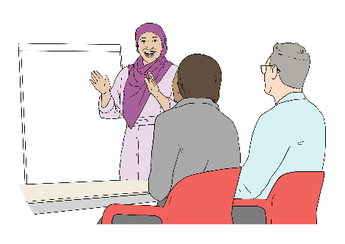
support People First NZ members to:
- learn new things
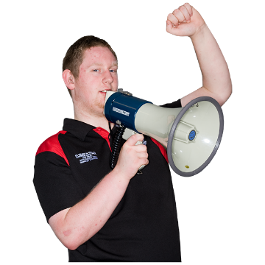
- speak up about their rights
tell people about human rights
make sure everyone is included / can make their own choices
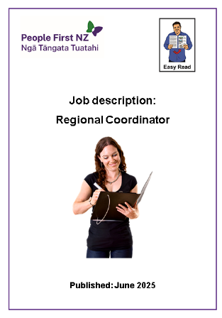
work with People First NZ staff.

Email People First NZ for the job description / full list of things the Regional Coordinator would do.

Our email is:
ask@peoplefirst.org.nz

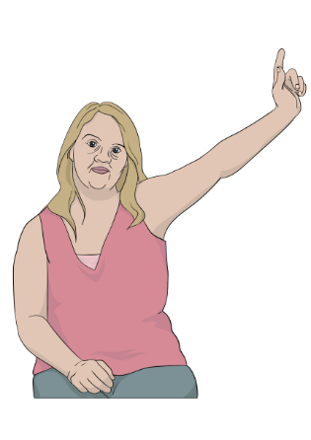
We want to hear from both:
disabled people
non-disabled people.


We want to make applying for jobs with People First NZ as easy for everyone as we can.

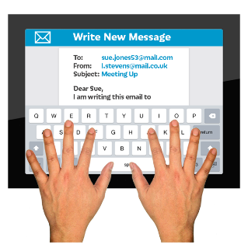
You can also contact People First NZ by email if you:
are interested in the job
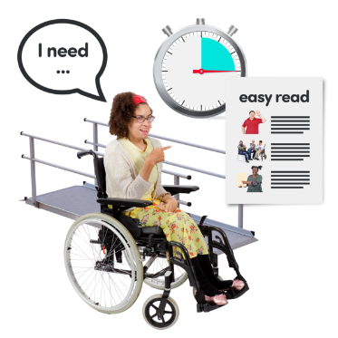
want to know more about the job
need a different way to apply instead of by email.
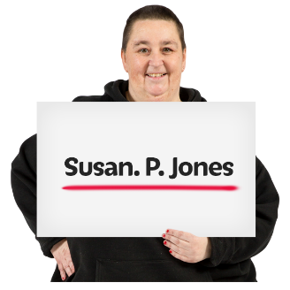
To apply please email us:
a letter telling us about you / why you would be good at the job
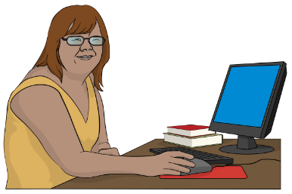
a CV / list of things you have done already like:
- jobs / volunteer roles
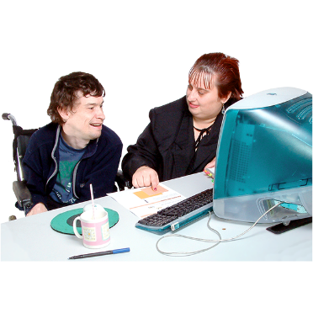
- study / qualifications
- ways you have supported disabled people before.
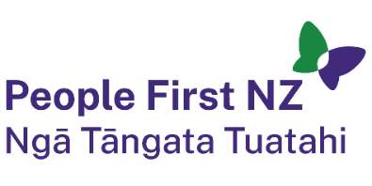
This information has been written by People First New Zealand Ngā Tāngata Tuatahi.

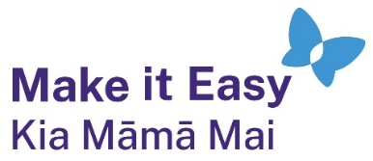
It has been translated into Easy Read by the Make it Easy Kia Māmā Mai service of People First New Zealand Ngā Tāngata Tuatahi.


All images used in this Easy Read document are subject to copyright rules and cannot be used without permission.


Make it Easy uses images from:

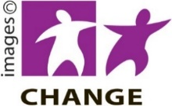
- Photosymbols

- Change Images


- Huriana Kopeke-Te Aho

- SGC Image Works

- T Wood

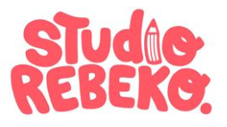
- Studio Rebeko

- Inga Kramer.

